**231-889-4429 5471 Fairview Street, Box 119 Onekama, MI**

**TRINITY LUTHERAN CHURCH**

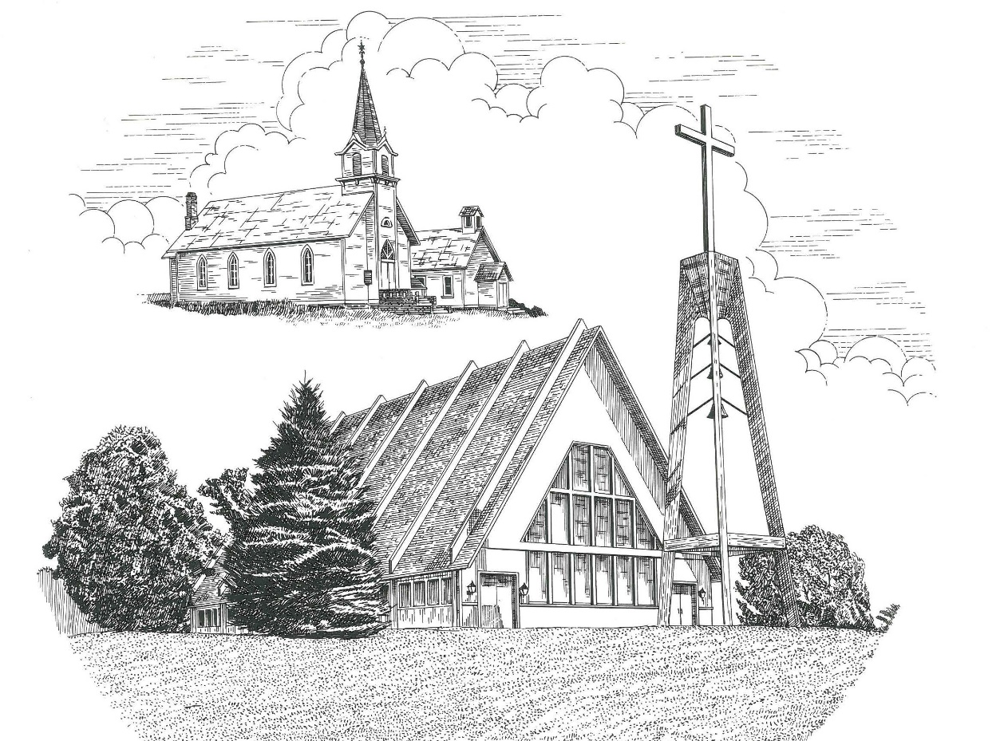

**Palm Sunday April 10th, 2022**

**WELCOME**

**Thanks for joining us!**

**Pastor Jacob Sherry Missouri Synod**

**~~PLEASE NOTE~~Calling on the name of the Lord**

Does not include the use of cell phones in the worship sanctuary.

Please check yours before the service begins. Thank you for your courtesy.

**~~TO OUR GUESTS AND VISITORS~~**

Please sign our guest book located on the stand at the church entrance. During the service, we ask you to sign the attendance sheets located inside your bulletin and leave them on the pew as you leave. If you need assistance or have questions about our worship service, please talk to an elder or any one of our church family. We are glad you could join us and hope to have you worship with us again soon.

**~~ATTENDING HOLY COMMUNION~~**

By checking the “Communing Today” box on the registration form on the attendance sheet, you are agreeing with the following statements:

* **I am a baptized Christian who believes Jesus Christ is my Lord and Savior.**
* **I believe that I am a sinner in need of Christ freely offered forgiveness.**
* **I believe that in the Lord’s Supper the body and blood of Jesus Christ**

**are truly present in, with, and under the bread and wine.**

* **I believe that my participation in Holy Communion grants me forgiveness**

**of my sins, new spiritual life, and eternal salvation.**

* **With God’s help, I sincerely seek to repent of my sins, live in service**

**to my Lord, and await His return.**

**If you agree with the above statements, you are welcome to attend the Lord’s Supper with us. May God bless your worship time with us.**

We do offer gluten-free wafers, please quietly ask an elder to help you.

**Order of Divine Service Setting One**

**Pre-Service Music……………..Call to Worship………………….Greeting**

**OPENING HYMN:** *“Hosanna, Loud Hosanna”*……………………….LSB #443

**CONFESSION & ABSOLUTION**……………………………………..LSB p. 151

**KYRIE**…………………………………………………………………...LSB pp. 152-153

**SALUTATION**…………………………………………………………..LSB p. 156

**Collect Prayer**

Almighty and everlasting God, You sent Your Son, our Savior Jesus Christ, to take upon Himself our flesh and to suffer death upon the cross. Mercifully grant that we may follow the example of His great humility and patience and be made partakers of His resurrection; through the same Jesus Christ, our Lord, who lives and reigns with You and the Holy Spirit, one God, now and forever.

**THE HOLY SCRIPTURES**

**OLD TESTAMENT:** (Deuteronomy 32:36-39)

**36**For the Lord will vindicate his people  
    and have compassion on his servants,  
when he sees that their power is gone  
    and there is none remaining, bond or free.  
**37**Then he will say, ‘Where are their gods,  
    the rock in which they took refuge,  
**38**who ate the fat of their sacrifices  
    and drank the wine of their drink offering?  
Let them rise up and help you;  
    let them be your protection!

**39**“‘See now that I, even I, am he,  
    and there is no god beside me;  
I kill and I make alive;  
    I wound and I heal;  
    and there is none that can deliver out of my hand.

**R:** This is the Word of the Lord**.** **Cong: Thanks be to God.**

**GRADUAL**

Reader: Christ entered once for all into the holy places, by means of his own blood,

**Cong.: thus securing an eternal redemption.**

Reader: Therefore he is the mediator of a new covenant,

**Cong.: so that those who are called may receive the promised eternal inheritance.**

Reader: He sent redemption to his people;

**Cong.: he has commanded his covenant forever.**

**EPISTLE:** (Philippians 2:5-11)

**5**Have this mind among yourselves, which is yours in Christ Jesus, **6**who, though he was in the form of God, did not count equality with God a thing to be grasped, **7**but emptied himself, by taking the form of a servant, being born in the likeness of men.  **8**And being found in human form, he humbled himself by becoming obedient to the point of death, even death on a cross.  **9**Therefore God has highly exalted him and bestowed on him the name that is above every name, **10**so that at the name of Jesus every knee should bow, in heaven and on earth and under the earth, **11**and every tongue confess that Jesus Christ is Lord, to the glory of God the Father.

**R:** This is the Word of the Lord. **Cong: Thanks be to God.**

**(PLEASE RISE for the reading of the Gospel)**

**R:** The Holy Gospel according to St. John, the 12th chapter.



**HOLY GOSPEL:** (John 12:20-43)

**20**Now among those who went up to worship at the feast were some Greeks.  **21**So these came to Philip, who was from Bethsaida in Galilee, and asked him, “Sir, we wish to see Jesus.”  **22**Philip went and told Andrew; Andrew and Philip went and told Jesus.  **23**And Jesus answered them, “The hour has come for the Son of Man to be glorified.  **24**Truly, truly, I say to you, unless a grain of wheat falls into the earth and dies, it remains alone; but if it dies, it bears much fruit.  **25**Whoever loves his life loses it, and whoever hates his life in this world will keep it for eternal life.  **26**If anyone serves me, he must follow me; and where I am, there will my servant be also.  If anyone serves me, the Father will honor him. **27**“Now is my soul troubled. And what shall I say? ‘Father, save me from this hour’? But for this purpose, I have come to this hour.  **28**Father, glorify your name.” Then a voice came from heaven: “I have glorified it, and I will glorify it again.”  **29**The crowd that stood there and heard it said that it had thundered. Others said, “An angel has spoken to him.”  **30**Jesus answered, “This voice has come for your sake, not mine. **31**Now is the judgment of this world; now will the ruler of this world be cast out.  **32**And I, when I am lifted up from the earth, will draw all people to myself.”  **33**He said this to show by what kind of death he was going to die.  **34**So the crowd answered him, “We have heard from the Law that the Christ remains forever. How can you say that the Son of Man must be lifted up? Who is this Son of Man?”  **35**So Jesus said to them, “The light is among you for a little while longer.  Walk while you have the light, lest darkness overtake you. The one who walks in the darkness does not know where he is going.  **36**While you have the light, believe in the light, that you may become sons of light.”

When Jesus had said these things, he departed and hid himself from them.  **37**Though he had done so many signs before them, they still did not believe in him, **38**so that the word spoken by the prophet Isaiah might be fulfilled:

“Lord, who has believed what he heard from us,  
  and to whom has the arm of the Lord been revealed?”

**39**Therefore they could not believe. For again Isaiah said,

**40**“He has blinded their eyes  
     and hardened their heart,  
 lest they see with their eyes,  
     and understand with their heart, and turn,  
     and I would heal them.”

**41**Isaiah said these things because he saw his glory and spoke of him. **42**Nevertheless, many even of the authorities believed in him, but for fear of the Pharisees they did not confess it, so that they would not be put out of the synagogue; **43**for they loved the glory that comes from man more than the glory that comes from God.

**R:** This is the Gospel of the Lord.



**SERMON HYMN**: *“All Glory, Laud, and Honor”*…………………...............LSB #442

**SERMON**

**NICENE CREED**

I believe in one God, the Father Almighty, maker of heaven and earth and of all things visible and invisible.

And in one Lord Jesus Christ, the only-begotten Son of God, begotten of His Father before all worlds, God of God, Light of Light, very God of very God, begotten, not made, being of one substance with the Father, by whom all things were made; who for us men and for our salvation came down from heaven and was incarnate by the Holy Spirit of the virgin Mary and was made man; and was crucified also for us under Pontius Pilate. He suffered and was buried. And the third day He rose again according to the Scriptures and ascended into heaven and sits at the right hand of the Father. And He will come again with glory to judge both the living and the dead, whose kingdom will have no end.

And I believe in the Holy Spirit, the Lord and giver of life, who proceeds from the Father and the Son, who with the Father and the Son together is worshiped and glorified, who spoke by the prophets. And I believe in one holy Christian and apostolic Church, I acknowledge one Baptism for the remission of sins, and I look for the resurrection of the dead and the life of the world to come. Amen.

**CONFIRMATION**

Aleah Mae Blackmore Philippians 4:6

*“Do not be anxious about anything, but in everything by prayer and supplication with thanksgiving let your requests be made known to God.”*

Anna Louise Bradford John 3:16

*“For God so loved the world, that he gave his only Son, that whoever believes in him should not perish but have eternal life.”*

Aubry Ann LeSarge Ephesians 2:8-9

*“For by grace you have been saved through faith. And this is not your own doing; it is the gift of God, not a result of works, so that no one may boast.”*

**THE GENERAL PRAYERS OF THE CHURCH**

**SERVICE OF THE SACRAMENT**

**PREFACE**……………………………………………………………………..LSB p. 160

**Proper Preface**

It is truly good, right, and salutary that we should at all times and in all places give thanks to You, holy Lord, almighty Father, everlasting God, through Jesus Christ, our Lord, who accomplished the salvation of mankind by the tree of the cross that, where death arose, there life also might rise again and that the serpent who overcame by the tree of the garden might likewise by the tree of the cross be overcome. Therefore, with angels and archangels and with all the company of heaven we laud and magnify Your glorious name, ever more praising You and saying:

**SANCTUS**……………………………………………………………………...LSB p. 161

**THE WORDS OF OUR LORD**……………………………………………….LSB p. 162

**AGNUS DEI**……………………………………………………………………LSB p. 163

*If you are not communing, it is acceptable to remain seated.*

**COMMUNION DISTRIBUTION HYMNS**

LSB #444 *“No Tramp of Soldiers’ Marching Feet”*

LSB #861 *“Christ Be My Leader”*

LSB #594 *“God’s Own Child, I Glady Say It”*

**NUNC DIMITTIS** – Song of Simeon…………………………………………LSB p. 165

**POST-COMMUNION COLLECT PRAYER**……………………………….LSB p. 166

**BENEDICTION**……………………………………………………………….LSB p. 166

**CLOSING HYMN:** *“Ride On, Ride On in Majesty”*……..……………..........LSB #441



**S**haring Jesus’s **t**ruth

**E**quipping for life

**R**eaching Out

**V**aluing each other

**E**vangelizing all ages

Mission Statement

The mission of Trinity Onekama is to SERVE

For even the Son of Man did not come to be served, but to serve,

and to give his life as a ransom for many. Mark 10:45

S haring Jesus’ ruth

E quipping for life

R eaching Out

V aluing each other

E vangelizing all age

**CHURCH INFORMATION**

**Church Office:** (231) 889-4429 **Website:** www.trinityonekama.org

**E-mail:** [trinityonekama@sbcglobal.net](mailto:trinityonekama@sbcglobal.net)

**Address:** P.O. Box 119, 5471 Fairview Street, Onekama, MI 49675

**Adult Bible Study**: Sunday @ 11:30 am (year round)

**Worship:** Sunday @ 10:30 am **The Lord’s Supper:**  Celebrated 2nd & 4th Sundays

**Pastoral Hours:** Wednesday and Friday 9:00am – Noon

**Pastor Phone:** 231-655-2680 **Pastor Email:** trinityonekama@gmail.com

**Copyright licensing covered under CCLI #2802932**