231-889-4429 5471 Fairview Street, Box 119 Onekama, MI

TRINITY LUTHERAN CHURCH
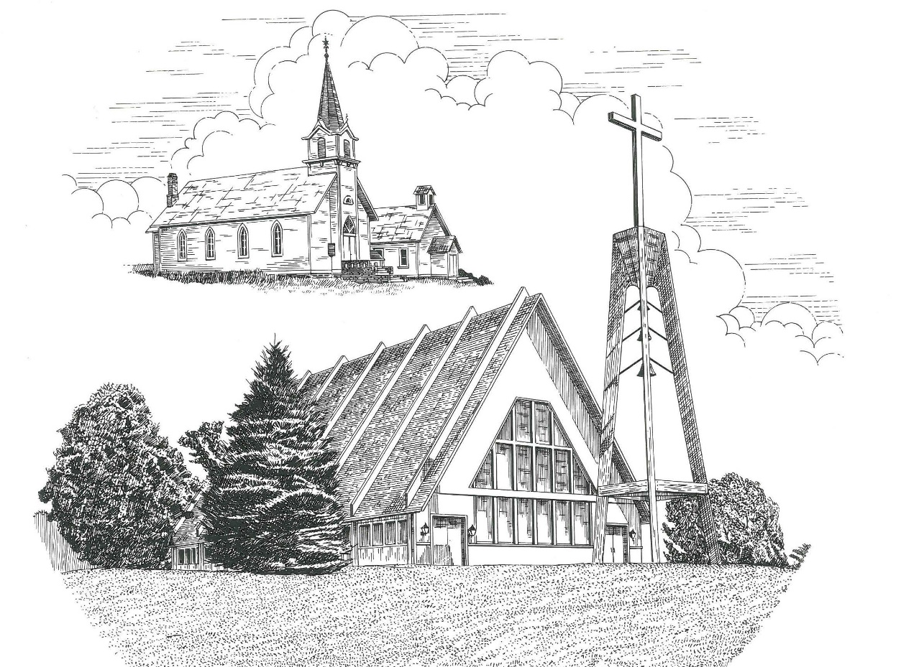

Maundy Thursday April 14th, 2022

WELCOME
Thanks for joining us!
Pastor Jacob Sherry Missouri Synod

~~PLEASE NOTE~~
Calling on the name of the Lord
Does not include the use of cell phones in the worship sanctuary.
Please check yours before the service begins. Thank you for your courtesy.
~~TO OUR GUESTS AND VISITORS~~
Please sign our guest book located on the stand at the church entrance. During the service, we ask you to sign the attendance sheet located in your bulletin and place it on the pew when you leave. If you need assistance or have questions about our worship service, please talk to an elder or any one of our church family. We are glad you could join us and hope to have you worship with us again soon.

~~ATTENDING HOLY COMMUNION~~
By checking the “Communing Today” box on the registration form found on the attendance sheet, you are agreeing with the following statements:

- I am a baptized Christian who believes Jesus Christ is my Lord and Savior.
- I believe that I am a sinner in need of Christ freely offered forgiveness.
- I believe that in the Lord’s Supper the body and blood of Jesus Christ
are truly present in, with, and under the bread and wine.
- I believe that my participation in Holy Communion grants me forgiveness
of my sins, new spiritual life, and eternal salvation.
- With God’s help, I sincerely seek to repent of my sins, live in service
to my Lord, and await His return.

If you agree with the above statements, you are welcome to attend the Lord’s Supper with us. May God bless your worship time with us.
We do offer gluten-free wafers, please quietly ask an elder to help you.

Order of Divine Service Setting Three

Pre-Service Music……………..Call to Worship………………….Greeting

OPENING HYMN: “What Is This Bread”..............................................LSB #629
OPENING LITURGY:
Confession & Absolution………..………………………………LSB pp. 184-185
Kyrie…………………………………….………………………..LSB p. 186
Salutation….……………………………….…………………….LSB p. 189

Collect Prayer
O Lord, in this wondrous Sacrament You have left us a remembrance of Your passion. Grant that we may so receive the sacred mystery of Your body and blood that the fruits of Your redemption may continually be manifest in us; for You live and reign with the Father and the Holy Spirit, one God, now and forever.

THE HOLY SCRIPTURES

OLD TESTAMENT: (Jeremiah 31:31-34)
³¹ “Behold, the days are coming, declares the Lord, when I will make a new covenant with the house of Israel and the house of Judah, ³² not like the covenant that I made with their fathers on the day when I took them by the hand to bring them out of the land of Egypt, my covenant that they broke, though I was their husband, declares the Lord. ³³For this is the covenant that I will make with the house of Israel after those days, declares the Lord: I will put my law within them, and I will write it on their hearts. And I will be their God, and they shall be my people. ³⁴ And no longer shall each one teach his neighbor and each his brother, saying, ‘Know the Lord,’ for they shall all know me, from the least of them to the greatest, declares the Lord. For I will forgive their iniquity, and I will remember their sin no more.”

R: This is the Word of the Lord. Cong: Thanks be to God.

GRADUAL
Reader: Christ entered once for all into the holy places, by means of his own blood,
Cong.: thus securing an eternal redemption.
Reader: Therefore he is the mediator of a new covenant,
Cong.: so that those who are called may receive the promised eternal inheritance.
Reader: He sent redemption to his people;
Cong.: he has commanded his covenant forever.

EPISTLE: (Hebrews 10:15-25)
¹⁵ And the Holy Spirit also bears witness to us; for after saying,
¹⁶ “This is the covenant that I will make with them
after those days, declares the Lord:
I will put my laws on their hearts,
and write them on their minds,”
¹⁷ then he adds,
“I will remember their sins and their lawless deeds no more.”
¹⁸ Where there is forgiveness of these, there is no longer any offering for sin.
¹⁹ Therefore, brothers, since we have confidence to enter the holy places by the blood of Jesus, ²⁰ by the new and living way that he opened for us through the curtain, that is, through his flesh, ²¹ and since we have a great priest over the house of God, ²² let us draw near with a true heart in full assurance of faith, with our hearts sprinkled clean from an evil conscience and our bodies washed with pure water. ²³ Let us hold fast the confession of our hope without wavering, for he who promised is faithful. ²⁴ And let us consider how to stir up one another to love and good works, ²⁵ not neglecting to meet together, as is the habit of some, but encouraging one another, and all the more as you see the Day drawing near.

R: This is the Word of the Lord. Cong: Thanks be to God.

(PLEASE RISE for the reading of the Gospel)

R: The Holy Gospel according to St. Luke, the 22nd chapter.

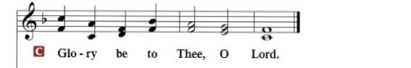

HOLY GOSPEL: (Luke 22:7-20)
⁷ Then came the day of Unleavened Bread, on which the Passover lamb had to be sacrificed. ⁸ So Jesus sent Peter and John, saying, “Go and prepare the Passover for us, that we may eat it.” ⁹ They said to him, “Where will you have us prepare it?” ¹⁰ He said to them, “Behold, when you have entered the city, a man carrying a jar of water will meet you. Follow him into the house that he enters ¹¹ and tell the master of the house, ‘The Teacher says to you, Where is the guest room, where I may eat the Passover with my disciples?’ ¹² And he will show you a large upper room furnished; prepare it there.” ¹³ And they went and found it just as he had told them, and they prepared the Passover.
¹⁴ And when the hour came, he reclined at table, and the apostles with him. ¹⁵ And he said to them, “I have earnestly desired to eat this Passover with you before I suffer. ¹⁶ For I tell you I will not eat it until it is fulfilled in the kingdom of God.” ¹⁷ And he took a cup, and when he had given thanks he said, “Take this, and divide it among yourselves. ¹⁸ For I tell you that from now on I will not drink of the fruit of the vine until the kingdom of God comes.” ¹⁹ And he took bread, and when he had given thanks, he broke it and gave it to them, saying, “This is my body, which is given for you. Do this in remembrance of me.” ²⁰ And likewise the cup after they had eaten, saying, “This cup that is poured out for you is the new covenant in my blood.

R: This is the Gospel of the Lord.

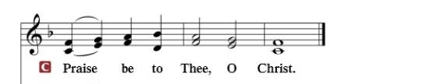

Nicene Creed…...……………………………………………………..…LSB p. 191
I believe in one God, the Father Almighty, maker of heaven and earth and of all things visible and invisible.
And in one Lord Jesus Christ, the only-begotten Son of God, begotten of His Father before all worlds, God of God, Light of Light, very God of very God, begotten, not made, being of one substance with the Father, by whom all things were made; who for us men and for our salvation came down from heaven and was incarnate by the Holy Spirit of the virgin Mary and was made man; and was crucified also for us under Pontius Pilate. He suffered and was buried. And the third day He rose again according to the Scriptures and ascended into heaven and sits at the right hand of the Father. And He will come again with glory to judge both the living and the dead, whose kingdom will have no end.
And I believe in the Holy Spirit, the Lord and giver of life, who proceeds from the Father and the Son, who with the Father and the Son together is worshiped and glorified, who spoke by the prophets. And I believe in one holy Christian and apostolic Church, I acknowledge one Baptism for the remission of sins, and I look for the resurrection of the dead and the life of the world to come. Amen.

SERMON HYMN: “Go To Dark Gethsemane”……………………………….LSB #436

SERMON

THE GENERAL PRAYERS OF THE CHURCH

SERVICE OF THE SACRAMENT
Preface…………………………………….…………….……….LSB p. 194
Proper Preface
It is truly good, right, and salutary that we should at all times and in all places give thanks to You, holy Lord, almighty Father, everlasting God, through Jesus Christ, our Lord, who overcame the assaults of the devil and gave His life as a ransom for many that with cleansed hearts we might be prepared joyfully to celebrate the paschal feast in sincerity and truth. Therefore, with angels and archangels and with all the company of heaven we laud and magnify Your glorious name, ever more praising You and saying:

Sanctus, Lord’s Prayer, The Words of Our Lord………………….....LSB pp. 195-197
Agnus Dei………………………………………………………………..LSB p. 198
If you are not communing, it is acceptable to remain seated.

COMMUNION DISTRIBUTION HYMNS:
LSB #637 “Draw Near and Take the Body of the Lord”
LSB #456 “Were You There”

NUNC DIMITTIS………………………………………………………LSB pp. 199-200

BENEDICTION

Please leave in reverent silence

The Mission of Trinity Onekama Is To SERVE

For even the Son of Man did not come to be served
but to serve and to give his life as a ransom for many.
Mark 10:45

S haring Jesus’s truth
E quipping for life
R eaching Out
V aluing each other
E vangelizing all ages
Mission Statement
The mission of Trinity Onekama is to SERVE
For even the Son of Man did not come to be served, but to serve,
and to give his life as a ransom for many. Mark 10:45
S haring Jesus’ ruth
E quipping for life
R eaching Out
V aluing each other
E vangelizing all age

CHURCH INFORMATION
Church Office: (231) 889-4429 Website: www.trinityonekama.org
E-mail: trinityonekama@sbcglobal.net
Address: P.O. Box 119, 5471 Fairview Street, Onekama, MI 49675
Adult Bible Study: Sunday @ 11:30 am (year round)
Worship: Sunday @ 10:30 am The Lord’s Supper: Celebrated 2nd & 4th Sundays
Pastoral Hours: Wednesday and Friday 9:00am – Noon
Pastor Phone: 231-655-2680 Pastor Email: trinityonekama@gmail.com

Copyright licensing covered under CCLI #2802932

