231-889-4429 5471 Fairview Street Onekama, MI

TRINITY LUTHERAN CHURCH
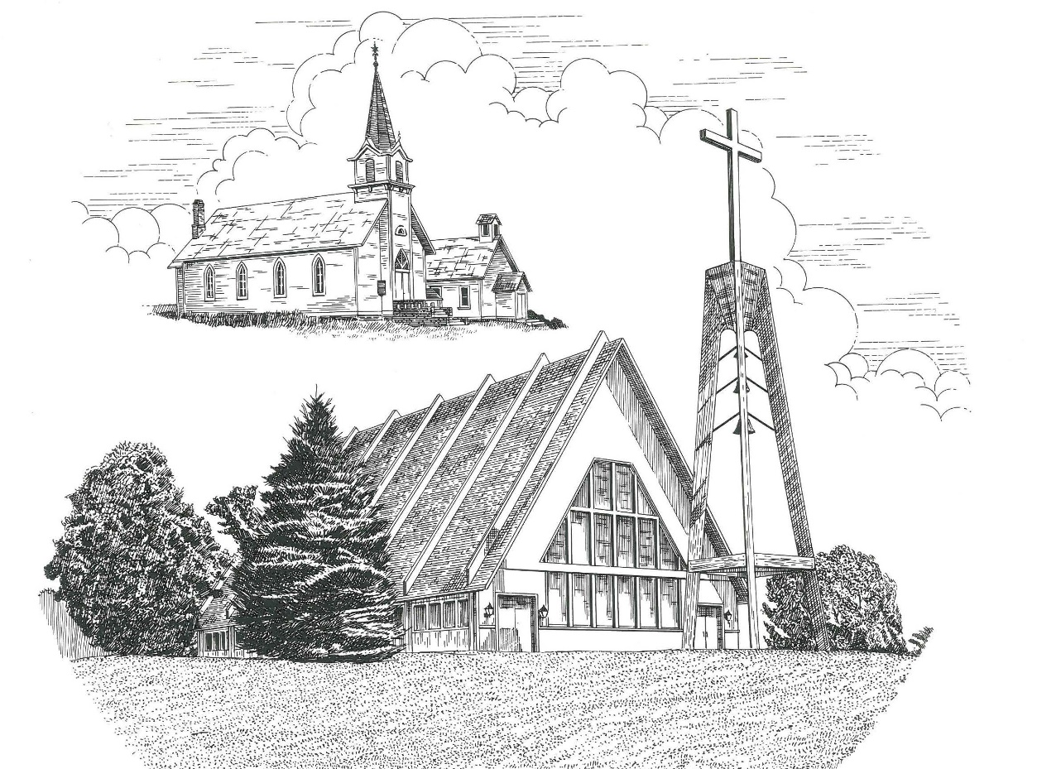

Third Sunday of Easter April 14th, 2024

WELCOME
Thanks for joining us!
Pastor Jacob Sherry Missouri Synod

~~PLEASE NOTE~~
Calling on the name of the Lord
Does not include the use of cell phones in the worship sanctuary.
Please check yours before the service begins. Thank you for your courtesy.
~~TO OUR GUESTS AND VISITORS~~
Please sign our guest book located on the stand at the church entrance. During the service, we ask you to sign the attendance sheet in your bulletin and leave it on the pew as you leave. If you need assistance or have questions about our worship service, please talk to an elder or any one of our church family. We are glad you could join us and hope to have you worship with us again soon.

~~ATTENDING HOLY COMMUNION~~
By checking the “Communing Today” box on the registration form found on the attendance sheet in your bulletin, you are agreeing with the following statements:

- I am a baptized Christian who believes Jesus Christ is my Lord and Savior.
- I believe that I am a sinner in need of Christ’s freely offered forgiveness.
- I believe that in the Lord’s Supper the body and blood of Jesus Christ
are truly present in, with, and under the bread and wine.
- I believe that my participation in Holy Communion grants me forgiveness
of my sins, new spiritual life, and eternal salvation.
- With God’s help, I sincerely seek to repent of my sins, live in service
to my Lord, and await His return.

If you agree with the above statements, you are welcome to attend the Lord’s Supper with us. May God bless your worship time with us.
We do offer gluten-free wafers, please quietly ask an elder to help you.

Order of Divine Service Setting Four

Pre-Service Music……………..Call to Worship………………….Greeting

OPENING HYMN: “Come, Thou Almighty King”…………………….LSB #905

CONFESSION & ABSOLUTION……….…………………………….LSB p. 203

INTROIT
P: In your presence there is fullness of joy;
C: at your right hand are pleasures forevermore.
P: I will extoll you, O Lord, for you have drawn me up
C: and have not let my foes rejoice over me.
P: O Lord my God, I cried to you for help,
C: and you have healed me.
P: O Lord, you have brought up my soul from Sheol;
C: you restored me to life from among those who go down to the pit.
P: Sing praises to the Lord, O you his saints,
C: and give thanks to his holy name.
P: For his anger is but for a moment, and his favor is for a lifetime.
C: Weeping may tarry for the night, but joy comes with the morning.
ALL: Glory be to the Father and to the Son and to the Holy Spirit; as it was in the
beginning, is now and will be forever. Amen.
P: In your presence there is fullness of joy;
C: at your right hand are pleasures forevermore.

KYRIE…………………………………………………………………….LSB p. 204
GLORIA IN EXCELSIS…………………………………………………LSB p. 204
SALUTATION.…………………………………………………………...LSB p. 205

Collect Prayer
O God, through the humiliation of Your Son, You raised up the fallen world. Grant to Your faithful people, rescued from the peril of everlasting death, perpetual gladness and eternal joys; through Jesus Christ, our Lord, who lives and reigns with You and the Holy Spirit, one God, now and forever.

THE HOLY SCRIPTURES

FIRST READING: (Acts 3:11-21)
¹¹ While he clung to Peter and John, all the people, utterly astounded, ran together to them in the portico called Solomon's. ¹² And when Peter saw it he addressed the people: “Men of Israel, why do you wonder at this, or why do you stare at us, as though by our own power or piety we have made him walk? ¹³ The God of Abraham, the God of Isaac, and the God of Jacob, the God of our fathers, glorified his servant Jesus, whom you delivered over and denied in the presence of Pilate, when he had decided to release him. ¹⁴ But you denied the Holy and Righteous One, and asked for a murderer to be granted to you, ¹⁵ and you killed the Author of life, whom God raised from the dead. To this we are witnesses. ¹⁶ And his name—by faith in his name—has made this man strong whom you see and know, and the faith that is through Jesus has given the man this perfect health in the presence of you all.
¹⁷ “And now, brothers, I know that you acted in ignorance, as did also your rulers. ¹⁸ But what God foretold by the mouth of all the prophets, that his Christ would suffer, he thus fulfilled. ¹⁹ Repent therefore, and turn back, that your sins may be blotted out, ²⁰ that times of refreshing may come from the presence of the Lord, and that he may send the Christ appointed for you, Jesus, ²¹ whom heaven must receive until the time for restoring all the things about which God spoke by the mouth of his holy prophets long ago.

R: This is the Word of the Lord. Cong: Thanks be to God.

GRADUAL
Reader: Christ has risen from the dead.
Cong.: God the Father has crowned him with glory and honor,
Reader: He has given him dominion over the works of his hands;
Cong.: he has put all things under his feet.

EPISTLE: (1 John 3:1-7)
See what kind of love the Father has given to us, that we should be called children of God; and so we are. The reason why the world does not know us is that it did not know him. ² Beloved, we are God's children now, and what we will be has not yet appeared; but we know that when he appears we shall be like him, because we shall see him as he is. ³ And everyone who thus hopes in him purifies himself as he is pure.
⁴ Everyone who makes a practice of sinning also practices lawlessness; sin is lawlessness. ⁵ You know that he appeared in order to take away sins, and in him there is no sin. ⁶ No one who abides in him keeps on sinning; no one who keeps on sinning has either seen him or known him. ⁷ Little children, let no one deceive you. Whoever practices righteousness is righteous, as he is righteous.

R: This is the Word of the Lord. Cong: Thanks be to God.

(PLEASE RISE for the reading of the Gospel)

R: The Holy Gospel according to St. Luke, the 24th chapter.
Cong: Glory to You, O Lord

HOLY GOSPEL: (Luke 24:36-49)
³⁶ As they were talking about these things, Jesus himself stood among them, and said to them, “Peace to you!” ³⁷ But they were startled and frightened and thought they saw a spirit. ³⁸ And he said to them, “Why are you troubled, and why do doubts arise in your hearts? ³⁹ See my hands and my feet, that it is I myself. Touch me, and see. For a spirit does not have flesh and bones as you see that I have.” ⁴⁰ And when he had said this, he showed them his hands and his feet. ⁴¹ And while they still disbelieved for joy and were marveling, he said to them, “Have you anything here to eat?” ⁴² They gave him a piece of broiled fish, ⁴³ and he took it and ate before them.
⁴⁴ Then he said to them, “These are my words that I spoke to you while I was still with you, that everything written about me in the Law of Moses and the Prophets and the Psalms must be fulfilled.” ⁴⁵ Then he opened their minds to understand the Scriptures, ⁴⁶ and said to them, “Thus it is written, that the Christ should suffer and on the third day rise from the dead, ⁴⁷ and that repentance for the forgiveness of sins should be proclaimed in his name to all nations, beginning from Jerusalem. ⁴⁸ You are witnesses of these things. ⁴⁹ And behold, I am sending the promise of my Father upon you. But stay in the city until you are clothed with power from on high.”

R: This is the Gospel of the Lord. Cong: Praise to You, O Christ.

NICENE CREED
I believe in one God, the Father Almighty, maker of heaven and earth and of all things visible and invisible.
And in one Lord Jesus Christ, the only-begotten Son of God, begotten of His Father before all worlds, God of God, Light of Light, very God of very God, begotten, not made, being of one substance with the Father, by whom all things were made; who for us men and for our salvation came down from heaven and was incarnate by the Holy Spirit of the virgin Mary and was made man; and was crucified also for us under Pontius Pilate. He suffered and was buried. And the third day He rose again according to the Scriptures and ascended into heaven and sits at the right hand of the Father. And He will come again with glory to judge both the living and the dead, whose kingdom will have no end.
And I believe in the Holy Spirit, the Lord and giver of life, who proceeds from the Father and the Son, who with the Father and the Son together is worshiped and glorified, who spoke by the prophets. And I believe in one holy Christian and apostolic Church, I acknowledge one Baptism for the remission of sins, and I look for the resurrection of the dead and the life of the world to come. Amen.

SERMON HYMN: “With High Delight Let Us Unite”……….……………….LSB #483
SERMON

THE GENERAL PRAYERS

COLLECTION OF THE OFFERING
OFFERTORY HYMN: “We Give Thee But Thine Own”……………………..LSB #781
Verse 1

Sharing the Peace of the Lord

SERVICE OF THE SACRAMENT
Preface…………………………………….…………….………..LSB p. 208
Proper Preface
It is truly good, right, and salutary that we should at all times and in all places give thanks to You, O Lord, holy Father, almighty and everlasting God, for the countless blessings You so freely bestow on us and all creation. Above all, we give thanks for Your boundless love shown to us when You sent Your only-begotten Son, Jesus Christ, into our flesh and laid on Him our sin, giving Him into death that we might not die eternally. Because He is now risen from the dead and lives and reigns to all eternity, all who believe in Him will overcome sin and death and will rise again to new life. Therefore, with angels and archangels and with all the company of heaven we laud and magnify Your glorious name, ever more praising You and saying:

Sanctus, Lord’s Prayer, The Words of Our Lord………………….....LSB pp. 208-209
Agnus Dei………………………………………………………………..LSB p. 210
If you are not communing, it is acceptable to remain seated.

COMMUNION DISTRIBUTION HYMNS:
LSB #822 “Alleluia! Let Praises Ring”
LSB #458 “Christ Jesus Lay in Death’s Strong Bands”
LSB #762 “There Is a Time for Everything”

CLOSING LITURGY:………………………………………………....LSB pp. 211-212

CLOSING HYMN: “Jesus Lives! The Victory’s Won”.........................LSB #490

The Mission of Trinity Onekama Is To SERVE

For even the Son of Man did not come to be served
but to serve and to give his life as a ransom for many.
Mark 10:45

S haring Jesus’s truth
E quipping for life
R eaching Out
V aluing each other
E vangelizing all ages
Mission Statement
The mission of Trinity Onekama is to SERVE
For even the Son of Man did not come to be served, but to serve,
and to give his life as a ransom for many. Mark 10:45
S haring Jesus’ ruth
E quipping for life
R eaching Out
V aluing each other
E vangelizing all age

CHURCH INFORMATION
Church Office: (231) 889-4429 Website: www.trinityonekama.org
E-mail: trinityonekama@sbcglobal.net
Address: 5471 Fairview Street, Onekama, MI 49675
Mailing Address: P.O. Box 119, Onekama, MI 49675
Sunday School & Adult Bible Study: Sunday @ 9:30am
Worship: Sunday @ 10:30 am The Lord’s Supper: Celebrated 2nd & 4th Sundays
Pastoral Hours: Wednesday and Friday 9:00am – Noon
Pastor Phone: 231-655-2680 Pastor Email: trinityonekama@gmail.com

Copyright licensing covered under CCLI #2802932

