231-889-4429 5471 Fairview Street, Box 119 Onekama, MI

TRINITY LUTHERAN CHURCH
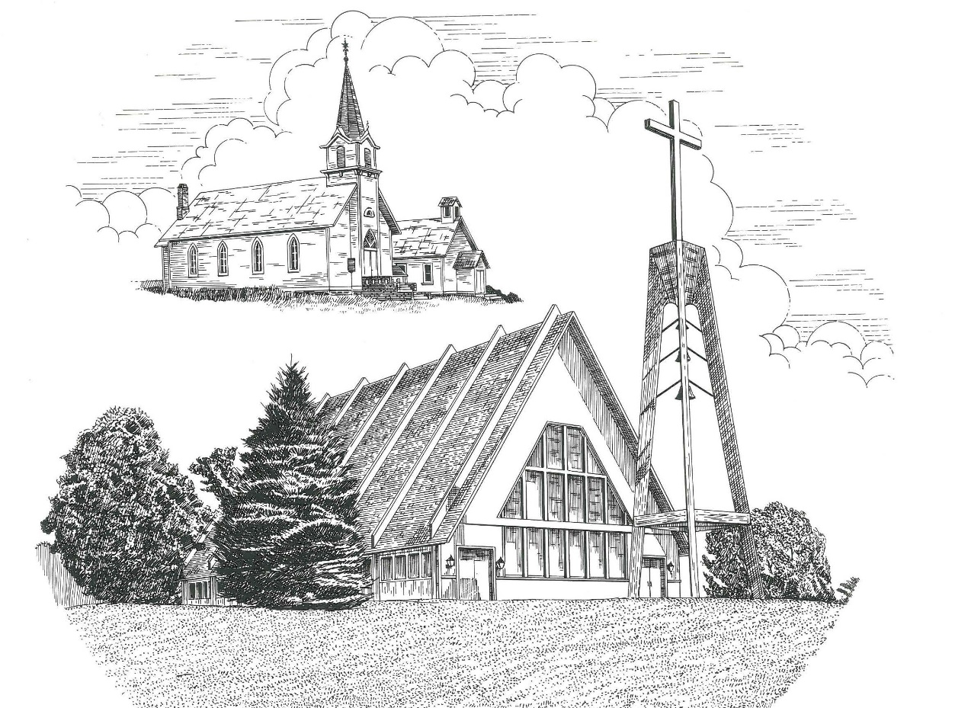

Third Sunday of Easter April 23rd, 2023

WELCOME
Thanks for joining us!
Pastor Jacob Sherry Missouri Synod

~~PLEASE NOTE~~
Calling on the name of the Lord
Does not include the use of cell phones in the worship sanctuary.
Please check yours before the service begins. Thank you for your courtesy.
~~TO OUR GUESTS AND VISITORS~~
Please sign our guest book located on the stand at the church entrance. During the service, we ask you to sign the attendance sheet in your bulletin and leave it on the pew as you leave. If you need assistance or have questions about our worship service, please talk to an elder or any one of our church family. We are glad you could join us and hope to have you worship with us again soon.

~~ATTENDING HOLY COMMUNION~~
By checking the “Communing Today” box on the registration form found on the attendance sheet in your bulletin, you are agreeing with the following statements:

- I am a baptized Christian who believes Jesus Christ is my Lord and Savior.
- I believe that I am a sinner in need of Christ’s freely offered forgiveness.
- I believe that in the Lord’s Supper the body and blood of Jesus Christ
are truly present in, with, and under the bread and wine.
- I believe that my participation in Holy Communion grants me forgiveness
of my sins, new spiritual life, and eternal salvation.
- With God’s help, I sincerely seek to repent of my sins, live in service
to my Lord, and await His return.

If you agree with the above statements, you are welcome to attend the Lord’s Supper with us. May God bless your worship time with us.
We do offer gluten-free wafers, please quietly ask an elder to help you.

Order of Divine Service Setting Four

Pre-Service Music……………..Call to Worship………………….Greeting

OPENING HYMN: “Christ Has Arisen, Alleluia”…………….……....LSB #466

OPENING LITURGY
Confession & Absolution……………………………………….LSB p. 203
Kyrie……………………………………………………………..LSB p. 204
Gloria in Excelsis………………………………………………..LSB p. 204
Salutation….…………………………………………………….LSB p. 205

Collect Prayer
O God, through the humiliation of Your Son You raised up the fallen world. Grant to Your faithful people, rescued from the peril of everlasting death, perpetual gladness and eternal joys; through Jesus Christ, our Lord, who lives and reigns with You and the Holy Spirit, one God, now and forever.

THE HOLY SCRIPTURES

FIRST READING: (Acts 2:14a, 36-41)
¹⁴ But Peter, standing with the eleven, lifted up his voice and addressed them: ³⁶ Let all the house of Israel therefore know for certain that God has made him both Lord and Christ, this Jesus whom you crucified.”
³⁷ Now when they heard this they were cut to the heart, and said to Peter and the rest of the apostles, “Brothers, what shall we do?” ³⁸ And Peter said to them, “Repent and be baptized every one of you in the name of Jesus Christ for the forgiveness of your sins, and you will receive the gift of the Holy Spirit. ³⁹ For the promise is for you and for your children and for all who are far off, everyone whom the Lord our God calls to himself.” ⁴⁰ And with many other words he bore witness and continued to exhort them, saying, “Save yourselves from this crooked generation.” ⁴¹ So those who received his word were baptized, and there were added that day about three thousand souls.

R: This is the Word of the Lord. Cong: Thanks be to God.

GRADUAL
Reader: Christ has risen from the dead.
Cong.: God the Father has crowned him with glory and honor,
Reader: He has given him dominion over the works of his hands;
Cong.: he has put all things under his feet.

EPISTLE: (1 Peter 1:17-25)
¹⁷ And if you call on him as Father who judges impartially according to each one's deeds, conduct yourselves with fear throughout the time of your exile, ¹⁸ knowing that you were ransomed from the futile ways inherited from your forefathers, not with perishable things such as silver or gold, ¹⁹ but with the precious blood of Christ, like that of a lamb without blemish or spot. ²⁰ He was foreknown before the foundation of the world but was made manifest in the last times for the sake of you ²¹ who through him are believers in God, who raised him from the dead and gave him glory, so that your faith and hope are in God. ²² Having purified your souls by your obedience to the truth for a sincere brotherly love, love one another earnestly from a pure heart, ²³ since you have been born again, not of perishable seed but of imperishable, through the living and abiding word of God; ²⁴ for
“All flesh is like grass
and all its glory like the flower of grass.
The grass withers,
and the flower falls,
²⁵ but the word of the Lord remains forever.”
And this word is the good news that was preached to you.

R: This is the Word of the Lord. Cong: Thanks be to God.

(PLEASE RISE for the reading of the Gospel)

R: The Holy Gospel according to St. Luke, the 24th chapter.
Cong: Glory to You, O Lord

HOLY GOSPEL: (Luke 24:13-35)
¹³ That very day two of them were going to a village named Emmaus, about seven miles from Jerusalem, ¹⁴ and they were talking with each other about all these things that had happened. ¹⁵ While they were talking and discussing together, Jesus himself drew near and went with them. ¹⁶ But their eyes were kept from recognizing him. ¹⁷ And he said to them, “What is this conversation that you are holding with each other as you walk?” And they stood still, looking sad. ¹⁸ Then one of them, named Cleopas, answered him, “Are you the only visitor to Jerusalem who does not know the things that have happened there in these days?” ¹⁹ And he said to them, “What things?” And they said to him, “Concerning Jesus of Nazareth, a man who was a prophet mighty in deed and word before God and all the people, ²⁰ and how our chief priests and rulers delivered him up to be condemned to death, and crucified him. ²¹ But we had hoped that he was the one to redeem Israel. Yes, and besides all this, it is now the third day since these things happened. ²² Moreover, some women of our company amazed us. They were at the tomb early in the morning, ²³ and when they did not find his body, they came back saying that they had even seen a vision of angels, who said that he was alive. ²⁴ Some of those who were with us went to the tomb and found it just as the women had said, but him they did not see.” ²⁵ And he said to them, “O foolish ones, and slow of heart to believe all that the prophets have spoken! ²⁶ Was it not necessary that the Christ should suffer these things and enter into his glory?” ²⁷ And beginning with Moses and all the Prophets, he interpreted to them in all the Scriptures the things concerning himself.
²⁸ So they drew near to the village to which they were going. He acted as if he were going farther, ²⁹ but they urged him strongly, saying, “Stay with us, for it is toward evening and the day is now far spent.” So he went in to stay with them. ³⁰ When he was at table with them, he took the bread and blessed and broke it and gave it to them. ³¹ And their eyes were opened, and they recognized him. And he vanished from their sight. ³² They said to each other, “Did not our hearts burn within us while he talked to us on the road, while he opened to us the Scriptures?” ³³ And they rose that same hour and returned to Jerusalem. And they found the eleven and those who were with them gathered together, ³⁴ saying, “The Lord has risen indeed, and has appeared to Simon!” ³⁵ Then they told what had happened on the road, and how he was known to them in the breaking of the bread.

R: This is the Gospel of the Lord. Cong: Praise to You, O Christ.

NICENE CREED
I believe in one God, the Father Almighty, maker of heaven and earth and of all things visible and invisible.
And in one Lord Jesus Christ, the only-begotten Son of God, begotten of His Father before all worlds, God of God, Light of Light, very God of very God, begotten, not made, being of one substance with the Father, by whom all things were made; who for us men and for our salvation came down from heaven and was incarnate by the Holy Spirit of the virgin Mary and was made man; and was crucified also for us under Pontius Pilate. He suffered and was buried. And the third day He rose again according to the Scriptures and ascended into heaven and sits at the right hand of the Father. And He will come again with glory to judge both the living and the dead, whose kingdom will have no end.
And I believe in the Holy Spirit, the Lord and giver of life, who proceeds from the Father and the Son, who with the Father and the Son together is worshiped and glorified, who spoke by the prophets. And I believe in one holy Christian and apostolic Church, I acknowledge one Baptism for the remission of sins, and I look for the resurrection of the dead and the life of the world to come. Amen.

SERMON HYMN: “With High Delight Let Us Unite”…………………LSB #483

SERMON
THE GENERAL PRAYERS

OFFERTORY HYMN: “Let the Vineyards Be Fruitful”………………LSB #955

Sharing the Peace of the Lord

SERVICE OF THE SACRAMENT
Preface…………………………………….…………….………..LSB p. 208
Proper Preface
It is truly good, right, and salutary that we should at all times and in all places give thanks to You, O Lord, holy Father, almighty and everlasting God, for the countless blessings You so freely bestow on us and all creation. Above all, we give thanks for Your boundless love shown to us when You sent Your only-begotten Son, Jesus Christ, into our flesh and laid on Him our sin, giving Him into death that we might not die eternally. Because He is now risen from the dead and lives and reigns to all eternity, all who believe in Him will overcome sin and death and will rise again to new life. Therefore, with angels and archangels and with all the company of heaven we laud and magnify Your glorious name, ever more praising You and saying:

Sanctus, Lord’s Prayer, The Words of Our Lord………………….....LSB pp. 208-209
Agnus Dei………………………………………………………………..LSB p. 210
If you are not communing, it is acceptable to remain seated.

COMMUNION DISTRIBUTION HYMNS:
LSB #468 “I Am Content! My Jesus Ever Lives”
LSB #617 “O Lord, We Praise Thee”
LSB #488 “He Is Arisen! Glorious Word”

CLOSING LITURGY:………………………………………………....LSB pp. 211-212

CLOSING HYMN: “Alleluia, Alleluia! Hearts to Heaven”..................LSB #477

The Mission of Trinity Onekama Is To SERVE

For even the Son of Man did not come to be served
but to serve and to give his life as a ransom for many.
Mark 10:45

S haring Jesus’s truth
E quipping for life
R eaching Out
V aluing each other
E vangelizing all ages
Mission Statement
The mission of Trinity Onekama is to SERVE
For even the Son of Man did not come to be served, but to serve,
and to give his life as a ransom for many. Mark 10:45
S haring Jesus’ ruth
E quipping for life
R eaching Out
V aluing each other
E vangelizing all age

CHURCH INFORMATION
Church Office: (231) 889-4429 Website: www.trinityonekama.org
E-mail: trinityonekama@sbcglobal.net
Address: P.O. Box 119, 5471 Fairview Street, Onekama, MI 49675
Sunday School & Adult Bible Study: Sunday @ 9:30am
Worship: Sunday @ 10:30 am The Lord’s Supper: Celebrated 2nd & 4th Sundays
Pastoral Hours: Wednesday and Friday 9:00am – Noon
Pastor Phone: 231-655-2680 Pastor Email: trinityonekama@gmail.com

Copyright licensing covered under CCLI #2802932

