**231-889-4429 5471 Fairview Street, Box 119 Onekama, MI**

**TRINITY LUTHERAN CHURCH**

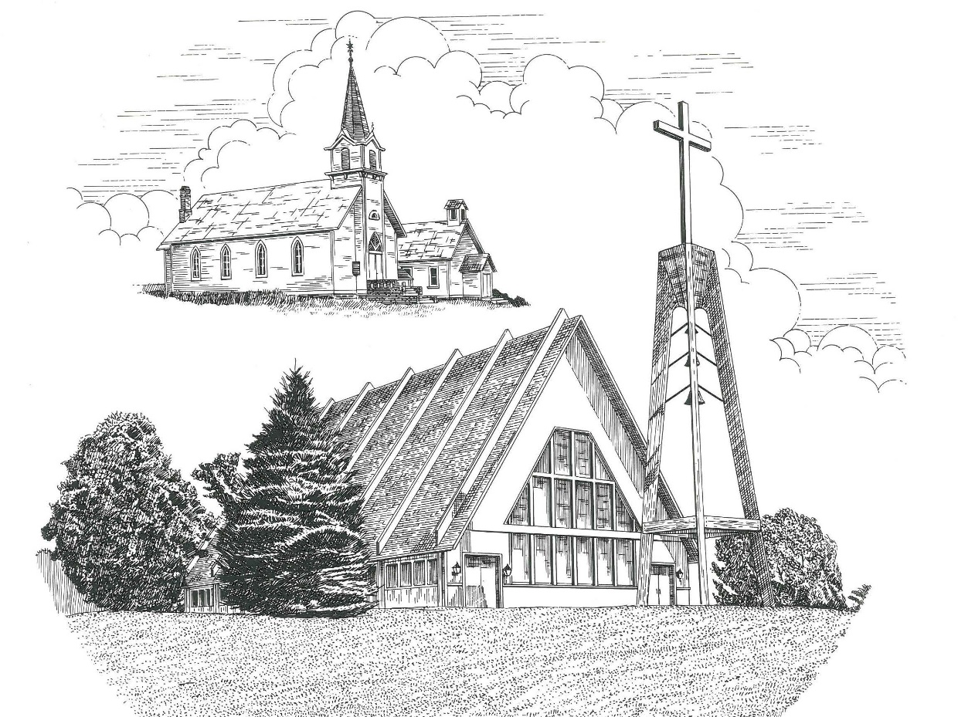

**The Third Sunday of Easter April 26th, 2020**

**WELCOME**

**Thanks for joining us!**

**Pastor Jacob Sherry Missouri Synod**

**~~PLEASE NOTE~~Calling on the name of the Lord**

Does not include the use of cell phones in the worship sanctuary.

Please check yours before the service begins. Thank you for your courtesy.

**~~TO OUR GUESTS AND VISITORS~~**

Please sign our guest book located on the stand at the church entrance. During the service, we ask you to sign the attendance booklet located at the end of each pew. If you need assistance or have questions about our worship service, please talk to an elder or any one of our church family. We are glad you could join us and hope to have you worship with us again soon.

**~~ATTENDING HOLY COMMUNION~~**

By checking the “Communing Today” box on the registration form found in the attendance booklet, you are agreeing with the following statements:

* **I am a baptized Christian who believes Jesus Christ is my Lord and Savior.**
* **I believe that I am a sinner in need of Christ freely offered forgiveness.**
* **I believe that in the Lord’s Supper the body and blood of Jesus Christ**

**are truly present in, with, and under the bread and wine.**

* **I believe that my participation in Holy Communion grants me forgiveness**

**of my sins, new spiritual life, and eternal salvation.**

* **With God’s help, I sincerely seek to repent of my sins, live in service**

**to my Lord, and await His return.**

**If you agree with the above statements, you are welcome to attend the Lord’s Supper with us. May God bless your worship time with us.**

We do offer gluten-free wafers, please quietly ask an elder to help you.

**Order of Divine Service Setting One**

**Pre-Service Music……………..Call to Worship………………….Greeting**

**OPENING HYMN:** *“He’s Risen, He’s Risen”*………...........................LSB #480

**OPENING LITURGY**

**Confession & Absolution**……………………………………….LSB p. 151

**Kyrie**……………………………………………………………..LSB pp. 152-153

**This Is the Feast**…………………………………………………LSB p. 155

**Salutation**….………………………………………………….....LSB p. 156

**Collect Prayer**

O God, through the humiliation of Your Son, You raised up the fallen world. Grant to Your faithful people, rescued from the peril of everlasting death, perpetual gladness and eternal joys; through Jesus Christ, our Lord, who lives and reigns with You and the Holy Spirit, one God, now and forever.

**THE HOLY SCRIPTURES**

**FIRST READING:** (Acts 2:14a, 36-41)

**14**But Peter, standing with the eleven, lifted up his voice and addressed them: **36 “**Let all the house of Israel therefore know for certain that God has made him both Lord and Christ, this Jesus whom you crucified.”

**37**Now when they heard this they were cut to the heart, and said to Peter and the rest of the apostles, “Brothers, what shall we do?” **38**And Peter said to them, “Repent and be baptized every one of you in the name of Jesus Christ for the forgiveness of your sins, and you will receive the gift of the Holy Spirit. **39**For the promise is for you and for your children and for all who are far off, everyone whom the Lord our God calls to himself.” **40**And with many other words he bore witness and continued to exhort them, saying, “Save yourselves from this crooked generation.” **41**So those who received his word were baptized, and there were added that day about three thousand souls.

**R:** This is the Word of the Lord**.** **Cong: Thanks be to God.**

**GRADUAL**

Reader: Christ has risen from the dead.

**Cong.: God the Father has crowned him with glory and honor,**

Reader: He has given him dominion over the works of his hands;

**Cong.: he has put all things under his feet.**

**SECOND READING:** (1 Peter 1:17-25)

**17**And if you call on him as Father who judges impartially according to each one's deeds, conduct yourselves with fear throughout the time of your exile, **18**knowing that you were ransomed from the futile ways inherited from your forefathers, not with perishable things such as silver or gold, **19**but with the precious blood of Christ, like that of a lamb without blemish or spot. **20**He was foreknown before the foundation of the world but was made manifest in the last times for the sake of you **21**who through him are believers in God, who raised him from the dead and gave him glory, so that your faith and hope are in God. **22**Having purified your souls by your obedience to the truth for a sincere brotherly love, love one another earnestly from a pure heart, **23**since you have been born again, not of perishable seed but of imperishable, through the living and abiding word of God; **24**for

“All flesh is like grass  
    and all its glory like the flower of grass.  
The grass withers,  
    and the flower falls,  
**25**but the word of the Lord remains forever.”

And this word is the good news that was preached to you.

**R:** This is the Word of the Lord. **Cong: Thanks be to God.**

**(PLEASE RISE for the reading of the Gospel)**



**R:** The Holy Gospel according to St. Luke, the 24th chapter.



**HOLY GOSPEL:** (Luke 24:13-35)

**13**That very day two of them were going to a village named Emmaus, about seven miles from Jerusalem, **14**and they were talking with each other about all these things that had happened. **15**While they were talking and discussing together, Jesus himself drew near and went with them. **16**But their eyes were kept from recognizing him. **17**And he said to them, “What is this conversation that you are holding with each other as you walk?” And they stood still, looking sad. **18**Then one of them, named Cleopas, answered him, “Are you the only visitor to Jerusalem who does not know the things that have happened there in these days?” **19**And he said to them, “What things?” And they said to him, “Concerning Jesus of Nazareth, a man who was a prophet mighty in deed and word before God and all the people, **20**and how our chief priests and rulers delivered him up to be condemned to death, and crucified him. **21**But we had hoped that he was the one to redeem Israel. Yes, and besides all this, it is now the third day since these things happened. **22**Moreover, some women of our company amazed us. They were at the tomb early in the morning, **23**and when they did not find his body, they came back saying that they had even seen a vision of angels, who said that he was alive. **24**Some of those who were with us went to the tomb and found it just as the women had said, but him they did not see.” **25**And he said to them, “O foolish ones, and slow of heart to believe all that the prophets have spoken! **26**Was it not necessary that the Christ should suffer these things and enter into his glory?” **27**And beginning with Moses and all the Prophets, he interpreted to them in all the Scriptures the things concerning himself.

**28**So they drew near to the village to which they were going. He acted as if he were going farther, **29**but they urged him strongly, saying, “Stay with us, for it is toward evening and the day is now far spent.” So he went in to stay with them. **30**When he was at table with them, he took the bread and blessed and broke it and gave it to them. **31**And their eyes were opened, and they recognized him. And he vanished from their sight. **32**They said to each other, “Did not our hearts burn within us while he talked to us on the road, while he opened to us the Scriptures?” **33**And they rose that same hour and returned to Jerusalem. And they found the eleven and those who were with them gathered together, **34**saying, “The Lord has risen indeed, and has appeared to Simon!” **35**Then they told what had happened on the road, and how he was known to them in the breaking of the bread.

**R:** This is the Gospel of the Lord.



**SERMON HYMN**: *“This Joyful Eastertide”*…………………………………LSB #482

**SERMON**

**Nicene Creed**…...……………………………………………………..……….LSB p. 158

I believe in one God, the Father Almighty, maker of heaven and earth and of all things visible and invisible.

And in one Lord Jesus Christ, the only-begotten Son of God, begotten of His Father before all worlds, God of God, Light of Light, very God of very God, begotten, not made, being of one substance with the Father, by whom all things were made; who for us men and for our salvation came down from heaven and was incarnate by the Holy Spirit of the virgin Mary and was made man; and was crucified also for us under Pontius Pilate. He suffered and was buried. And the third day He rose again according to the Scriptures and ascended into heaven and sits at the right hand of the Father. And He will come again with glory to judge both the living and the dead, whose kingdom will have no end.

And I believe in the Holy Spirit, the Lord and giver of life, who proceeds from the Father and the Son, who with the Father and the Son together is worshiped and glorified, who spoke by the prophets. And I believe in one holy Christian and apostolic Church, I acknowledge one Baptism for the remission of sins, and I look for the resurrection of the dead and the life of the world to come. Amen.

**THE GENERAL PRAYERS OF THE CHURCH**

**GATHERING OF OUR FIRST FRUITS & OFFERTORY**…………LSB pp. 159-160

**INSTITUTION OF THE LORD’S SUPPER**

**Preface**…………………………………….…………….……….LSB p. 160

**Proper Preface**

It is truly good, right, and salutary that we should at all times and in all places give thanks to You, holy Lord, almighty Father, everlasting God, through Jesus Christ, our Lord, who, out of love for His fallen creation, humbled Himself by taking on the form of a servant, becoming obedient unto death, even death upon a cross. Risen from the dead, He has freed us from eternal death and given us life everlasting. Therefore, with angels and archangels and with all the company of heaven we laud and magnify Your glorious name, ever more praising You and saying:

**Sanctus, Lord’s Prayer, The Words of Our Lord**………………….....LSB pp. 161-162

**Agnus Dei**………………………………………………………………..LSB p. 163

*If you are not communing it is acceptable to remain seated.*

**COMMUNION DISTRIBUTION HYMNS:**

LSB #468 *“I Am Content! My Jesus Ever Lives”*

LSB #470 *“O Sons and Daughters of the King”*

**CLOSING LITURGY:**….…….......……………………………………LSB pp. 165-166

**CLOSING HYMN:** *“He Is Arisen! Glorious Word”*………………….LSB #488

The Mission of Trinity Onekama Is To **SERVE**

For even the Son of Man did not come to be served

but to serve and to give his life as a ransom for many.            
                                                                       Mark 10:45



**S**haring Jesus’s **t**ruth

**E**quipping for life

**R**eaching Out

**V**aluing each other

**E**vangelizing all ages

Mission Statement

The mission of Trinity Onekama is to SERVE

For even the Son of Man did not come to be served, but to serve,

and to give his life as a ransom for many. Mark 10:45

S haring Jesus’ ruth

E quipping for life

R eaching Out

V aluing each other

E vangelizing all age

**CHURCH INFORMATION**

**Church Office:** (231) 889-4429 **Website:** www.trinityonekama.org

**E-mail:** [trinityonekama@sbcglobal.net](mailto:trinityonekama@sbcglobal.net)

**Address:** P.O. Box 119, 5471 Fairview Street, Onekama, MI 49675

**Adult Bible Study**: Sunday @ 9:15 am (year round)

**Worship:** Sunday @ 10:30 am **The Lord’s Supper:**  Celebrated 2nd & 4th Sundays

**Pastoral Hours:** Wednesday and Friday 8:30am – Noon

**Pastor Phone:** 231-655-2680 **Pastor Email:** trinityonekama@gmail.com

**Copyright licensing covered under CCLI #2802932**