231-889-4429 5471 Fairview Street Onekama, MI

TRINITY LUTHERAN CHURCH
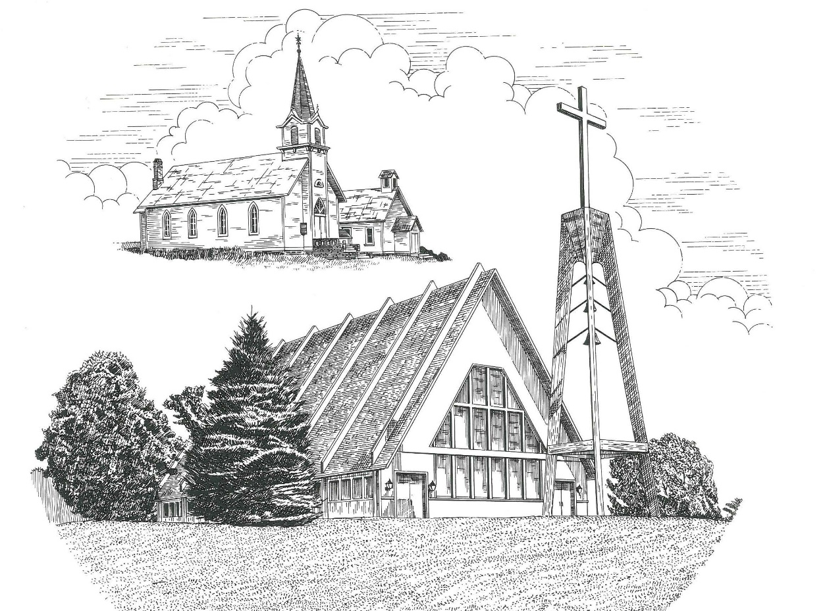

Fifth Sunday of Easter April 28th, 2024

WELCOME
Thanks for joining us!
Pastor Jacob Sherry Missouri Synod

~~PLEASE NOTE~~
Calling on the name of the Lord
Does not include the use of cell phones in the worship sanctuary.
Please check yours before the service begins. Thank you for your courtesy.
~~TO OUR GUESTS AND VISITORS~~
Please sign our guest book located on the stand at the church entrance. During the service, we ask you to sign the attendance sheet in your bulletin and leave it on the pew as you leave. If you need assistance or have questions about our worship service, please talk to an elder or any one of our church family. We are glad you could join us and hope to have you worship with us again soon.

~~ATTENDING HOLY COMMUNION~~
By checking the “Communing Today” box on the registration form found on the attendance sheet in your bulletin, you are agreeing with the following statements:

- I am a baptized Christian who believes Jesus Christ is my Lord and Savior.
- I believe that I am a sinner in need of Christ’s freely offered forgiveness.
- I believe that in the Lord’s Supper the body and blood of Jesus Christ
are truly present in, with, and under the bread and wine.
- I believe that my participation in Holy Communion grants me forgiveness
of my sins, new spiritual life, and eternal salvation.
- With God’s help, I sincerely seek to repent of my sins, live in service
to my Lord, and await His return.

If you agree with the above statements, you are welcome to attend the Lord’s Supper with us. May God bless your worship time with us.
We do offer gluten-free wafers, please quietly ask an elder to help you.

Order of Divine Service Setting Four

Pre-Service Music……………..Call to Worship………………….Greeting

OPENING HYMN: “Christ, Whose Glory Fills the Skies”……………LSB #873

CONFESSION & ABSOLUTION……….…………………………….LSB p. 203

INTROIT
P: A little while, and you will see me no longer;
C: and again a little while, and you will see me.
P: I will extoll you, my God and King,
C: and bless your name forever and ever.
P: Every day I will bless you
C: and praise your name forever and ever.
P: The Lord is gracious and merciful,
C: slow to anger and abounding in steadfast love.
P: All your works shall give thanks to you, O Lord,
C: and all your saints shall bless you!
P: My mouth will speak the praise of the Lord,
C: and let all flesh bless his holy name forever and ever.
ALL: Glory be to the Father and to the Son and to the Holy Spirit; as it was in the
beginning, is now and will be forever. Amen.
P: A little while, and you will see me no longer;
C: and again a little while, and you will see me.

KYRIE…………………………………………………………………….LSB p. 204
GLORIA IN EXCELSIS…………………………………………………LSB p. 204
SALUTATION.…………………………………………………………...LSB p. 205

Collect Prayer
O God, You make the minds of Your faithful to be of one will. Grant that we may love what You have commanded and desire what You promise, that among the many changes of this world our hearts may be fixed where true joys are found; through Jesus Christ, Your Son, our Lord, who lives and reigns with You and the Holy Spirit, one God, now and forever.
THE HOLY SCRIPTURES

FIRST READING: (Acts 8:26-40)
²⁶ Now an angel of the Lord said to Philip, “Rise and go toward the south to the road that goes down from Jerusalem to Gaza.” This is a desert place. ²⁷ And he rose and went. And there was an Ethiopian, a eunuch, a court official of Candace, queen of the Ethiopians, who was in charge of all her treasure. He had come to Jerusalem to worship ²⁸ and was returning, seated in his chariot, and he was reading the prophet Isaiah. ²⁹ And the Spirit said to Philip, “Go over and join this chariot.” ³⁰ So Philip ran to him and heard him reading Isaiah the prophet and asked, “Do you understand what you are reading?” ³¹ And he said, “How can I, unless someone guides me?” And he invited Philip to come up and sit with him. ³² Now the passage of the Scripture that he was reading was this:
“Like a sheep he was led to the slaughter
and like a lamb before its shearer is silent,
so he opens not his mouth.
³³ In his humiliation justice was denied him.
Who can describe his generation?
For his life is taken away from the earth.”
³⁴ And the eunuch said to Philip, “About whom, I ask you, does the prophet say this, about himself or about someone else?” ³⁵ Then Philip opened his mouth, and beginning with this Scripture, he told him the good news about Jesus. ³⁶ And as they were going along the road they came to some water, and the eunuch said, “See, here is water! What prevents me from being baptized?” ³⁸ And he commanded the chariot to stop, and they both went down into the water, Philip and the eunuch, and he baptized him. ³⁹ And when they came up out of the water, the Spirit of the Lord carried Philip away, and the eunuch saw him no more, and went on his way rejoicing. ⁴⁰ But Philip found himself at Azotus, and as he passed through he preached the gospel to all the towns until he came to Caesarea.

R: This is the Word of the Lord. Cong: Thanks be to God.

GRADUAL
Reader: Christ has risen from the dead.
Cong.: God the Father has crowned him with glory and honor,
Reader: He has given him dominion over the works of his hands;
Cong.: he has put all things under his feet.

EPISTLE: (1 John 4:1-11)
Beloved, do not believe every spirit, but test the spirits to see whether they are from God, for many false prophets have gone out into the world. ² By this you know the Spirit of God: every spirit that confesses that Jesus Christ has come in the flesh is from God, ³ and every spirit that does not confess Jesus is not from God. This is the spirit of the antichrist, which you heard was coming and now is in the world already. ⁴ Little children, you are from God and have overcome them, for he who is in you is greater than he who is in the world. ⁵ They are from the world; therefore they speak from the world, and the world listens to them. ⁶ We are from God. Whoever knows God listens to us; whoever is not from God does not listen to us. By this we know the Spirit of truth and the spirit of error.
⁷ Beloved, let us love one another, for love is from God, and whoever loves has been born of God and knows God. ⁸ Anyone who does not love does not know God, because God is love. ⁹ In this the love of God was made manifest among us, that God sent his only Son into the world, so that we might live through him. ¹⁰ In this is love, not that we have loved God but that he loved us and sent his Son to be the propitiation for our sins. ¹¹ Beloved, if God so loved us, we also ought to love one another.

R: This is the Word of the Lord. Cong: Thanks be to God.

(PLEASE RISE for the reading of the Gospel)

R: The Holy Gospel according to St. John, the 15th chapter.
Cong: Glory to You, O Lord

HOLY GOSPEL: (John 15:1-8)
“I am the true vine, and my Father is the vinedresser. ² Every branch in me that does not bear fruit he takes away, and every branch that does bear fruit he prunes, that it may bear more fruit. ³ Already you are clean because of the word that I have spoken to you. ⁴Abide in me, and I in you. As the branch cannot bear fruit by itself, unless it abides in the vine, neither can you, unless you abide in me. ⁵ I am the vine; you are the branches. Whoever abides in me and I in him, he it is that bears much fruit, for apart from me you can do nothing. ⁶ If anyone does not abide in me he is thrown away like a branch and withers; and the branches are gathered, thrown into the fire, and burned. ⁷ If you abide in me, and my words abide in you, ask whatever you wish, and it will be done for you. ⁸ By this my Father is glorified, that you bear much fruit and so prove to be my disciples.

R: This is the Gospel of the Lord. Cong: Praise to You, O Christ.

NICENE CREED
I believe in one God, the Father Almighty, maker of heaven and earth and of all things visible and invisible.
And in one Lord Jesus Christ, the only-begotten Son of God, begotten of His Father before all worlds, God of God, Light of Light, very God of very God, begotten, not made, being of one substance with the Father, by whom all things were made; who for us men and for our salvation came down from heaven and was incarnate by the Holy Spirit of the virgin Mary and was made man; and was crucified also for us under Pontius Pilate. He suffered and was buried. And the third day He rose again according to the Scriptures and ascended into heaven and sits at the right hand of the Father. And He will come again with glory to judge both the living and the dead, whose kingdom will have no end.
And I believe in the Holy Spirit, the Lord and giver of life, who proceeds from the Father and the Son, who with the Father and the Son together is worshiped and glorified, who spoke by the prophets. And I believe in one holy Christian and apostolic Church, I acknowledge one Baptism for the remission of sins, and I look for the resurrection of the dead and the life of the world to come. Amen.

SERMON HYMN: “Good Christian Friends, Rejoice and Sing”……….…….LSB #475

SERMON

THE GENERAL PRAYERS

COLLECTION OF THE OFFERING
OFFERTORY HYMN: “We Give Thee But Thine Own”……………..LSB #781
Verse 1

Sharing the Peace of the Lord

SERVICE OF THE SACRAMENT
Preface…………………………………….…………….………..LSB p. 208
Proper Preface
It is truly good, right, and salutary that we should at all times and in all places give thanks to You, O Lord, holy Father, almighty and everlasting God, for the countless blessings You so freely bestow on us and all creation. Above all, we give thanks for Your boundless love shown to us when You sent Your only-begotten Son, Jesus Christ, into our flesh and laid on Him our sin, giving Him into death that we might not die eternally. Because He is now risen from the dead and lives and reigns to all eternity, all who believe in Him will overcome sin and death and will rise again to new life. Therefore, with angels and archangels and with all the company of heaven we laud and magnify Your glorious name, ever more praising You and saying:

Sanctus, Lord’s Prayer, The Words of Our Lord………………….....LSB pp. 208-209
Agnus Dei………………………………………………………………..LSB p. 210
If you are not communing, it is acceptable to remain seated.

COMMUNION DISTRIBUTION HYMNS:
LSB #484 “Make Songs of Joy”
LSB #615 “When in the Hour of Deepest Need”
LSB #847 “Christ, Our Human Likeness Sharing”

CLOSING LITURGY:………………………………………………....LSB pp. 211-212

CLOSING HYMN: “Jesus, Lead Thou On”...........................................LSB #718

The Mission of Trinity Onekama Is To SERVE

For even the Son of Man did not come to be served
but to serve and to give his life as a ransom for many.
Mark 10:45

S haring Jesus’s truth
E quipping for life
R eaching Out
V aluing each other
E vangelizing all ages
Mission Statement
The mission of Trinity Onekama is to SERVE
For even the Son of Man did not come to be served, but to serve,
and to give his life as a ransom for many. Mark 10:45
S haring Jesus’ ruth
E quipping for life
R eaching Out
V aluing each other
E vangelizing all age

CHURCH INFORMATION
Church Office: (231) 889-4429 Website: www.trinityonekama.org
E-mail: trinityonekama@sbcglobal.net
Address: 5471 Fairview Street, Onekama, MI 49675
Mailing Address: P.O. Box 119, Onekama, MI 49675
Sunday School & Adult Bible Study: Sunday @ 9:30am
Worship: Sunday @ 10:30 am The Lord’s Supper: Celebrated 2nd & 4th Sundays
Pastoral Hours: Wednesday and Friday 9:00am – Noon
Pastor Phone: 231-655-2680 Pastor Email: trinityonekama@gmail.com

Copyright licensing covered under CCLI #2802932

