**231-889-4429 5471 Fairview Street, Box 119 Onekama, MI**

**TRINITY LUTHERAN CHURCH**

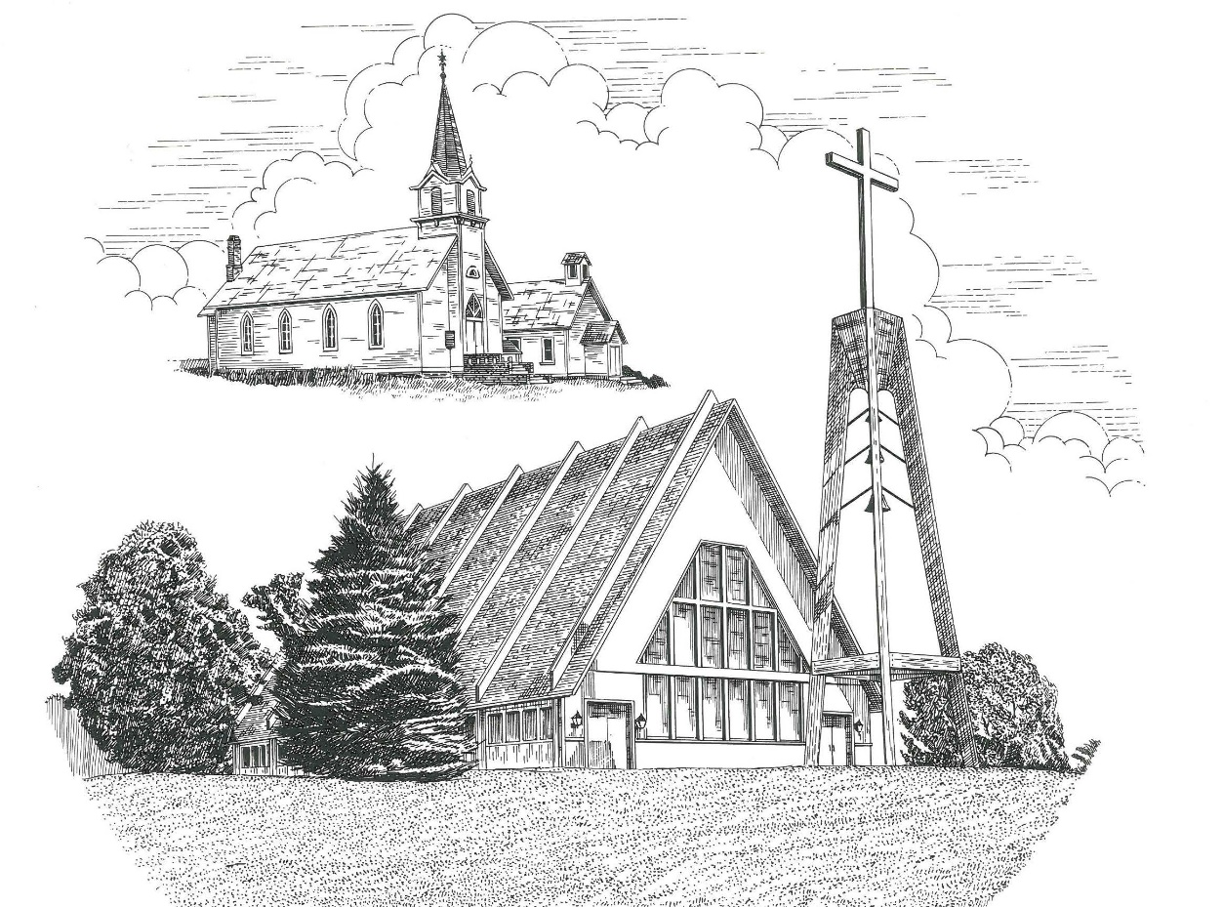

**Twelfth Sunday after Pentecost August 28th, 2022**

**WELCOME**

**Thanks for joining us!**

**Pastor Jacob Sherry Missouri Synod**

**~~PLEASE NOTE~~Calling on the name of the Lord**

Does not include the use of cell phones in the worship sanctuary.

Please check yours before the service begins. Thank you for your courtesy.

**~~TO OUR GUESTS AND VISITORS~~**

Please sign our guest book located on the stand at the church entrance. During the service, we ask you to sign the attendance sheets located inside your bulletin and leave them on the pew as you leave. If you need assistance or have questions about our worship service, please talk to an elder or any one of our church family. We are glad you could join us and hope to have you worship with us again soon.

**~~ATTENDING HOLY COMMUNION~~**

By checking the “Communing Today” box on the registration form on the attendance sheet, you are agreeing with the following statements:

* **I am a baptized Christian who believes Jesus Christ is my Lord and Savior.**
* **I believe that I am a sinner in need of Christ freely offered forgiveness.**
* **I believe that in the Lord’s Supper the body and blood of Jesus Christ**

**are truly present in, with, and under the bread and wine.**

* **I believe that my participation in Holy Communion grants me forgiveness**

**of my sins, new spiritual life, and eternal salvation.**

* **With God’s help, I sincerely seek to repent of my sins, live in service**

**to my Lord, and await His return.**

**If you agree with the above statements, you are welcome to attend the Lord’s Supper with us. May God bless your worship time with us.**

We do offer gluten-free wafers, please quietly ask an elder to help you.

**Order of Divine Service Setting One**

**Pre-Service Music……………..Call to Worship………………….Greeting**

**OPENING HYMN:** *“Today Your Mercy Calls Us”*…………………....LSB #915

**CONFESSION & ABSOLUTION**……………………………………..LSB p. 151

**KYRIE**…………………………………………………………………...LSB pp. 152-153

**THIS IS THE FEAST**…………………………………………………...LSB p. 155

**SALUTATION**…………………………………………………………..LSB p. 156

**Collect Prayer**

O Lord of grace and mercy, teach us by Your Holy Spirit to follow the example of Your Son in true humility, that we may withstand the temptations of the devil and with pure hearts and minds avoid ungodly pride; through the same Jesus Christ, our Lord, who lives and reigns with the You and the Holy Spirit, one God, now and forever.

**THE HOLY SCRIPTURES**

**OLD TESTAMENT:** (Proverbs 25:2-10)

**2**It is the glory of God to conceal things,  
    but the glory of kings is to search things out.  
**3**As the heavens for height, and the earth for depth,  
    so the heart of kings is unsearchable.  
**4**Take away the dross from the silver,  
    and the smith has material for a vessel;  
**5**take away the wicked from the presence of the king,  
    and his throne will be established in righteousness.  
**6**Do not put yourself forward in the king's presence  
    or stand in the place of the great,  
**7**for it is better to be told, “Come up here,”  
    than to be put lower in the presence of a noble.

What your eyes have seen  
**8**    do not hastily bring into court,  
for what will you do in the end,  
    when your neighbor puts you to shame?  
**9**Argue your case with your neighbor himself,  
    and do not reveal another's secret,  
**10**lest he who hears you bring shame upon you,  
    and your ill repute have no end.

**R:** This is the Word of the Lord**.** **Cong: Thanks be to God.**

**GRADUAL**

Reader: Fear the Lord, you his saints,

**Cong.: for those who fear him lack nothing!**

Reader: Many are the afflictions of the righteous,

**Cong.: but the Lord delivers him out of them all.**

**EPISTLE:** (Hebrews 13:1-17)

Let brotherly love continue.  **2**Do not neglect to show hospitality to strangers, for thereby some have entertained angels unawares.  **3**Remember those who are in prison, as though in prison with them, and those who are mistreated, since you also are in the body.  **4**Let marriage be held in honor among all, and let the marriage bed be undefiled, for God will judge the sexually immoral and adulterous.  **5**Keep your life free from love of money, and be content with what you have, for he has said, “I will never leave you nor forsake you.” **6**So we can confidently say,

“The Lord is my helper;  
    I will not fear;  
what can man do to me?”

**7**Remember your leaders, those who spoke to you the word of God. Consider the outcome of their way of life, and imitate their faith. **8**Jesus Christ is the same yesterday and today and forever.  **9**Do not be led away by diverse and strange teachings, for it is good for the heart to be strengthened by grace, not by foods, which have not benefited those devoted to them.  **10**We have an altar from which those who serve the tent have no right to eat.  **11**For the bodies of those animals whose blood is brought into the holy places by the high priest as a sacrifice for sin are burned outside the camp.  **12**So Jesus also suffered outside the gate in order to sanctify the people through his own blood. **13**Therefore let us go to him outside the camp and bear the reproach he endured. **14**For here we have no lasting city, but we seek the city that is to come.  **15**Through him then let us continually offer up a sacrifice of praise to God, that is, the fruit of lips that acknowledge his name. **16**Do not neglect to do good and to share what you have, for such sacrifices are pleasing to God. **17**Obey your leaders and submit to them, for they are keeping watch over your souls, as those who will have to give an account.  Let them do this with joy and not with groaning, for that would be of no advantage to you.

**R:** This is the Word of the Lord. **Cong: Thanks be to God.**

**(PLEASE RISE for the reading of the Gospel)**



**R:** The Holy Gospel according to St. Luke, the 14th chapter.



**HOLY GOSPEL:** (Luke 14:1-14)

One Sabbath, when Jesus went to dine at the house of a ruler of the Pharisees, they were watching him carefully.  **2**And behold, there was a man before him who had dropsy. **3**And Jesus responded to the lawyers and Pharisees, saying, “Is it lawful to heal on the Sabbath, or not?”  **4**But they remained silent. Then he took him and healed him and sent him away.  **5**And he said to them, “Which of you, having a son or an ox that has fallen into a well on a Sabbath day, will not immediately pull him out?”  **6**And they could not reply to these things.

**7**Now he told a parable to those who were invited, when he noticed how they chose the places of honor, saying to them, **8**“When you are invited by someone to a wedding feast, do not sit down in a place of honor, lest someone more distinguished than you be invited by him, **9**and he who invited you both will come and say to you, ‘Give your place to this person,’ and then you will begin with shame to take the lowest place.  **10**But when you are invited, go and sit in the lowest place, so that when your host comes, he may say to you, ‘Friend, move up higher.’ Then you will be honored in the presence of all who sit at table with you.  **11**For everyone who exalts himself will be humbled, and he who humbles himself will be exalted.”

**12**He said also to the man who had invited him, “When you give a dinner or a banquet, do not invite your friends or your brothers or your relatives or rich neighbors, lest they also invite you in return and you be repaid.  **13**But when you give a feast, invite the poor, the crippled, the lame, the blind, **14**and you will be blessed, because they cannot repay you. For you will be repaid at the resurrection of the just.”

**R:** This is the Gospel of the Lord.



**SERMON HYMN**: *“Son of God, Eternal Savior”*……………………………..LSB #842

**SERMON**

**NICENE CREED**

I believe in one God, the Father Almighty, maker of heaven and earth and of all things visible and invisible.

And in one Lord Jesus Christ, the only-begotten Son of God, begotten of His Father before all worlds, God of God, Light of Light, very God of very God, begotten, not made, being of one substance with the Father, by whom all things were made; who for us men and for our salvation came down from heaven and was incarnate by the Holy Spirit of the virgin Mary and was made man; and was crucified also for us under Pontius Pilate. He suffered and was buried. And the third day He rose again according to the Scriptures and ascended into heaven and sits at the right hand of the Father. And He will come again with glory to judge both the living and the dead, whose kingdom will have no end.

And I believe in the Holy Spirit, the Lord and giver of life, who proceeds from the Father and the Son, who with the Father and the Son together is worshiped and glorified, who spoke by the prophets. And I believe in one holy Christian and apostolic Church, I acknowledge one Baptism for the remission of sins, and I look for the resurrection of the dead and the life of the world to come. Amen.

**THE GENERAL PRAYERS OF THE CHURCH**

**OFFERTORY**…………………………………………………………...LSB pp. 159-160

**Sharing the Peace of the Lord**

**SERVICE OF THE SACRAMENT**

**PREFACE**……………………………………………………………………..LSB p. 160

**Proper Preface**

It is truly good, right, and salutary that we should at all times and in all places give thanks to You, holy Lord, almighty Father, everlasting God, through Jesus Christ, our Lord, who, out of love for His fallen creation, humbled Himself by taking on the form of a servant, becoming obedient unto death, even death upon a cross. Risen from the dead, He has freed us from eternal death and given us life everlasting. Therefore, with angels and archangels and with all the company of heaven we laud and magnify Your glorious name, ever more praising You and saying:

**SANCTUS**……………………………………………………………………...LSB p. 161

**THE WORDS OF OUR LORD**……………………………………………….LSB p. 162

**AGNUS DEI**……………………………………………………………………LSB p. 163

*If you are not communing, it is acceptable to remain seated.*

**COMMUNION DISTRIBUTION HYMNS**

LSB #817 *“Earth and All Stars”*

LSB #697 *“Awake, O Sleeper, Rise from Death”*

LSB #628 *“Your Table I Approach”*

**THANK THE LORD**………………………………………………………….LSB p. 164

**POST-COMMUNION COLLECT PRAYER**……………………………….LSB p. 166

**BENEDICTION**……………………………………………………………….LSB p. 166

**CLOSING HYMN:** *“Rejoice, O Pilgrim Throng”*……..……………………..LSB #813

**CHURCH INFORMATION**

**Church Office:** (231) 889-4429 **Website:** www.trinityonekama.org

**E-mail:** [trinityonekama@sbcglobal.net](mailto:trinityonekama@sbcglobal.net)

**Address:** P.O. Box 119, 5471 Fairview Street, Onekama, MI 49675

**Adult Bible Study**: Sunday @ 11:30 am (year round)

**Worship:** Sunday @ 10:30 am **The Lord’s Supper:**  Celebrated 2nd & 4th Sundays

**Pastoral Hours:** Wednesday and Friday 9:00am – Noon

**Pastor Phone:** 231-655-2680 **Pastor Email:** trinityonekama@gmail.com

**Copyright licensing covered under CCLI #2802932**