**231-889-4429 5471 Fairview Street, Box 119 Onekama, MI**

**TRINITY LUTHERAN CHURCH**

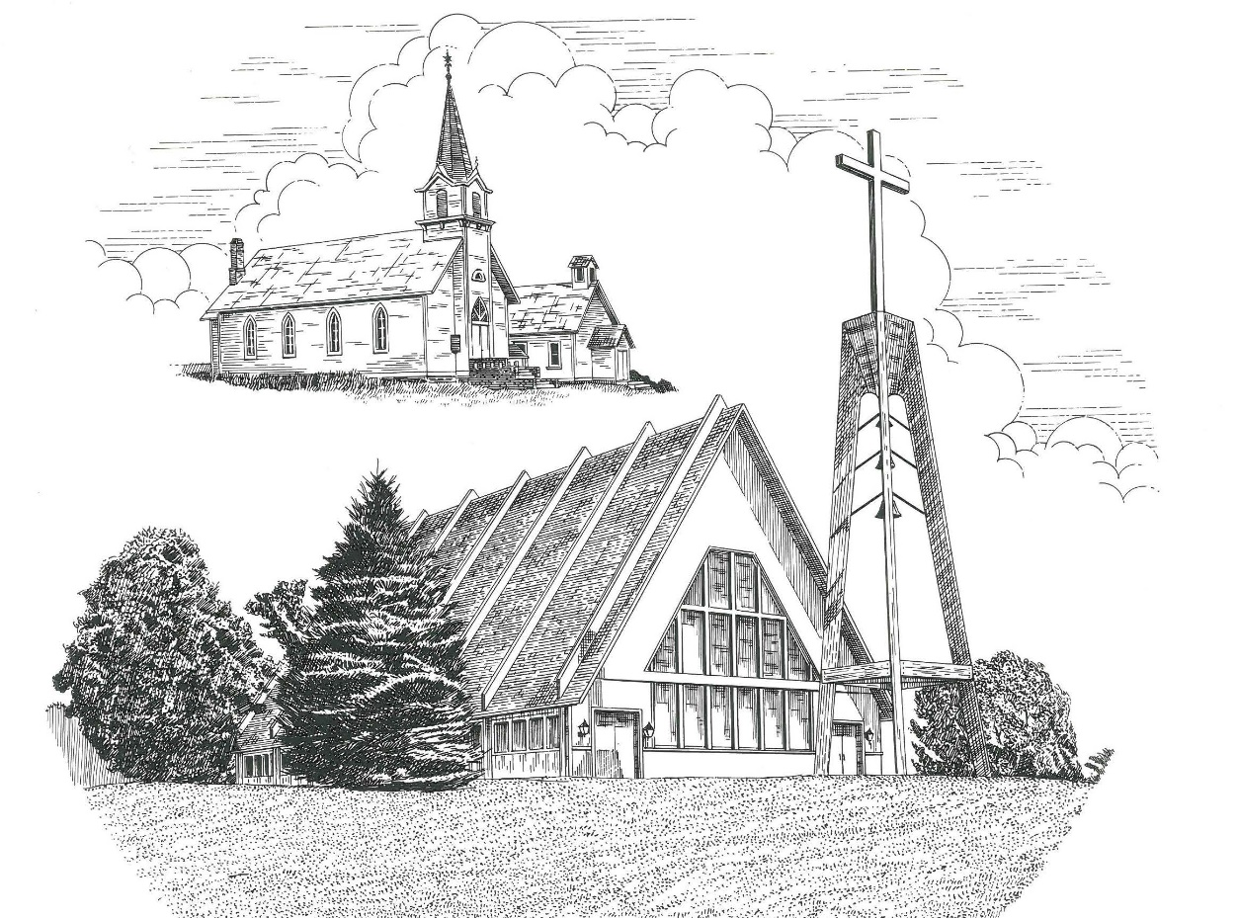

**Second Sunday in Advent December 10th, 2023**

**WELCOME**

**Thanks for joining us!**

**Pastor Jacob Sherry Missouri Synod**

**~~PLEASE NOTE~~Calling on the name of the Lord**

Does not include the use of cell phones in the worship sanctuary.

Please check yours before the service begins. Thank you for your courtesy.

**~~TO OUR GUESTS AND VISITORS~~**

Please sign our guest book located on the stand at the church entrance. During the service, we ask you to sign the attendance sheets located inside your bulletin and leave them on the pew as you leave. If you need assistance or have questions about our worship service, please talk to an elder or any one of our church family. We are glad you could join us and hope to have you worship with us again soon.

**~~ATTENDING HOLY COMMUNION~~**

By checking the “Communing Today” box on the registration form on the attendance sheet, you are agreeing with the following statements:

* **I am a baptized Christian who believes Jesus Christ is my Lord and Savior.**
* **I believe that I am a sinner in need of Christ’s freely offered forgiveness.**
* **I believe that in the Lord’s Supper the body and blood of Jesus Christ**

**are truly present in, with, and under the bread and wine.**

* **I believe that my participation in Holy Communion grants me forgiveness**

**of my sins, new spiritual life, and eternal salvation.**

* **With God’s help, I sincerely seek to repent of my sins, live in service**

**to my Lord, and await His return.**

**If you agree with the above statements, you are welcome to attend the Lord’s Supper with us. May God bless your worship time with us.**

We do offer gluten-free wafers, please quietly ask an elder to help you.

**Order of Divine Service Setting One**

**Pre-Service Music……………..Call to Worship………………….Greeting**

**OPENING HYMN:** *“Lift Up Your Heads, Ye Mighty Gates”*………….LSB #341

**CONFESSION & ABSOLUTION**……………………………………..LSB p. 151

**INTROIT**

P: Restore us, O God;

**C: let your face shine, that we may be saved!**

P: Give ear, O Shepherd of Israel, you who lead Joseph like a flock!

**C: You who are enthroned upon the cherubim, shine forth.**

P: You brought a vine out of Egypt;

**C: it took deep root and filled the land.**

P: Restore us, O God of hosts;

**C: let your face shine, that we may be saved!**

**ALL: Glory be to the Father and to the Son and to the Holy Spirit; as it was in the**

**beginning, is now, and will be forever. Amen.**

P: Restore us, O God;

**C: let your face shine, that we may be saved!**

**KYRIE**…………………………………………………………………...LSB pp. 152-153

**SALUTATION**…………………………………………………………..LSB p. 156

**Collect Prayer**

Stir up our hearts, O Lord, to make ready the way of Your only-begotten Son, that by His coming we may be enabled to serve You with pure minds; through the same Jesus Christ, our Lord, who lives and reigns with the You and the Holy Spirit, one God, now and forever.

**THE HOLY SCRIPTURES**

**OLD TESTAMENT:** (Isaiah 40:1-11)

Comfort, comfort my people, says your God.  
**2**Speak tenderly to Jerusalem,  
    and cry to her  
that her warfare is ended,  
    that her iniquity is pardoned,  
that she has received from the Lord's hand  
    double for all her sins.

**3**A voice cries:  
“In the wilderness prepare the way of the Lord;  
    make straight in the desert a highway for our God.  
**4**Every valley shall be lifted up,  
    and every mountain and hill be made low;  
the uneven ground shall become level,  
    and the rough places a plain.  
**5**And the glory of the Lord shall be revealed,  
    and all flesh shall see it together,  
    for the mouth of the Lord has spoken.”

**6**A voice says, “Cry!”  
    And I said, “What shall I cry?”  
All flesh is grass,  
    and all its beauty is like the flower of the field.  
**7**The grass withers, the flower fades  
    when the breath of the Lord blows on it;  
    surely the people are grass.  
**8**The grass withers, the flower fades,  
    but the word of our God will stand forever.

**9**Go on up to a high mountain,  
    O Zion, herald of good news;  
lift up your voice with strength,  
    O Jerusalem, herald of good news;  
    lift it up, fear not;  
say to the cities of Judah,  
    “Behold your God!”  
**10**Behold, the Lord God comes with might,  
    and his arm rules for him;  
behold, his reward is with him,  
    and his recompense before him.  
**11**He will tend his flock like a shepherd;  
    he will gather the lambs in his arms;  
he will carry them in his bosom,  
    and gently lead those that are with young.

**R:** This is the Word of the Lord**.** **Cong: Thanks be to God.**

**GRADUAL**

Reader: Rejoice greatly, O daughter of Zion.

**C: Shout aloud, O daughter of Jerusalen.**

Reader: Behold, your king is coming to you;

**C: righteous and having salvation.**

Reader: Blessed is he who comes in the name of the Lord.

**C: From the house of the Lord we bless you.**

**EPISTLE:** (2 Peter 3:8-14)

**8**But do not overlook this one fact, beloved, that with the Lord one day is as a thousand years, and a thousand years as one day. **9**The Lord is not slow to fulfill his promise as some count slowness, but is patient toward you, not wishing that any should perish, but that all should reach repentance. **10**But the day of the Lord will come like a thief, and then the heavens will pass away with a roar, and the heavenly bodies will be burned up and dissolved, and the earth and the works that are done on it will be exposed.

**11**Since all these things are thus to be dissolved, what sort of people ought you to be in lives of holiness and godliness, **12**waiting for and hastening the coming of the day of God, because of which the heavens will be set on fire and dissolved, and the heavenly bodies will melt as they burn! **13**But according to his promise we are waiting for new heavens and a new earth in which righteousness dwells.

**14**Therefore, beloved, since you are waiting for these, be diligent to be found by him without spot or blemish, and at peace.

**R:** This is the Word of the Lord. **Cong: Thanks be to God.**

**(PLEASE RISE for the reading of the Gospel)**



**R:** The Holy Gospel according to St. Mark, the 1st chapter.



**HOLY GOSPEL:** (Mark 1:1-8)

The beginning of the gospel of Jesus Christ, the Son of God. **2**As it is written in Isaiah the prophet,

“Behold, I send my messenger before your face,  
    who will prepare your way,  
**3**the voice of one crying in the wilderness:  
    ‘Prepare the way of the Lord,  
    make his paths straight,’”

**4**John appeared, baptizing in the wilderness and proclaiming a baptism of repentance for the forgiveness of sins. **5**And all the country of Judea and all Jerusalem were going out to him and were being baptized by him in the river Jordan, confessing their sins. **6**Now John was clothed with camel's hair and wore a leather belt around his waist and ate locusts and wild honey. **7**And he preached, saying, “After me comes he who is mightier than I, the strap of whose sandals I am not worthy to stoop down and untie. **8**I have baptized you with water, but he will baptize you with the Holy Spirit.”

**R:** This is the Gospel of the Lord.



**SERMON HYMN**: *“On Jordan’s Bank the Baptist’s Cry”*…………….LSB #344

**SERMON**

**NICENE CREED**

I believe in one God, the Father Almighty, maker of heaven and earth and of all things visible and invisible.

And in one Lord Jesus Christ, the only-begotten Son of God, begotten of His Father before all worlds, God of God, Light of Light, very God of very God, begotten, not made, being of one substance with the Father, by whom all things were made; who for us men and for our salvation came down from heaven and was incarnate by the Holy Spirit of the virgin Mary and was made man; and was crucified also for us under Pontius Pilate. He suffered and was buried. And the third day He rose again according to the Scriptures and ascended into heaven and sits at the right hand of the Father. And He will come again with glory to judge both the living and the dead, whose kingdom will have no end.

And I believe in the Holy Spirit, the Lord and giver of life, who proceeds from the Father and the Son, who with the Father and the Son together is worshiped and glorified, who spoke by the prophets. And I believe in one holy Christian and apostolic Church, I acknowledge one Baptism for the remission of sins, and I look for the resurrection of the dead and the life of the world to come. Amen.

**THE GENERAL PRAYERS OF THE CHURCH**

**COLLECTION OF THE OFFERING**

**OFFERTORY**…………………………………………………………...LSB pp. 159-160

**Sharing the Peace of the Lord**

**SERVICE OF THE SACRAMENT**

**PREFACE**……………………………………………………………….LSB p. 160

**Proper Preface**

It is truly good, right, and salutary that we should at all times and in all places give thanks to You, holy Lord, almighty Father, everlasting God, through Jesus Christ, our Lord, whose way John the Baptist prepared, proclaiming Him the promised Messiah, the very Lamb of God who takes away the sin of the world, and calling sinners to repentance that they might escape from the wrath to be revealed when He comes again in glory. Therefore, with angels and archangels and with all the company of heaven we laud and magnify Your glorious name, ever more praising You and saying:

**SANCTUS**……………………………………………………………………...LSB p. 161

**THE WORDS OF OUR LORD**……………………………………………….LSB p. 162

**AGNUS DEI**……………………………………………………………………LSB p. 163

*If you are not communing, it is acceptable to remain seated.*

**COMMUNION DISTRIBUTION HYMNS**

LSB #336 *“Lo! He Comes with Clouds Descending”*

LSB #346 *“When All the World Was Cursed”*

LSB #547 *“The Lamb”*

**POST COMMUNION CANTICLE:** *“Thank the Lord”*………………….....LSB p. 164

**POST-COMMUNION COLLECT PRAYER**………………………………LSB p. 166

**BENEDICTION**……………………………………………………………….LSB p. 166

**CLOSING HYMN:** *“Prepare the Royal Highway”*……..……………………LSB #343

**CHURCH INFORMATION**

**Church Office:** (231) 889-4429 **Website:** www.trinityonekama.org

**E-mail:** [trinityonekama@sbcglobal.net](mailto:trinityonekama@sbcglobal.net)

**Address:** P.O. Box 119, 5471 Fairview Street, Onekama, MI 49675

**Sunday School & Adult Bible Study**: Sunday @ 9:30 am

**Worship:** Sunday @ 10:30 am **The Lord’s Supper:**  Celebrated 2nd & 4th Sundays

**Pastoral Hours:** Wednesday and Friday 9:00am – Noon

**Pastor Phone:** 231-655-2680 **Pastor Email:** trinityonekama@gmail.com

**Copyright licensing covered under CCLI #2802932**