231-889-4429 5471 Fairview Street, Box 119 Onekama, MI

TRINITY LUTHERAN CHURCH
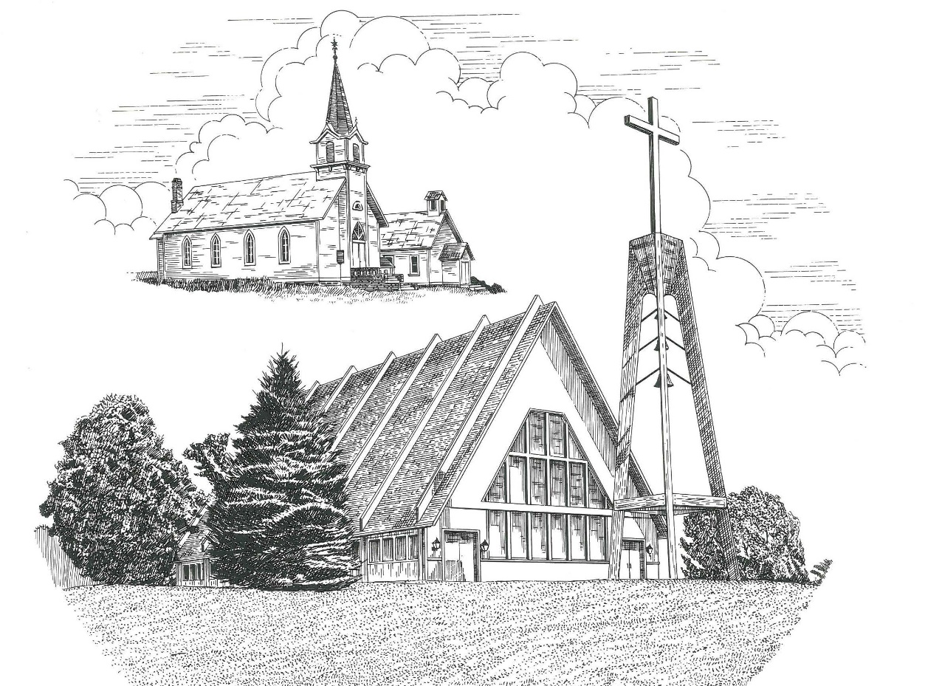

Third Sunday in Advent December 11th, 2022

WELCOME
Thanks for joining us!
Pastor Jacob Sherry Missouri Synod

~~PLEASE NOTE~~
Calling on the name of the Lord
Does not include the use of cell phones in the worship sanctuary.
Please check yours before the service begins. Thank you for your courtesy.
~~TO OUR GUESTS AND VISITORS~~
Please sign our guest book located on the stand at the church entrance. During the service, we ask you to sign the attendance sheet located in your bulletin and place it on the pew when you leave. If you need assistance or have questions about our worship service, please talk to an elder or any one of our church family. We are glad you could join us and hope to have you worship with us again soon.

~~ATTENDING HOLY COMMUNION~~
By checking the “Communing Today” box on the registration form found on the attendance sheet, you are agreeing with the following statements:

- I am a baptized Christian who believes Jesus Christ is my Lord and Savior.
- I believe that I am a sinner in need of Christ’s freely offered forgiveness.
- I believe that in the Lord’s Supper the body and blood of Jesus Christ
are truly present in, with, and under the bread and wine.
- I believe that my participation in Holy Communion grants me forgiveness
of my sins, new spiritual life, and eternal salvation.
- With God’s help, I sincerely seek to repent of my sins, live in service
to my Lord, and await His return.

If you agree with the above statements, you are welcome to attend the Lord’s Supper with us. May God bless your worship time with us.
We do offer gluten-free wafers, please quietly ask an elder to help you.

Order of Divine Service Setting Three

Pre-Service Music……………..Call to Worship………………….Greeting

OPENING HYMN: “Once He Came in Blessing”..................................LSB #333
OPENING LITURGY:
Confession & Absolution………..………………………………LSB pp. 184-185
Kyrie…………………………………….………………………..LSB p. 186
Salutation….……………………………….…………………….LSB p. 189

Collect Prayer
Lord Jesus Christ, we implore You to hear our prayers and to lighten the darkness of our hearts by Your gracious visitation; for You live and reign with the Father and the Holy Spirit, one God, now and forever.

THE HOLY SCRIPTURES

OLD TESTAMENT: (Isaiah 35:1-10)
The wilderness and the dry land shall be glad;
the desert shall rejoice and blossom like the crocus;
² it shall blossom abundantly
and rejoice with joy and singing.
The glory of Lebanon shall be given to it,
the majesty of Carmel and Sharon.
They shall see the glory of the Lord,
the majesty of our God.
³ Strengthen the weak hands,
and make firm the feeble knees.
⁴ Say to those who have an anxious heart,
“Be strong; fear not!
Behold, your God
will come with vengeance,
with the recompense of God.
He will come and save you.”
⁵ Then the eyes of the blind shall be opened,
and the ears of the deaf unstopped;
⁶ then shall the lame man leap like a deer,
and the tongue of the mute sing for joy.
For waters break forth in the wilderness,
and streams in the desert;
⁷ the burning sand shall become a pool,
and the thirsty ground springs of water;
in the haunt of jackals, where they lie down,
the grass shall become reeds and rushes.
⁸ And a highway shall be there,
and it shall be called the Way of Holiness;
the unclean shall not pass over it.
It shall belong to those who walk on the way;
even if they are fools, they shall not go astray.
⁹ No lion shall be there,
nor shall any ravenous beast come up on it;
they shall not be found there,
but the redeemed shall walk there.
¹⁰ And the ransomed of the Lord shall return
and come to Zion with singing;
everlasting joy shall be upon their heads;
they shall obtain gladness and joy,
and sorrow and sighing shall flee away.

R: This is the Word of the Lord. Cong: Thanks be to God.

GRADUAL
Reader: Rejoice greatly, O daughter of Zion.
Cong.: Shout aloud, O daughter of Jerusalem.
Reader: Behold, your king is coming to you;
Cong.: righteous and having salvation.
Reader: Blessed is he who comes in the name of the Lord.
Cong.: From the house of the Lord we bless you.

EPISTLE: (James 5:7-11)
⁷ Be patient, therefore, brothers, until the coming of the Lord. See how the farmer waits for the precious fruit of the earth, being patient about it, until it receives the early and the late rains. ⁸ You also, be patient. Establish your hearts, for the coming of the Lord is at hand. ⁹ Do not grumble against one another, brothers, so that you may not be judged; behold, the Judge is standing at the door. ¹⁰ As an example of suffering and patience, brothers, take the prophets who spoke in the name of the Lord. ¹¹ Behold, we consider those blessed who remained steadfast. You have heard of the steadfastness of Job, and you have seen the purpose of the Lord, how the Lord is compassionate and merciful.

R: This is the Word of the Lord. Cong: Thanks be to God.

(PLEASE RISE for the reading of the Gospel)

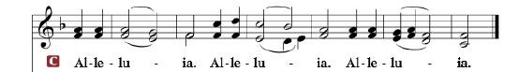

R: The Holy Gospel according to St. Matthew, the 11th chapter.

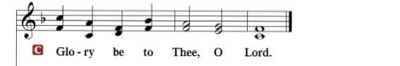

HOLY GOSPEL: (Matthew 11:2-15)
² Now when John heard in prison about the deeds of the Christ, he sent word by his disciples ³ and said to him, “Are you the one who is to come, or shall we look for another?” ⁴ And Jesus answered them, “Go and tell John what you hear and see: ⁵ the blind receive their sight and the lame walk, lepers are cleansed and the deaf hear, and the dead are raised up, and the poor have good news preached to them. ⁶ And blessed is the one who is not offended by me.”
⁷ As they went away, Jesus began to speak to the crowds concerning John: “What did you go out into the wilderness to see? A reed shaken by the wind? ⁸ What then did you go out to see? A man dressed in soft clothing? Behold, those who wear soft clothing are in kings' houses. ⁹ What then did you go out to see? A prophet? Yes, I tell you, and more than a prophet. ¹⁰ This is he of whom it is written,
“‘Behold, I send my messenger before your face,
who will prepare your way before you.’
¹¹ Truly, I say to you, among those born of women there has arisen no one greater than John the Baptist. Yet the one who is least in the kingdom of heaven is greater than he. ¹² From the days of John the Baptist until now the kingdom of heaven has suffered violence, and the violent take it by force. ¹³ For all the Prophets and the Law prophesied until John, ¹⁴ and if you are willing to accept it, he is Elijah who is to come. ¹⁵ He who has ears to hear, let him hear.

R: This is the Gospel of the Lord.

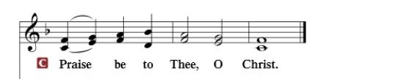

Nicene Creed
I believe in one God, the Father Almighty, maker of heaven and earth and of all things visible and invisible.
And in one Lord Jesus Christ, the only-begotten Son of God, begotten of His Father before all worlds, God of God, Light of Light, very God of very God, begotten, not made, being of one substance with the Father, by whom all things were made; who for us men and for our salvation came down from heaven and was incarnate by the Holy Spirit of the virgin Mary and was made man; and was crucified also for us under Pontius Pilate. He suffered and was buried. And the third day He rose again according to the Scriptures and ascended into heaven and sits at the right hand of the Father. And He will come again with glory to judge both the living and the dead, whose kingdom will have no end.
And I believe in the Holy Spirit, the Lord and giver of life, who proceeds from the Father and the Son, who with the Father and the Son together is worshiped and glorified, who spoke by the prophets. And I believe in one holy Christian and apostolic Church, I acknowledge one Baptism for the remission of sins, and I look for the resurrection of the dead and the life of the world to come. Amen.

SERMON HYMN: “Hark! A Thrilling Voice Is Sounding”…………….LSB #345

SERMON

OFFERTORY…………………………………………………………...LSB pp. 192-193

GENERAL PRAYERS OF THE CHURCH

Sharing the Peace of the Lord

SERVICE OF THE SACRAMENT
Preface…………………………………….…………….……….LSB p. 194
Proper Preface
It is truly good, right, and salutary that we should at all times and in all places give thanks to You, holy Lord, almighty Father, everlasting God, through Jesus Christ, our Lord, whose way John the Baptist prepared, proclaiming Him the promised Messiah, the very Lamb of God who takes away the sin of the world, and calling sinners to repentance that they might escape from the wrath to be revealed when He comes again in glory. Therefore, with angels and archangels and with all the company of heaven we laud and magnify Your glorious name, ever more praising You and saying:
Sanctus, Lord’s Prayer, The Words of Our Lord………………….....LSB pp. 195-197
Agnus Dei………………………………………………………………..LSB p. 198
If you are not communing, it is acceptable to remain seated.

COMMUNION DISTRIBUTION HYMNS:
LSB #343 “Prepare the Royal Highway”
LSB #555 “Salvation unto Us Has Come”
LSB #725 “Children of the Heavenly Father”

NUNC DIMITTIS………………………………………………………LSB pp. 199-200

BENEDICTION

CLOSING HYMN: “Come, Thou Precious Ransom, Come”.................LSB #350

CHURCH INFORMATION
Church Office: (231) 889-4429 Website: www.trinityonekama.org
E-mail: trinityonekama@sbcglobal.net
Address: P.O. Box 119, 5471 Fairview Street, Onekama, MI 49675
Adult Bible Study: Sunday @ 11:30 am (year round)
Worship: Sunday @ 10:30 am The Lord’s Supper: Celebrated 2nd & 4th Sundays
Pastoral Hours: Wednesday and Friday 9:00am – Noon
Pastor Phone: 231-655-2680 Pastor Email: trinityonekama@gmail.com

Copyright licensing covered under CCLI #2802932

