**231-889-4429 5471 Fairview Street, Box 119 Onekama, MI**

**TRINITY LUTHERAN CHURCH**

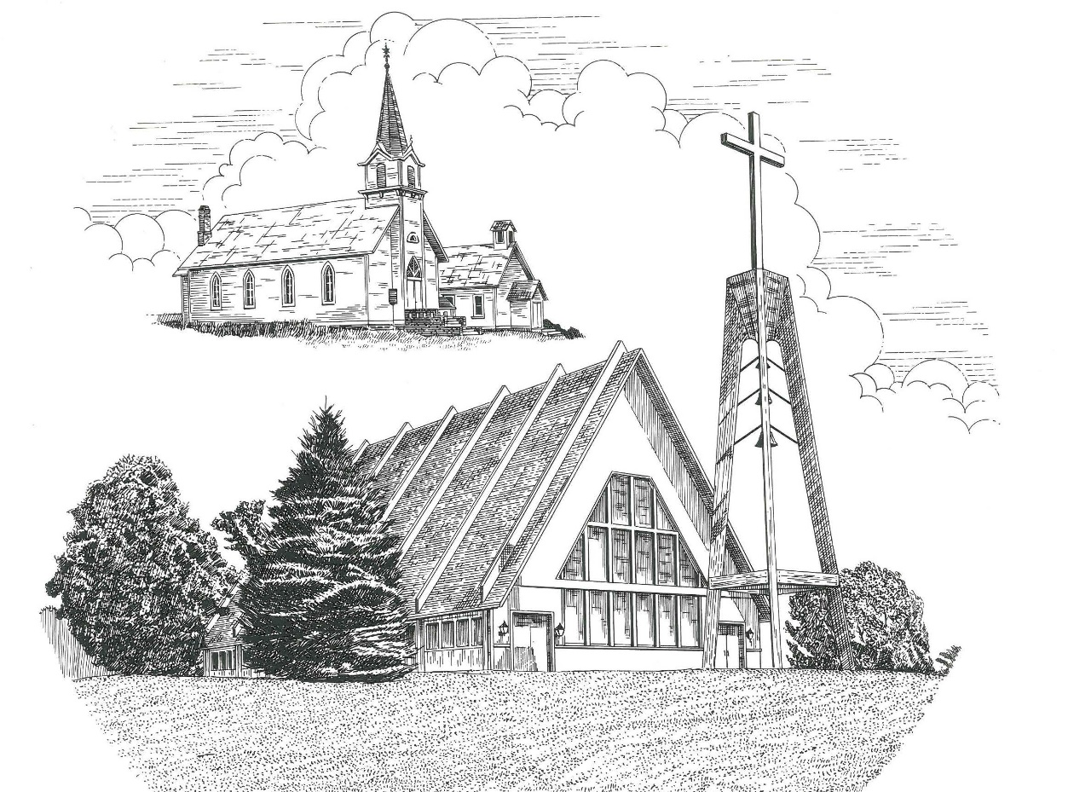

**Fourth Sunday in Advent December 18th, 2022**

**WELCOME**

**Thanks for joining us!**

**Pastor Jacob Sherry Missouri Synod**

**~~PLEASE NOTE~~Calling on the name of the Lord**

Does not include the use of cell phones in the worship sanctuary.

Please check yours before the service begins. Thank you for your courtesy.

**~~TO OUR GUESTS AND VISITORS~~**

Please sign our guest book located on the stand at the church entrance. During the service, we ask you to sign the attendance sheets located inside your bulletin and leave them on the pew as you leave. If you need assistance or have questions about our worship service, please talk to an elder or any one of our church family. We are glad you could join us and hope to have you worship with us again soon.

**Order of Divine Service Setting One**

**Pre-Service Music……………..Call to Worship………………….Greeting**

**OPENING HYMN:** *“Hark! The Herald Angels Sing”*…………………LSB #380

**CONFESSION & ABSOLUTION**……………………………………..LSB p. 151

**KYRIE**…………………………………………………………………...LSB pp. 152-153

**SALUTATION**…………………………………………………………..LSB p. 156

**Collect Prayer**

Stir up Your power, O Lord, and come and help us by Your might, that the sins which weigh us down may be quickly lifted by Your grace and mercy; for You live and reign with the Father and the Holy Spirit, one God, now and forever.

**THE HOLY SCRIPTURES**

**OLD TESTAMENT:** (Isaiah 7:10-17)

**10**Again the Lord spoke to Ahaz: **11**“Ask a sign of the Lord your God; let it be deep as Sheol or high as heaven.” **12**But Ahaz said, “I will not ask, and I will not put the Lord to the test.” **13**And he said, “Hear then, O house of David! Is it too little for you to weary men, that you weary my God also? **14**Therefore the Lord himself will give you a sign. Behold, the virgin shall conceive and bear a son, and shall call his name Immanuel. **15**He shall eat curds and honey when he knows how to refuse the evil and choose the good. **16**For before the boy knows how to refuse the evil and choose the good, the land whose two kings you dread will be deserted. **17**The Lord will bring upon you and upon your people and upon your father's house such days as have not come since the day that Ephraim departed from Judah—the king of Assyria!”

**R:** This is the Word of the Lord**.** **Cong: Thanks be to God.**

**GRADUAL**

Reader: Rejoice greatly, O daughter of Zion.

**Cong.: Shout aloud, O daughter of Jerusalem.**

Reader: Behold, your king is coming to you;

**Cong.: righteous and having salvation.**

Reader: Blessed is he who comes in the name of the Lord.

**Cong.: From the house of the Lord we bless you.**

**EPISTLE:** (Romans 1:1-7)

Paul, a servant of Christ Jesus, called to be an apostle, set apart for the gospel of God, **2**which he promised beforehand through his prophets in the holy Scriptures, **3**concerning his Son, who was descended from David according to the flesh **4**and was declared to be the Son of God in power according to the Spirit of holiness by his resurrection from the dead, Jesus Christ our Lord, **5**through whom we have received grace and apostleship to bring about the obedience of faith for the sake of his name among all the nations, **6**including you who are called to belong to Jesus Christ, **7**to all those in Rome who are loved by God and called to be saints: Grace to you and peace from God our Father and the Lord Jesus Christ.

**R:** This is the Word of the Lord. **Cong: Thanks be to God.**

**(PLEASE RISE for the reading of the Gospel)**



**R:** The Holy Gospel according to St. Matthew, the 1st chapter.



**HOLY GOSPEL:** (Matthew 1:18-25)

**18**Now the birth of Jesus Christ took place in this way. When his mother Mary had been betrothed to Joseph, before they came together she was found to be with child from the Holy Spirit. **19**And her husband Joseph, being a just man and unwilling to put her to shame, resolved to divorce her quietly. **20**But as he considered these things, behold, an angel of the Lord appeared to him in a dream, saying, “Joseph, son of David, do not fear to take Mary as your wife, for that which is conceived in her is from the Holy Spirit. **21**She will bear a son, and you shall call his name Jesus, for he will save his people from their sins.” **22**All this took place to fulfill what the Lord had spoken by the prophet:

**23**“Behold, the virgin shall conceive and bear a son,  
    and they shall call his name Immanuel”

(which means, God with us). **24**When Joseph woke from sleep, he did as the angel of the Lord commanded him: he took his wife, **25**but knew her not until she had given birth to a son. And he called his name Jesus.

**R:** This is the Gospel of the Lord.



**SERMON HYMN**: *“What Child Is This”*…………………………………..LSB #370

verses 1 & 2

**THE MESSAGE PRESENTED BY THE CHILDREN**

Leader: To us . . .

**Cong.: A Child is born!**

Leader: To us . . .

**Cong.: A Son is given!**

Leader: This Christmas, we receive . . .

**Cong.: The blessed gift of heaven.**

Anna Bradford: Now the birth of Jesus Christ took place in this way. When His mother Mary had been betrothed to Joseph, before they came together, she was found to be with child from the Holy Spirit. And her husband Joseph, being a just man and unwilling to put her to shame, resolved to divorce her quietly. But as he considered these things, behold, an angel of the Lord appeared to him in a dream, saying, “Joseph, son of David, do not fear to take Mary as your wife, for that which is conceived in her is from the Holy Spirit. She will bear a son, and you shall call His name Jesus, for He will save His people from their sins.”

Emma Bradford: All this took place to fulfill what the Lord had spoken by the prophet:

“Behold, the virgin shall conceive and bear a son,

and they shall call His name Immanuel”

(which means, God with us). When Joseph woke from sleep, he did as the angel of the Lord commanded him: he took his wife, but knew her not until she had given birth to a son. And he called His name Jesus. [Matthew 1:18–25]

**HYMN: *“Away in a Manger”* (sung by the children)**

Away in a manger, no crib for a bed,

The little Lord Jesus laid down his sweet head.

The stars in the sky looked down where He lay,

The little Lord Jesus asleep on the hay.

The cattle are lowing, the baby awakes,

But little Lord Jesus, no crying He makes.

I love Thee, Lord Jesus! Look down from the sky,

And stay by my cradle till morning is nigh.

Be near me, Lord Jesus; I ask Thee to stay

Close by me forever and love me, I pray.

Bless all the dear children in They tender care,

And take us to heaven to live with Thee there.

**HYMN: *“Of the Father’s Love Begotten”* (Congregation) LSB 384, verses 1 & 3**

Of the Father’s love begotten

Ere the worlds began to be,

He is Alpha and Omega,

He the source, the ending He,

Of the things that are, that have been,

And that future years shall see

Evermore and evermore.

This is He whom seers in old time

Chanted of with one accord,

Whom the voices of the prophets

Promised in their faithful word.

Now He shines, the long-expected;

Let creation praise its Lord

Evermore and evermore.

**Charlie Sherry:** Our God gave us a promise true:

**Lincoln Lutz:** His Son would come for me and you.

**Annaleigh Eckholm:** His grace and peace to us will bring:

**Layton Lutz:** This Prince of peace, this holy King.

Children: To us a Child is born!

**Cong.: To us a Son is given!**

**SONG: *“To Us a Child Is Born”* (sung by children) SCY 3, verse 1**

*Refrain*: *Stanza 1*:

To us a Child is born, The prophets spoke about

To us a Son is given. The Savior God would send,

This Christmas we receive The glorious Prince of Peace

The blessed gift of heaven. Whose kingdom shall not end. *Refrain.*

**Connor LeSarge:** And in the same region there were shepherds out in the field, keeping watch over their flock by night. And an angel of the Lord appeared to them, and the glory of the Lord shone around them, and they were filled with great fear. And the angel said to them, “Fear not, for behold, I bring you good news of great joy that will be for all the people.”

**Aubry LeSarge:** “For unto you is born this day in the city of David a Savior, who is Christ the Lord. And this will be a sign for you: you will find a baby wrapped in swaddling cloths and lying in a manger.” And suddenly there was with the angel a multitude of the heavenly host praising God and saying, “Glory to God in the highest, and on earth peace among those with whom He is pleased!” [*Luke 2:8–14*]

**HYMN: *“Angels We Have Heard on High”* (Congregation) LSB 368, verses 1 & 3**

Angels we have heard on high,

Sweetly singing o’er the plains, *Refrain*:

And the mountains in reply, Gloria in excelsis Deo.

Echoing their joyous strains. Gloria in excelsis Deo.

Come to Bethlehem and see,

Him whose birth the angels sing, *Refrain*:

Come, adore on bended knee, Gloria in excelsis Deo.

Christ the Lord, the newborn King. Gloria in excelsis Deo.

**Sarah Sherry:** The angels fill the nighttime air

To sing and joyfully declare:

“All praise to God in majesty;

He sent His Son to set you free!”

Children: To us a Child is born!

**Cong.: To us a Son is given!**

**HYMN: *“To Us a Child Is Born”* (sung by children) SCY 3, verse 2**

*Refrain*: *Stanza 2*:

To us a Child is born, The angels sang God’s praise

To us a Son is given. Amid the heavens bright.

This Christmas we receive We also join in song

The blessed gift of heaven. And fill the church with light. *Refrain.*

**Ashlyn Blackmore:** When the angels went away from them into heaven, the shepherds said to one another, “Let us go over to Bethlehem and see this thing that has happened, which the Lord has made known to us.” And they went with haste and found Mary and Joseph, and the baby lying in a manger.

**Aleah Blackmore:** And when they saw it, they made known the saying that had been told them concerning this child. And all who heard it wondered at what the shepherds told them. But Mary treasured up all these things, pondering them in her heart. And the shepherds returned, glorifying and praising God for all they had heard and seen, as it had been told them. [*Luke 2:15–20*]

**HYMN: *“Infant Holy, Infant Lowly”* (Congregation) LSB 393**

Infant holy, infant lowly,

For His bed a cattle stall;

Oxen lowing, little knowing

Christ the child is Lord of all.

Swiftly winging, angels singing,

Bells are ringing, tidings bringing:

Christ the child is Lord of all!

Christ the child is Lord of all!

Flocks were sleeping, shepherds keeping

Vigil till the morning new.

Saw the glory, heard the story,

Tidings of a Gospel true.

Thus rejoicing, free from sorrow,

Praises voicing, greet the morrow:

Christ the child was born for you!

Christ the child was born for you!

**Lane Bradford:** O shepherds, go and see the sight

The angels gladly share this night.

For Jesus is the holy Lamb,

The Son of God, the great I Am.

**Katrina Schoedel:** And He is your Good Shepherd too;

He will lay down His life for you.

So listen to His voice each day:

He is the truth, the life, the way.

Children: To us a Child is born!

**Cong.: To us a Son is given!**

**HYMN: *“To Us a Child Is Born”* (sung by children) SCY 3, verse 3**

*Refrain*: *Stanza 3*:

To us a Child is born, The shepherds left the sheep.

To us a Son is given. They watched in nearby fields

This Christmas we receive To see the Lamb of God

The blessed gift of heaven. In human flesh revealed. *Refrain.*

**Anna Bradford:** For to us a child is born, to us a son is given; and the government shall be upon His shoulder, and His name shall be called Wonderful Counselor, Mighty God, Everlasting Father, Prince of Peace. Of the increase of His government and of peace there will be no end, on the throne of David and over his kingdom, to establish it and to uphold it with justice and with righteousness from this time forth and forevermore. The zeal of the Lord of hosts will do this. [*Isaiah 9:6–7*]

**HYMN: *“Angels from the Realms of Glory”* (Congregation) LSB 367, verses 1, 2, & 5**

Angels from the realms of glory,

Wing your flight o’er all the earth; *Refrain*:

Ye who sang creation’s story, Come and worship, come and worship

Now proclaim Messiah’s birth. Worship Christ, the newborn King.

Shepherds in the field abiding,

Watching o’er your flocks by night, *Refrain*:

God with us is now residing, Come and worship, come and worship

Yonder shines the Infant Light. Worship Christ, the newborn King.

All creation, join in praising

God the Father, Spirit, Son, *Refrain*:

Evermore your voices raising Come and worship, come and worship

To the eternal Three in One. Worship Christ, the newborn King.

**Sarah Sherry:** For unto us a Child is born;

He came to sinners all forlorn.

When we were trapped in sin and shame,

He made us pure and took our blame.

**Leah Sherry:** This gift from God, this holy Son

Died on the cross, salvation won.

When He arose, He saved us all.

Rejoicing, to our knees we fall!

Children: To us a Child is born!

**Cong.: To us a Son is given!**

**HYMN: *“To Us a Child Is Born”* (sung by children) SCY 3, verse 4**

*Refrain*: Stanza 4:

To us a Child is born, We also kneel before

To us a Son is given. The Babe in humble stall,

This Christmas we receive The Lord our Righteousness

The blessed gift of heaven. Who came to save us all.

***Final Refrain Congregation and Children*:**

To us a Child is born,

To us a Son is given.

This Christmas we receive

The blessed gift of heaven.

Leader: To us . . .

Children: A Child is born!

**Cong.: Thanks be to God!**

Leader: To us . . .

Children: A Son is given!

**Cong.: Thanks be to God!**

Leader: This Christmas we receive . . .

Children: The blessed gift of heaven!

**Cong.: Thanks be to God!**

Youth Readers: Anna Bradford, Emma Bradford, Aubry LeSarge, Connor LeSarge,

Aleah Blackmore, Ashlyn Blackmore

Joseph: Lane Bradford

Mary: Katrina Schoedel

Angels: Sarah Sherry, Leah Sherry, Annaleigh Eckholm

Shepherds: Layton Lutz, Lincoln Lutz, Charlie Sherry, Max Purple

Sheep: Karleigh Bratton, Karson Bratton, Stanley Eckholm, Gabriel Sherry,

Emma Purple, Laura Lutz

**APOSTLES’ CREED**

I believe in God, the Father Almighty, maker of heaven and earth. And in Jesus Christ, His only Son, our Lord, who was conceived by the Holy Spirit, born of the virgin Mary, suffered under Pontius Pilate, was crucified, died and was buried. He descended into hell. The third day He rose again from the dead. He ascended into heaven and sits at the right hand of God the Father Almighty. From thence He will come to judge the living and the dead. I believe in the Holy Spirit, the holy Christian Church, the communion of saints, the forgiveness of sins, the resurrection of the body, and the life everlasting. Amen.

**THE GENERAL PRAYERS OF THE CHURCH**

**OFFERTORY**…………………………………………………………...LSB pp. 159-160

**BENEDICTION**…………………………………………………………LSB p. 166

**CLOSING HYMN:** *“Joy to the World”*……..………………………….LSB #387

**CHURCH INFORMATION**

**Church Office:** (231) 889-4429 **Website:** www.trinityonekama.org

**E-mail:** [trinityonekama@sbcglobal.net](mailto:trinityonekama@sbcglobal.net)

**Address:** P.O. Box 119, 5471 Fairview Street, Onekama, MI 49675

**Adult Bible Study**: Sunday @ 11:30 am (year round)

**Worship:** Sunday @ 10:30 am **The Lord’s Supper:**  Celebrated 2nd & 4th Sundays

**Pastoral Hours:** Wednesday and Friday 9:00am – Noon

**Pastor Phone:** 231-655-2680 **Pastor Email:** trinityonekama@gmail.com

**Copyright licensing covered under CCLI #2802932**