231-889-4429 5471 Fairview Street, Box 119 Onekama, MI

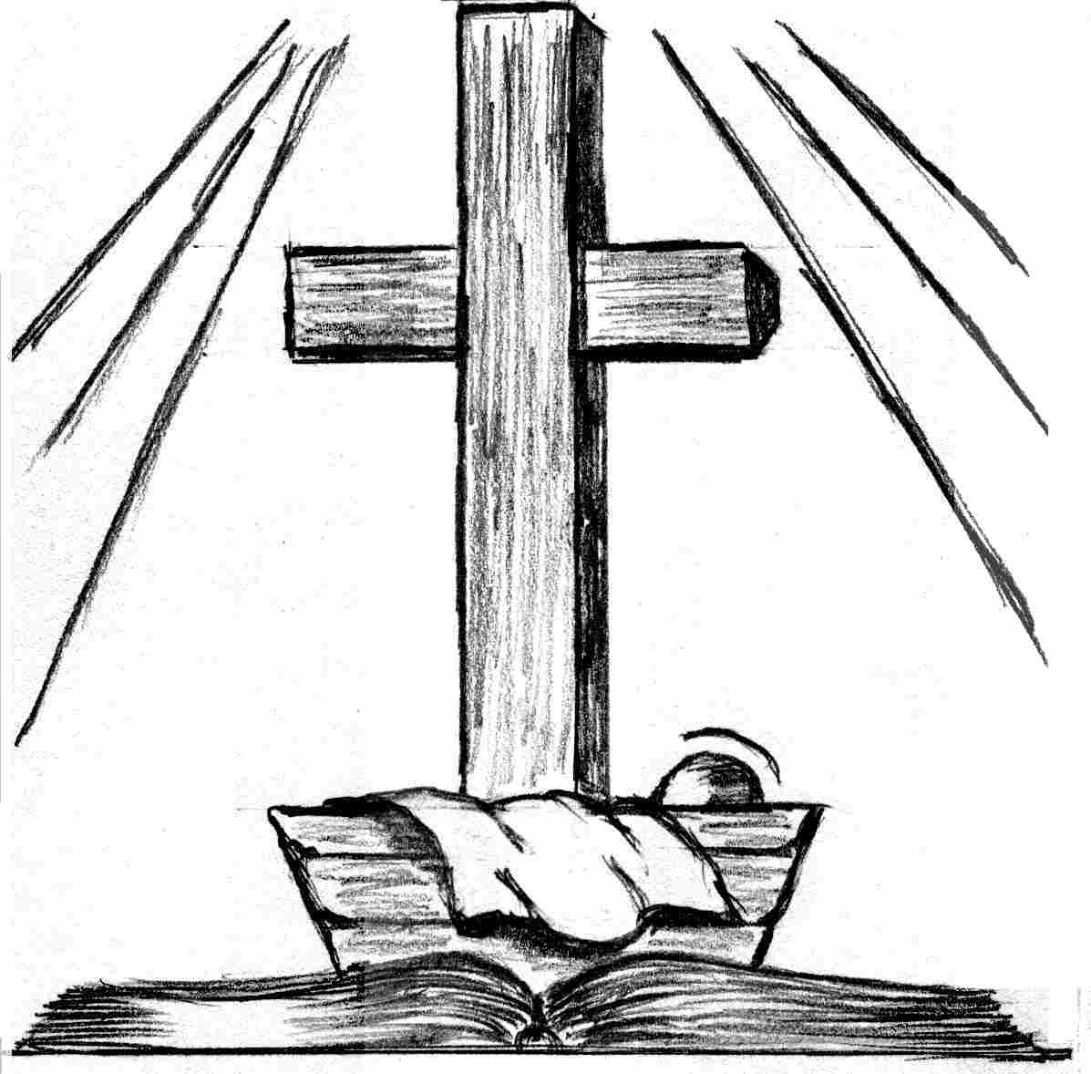
Christmas Eve Service
December 24th, 2021
Trinity Lutheran Church
Onekama, MI
Pastor Jacob Sherry Missouri Synod

ORDER OF DIVINE SERVICE

Pre-Service Music……………..Call to Worship………………….Greeting

OPENING HYMN: “O Come, All Ye Faithful”…….……..…………....LSB #379

CONFESSION AND ABSOLUTION:………………………...............LSB pp. 184-185

PSALM 24
(P) The earth is the Lord's and the fullness thereof,
(C) the world and those who dwell therein,
(P) ² for he has founded it upon the seas
(C) and established it upon the rivers.
(P) ³ Who shall ascend the hill of the Lord?
(C) And who shall stand in his holy place?
(P) ⁴ He who has clean hands and a pure heart,
(C) who does not lift up his soul to what is false and does not swear deceitfully.
(P) ⁵ He will receive blessing from the Lord
(C) and righteousness from the God of his salvation.
(P) ⁶ Such is the generation of those who seek him,
(C) who seek the face of the God of Jacob.
(P) ⁷ Lift up your heads, O gates!
(C) And be lifted up, O ancient doors, that the King of glory may come in.
(P) ⁸ Who is this King of glory?
(C) The Lord, strong and mighty, the Lord, mighty in battle!
(P) ⁹ Lift up your heads, O gates!
(C) And lift them up, O ancient doors, that the King of glory may come in.
(P) ¹⁰ Who is this King of glory?
(C) The Lord of hosts, he is the King of glory!

GLORIA PATRI:………………………………………………………LSB p. 186

KYRIE:………………………………………………………………….LSB p. 186

SALUTATION:…………………………………………………………LSB p. 189
Collect Prayer
O God, You make us glad with the yearly remembrance of the birth of Your only-begotten Son, Jesus Christ. Grant that as we joyfully receive Him as our Redeemer, we may with sure confidence behold Him when He comes to be our Judge; through the same Jesus Christ, our Lord, who lives and reigns with You and the Holy Spirit, one God, now and forever.

HYMN: “What Child Is This”…………………………………………..LSB #370

THE HOLY SCRIPTURES

OLD TESTAMENT: (Isaiah 7:10-14)
¹⁰ Again the Lord spoke to Ahaz: ¹¹ “Ask a sign of the Lord your God; let it be deep as Sheol or high as heaven.” ¹² But Ahaz said, “I will not ask, and I will not put the Lord to the test.” ¹³ And he said, “Hear then, O house of David! Is it too little for you to weary men, that you weary my God also? ¹⁴ Therefore the Lord himself will give you a sign. Behold, the virgin shall conceive and bear a son, and shall call his name Immanuel.

R: This is the Word of the Lord. Cong: Thanks be to God.

EPISTLE: (1 John 4:7-16)
⁷ Beloved, let us love one another, for love is from God, and whoever loves has been born of God and knows God. ⁸ Anyone who does not love does not know God, because God is love. ⁹ In this the love of God was made manifest among us, that God sent his only Son into the world, so that we might live through him. ¹⁰ In this is love, not that we have loved God but that he loved us and sent his Son to be the propitiation for our sins. ¹¹Beloved, if God so loved us, we also ought to love one another. ¹² No one has ever seen God; if we love one another, God abides in us and his love is perfected in us. ¹³ By this we know that we abide in him and he in us, because he has given us of his Spirit. ¹⁴And we have seen and testify that the Father has sent his Son to be the Savior of the world. ¹⁵ Whoever confesses that Jesus is the Son of God, God abides in him, and he in God. ¹⁶ So we have come to know and to believe the love that God has for us. God is love, and whoever abides in love abides in God, and God abides in him.

R: This is the Word of the Lord. Cong: Thanks be to God.

(PLEASE RISE for the reading of the Gospel)

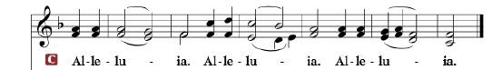

R: The Holy Gospel according to St. Matthew, the 1st chapter.

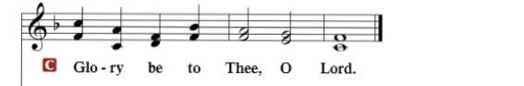

HOLY GOSPEL: (Matthew 1:18-25)
¹⁸ Now the birth of Jesus Christ took place in this way. When his mother Mary had been betrothed to Joseph, before they came together she was found to be with child from the Holy Spirit. ¹⁹ And her husband Joseph, being a just man and unwilling to put her to shame, resolved to divorce her quietly. ²⁰ But as he considered these things, behold, an angel of the Lord appeared to him in a dream, saying, “Joseph, son of David, do not fear to take Mary as your wife, for that which is conceived in her is from the Holy Spirit. ²¹ She will bear a son, and you shall call his name Jesus, for he will save his people from their sins.” ²² All this took place to fulfill what the Lord had spoken by the prophet:
²³ “Behold, the virgin shall conceive and bear a son,
and they shall call his name Immanuel”
(which means, God with us). ²⁴ When Joseph woke from sleep, he did as the angel of the Lord commanded him: he took his wife, ²⁵ but knew her not until she had given birth to a son. And he called his name Jesus.

R: This is the Gospel of the Lord.
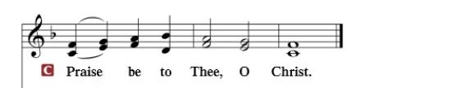

Apostles’ Creed
I believe in God, the Father Almighty, maker of heaven and earth. And in Jesus Christ, His only Son, our Lord, who was conceived by the Holy Spirit, born of the virgin Mary, suffered under Pontius Pilate, was crucified, died and was buried. He descended into hell. The third day He rose again from the dead. He ascended into heaven and sits at the right hand of God the Father Almighty. From thence He will come to judge the living and the dead. I believe in the Holy Spirit, the holy Christian Church, the communion of saints, the forgiveness of sins, the resurrection of the body, and the life everlasting. Amen.

SERMON HYMN: “Hark! The Herald Angels Sing”………………………..LSB #380

SERMON

HYMN: “Angels We Have Heard on High”…………………………………..LSB #368

THE GENERAL PRAYERS

THE LORD’S PRAYER

BENEDICTION:……….......…………………………………………………LSB p. 201

Lighting of the individual pew candles

CLOSING HYMN: “Silent Night, Holy Night” ……….……………………...LSB # 363

The Mission of Trinity Onekama Is To SERVE

For even the Son of Man did not come to be served
but to serve and to give his life as a ransom for many.
Mark 10:45

S haring Jesus’s truth
E quipping for life
R eaching Out
V aluing each other
E vangelizing all ages
Mission Statement
The mission of Trinity Onekama is to SERVE
For even the Son of Man did not come to be served, but to serve,
and to give his life as a ransom for many. Mark 10:45
S haring Jesus’ ruth
E quipping for life
R eaching Out
V aluing each other
E vangelizing all age

CHURCH INFORMATION
Church Office: (231) 889-4429 Website: www.trinityonekama.org
E-mail: trinityonekama@sbcglobal.net
Address: P.O. Box 119, 5471 Fairview Street, Onekama, MI 49675
Adult Bible Study: Sunday @ 11:30 am (year round)
Worship: Sunday @ 10:30 am The Lord’s Supper: Celebrated 2nd & 4th Sundays
Pastoral Hours: Wednesday and Friday 9:00am – Noon
Pastor Phone: 231-655-2680 Pastor Email: trinityonekama@gmail.com

Copyright licensing covered under CCLI #2802932

