**231-889-4429 5471 Fairview Street, Box 119 Onekama, MI**

**TRINITY LUTHERAN CHURCH**

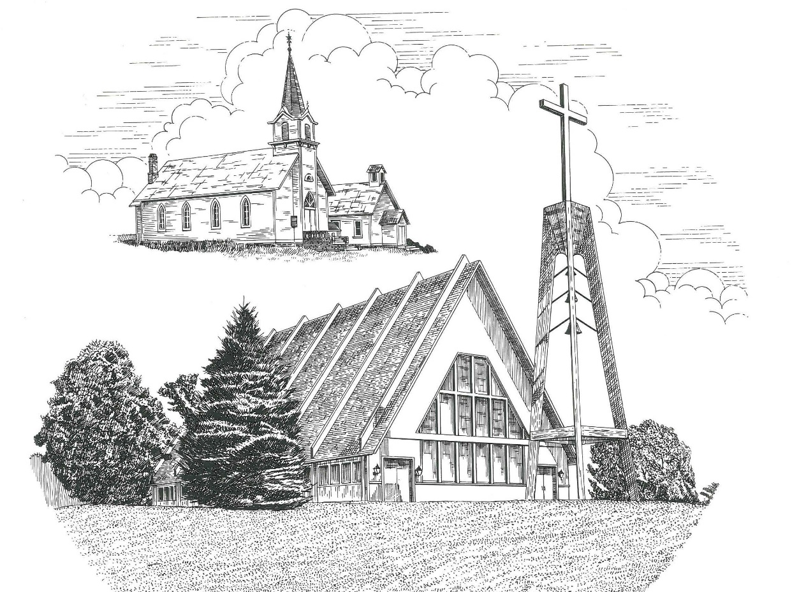

**Fourth Sunday in Advent December 24th, 2023**

**WELCOME**

**Thanks for joining us!**

**Pastor Jacob Sherry Missouri Synod**

**~~PLEASE NOTE~~Calling on the name of the Lord**

Does not include the use of cell phones in the worship sanctuary.

Please check yours before the service begins. Thank you for your courtesy.

**~~TO OUR GUESTS AND VISITORS~~**

Please sign our guest book located on the stand at the church entrance. During the service, we ask you to sign the attendance sheets located inside your bulletin and leave them on the pew as you leave. If you need assistance or have questions about our worship service, please talk to an elder or any one of our church family. We are glad you could join us and hope to have you worship with us again soon.

**~~ATTENDING HOLY COMMUNION~~**

By checking the “Communing Today” box on the registration form on the attendance sheet, you are agreeing with the following statements:

* **I am a baptized Christian who believes Jesus Christ is my Lord and Savior.**
* **I believe that I am a sinner in need of Christ’s freely offered forgiveness.**
* **I believe that in the Lord’s Supper the body and blood of Jesus Christ**

**are truly present in, with, and under the bread and wine.**

* **I believe that my participation in Holy Communion grants me forgiveness**

**of my sins, new spiritual life, and eternal salvation.**

* **With God’s help, I sincerely seek to repent of my sins, live in service**

**to my Lord, and await His return.**

**If you agree with the above statements, you are welcome to attend the Lord’s Supper with us. May God bless your worship time with us.**

We do offer gluten-free wafers, please quietly ask an elder to help you.

**Order of Divine Service Setting One**

**Pre-Service Music……………..Call to Worship………………….Greeting**

**OPENING HYMN:** *“Hark the Glad Sound”*…………………………..LSB #349

**CONFESSION & ABSOLUTION**……………………………………..LSB p. 151

**INTROIT**

P: Shower, O heavens, from above, and let the clouds rain down righteousness;

**C: let the earth open, that salvation and righteousness may bear fruit.**

P: The heavens declare the glory of God, and the sky above proclaims his handiwork.

**C: In them he has set a tent for the sun,**

P: which comes out like a bridegroom leaving his chamber,

**C: and, like a strong man, runs its course with joy.**

P: Its rising is from the end of the heavens, and its circuit to the end of them,

**C: and there is nothing hidden from its heat.**

**ALL: Glory be to the Father and to the Son and to the Holy Spirit; as it was in the**

**beginning, is now, and will be forever. Amen.**

P: Shower, O heavens, from above, and let the clouds rain down righteousness;

**C: let the earth open, that salvation and righteousness may bear fruit.**

**KYRIE**…………………………………………………………………...LSB pp. 152-153

**SALUTATION**…………………………………………………………..LSB p. 156

**Collect Prayer**

Stir up Your power, O Lord, and come and help us by Your might, that the sins which weigh us down may be quickly lifted by Your grace and mercy; for You live and reign with the Father and the Holy Spirit, one God, now and forever.

**THE HOLY SCRIPTURES**

**OLD TESTAMENT:** (2 Samuel 7:1-11, 16)

Now when the king lived in his house and the Lord had given him rest from all his surrounding enemies, **2**the king said to Nathan the prophet, “See now, I dwell in a house of cedar, but the ark of God dwells in a tent.” **3**And Nathan said to the king, “Go, do all that is in your heart, for the Lord is with you.”

**4**But that same night the word of the Lord came to Nathan, **5**“Go and tell my servant David, ‘Thus says the Lord: Would you build me a house to dwell in? **6**I have not lived in a house since the day I brought up the people of Israel from Egypt to this day, but I have been moving about in a tent for my dwelling. **7**In all places where I have moved with all the people of Israel, did I speak a word with any of the judges of Israel, whom I commanded to shepherd my people Israel, saying, “Why have you not built me a house of cedar?”’ **8**Now, therefore, thus you shall say to my servant David, ‘Thus says the Lord of hosts, I took you from the pasture, from following the sheep, that you should be prince over my people Israel. **9**And I have been with you wherever you went and have cut off all your enemies from before you. And I will make for you a great name, like the name of the great ones of the earth. **10**And I will appoint a place for my people Israel and will plant them, so that they may dwell in their own place and be disturbed no more. And violent men shall afflict them no more, as formerly, **11**from the time that I appointed judges over my people Israel. And I will give you rest from all your enemies. Moreover, the Lord declares to you that the Lord will make you a house. **16**And your house and your kingdom shall be made sure forever before me. Your throne shall be established forever.’”

**R:** This is the Word of the Lord**.** **Cong: Thanks be to God.**

**GRADUAL**

Reader: Rejoice greatly, O daughter of Zion.

**C: Shout aloud, O daughter of Jerusalen.**

Reader: Behold, your king is coming to you;

**C: righteous and having salvation.**

Reader: Blessed is he who comes in the name of the Lord.

**C: From the house of the Lord we bless you.**

**EPISTLE:** (Romans 16:25-27)

**25**Now to him who is able to strengthen you according to my gospel and the preaching of Jesus Christ, according to the revelation of the mystery that was kept secret for long ages **26**but has now been disclosed and through the prophetic writings has been made known to all nations, according to the command of the eternal God, to bring about the obedience of faith— **27**to the only wise God be glory forevermore through Jesus Christ! Amen.

**R:** This is the Word of the Lord. **Cong: Thanks be to God.**

**(PLEASE RISE for the reading of the Gospel)**



**R:** The Holy Gospel according to St. Luke, the 1st chapter.



**HOLY GOSPEL:** (Luke 1:26-38)

**26**In the sixth month, the angel Gabriel was sent from God to a city of Galilee named Nazareth, **27**to a virgin betrothed to a man whose name was Joseph, of the house of David. And the virgin's name was Mary. **28**And he came to her and said, “Greetings, O favored one, the Lord is with you!” **29**But she was greatly troubled at the saying, and tried to discern what sort of greeting this might be. **30**And the angel said to her, “Do not be afraid, Mary, for you have found favor with God. **31**And behold, you will conceive in your womb and bear a son, and you shall call his name Jesus. **32**He will be great and will be called the Son of the Most High. And the Lord God will give to him the throne of his father David, **33**and he will reign over the house of Jacob forever, and of his kingdom there will be no end.”

**34**And Mary said to the angel, “How will this be, since I am a virgin?”

**35**And the angel answered her, “The Holy Spirit will come upon you, and the power of the Most High will overshadow you; therefore the child to be born will be called holy—the Son of God. **36**And behold, your relative Elizabeth in her old age has also conceived a son, and this is the sixth month with her who was called barren. **37**For nothing will be impossible with God.” **38**And Mary said, “Behold, I am the servant of the Lord; let it be to me according to your word.” And the angel departed from her.

**R:** This is the Gospel of the Lord.



**SERMON HYMN**: *“O Come, O Come, Emmanuel”*…………………………..LSB #357

**SERMON**

**NICENE CREED**

I believe in one God, the Father Almighty, maker of heaven and earth and of all things visible and invisible.

And in one Lord Jesus Christ, the only-begotten Son of God, begotten of His Father before all worlds, God of God, Light of Light, very God of very God, begotten, not made, being of one substance with the Father, by whom all things were made; who for us men and for our salvation came down from heaven and was incarnate by the Holy Spirit of the virgin Mary and was made man; and was crucified also for us under Pontius Pilate. He suffered and was buried. And the third day He rose again according to the Scriptures and ascended into heaven and sits at the right hand of the Father. And He will come again with glory to judge both the living and the dead, whose kingdom will have no end.

And I believe in the Holy Spirit, the Lord and giver of life, who proceeds from the Father and the Son, who with the Father and the Son together is worshiped and glorified, who spoke by the prophets. And I believe in one holy Christian and apostolic Church, I acknowledge one Baptism for the remission of sins, and I look for the resurrection of the dead and the life of the world to come. Amen.

**THE GENERAL PRAYERS OF THE CHURCH**

**COLLECTION OF THE OFFERING**

**OFFERTORY**…………………………………………………………...LSB pp. 159-160

**Sharing the Peace of the Lord**

**SERVICE OF THE SACRAMENT**

**PREFACE**……………………………………………………………….LSB p. 160

**Proper Preface**

It is truly good, right, and salutary that we should at all times and in all places give thanks to You, holy Lord, almighty Father, everlasting God, through Jesus Christ, our Lord, whose way John the Baptist prepared, proclaiming Him the promised Messiah, the very Lamb of God who takes away the sin of the world, and calling sinners to repentance that they might escape from the wrath to be revealed when He comes again in glory. Therefore, with angels and archangels and with all the company of heaven we laud and magnify Your glorious name, ever more praising You and saying:

**SANCTUS**………………………………………………………………..LSB p. 161

**THE WORDS OF OUR LORD**………………………………………...LSB p. 162

**AGNUS DEI**……………………………………………………………..LSB p. 163

*If you are not communing, it is acceptable to remain seated.*

**COMMUNION DISTRIBUTION HYMNS**

LSB #347 *“Comfort, Comfort Ye My People”*

LSB #333 *“Once He Came in Blessing”*

LSB #353 *“Jesus Came, the Heavens Adoring”*

**POST COMMUNION CANTICLE:** *“Thank the Lord”*……………….LSB p. 164

**POST-COMMUNION COLLECT PRAYER**…………………………LSB p. 166

**BENEDICTION**…………………………………………………………LSB p. 166

**CLOSING HYMN:** *“The King Shall Come When Morning Dawns”*…..LSB #348

The Mission of Trinity Onekama Is To **SERVE**

For even the Son of Man did not come to be served

but to serve and to give his life as a ransom for many.            
                                                                       Mark 10:45



**S**haring Jesus’s **t**ruth

**E**quipping for life

**R**eaching Out

**V**aluing each other

**E**vangelizing all ages

Mission Statement

The mission of Trinity Onekama is to SERVE

For even the Son of Man did not come to be served, but to serve,

and to give his life as a ransom for many. Mark 10:45

S haring Jesus’ ruth

E quipping for life

R eaching Out

V aluing each other

E vangelizing all age

**CHURCH INFORMATION**

**Church Office:** (231) 889-4429 **Website:** www.trinityonekama.org

**E-mail:** [trinityonekama@sbcglobal.net](mailto:trinityonekama@sbcglobal.net)

**Address:** P.O. Box 119, 5471 Fairview Street, Onekama, MI 49675

**Sunday School & Adult Bible Study**: Sunday @ 9:30 am

**Worship:** Sunday @ 10:30 am **The Lord’s Supper:**  Celebrated 2nd & 4th Sundays

**Pastoral Hours:** Wednesday and Friday 9:00am – Noon

**Pastor Phone:** 231-655-2680 **Pastor Email:** trinityonekama@gmail.com

**Copyright licensing covered under CCLI #2802932**