**231-889-4429 5471 Fairview Street, Box 119 Onekama, MI**

**TRINITY LUTHERAN CHURCH**

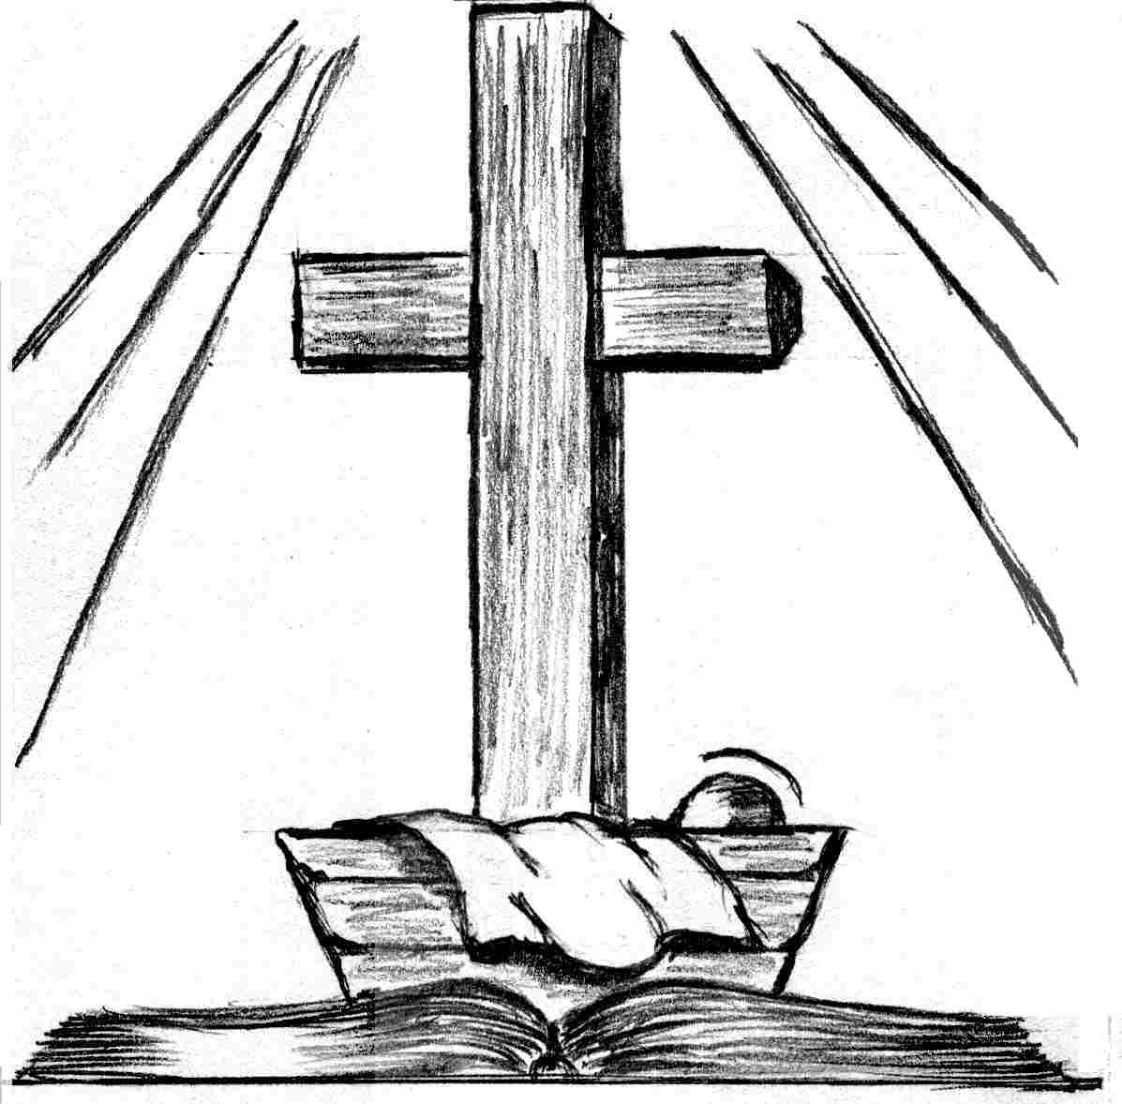

**Christmas Day December 25th, 2022**

**WELCOME**

**Thanks for joining us!**

**Pastor Jacob Sherry Missouri Synod**

**~~PLEASE NOTE~~Calling on the name of the Lord**

Does not include the use of cell phones in the worship sanctuary.

Please check yours before the service begins. Thank you for your courtesy.

**~~TO OUR GUESTS AND VISITORS~~**

Please sign our guest book located on the stand at the church entrance. During the service, we ask you to sign the attendance sheets located inside your bulletin and leave them on the pew as you leave. If you need assistance or have questions about our worship service, please talk to an elder or any one of our church family. We are glad you could join us and hope to have you worship with us again soon.

**~~ATTENDING HOLY COMMUNION~~**

By checking the “Communing Today” box on the registration form on the attendance sheet, you are agreeing with the following statements:

* **I am a baptized Christian who believes Jesus Christ is my Lord and Savior.**
* **I believe that I am a sinner in need of Christ’s freely offered forgiveness.**
* **I believe that in the Lord’s Supper the body and blood of Jesus Christ**

**are truly present in, with, and under the bread and wine.**

* **I believe that my participation in Holy Communion grants me forgiveness**

**of my sins, new spiritual life, and eternal salvation.**

* **With God’s help, I sincerely seek to repent of my sins, live in service**

**to my Lord, and await His return.**

**If you agree with the above statements, you are welcome to attend the Lord’s Supper with us. May God bless your worship time with us.**

We do offer gluten-free wafers, please quietly ask an elder to help you.

**Order of Divine Service Setting One**

**Pre-Service Music……………..Call to Worship………………….Greeting**

**OPENING HYMN:** *“O Little Town of Bethlehem”*………………….....LSB #361

**CONFESSION & ABSOLUTION**……………………………………..LSB p. 151

**KYRIE**…………………………………………………………………...LSB pp. 152-153

**THIS IS THE FEAST**…………………………………………………...LSB p. 155

**SALUTATION**…………………………………………………………..LSB p. 156

**Collect Prayer**

Almighty God, grant that the birth of Your only-begotten Son in the flesh may set us free from the bondage of sin; through Jesus Christ, Your Son, our Lord, who lives and reigns with You and the Holy Spirit, one God, now and forever.

**THE HOLY SCRIPTURES**

**OLD TESTAMENT:** (Isaiah 52:7-10)

**7**How beautiful upon the mountains  
    are the feet of him who brings good news,  
who publishes peace, who brings good news of happiness,  
    who publishes salvation,  
    who says to Zion, “Your God reigns.”  
**8**The voice of your watchmen—they lift up their voice;  
    together they sing for joy;  
for eye to eye they see  
    the return of the Lord to Zion.  
**9**Break forth together into singing,  
    you waste places of Jerusalem,  
for the Lord has comforted his people;  
    he has redeemed Jerusalem.  
**10**The Lord has bared his holy arm  
    before the eyes of all the nations,  
and all the ends of the earth shall see  
    the salvation of our God.

**R:** This is the Word of the Lord**.** **Cong: Thanks be to God.**

**GRADUAL**

Reader: To us a child is born, to us a son is given;

**Cong.: and the government shall be upon his shoulder.**

Reader: And his name shall be called Wonderful Counselor, Mighty God,

**Cong.: Everlasting Father, Prince of Peace.**

Reader: Sing to the Lord a new song,

**Cong.: for he has done marvelous things!**

**EPISTLE:** (Hebrews 1:1-6)

Long ago, at many times and in many ways, God spoke to our fathers by the prophets, **2**but in these last days he has spoken to us by his Son, whom he appointed the heir of all things, through whom also he created the world. **3**He is the radiance of the glory of God and the exact imprint of his nature, and he upholds the universe by the word of his power. After making purification for sins, he sat down at the right hand of the Majesty on high, **4**having become as much superior to angels as the name he has inherited is more excellent than theirs. **5**For to which of the angels did God ever say,

“You are my Son,  
    today I have begotten you”?

Or again,

“I will be to him a father,  
    and he shall be to me a son”?

**6**And again, when he brings the firstborn into the world, he says,

“Let all God's angels worship him.”

**R:** This is the Word of the Lord. **Cong: Thanks be to God.**

**(PLEASE RISE for the reading of the Gospel)**



**R:** The Holy Gospel according to St. Matthew, the 21st chapter.



**HOLY GOSPEL:** (John 1:1-14)

In the beginning was the Word, and the Word was with God, and the Word was God. **2**He was in the beginning with God. **3**All things were made through him, and without him was not any thing made that was made. **4**In him was life, and the life was the light of men. **5**The light shines in the darkness, and the darkness has not overcome it.

**6**There was a man sent from God, whose name was John. **7**He came as a witness, to bear witness about the light, that all might believe through him. **8**He was not the light, but came to bear witness about the light.

**9**The true light, which gives light to everyone, was coming into the world. **10**He was in the world, and the world was made through him, yet the world did not know him. **11**He came to his own, and his own people did not receive him. **12**But to all who did receive him, who believed in his name, he gave the right to become children of God, **13**who were born, not of blood nor of the will of the flesh nor of the will of man, but of God.

**14**And the Word became flesh and dwelt among us, and we have seen his glory, glory as of the only Son from the Father, full of grace and truth.

**R:** This is the Gospel of the Lord.



**SERMON HYMN**: *“Angels from the Realms of Glory”*………………………LSB #367

**SERMON**

**NICENE CREED**

I believe in one God, the Father Almighty, maker of heaven and earth and of all things visible and invisible.

And in one Lord Jesus Christ, the only-begotten Son of God, begotten of His Father before all worlds, God of God, Light of Light, very God of very God, begotten, not made, being of one substance with the Father, by whom all things were made; who for us men and for our salvation came down from heaven and was incarnate by the Holy Spirit of the virgin Mary and was made man; and was crucified also for us under Pontius Pilate. He suffered and was buried. And the third day He rose again according to the Scriptures and ascended into heaven and sits at the right hand of the Father. And He will come again with glory to judge both the living and the dead, whose kingdom will have no end.

And I believe in the Holy Spirit, the Lord and giver of life, who proceeds from the Father and the Son, who with the Father and the Son together is worshiped and glorified, who spoke by the prophets. And I believe in one holy Christian and apostolic Church, I acknowledge one Baptism for the remission of sins, and I look for the resurrection of the dead and the life of the world to come. Amen.

**THE GENERAL PRAYERS OF THE CHURCH**

**OFFERTORY**…………………………………………………………...LSB pp. 159-160

**Sharing the Peace of the Lord**

**SERVICE OF THE SACRAMENT**

**PREFACE**……………………………………………………………………..LSB p. 160

**Proper Preface**

It is truly good, right, and salutary that we should at all times and in all places give thanks to You, holy Lord, almighty Father, everlasting God, through Jesus Christ, our Lord, for in the mystery of the Word made flesh You have given us a new revelation of Your glory that, seeing You in the person of Your Son, we may know and love those things which are not seen. Therefore, with angels and archangels and with all the company of heaven we laud and magnify Your glorious name, ever more praising You and saying:

**SANCTUS**……………………………………………………………………...LSB p. 161

**THE WORDS OF OUR LORD**……………………………………………….LSB p. 162

**AGNUS DEI**……………………………………………………………………LSB p. 163

*If you are not communing, it is acceptable to remain seated.*

**COMMUNION DISTRIBUTION HYMNS**

LSB #366 *“It Came upon the Midnight Clear”*

LSB #376 *“Once in Royal David’s City”*

LSB #389 *“Let All Together Praise Our God”*

**THANK THE LORD**………………………………………………………….LSB p. 164

**POST-COMMUNION COLLECT PRAYER**……………………………….LSB p. 166

**BENEDICTION**……………………………………………………………….LSB p. 166

**CLOSING HYMN:** *“Go Tell It on the Mountain”*……..……………………..LSB #388

The Mission of Trinity Onekama Is To **SERVE**

For even the Son of Man did not come to be served

but to serve and to give his life as a ransom for many.            
                                                                       Mark 10:45



**S**haring Jesus’s **t**ruth

**E**quipping for life

**R**eaching Out

**V**aluing each other

**E**vangelizing all ages

Mission Statement

The mission of Trinity Onekama is to SERVE

For even the Son of Man did not come to be served, but to serve,

and to give his life as a ransom for many. Mark 10:45

S haring Jesus’ ruth

E quipping for life

R eaching Out

V aluing each other

E vangelizing all age

**CHURCH INFORMATION**

**Church Office:** (231) 889-4429 **Website:** www.trinityonekama.org

**E-mail:** [trinityonekama@sbcglobal.net](mailto:trinityonekama@sbcglobal.net)

**Address:** P.O. Box 119, 5471 Fairview Street, Onekama, MI 49675

**Adult Bible Study**: Sunday @ 11:30 am (year round)

**Worship:** Sunday @ 10:30 am **The Lord’s Supper:**  Celebrated 2nd & 4th Sundays

**Pastoral Hours:** Wednesday and Friday 9:00am – Noon

**Pastor Phone:** 231-655-2680 **Pastor Email:** trinityonekama@gmail.com

**Copyright licensing covered under CCLI #2802932**