231-889-4429 5471 Fairview Street, Box 119 Onekama, MI

TRINITY LUTHERAN CHURCH
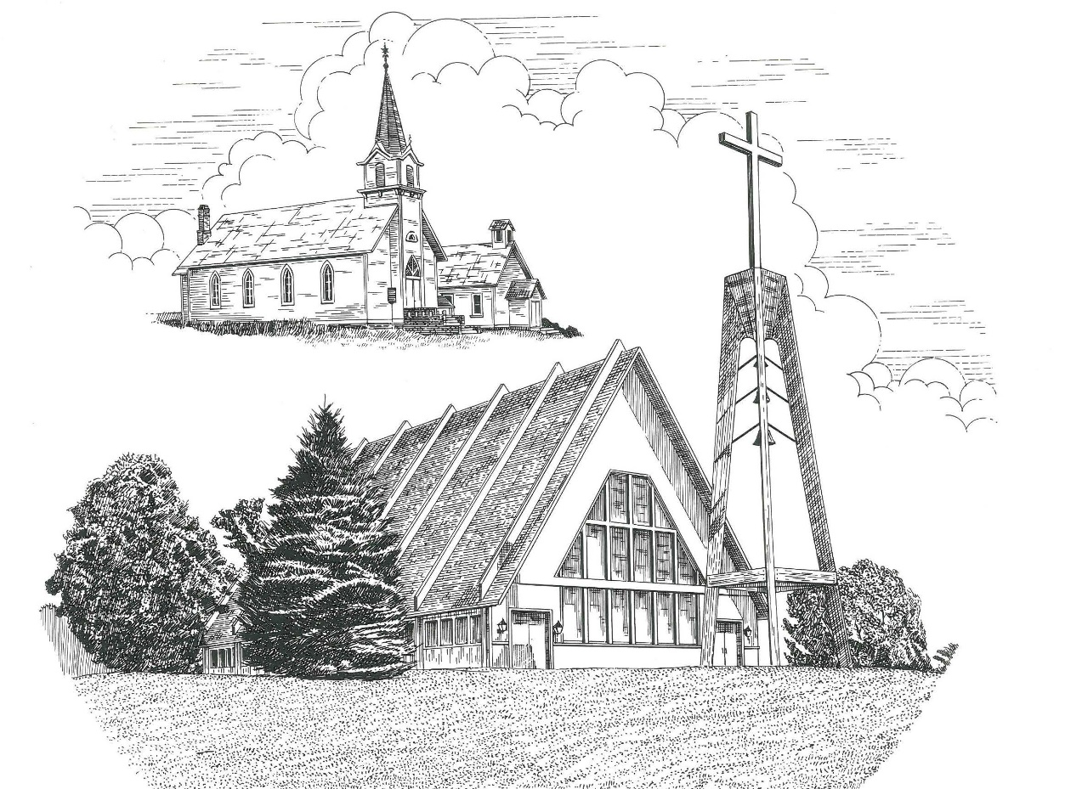

First Sunday after Christmas December 26th, 2021

WELCOME
Thanks for joining us!
Pastor Jacob Sherry Missouri Synod

~~PLEASE NOTE~~
Calling on the name of the Lord
Does not include the use of cell phones in the worship sanctuary.
Please check yours before the service begins. Thank you for your courtesy.
~~TO OUR GUESTS AND VISITORS~~
Please sign our guest book located on the stand at the church entrance. During the service, we ask you to sign the attendance sheet in your bulletin and leave it on the pew as you leave. If you need assistance or have questions about our worship service, please talk to an elder or any one of our church family. We are glad you could join us and hope to have you worship with us again soon.

~~ATTENDING HOLY COMMUNION~~
By checking the “Communing Today” box on the registration form found on the attendance sheet, you are agreeing with the following statements:

- I am a baptized Christian who believes Jesus Christ is my Lord and Savior.
- I believe that I am a sinner in need of Christ freely offered forgiveness.
- I believe that in the Lord’s Supper the body and blood of Jesus Christ
are truly present in, with, and under the bread and wine.
- I believe that my participation in Holy Communion grants me forgiveness
of my sins, new spiritual life, and eternal salvation.
- With God’s help, I sincerely seek to repent of my sins, live in service
to my Lord, and await His return.

If you agree with the above statements, you are welcome to attend the Lord’s Supper with us. May God bless your worship time with us.
We do offer gluten-free wafers, please quietly ask an elder to help you.

Order of Divine Service Setting Four

Pre-Service Music……………..Call to Worship………………….Greeting

OPENING HYMN: “Away in a Manger”……………………………...LSB #364

OPENING LITURGY:
Confession & Absolution……………………………………….LSB p. 203
Kyrie……………………………………………………………..LSB p. 204
Canticle Hymn “Of the Father’s Love Begotten”……………....LSB #384
Salutation….…………………………………………………….LSB p. 205

Collect Prayer
O God, our Maker and Redeemer, You wonderfully created us and in the incarnation of Your Son yet more wondrously restored our human nature. Grant that we may ever be alive in Him who made Himself to be like us; through Jesus Christ, our Lord, who lives and reigns with You and the Holy Spirit, one God, now and forever.

THE HOLY SCRIPTURES

OLD TESTAMENT: (Exodus 13:1-3a, 11-15)
The Lord said to Moses, ² “Consecrate to me all the firstborn. Whatever is the first to open the womb among the people of Israel, both of man and of beast, is mine.” ³ Then Moses said to the people, “Remember this day in which you came out from Egypt, out of the house of slavery, for by a strong hand the Lord brought you out from this place.
¹¹ “When the Lord brings you into the land of the Canaanites, as he swore to you and your fathers, and shall give it to you, ¹² you shall set apart to the Lord all that first opens the womb. All the firstborn of your animals that are males shall be the Lord's. ¹³ Every firstborn of a donkey you shall redeem with a lamb, or if you will not redeem it, you shall break its neck. Every firstborn of man among your sons you shall redeem. ¹⁴ And when in time to come your son asks you, ‘What does this mean?’ you shall say to him, ‘By a strong hand the Lord brought us out of Egypt, from the house of slavery. ¹⁵ For when Pharaoh stubbornly refused to let us go, the Lord killed all the firstborn in the land of Egypt, both the firstborn of man and the firstborn of animals. Therefore, I sacrifice to the Lord all the males that first open the womb, but all the firstborn of my sons I redeem.’

R: This is the Word of the Lord. Cong: Thanks be to God.
GRADUAL
Reader: To us a child is born, to us a son is given;
Cong.: and the government shall be upon his shoulder.
Reader: And his name shall be called Wonderful Counselor, Mighty God,
Cong.: Everlasting Father, Prince of Peace.
Reader: Sing to the Lord a new song,
Cong.: for he has done marvelous things!

EPISTLE: (Colossians 3:12-17)
¹² Put on then, as God's chosen ones, holy and beloved, compassionate hearts, kindness, humility, meekness, and patience, ¹³ bearing with one another and, if one has a complaint against another, forgiving each other; as the Lord has forgiven you, so you also must forgive. ¹⁴ And above all these put on love, which binds everything together in perfect harmony. ¹⁵ And let the peace of Christ rule in your hearts, to which indeed you were called in one body. And be thankful. ¹⁶ Let the word of Christ dwell in you richly, teaching and admonishing one another in all wisdom, singing psalms and hymns and spiritual songs, with thankfulness in your hearts to God. ¹⁷ And whatever you do, in word or deed, do everything in the name of the Lord Jesus, giving thanks to God the Father through him.

R: This is the Word of the Lord. Cong: Thanks be to God.

(PLEASE RISE for the reading of the Gospel)

R: The Holy Gospel according to St. Luke, the 2nd chapter.
Cong: Glory to You, O Lord

HOLY GOSPEL: (Luke 2:22-40)
²² And when the time came for their purification according to the Law of Moses, they brought him up to Jerusalem to present him to the Lord ²³ (as it is written in the Law of the Lord, “Every male who first opens the womb shall be called holy to the Lord”) ²⁴ and to offer a sacrifice according to what is said in the Law of the Lord, “a pair of turtledoves, or two young pigeons.” ²⁵ Now there was a man in Jerusalem, whose name was Simeon, and this man was righteous and devout, waiting for the consolation of Israel, and the Holy Spirit was upon him. ²⁶ And it had been revealed to him by the Holy Spirit that he would not see death before he had seen the Lord's Christ. ²⁷ And he came in the Spirit into the temple, and when the parents brought in the child Jesus, to do for him according to the custom of the Law, ²⁸ he took him up in his arms and blessed God and said,
²⁹ “Lord, now you are letting your servant depart in peace,
according to your word;
³⁰ for my eyes have seen your salvation
³¹ that you have prepared in the presence of all peoples,
³² a light for revelation to the Gentiles,
and for glory to your people Israel.”
³³ And his father and his mother marveled at what was said about him. ³⁴ And Simeon blessed them and said to Mary his mother, “Behold, this child is appointed for the fall and rising of many in Israel, and for a sign that is opposed ³⁵ (and a sword will pierce through your own soul also), so that thoughts from many hearts may be revealed.”
³⁶ And there was a prophetess, Anna, the daughter of Phanuel, of the tribe of Asher. She was advanced in years, having lived with her husband seven years from when she was a virgin, ³⁷ and then as a widow until she was eighty-four. She did not depart from the temple, worshiping with fasting and prayer night and day. ³⁸ And coming up at that very hour she began to give thanks to God and to speak of him to all who were waiting for the redemption of Jerusalem.
³⁹ And when they had performed everything according to the Law of the Lord, they returned into Galilee, to their own town of Nazareth. ⁴⁰ And the child grew and became strong, filled with wisdom. And the favor of God was upon him.

R: This is the Gospel of the Lord. Cong: Praise to You, O Christ.

Nicene Creed
I believe in one God, the Father Almighty, maker of heaven and earth and of all things visible and invisible.
And in one Lord Jesus Christ, the only-begotten Son of God, begotten of His Father before all worlds, God of God, Light of Light, very God of very God, begotten, not made, being of one substance with the Father, by whom all things were made; who for us men and for our salvation came down from heaven and was incarnate by the Holy Spirit of the virgin Mary and was made man; and was crucified also for us under Pontius Pilate. He suffered and was buried. And the third day He rose again according to the Scriptures and ascended into heaven and sits at the right hand of the Father. And He will come again with glory to judge both the living and the dead, whose kingdom will have no end.
And I believe in the Holy Spirit, the Lord and giver of life, who proceeds from the Father and the Son, who with the Father and the Son together is worshiped and glorified, who spoke by the prophets. And I believe in one holy Christian and apostolic Church, I acknowledge one Baptism for the remission of sins, and I look for the resurrection of the dead and the life of the world to come. Amen.

SERMON HYMN: “Angels from the Realms of Glory”……………………….LSB #367

SERMON
THE GENERAL PRAYERS

INSTITUTION OF THE LORD’S SUPPER
Preface…………………………………….…………….………..LSB p. 208
Proper Preface
It is truly good, right, and salutary that we should at all times and in all places give thanks to You, O Lord, holy Father, almighty and everlasting God, for the countless blessings You so freely bestow on us and all creation. Above all, we give thanks for Your boundless love shown to us when You sent Your only-begotten Son, Jesus Christ, into our flesh and laid on Him our sin, giving Him into death that we might not die eternally. Because He is now risen from the dead and lives and reigns to all eternity, all who believe in Him will overcome sin and death and will rise again to new life. Therefore, with angels and archangels and with all the company of heaven we laud and magnify Your glorious name, ever more praising You and saying:

Sanctus, Lord’s Prayer, The Words of Our Lord………………….....LSB pp. 208-209
Agnus Dei………………………………………………………………..LSB p. 210
If you are not communing it is acceptable to remain seated.

COMMUNION DISTRIBUTION HYMNS:
LSB #358 “From Heaven Above to Earth I Come”
LSB #359 “Lo, How a Rose E’er Blooming”
LSB #393“Infant Holy, Infant Lowly”

CLOSING LITURGY:………………………………………………....LSB pp. 211-212

CLOSING HYMN: “Go Tell It on the Mountain”..................................LSB #388

The Mission of Trinity Onekama Is To SERVE

For even the Son of Man did not come to be served
but to serve and to give his life as a ransom for many.
Mark 10:45

S haring Jesus’s truth
E quipping for life
R eaching Out
V aluing each other
E vangelizing all ages
Mission Statement
The mission of Trinity Onekama is to SERVE
For even the Son of Man did not come to be served, but to serve,
and to give his life as a ransom for many. Mark 10:45
S haring Jesus’ ruth
E quipping for life
R eaching Out
V aluing each other
E vangelizing all age

CHURCH INFORMATION
Church Office: (231) 889-4429 Website: www.trinityonekama.org
E-mail: trinityonekama@sbcglobal.net
Address: P.O. Box 119, 5471 Fairview Street, Onekama, MI 49675
Adult Bible Study: Sunday @ 11:30 am (year round)
Worship: Sunday @ 10:30 am The Lord’s Supper: Celebrated 2nd & 4th Sundays
Pastoral Hours: Wednesday and Friday 9:00am – Noon
Pastor Phone: 231-655-2680 Pastor Email: trinityonekama@gmail.com

Copyright licensing covered under CCLI #2802932

