231-889-4429 5471 Fairview Street, Box 119 Onekama, MI

TRINITY LUTHERAN CHURCH
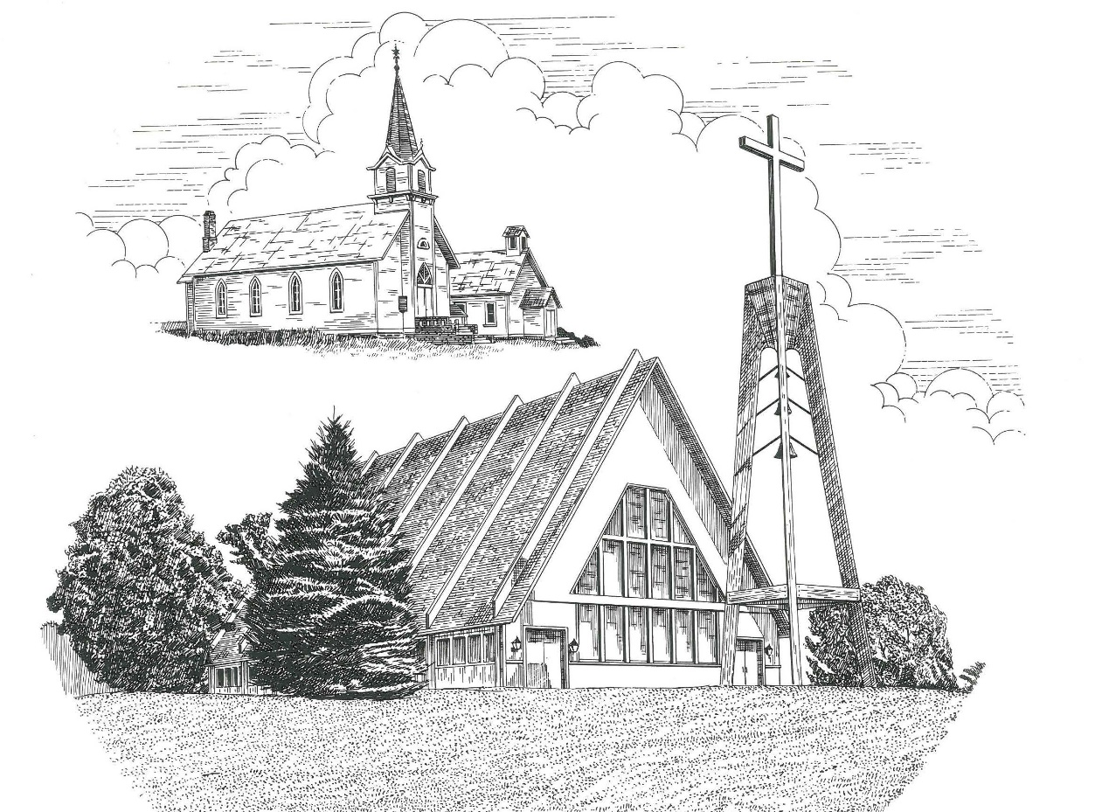

First Sunday after Christmas December 29th, 2019

WELCOME
Thanks for joining us!
Pastor Jacob Sherry Missouri Synod
~~PLEASE NOTE~~
Calling on the name of the Lord
Does not include the use of cell phones in the worship sanctuary.
Please check yours before the service begins. Thank you for your courtesy.
~~TO OUR GUESTS AND VISITORS~~
Please sign our guest book located on the stand at the church entrance. During the service, we ask you to sign the attendance booklet located at the end of each pew. If you need assistance or have questions about our worship service, please talk to an elder or any one of our church family. We are glad you could join us and hope to have you worship with us again soon.

~~ATTENDING HOLY COMMUNION~~
By checking the “Communing Today” box on the registration form found in the attendance booklet, you are agreeing with the following statements:

- I am a baptized Christian who believes Jesus Christ is my Lord and Savior.
- I believe that I am a sinner in need of Christ freely offered forgiveness.
- I believe that in the Lord’s Supper the body and blood of Jesus Christ
are truly present in, with, and under the bread and wine.
- I believe that my participation in Holy Communion grants me forgiveness
of my sins, new spiritual life, and eternal salvation.
- With God’s help, I sincerely seek to repent of my sins, live in service
to my Lord, and await His return.

If you agree with the above statements, you are welcome to attend the Lord’s Supper with us. May God bless your worship time with us.
We do offer gluten-free wafers, please quietly ask an elder to help you.

Order of Divine Service Setting One

Pre-Service Music……………..Call to Worship………………….Greeting

OPENING HYMN: “O Little Town of Bethlehem”………....................LSB #361

OPENING LITURGY
Confession & Absolution……………………………………….LSB p. 151
Kyrie……………………………………………………………..LSB pp. 152-153
This is the Feast…………………………………………………LSB p. 155
Salutation….………………………………………………….....LSB p. 156

Collect Prayer
O God, our Maker and Redeemer, You wonderfully created us and in the incarnation of Your Son yet more wondrously restored our human nature. Grant that we may ever be alive in Him who made Himself to be like us; through Jesus Christ, our Lord, who lives and reigns with You and the Holy Spirit, one God, now and forever.

THE HOLY SCRIPTURES

OLD TESTAMENT: (Isaiah 63:7-14)
⁷ I will recount the steadfast love of the Lord,
the praises of the Lord,
according to all that the Lord has granted us,
and the great goodness to the house of Israel
that he has granted them according to his compassion,
according to the abundance of his steadfast love.
⁸ For he said, “Surely they are my people,
children who will not deal falsely.”
And he became their Savior.
⁹ In all their affliction he was afflicted,
and the angel of his presence saved them;
in his love and in his pity he redeemed them;
he lifted them up and carried them all the days of old.
¹⁰ But they rebelled
and grieved his Holy Spirit;
therefore he turned to be their enemy,
and himself fought against them.
¹¹ Then he remembered the days of old,
of Moses and his people.
Where is he who brought them up out of the sea
with the shepherds of his flock?
Where is he who put in the midst of them
his Holy Spirit,
¹² who caused his glorious arm
to go at the right hand of Moses,
who divided the waters before them
to make for himself an everlasting name,
¹³ who led them through the depths?
Like a horse in the desert,
they did not stumble.
¹⁴ Like livestock that go down into the valley,
the Spirit of the Lord gave them rest.
So you led your people,
to make for yourself a glorious name.

R: This is the Word of the Lord. Cong: Thanks be to God.

GRADUAL
Reader: To us a child is born, to us a son is given;
Cong.: and the government shall be upon his shoulder.
Reader: And his name shall be called Wonderful Counselor, Mighty God,
Cong.: Everlasting Father, Prince of Peace.
Reader: Sing to the Lord a new song,
Cong.: for he has done marvelous things!

EPISTLE: (Galatians 4:4-7)
⁴ But when the fullness of time had come, God sent forth his Son, born of woman, born under the law, ⁵ to redeem those who were under the law, so that we might receive adoption as sons. ⁶ And because you are sons, God has sent the Spirit of his Son into our hearts, crying, “Abba! Father!” ⁷ So you are no longer a slave, but a son, and if a son, then an heir through God.

R: This is the Word of the Lord. Cong: Thanks be to God.

(PLEASE RISE for the reading of the Gospel)

R: The Holy Gospel according to St. Matthew, the 2nd Chapter.

HOLY GOSPEL: (Matthew 2:13-23)
¹³ Now when they had departed, behold, an angel of the Lord appeared to Joseph in a dream and said, “Rise, take the child and his mother, and flee to Egypt, and remain there until I tell you, for Herod is about to search for the child, to destroy him.” ¹⁴ And he rose and took the child and his mother by night and departed to Egypt ¹⁵ and remained there until the death of Herod. This was to fulfill what the Lord had spoken by the prophet,
“Out of Egypt I called my son.”
¹⁶ Then Herod, when he saw that he had been tricked by the wise men, became furious, and he sent and killed all the male children in Bethlehem and in all that region who were two years old or under, according to the time that he had ascertained from the wise men. ¹⁷ Then was fulfilled what was spoken by the prophet Jeremiah:
¹⁸ “A voice was heard in Ramah,
weeping and loud lamentation,
Rachel weeping for her children;
she refused to be comforted, because they are no more.”
¹⁹ But when Herod died, behold, an angel of the Lord appeared in a dream to Joseph in Egypt, ²⁰ saying, “Rise, take the child and his mother and go to the land of Israel, for those who sought the child's life are dead.” ²¹ And he rose and took the child and his mother and went to the land of Israel. ²² But when he heard that Archelaus was reigning over Judea in place of his father Herod, he was afraid to go there, and being warned in a dream he withdrew to the district of Galilee. ²³ And he went and lived in a city called Nazareth, so that what was spoken by the prophets might be fulfilled, that he would be called a Nazarene.

R: This is the Gospel of the Lord.

SERMON HYMN: “Let All Together Praise Our God”……………………..LSB #389

SERMON

Nicene Creed…...……………………………………………………..……….LSB p. 158
I believe in one God, the Father Almighty, maker of heaven and earth and of all things visible and invisible.
And in one Lord Jesus Christ, the only-begotten Son of God, begotten of His Father before all worlds, God of God, Light of Light, very God of very God, begotten, not made, being of one substance with the Father, by whom all things were made; who for us men and for our salvation came down from heaven and was incarnate by the Holy Spirit of the virgin Mary and was made man; and was crucified also for us under Pontius Pilate. He suffered and was buried. And the third day He rose again according to the Scriptures and ascended into heaven and sits at the right hand of the Father. And He will come again with glory to judge both the living and the dead, whose kingdom will have no end.
And I believe in the Holy Spirit, the Lord and giver of life, who proceeds from the Father and the Son, who with the Father and the Son together is worshiped and glorified, who spoke by the prophets. And I believe in one holy Christian and apostolic Church, I acknowledge one Baptism for the remission of sins, and I look for the resurrection of the dead and the life of the world to come. Amen.

THE GENERAL PRAYERS OF THE CHURCH

GATHERING OF OUR FIRST FRUITS & OFFERTORY…………LSB pp. 159-160

Congregational Sharing of the Peace of the Lord
INSTITUTION OF THE LORD’S SUPPER
Preface…………………………………….…………….……….LSB p. 160
Proper Preface
It is truly good, right, and salutary that we should at all times and in all places give thanks to You, holy Lord, almighty Father, everlasting God, through Jesus Christ, our Lord, for in the mystery of the Word made flesh You have given us a new revelation of Your glory that, seeing You in the person of Your Son, we may know and love those things which are not seen. Therefore, with angels and archangels and with all the company of heaven we laud and magnify Your glorious name, ever more praising You and saying:

Sanctus, Lord’s Prayer, The Words of Our Lord………………….....LSB pp. 161-162
Agnus Dei………………………………………………………………..LSB p. 163
If you are not communing it is acceptable to remaining seated.

COMMUNION DISTRIBUTION HYMNS:
LSB #370 “What Child Is This”
LSB #384 “Of the Father’s Love Begotten”
LSB #386 “Now Sing We, Now Rejoice”

CLOSING LITURGY:….…….......……………………………………LSB pp. 164-166

CLOSING HYMN: “Go Tell It on the Mountain”…………………….LSB #388

The Mission of Trinity Onekama Is To SERVE

For even the Son of Man did not come to be served
but to serve and to give his life as a ransom for many.
Mark 10:45

S haring Jesus’s truth
E quipping for life
R eaching Out
V aluing each other
E vangelizing all ages
Mission Statement
The mission of Trinity Onekama is to SERVE
For even the Son of Man did not come to be served, but to serve,
and to give his life as a ransom for many. Mark 10:45
S haring Jesus’ ruth
E quipping for life
R eaching Out
V aluing each other
E vangelizing all age

CHURCH INFORMATION
Church Office: (231) 889-4429 Website: www.trinityonekama.org
E-mail: trinityonekama@sbcglobal.net
Address: P.O. Box 119, 5471 Fairview Street, Onekama, MI 49675
Adult Bible Study: Sunday @ 9:15 am (year round)
Worship: Sunday @ 10:30 am The Lord’s Supper: Celebrated 2nd & 4th Sundays
Pastoral Hours: Wednesday and Friday 8:30am – Noon
Pastor Phone: 231-655-2680 Pastor Email: trinityonekama@gmail.com

Copyright licensing covered under CCLI #2802932

