231-889-4429 5471 Fairview Street, Box 119 Onekama, MI

TRINITY LUTHERAN CHURCH
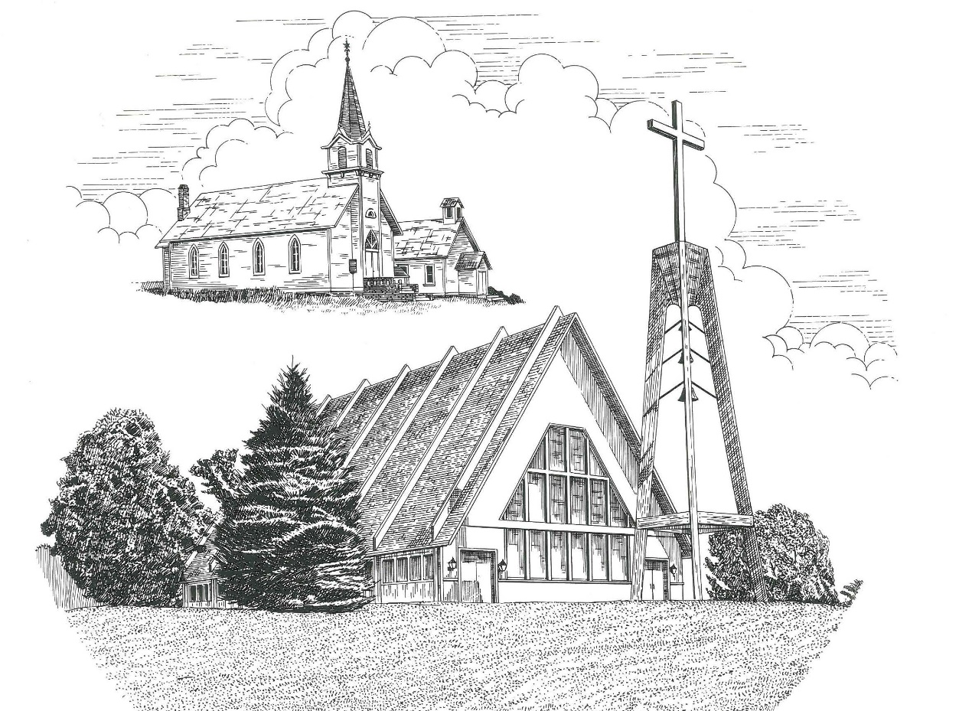

Second Sunday of Advent December 5th, 2021

WELCOME
Thanks for joining us!
Pastor Jacob Sherry Missouri Synod

~~PLEASE NOTE~~
Calling on the name of the Lord
Does not include the use of cell phones in the worship sanctuary.
Please check yours before the service begins. Thank you for your courtesy.
~~TO OUR GUESTS AND VISITORS~~
Please sign our guest book located on the stand at the church entrance. During the service, we ask you to sign the attendance booklet located at the end of each pew. If you need assistance or have questions about our worship service, please talk to an elder or any one of our church family. We are glad you could join us and hope to have you worship with us again soon.

Order of Divine Service Setting Three

Pre-Service Music……………..Call to Worship………………….Greeting

OPENING HYMN: “Prepare the Royal Highway”................................LSB #343

OPENING LITURGY:
Confession & Absolution………..………………………………LSB pp. 184-185
Kyrie…………………………………….………………………..LSB p. 186
Salutation….……………………………….…………………….LSB p. 189

Collect Prayer
Stir up our hearts, O Lord, to make ready the way of Your only-begotten Son, that by His coming we may be enabled to serve You with pure minds; through the same Jesus Christ, our Lord, who lives and reigns with You and the Holy Spirit, one God, now and forever.

THE HOLY SCRIPTURES

OLD TESTAMENT: (Malachi 3:1-7)
Behold, I send my messenger, and he will prepare the way before me. And the Lord whom you seek will suddenly come to his temple; and the messenger of the covenant in whom you delight, behold, he is coming, says the Lord of hosts. ² But who can endure the day of his coming, and who can stand when he appears? For he is like a refiner's fire and like fullers' soap. ³ He will sit as a refiner and purifier of silver, and he will purify the sons of Levi and refine them like gold and silver, and they will bring offerings in righteousness to the Lord. ⁴ Then the offering of Judah and Jerusalem will be pleasing to the Lord as in the days of old and as in former years. ⁵ “Then I will draw near to you for judgment. I will be a swift witness against the sorcerers, against the adulterers, against those who swear falsely, against those who oppress the hired worker in his wages, the widow and the fatherless, against those who thrust aside the sojourner, and do not fear me, says the Lord of hosts.
⁶ “For I the Lord do not change; therefore you, O children of Jacob, are not consumed. ⁷ From the days of your fathers you have turned aside from my statutes and have not kept them. Return to me, and I will return to you, says the Lord of hosts. But you say, ‘How shall we return?’

R: This is the Word of the Lord. Cong: Thanks be to God.

GRADUAL
Reader: Rejoice greatly, O daughter of Zion.
Cong.: Shout aloud, O daughter of Jerusalem.
Reader: Behold, your king is coming to you;
Cong.: righteous and having salvation.
Reader: Blessed is he who comes in the name of the Lord.
Cong.: From the house of the Lord we bless you.

EPISTLE: (Philippians 1:2-11)
² Grace to you and peace from God our Father and the Lord Jesus Christ.
³ I thank my God in all my remembrance of you, ⁴ always in every prayer of mine for you all making my prayer with joy, ⁵ because of your partnership in the gospel from the first day until now. ⁶ And I am sure of this, that he who began a good work in you will bring it to completion at the day of Jesus Christ. ⁷ It is right for me to feel this way about you all, because I hold you in my heart, for you are all partakers with me of grace, both in my imprisonment and in the defense and confirmation of the gospel. ⁸ For God is my witness, how I yearn for you all with the affection of Christ Jesus. ⁹ And it is my prayer that your love may abound more and more, with knowledge and all discernment, ¹⁰ so that you may approve what is excellent, and so be pure and blameless for the day of Christ, ¹¹ filled with the fruit of righteousness that comes through Jesus Christ, to the glory and praise of God.

R: This is the Word of the Lord. Cong: Thanks be to God.
(PLEASE RISE for the reading of the Gospel)

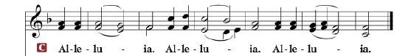

R: The Holy Gospel according to St. Luke, the 3rd chapter.

HOLY GOSPEL: (Luke 3:1-20)
In the fifteenth year of the reign of Tiberius Caesar, Pontius Pilate being governor of Judea, and Herod being tetrarch of Galilee, and his brother Philip tetrarch of the region of Ituraea and Trachonitis, and Lysanias tetrarch of Abilene, ² during the high priesthood of Annas and Caiaphas, the word of God came to John the son of Zechariah in the wilderness. ³ And he went into all the region around the Jordan, proclaiming a baptism of repentance for the forgiveness of sins. ⁴ As it is written in the book of the words of Isaiah the prophet,
“The voice of one crying in the wilderness:
‘Prepare the way of the Lord,
make his paths straight.
⁵ Every valley shall be filled,
and every mountain and hill shall be made low,
and the crooked shall become straight,
and the rough places shall become level ways,
⁶ and all flesh shall see the salvation of God.’”
⁷ He said therefore to the crowds that came out to be baptized by him, “You brood of vipers! Who warned you to flee from the wrath to come? ⁸ Bear fruits in keeping with repentance. And do not begin to say to yourselves, ‘We have Abraham as our father.’ For I tell you, God is able from these stones to raise up children for Abraham. ⁹ Even now the axe is laid to the root of the trees. Every tree therefore that does not bear good fruit is cut down and thrown into the fire.”
¹⁰ And the crowds asked him, “What then shall we do?” ¹¹ And he answered them, “Whoever has two tunics is to share with him who has none, and whoever has food is to do likewise.” ¹² Tax collectors also came to be baptized and said to him, “Teacher, what shall we do?” ¹³ And he said to them, “Collect no more than you are authorized to do.” ¹⁴ Soldiers also asked him, “And we, what shall we do?” And he said to them, “Do not extort money from anyone by threats or by false accusation, and be content with your wages.”
¹⁵ As the people were in expectation, and all were questioning in their hearts concerning John, whether he might be the Christ, ¹⁶ John answered them all, saying, “I baptize you with water, but he who is mightier than I is coming, the strap of whose sandals I am not worthy to untie. He will baptize you with the Holy Spirit and fire. ¹⁷ His winnowing fork is in his hand, to clear his threshing floor and to gather the wheat into his barn, but the chaff he will burn with unquenchable fire.”
¹⁸ So with many other exhortations he preached good news to the people. ¹⁹ But Herod the tetrarch, who had been reproved by him for Herodias, his brother's wife, and for all the evil things that Herod had done, ²⁰ added this to them all, that he locked up John in prison.

R: This is the Gospel of the Lord.

APOSTLES’ CREED
I believe in God, the Father Almighty, Maker of heaven and earth. And in Jesus Christ, His only Son, our Lord; who was conceived by the Holy Spirit, born of the Virgin Mary, suffered under Pontius Pilate, was crucified, died, and was buried. He descended into hell. The third day he rose again from the dead. He ascended into heaven, and sits at the right hand of God the Father Almighty. From there he will come to judge the living and the dead. I believe in the Holy Spirit, the holy Christian Church, the communion of saints, the forgiveness of sins, the resurrection of the body, and the life everlasting. Amen.

SERMON HYMN: “On Jordan’s Bank the Baptist’s Cry”....................LSB #344

SERMON

OFFERTORY……………………………………………………..……LSB pp. 192-193

THE GENERAL PRAYERS OF THE CHURCH

THE LORD’S PRAYER

BENEDICTION

CLOSING HYMN: “When All the World Was Cursed”........................LSB #346

Special Prayers

Nellie Blakley Jim Poellet Steve Schimke
Steve Fredericks Shirley Poellet Phyllis Schramski
Joan Malmgren Barbara Potter Cecil Somsel
Lynda Byrd Meister Marge Reckow Rev. Jeff Walsh (Cancer)
Candi Moerdyk Jim Reeves Steve Zupin
Pam Monroe

Prayers for Our Military
Andrew Burch, Jr., grandson of John & Loree Sprawka.
Mark Granzotto with U.S. Navy in Bahrain, grandson of Rita Merkey
Army Major Riley Morgan Kennedy, stationed in Washington, DC, George & Margaret Punches’ grand-niece
Carol Sprawka, daughter-in-law of John & Loree Sprawka
Derek Sprawka, grandson of John & Loree Sprawka
Alyssa Eisenlohr with the U.S. Navy in Japan, friend of Janette & Fred May
Ian Nelson, nephew of Jack and Pebbla Nelson
Tyge Nelson & family, nephew of Jack and Pebbla Nelson
Capt. Tim Brandt at Madigan Medical Center, Fort Lewis, WA, son of Bruce & Debbie Brandt

If you wish to add someone’s name, please call or e-mail the church office.

The Mission of Trinity Onekama Is To SERVE

For even the Son of Man did not come to be served
but to serve and to give his life as a ransom for many.
Mark 10:45

S haring Jesus’s truth
E quipping for life
R eaching Out
V aluing each other
E vangelizing all ages
Mission Statement
The mission of Trinity Onekama is to SERVE
For even the Son of Man did not come to be served, but to serve,
and to give his life as a ransom for many. Mark 10:45
S haring Jesus’ ruth
E quipping for life
R eaching Out
V aluing each other
E vangelizing all age

CHURCH INFORMATION
Church Office: (231) 889-4429 Website: www.trinityonekama.org
E-mail: trinityonekama@sbcglobal.net
Address: P.O. Box 119, 5471 Fairview Street, Onekama, MI 49675
Adult Bible Study: Sunday @ 9:15 am (year round)
Worship: Sunday @ 10:30 am The Lord’s Supper: Celebrated 2nd & 4th Sundays
Pastoral Hours: Wednesday and Friday 8:30am – Noon
Pastor Phone: 231-655-2680 Pastor Email: trinityonekama@gmail.com

Copyright licensing covered under CCLI #2802932

