231-889-4429 5471 Fairview Street, Box 119 Onekama, MI

TRINITY LUTHERAN CHURCH
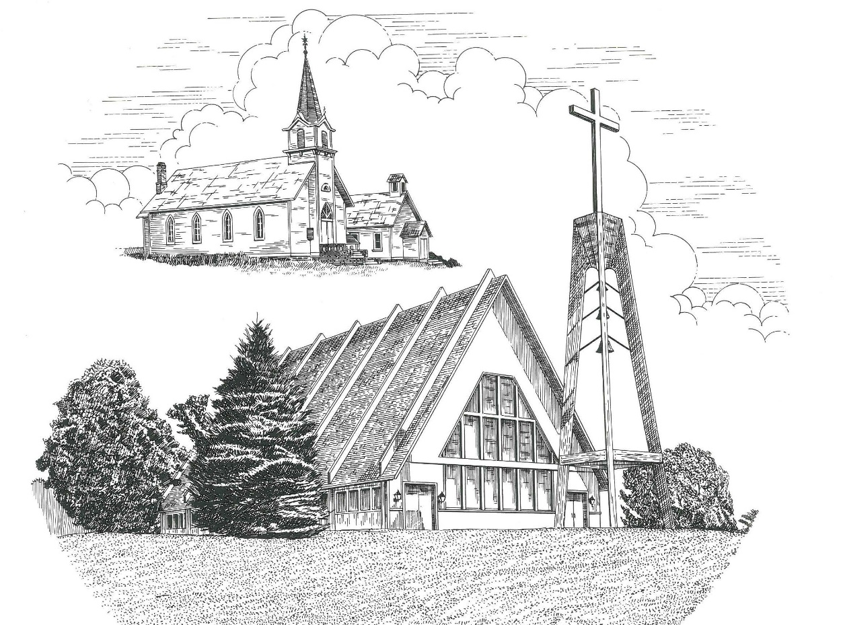

Second Sunday in Advent December 8th, 2019

WELCOME
Thanks for joining us!
Pastor Jacob Sherry Missouri Synod
~~PLEASE NOTE~~
Calling on the name of the Lord
Does not include the use of cell phones in the worship sanctuary.
Please check yours before the service begins. Thank you for your courtesy.
~~TO OUR GUESTS AND VISITORS~~
Please sign our guest book located on the stand at the church entrance. During the service, we ask you to sign the attendance booklet located at the end of each pew. If you need assistance or have questions about our worship service, please talk to an elder or any one of our church family. We are glad you could join us and hope to have you worship with us again soon.

~~ATTENDING HOLY COMMUNION~~
By checking the “Communing Today” box on the registration form found in the attendance booklet, you are agreeing with the following statements:

- I am a baptized Christian who believes Jesus Christ is my Lord and Savior.
- I believe that I am a sinner in need of Christ freely offered forgiveness.
- I believe that in the Lord’s Supper the body and blood of Jesus Christ
are truly present in, with, and under the bread and wine.
- I believe that my participation in Holy Communion grants me forgiveness
of my sins, new spiritual life, and eternal salvation.
- With God’s help, I sincerely seek to repent of my sins, live in service
to my Lord, and await His return.

If you agree with the above statements, you are welcome to attend the Lord’s Supper with us. May God bless your worship time with us.
We do offer gluten-free wafers, please quietly ask an elder to help you.

Order of Divine Service Setting One

Pre-Service Music……………..Call to Worship………………….Greeting

OPENING HYMN: “The Advent of Our King”………..........................LSB #331

OPENING LITURGY
Confession & Absolution……………………………………….LSB p. 151
Kyrie……………………………………………………………..LSB pp. 152-153
Salutation….………………………………………………….....LSB p. 156

Collect Prayer
Stir up our hearts, O Lord, to make ready the way of Your only-begotten Son, that by His coming we may be enabled to serve You with pure minds; through the same Jesus Christ, our Lord, who lives and reigns with You and the Holy Spirit, one God, now and forever.

THE HOLY SCRIPTURES

OLD TESTAMENT: (Isaiah 11:1-10)
There shall come forth a shoot from the stump of Jesse,
and a branch from his roots shall bear fruit.
² And the Spirit of the Lord shall rest upon him,
the Spirit of wisdom and understanding,
the Spirit of counsel and might,
the Spirit of knowledge and the fear of the Lord.
³ And his delight shall be in the fear of the Lord.
He shall not judge by what his eyes see,
or decide disputes by what his ears hear,
⁴ but with righteousness he shall judge the poor,
and decide with equity for the meek of the earth;
and he shall strike the earth with the rod of his mouth,
and with the breath of his lips he shall kill the wicked.
⁵ Righteousness shall be the belt of his waist,
and faithfulness the belt of his loins.
⁶ The wolf shall dwell with the lamb,
and the leopard shall lie down with the young goat,
and the calf and the lion and the fattened calf together;
and a little child shall lead them.
⁷ The cow and the bear shall graze;
their young shall lie down together;
and the lion shall eat straw like the ox.
⁸ The nursing child shall play over the hole of the cobra,
and the weaned child shall put his hand on the adder's den.
⁹ They shall not hurt or destroy
in all my holy mountain;
for the earth shall be full of the knowledge of the Lord
as the waters cover the sea.
¹⁰ In that day the root of Jesse, who shall stand as a signal for the peoples—of him shall the nations inquire, and his resting place shall be glorious.

R: This is the Word of the Lord. Cong: Thanks be to God.

GRADUAL
Reader: Rejoice greatly, O daughter of Zion.
Cong.: Shout aloud, O daughter of Jerusalem.
Reader: Behold, your king is coming to you;
Cong.: righteous and having salvation.
Reader: Blessed is he who comes in the name of the Lord.
Cong.: From the house of the Lord we bless you.

EPISTLE: (Romans 15:4-13)
⁴ For whatever was written in former days was written for our instruction, that through endurance and through the encouragement of the Scriptures we might have hope. ⁵ May the God of endurance and encouragement grant you to live in such harmony with one another, in accord with Christ Jesus, ⁶ that together you may with one voice glorify the God and Father of our Lord Jesus Christ. ⁷ Therefore welcome one another as Christ has welcomed you, for the glory of God.
⁸ For I tell you that Christ became a servant to the circumcised to show God's truthfulness, in order to confirm the promises given to the patriarchs, ⁹ and in order that the Gentiles might glorify God for his mercy. As it is written,
“Therefore I will praise you among the Gentiles,
and sing to your name.”
¹⁰ And again it is said,
“Rejoice, O Gentiles, with his people.”
¹¹ And again,
“Praise the Lord, all you Gentiles,
and let all the peoples extol him.”
¹² And again Isaiah says,
“The root of Jesse will come,
even he who arises to rule the Gentiles;
in him will the Gentiles hope.”
¹³ May the God of hope fill you with all joy and peace in believing, so that by the power of the Holy Spirit you may abound in hope.

R: This is the Word of the Lord. Cong: Thanks be to God.

(PLEASE RISE for the reading of the Gospel)

R: The Holy Gospel according to St. Matthew, the 3rd Chapter.

HOLY GOSPEL: (Matthew 3:1-12)
In those days John the Baptist came preaching in the wilderness of Judea, ² “Repent, for the kingdom of heaven is at hand.” ³ For this is he who was spoken of by the prophet Isaiah when he said,
“The voice of one crying in the wilderness:
‘Prepare the way of the Lord;
make his paths straight.’”
⁴ Now John wore a garment of camel's hair and a leather belt around his waist, and his food was locusts and wild honey. ⁵ Then Jerusalem and all Judea and all the region about the Jordan were going out to him, ⁶ and they were baptized by him in the river Jordan, confessing their sins.
⁷ But when he saw many of the Pharisees and Sadducees coming to his baptism, he said to them, “You brood of vipers! Who warned you to flee from the wrath to come? ⁸ Bear fruit in keeping with repentance. ⁹ And do not presume to say to yourselves, ‘We have Abraham as our father,’ for I tell you, God is able from these stones to raise up children for Abraham. ¹⁰ Even now the axe is laid to the root of the trees. Every tree therefore that does not bear good fruit is cut down and thrown into the fire.
¹¹ “I baptize you with water for repentance, but he who is coming after me is mightier than I, whose sandals I am not worthy to carry. He will baptize you with the Holy Spirit and fire. ¹² His winnowing fork is in his hand, and he will clear his threshing floor and gather his wheat into the barn, but the chaff he will burn with unquenchable fire.”

R: This is the Gospel of the Lord.

SERMON HYMN: “On Jordan’s Bank the Baptist’s Cry”…………………..LSB #344

SERMON

Nicene Creed…...……………………………………………………..……….LSB p. 158
I believe in one God, the Father Almighty, maker of heaven and earth and of all things visible and invisible.
And in one Lord Jesus Christ, the only-begotten Son of God, begotten of His Father before all worlds, God of God, Light of Light, very God of very God, begotten, not made, being of one substance with the Father, by whom all things were made; who for us men and for our salvation came down from heaven and was incarnate by the Holy Spirit of the virgin Mary and was made man; and was crucified also for us under Pontius Pilate. He suffered and was buried. And the third day He rose again according to the Scriptures and ascended into heaven and sits at the right hand of the Father. And He will come again with glory to judge both the living and the dead, whose kingdom will have no end.
And I believe in the Holy Spirit, the Lord and giver of life, who proceeds from the Father and the Son, who with the Father and the Son together is worshiped and glorified, who spoke by the prophets. And I believe in one holy Christian and apostolic Church, I acknowledge one Baptism for the remission of sins, and I look for the resurrection of the dead and the life of the world to come. Amen.

THE GENERAL PRAYERS OF THE CHURCH

GATHERING OF OUR FIRST FRUITS & OFFERTORY…………LSB pp. 159-160

Congregational Sharing of the Peace of the Lord
INSTITUTION OF THE LORD’S SUPPER
Preface…………………………………….…………….………..LSB p. 160
Proper Preface
It is truly good, right, and salutary that we should at all times and in all places give thanks to You, holy Lord, almighty Father, everlasting God, through Jesus Christ, our Lord, whose way John the Baptist prepared, proclaiming Him the promised Messiah, the very Lamb of God who takes away the sin of the world, and calling sinners to repentance that they might escape from the wrath to be revealed when He comes again in glory. Therefore, with angels and archangels and with all the company of heaven we laud and magnify Your glorious name, ever more praising You and saying:

Sanctus, Lord’s Prayer, The Words of Our Lord………………….....LSB pp. 161-162
Agnus Dei………………………………………………………………..LSB p. 163
If you are not communing it is acceptable to remaining seated.
COMMUNION DISTRIBUTION HYMNS:
LSB #347 “Comfort, Comfort Ye My People”
LSB #341 “Lift Up Your Heads, Ye Mighty Gates”

CLOSING LITURGY:….…….......……………………………………LSB pp. 164-166

CLOSING HYMN: “Prepare the Royal Highway”……………………LSB #343

CHURCH INFORMATION
Church Office: (231) 889-4429 Website: www.trinityonekama.org
E-mail: trinityonekama@sbcglobal.net
Address: P.O. Box 119, 5471 Fairview Street, Onekama, MI 49675
Adult Bible Study: Sunday @ 9:15 am (year round)
Worship: Sunday @ 10:30 am The Lord’s Supper: Celebrated 2nd & 4th Sundays
Pastoral Hours: Wednesday and Friday 8:30am – Noon
Pastor Phone: 231-655-2680 Pastor Email: trinityonekama@gmail.com

Copyright licensing covered under CCLI #2802932

