**231-889-4429 5471 Fairview Street, Box 119 Onekama, MI**

**TRINITY LUTHERAN CHURCH**

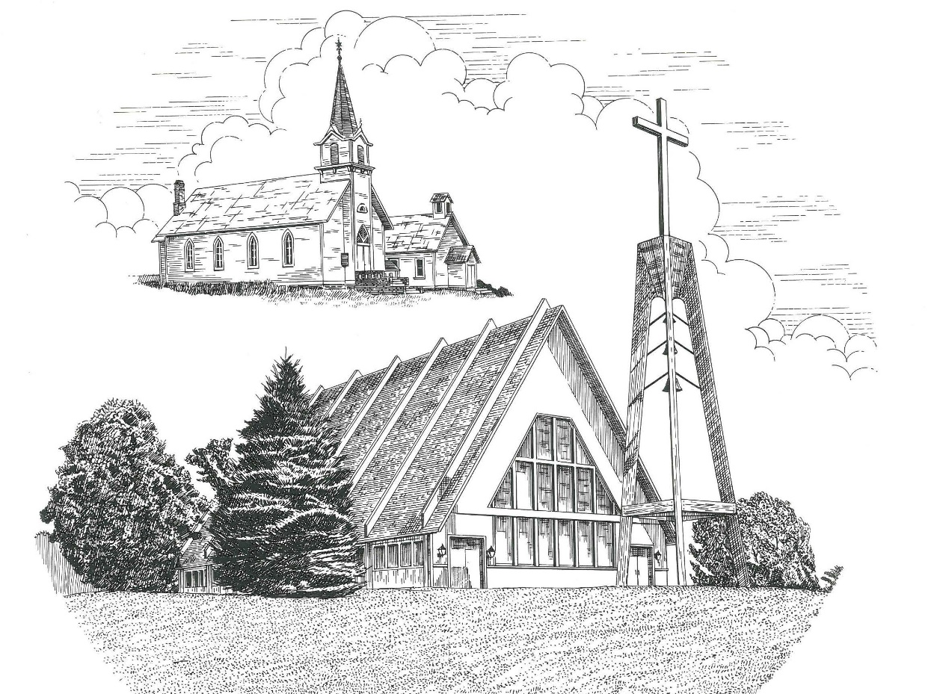

**The Transfiguration of Our Lord February 11th, 2024**

**WELCOME**

**Thanks for joining us!**

**Pastor Jacob Sherry Missouri Synod**

**~~PLEASE NOTE~~Calling on the name of the Lord**

Does not include the use of cell phones in the worship sanctuary.

Please check yours before the service begins. Thank you for your courtesy.

**~~TO OUR GUESTS AND VISITORS~~**

Please sign our guest book located on the stand at the church entrance. During the service, we ask you to sign the attendance sheets located inside your bulletin and leave them on the pew as you leave. If you need assistance or have questions about our worship service, please talk to an elder or any one of our church family. We are glad you could join us and hope to have you worship with us again soon.

**~~ATTENDING HOLY COMMUNION~~**

By checking the “Communing Today” box on the registration form on the attendance sheet, you are agreeing with the following statements:

* **I am a baptized Christian who believes Jesus Christ is my Lord and Savior.**
* **I believe that I am a sinner in need of Christ’s freely offered forgiveness.**
* **I believe that in the Lord’s Supper the body and blood of Jesus Christ**

**are truly present in, with, and under the bread and wine.**

* **I believe that my participation in Holy Communion grants me forgiveness**

**of my sins, new spiritual life, and eternal salvation.**

* **With God’s help, I sincerely seek to repent of my sins, live in service**

**to my Lord, and await His return.**

**If you agree with the above statements, you are welcome to attend the Lord’s Supper with us. May God bless your worship time with us.**

We do offer gluten-free wafers, please quietly ask an elder to help you.

**Order of Divine Service Setting One**

**Pre-Service Music……………..Call to Worship………………….Greeting**

**OPENING HYMN:** *“’Tis Good, Lord, to be Here”*……………………LSB #414

**CONFESSION & ABSOLUTION**……………………………………..LSB p. 151

**INTROIT**

P: Exalt the Lord our God, and worship at his holy mountain;

**C: for the Lord our God is holy!**

P: The Lord reigns; let the peoples tremble!

**C: He sits enthroned upon the cherubim; let the earth quake!**

P: The Lord is great in Zion;

**C: he is exalted over all the peoples.**

P: Let them praise your great and awesome name!

**C: Holy is he!**

P: The King in his might loves justice.

**C: You have established equity; you have executed justice**

**and righteousness in Jacob.**

P: Exalt the Lord our God; worship at his footstool!

**C: Holy is he!**

**ALL: Glory be to the Father and to the Son and to the Holy Spirit; as it was in the**

**beginning, is now, and will be forever. Amen.**

P: Exalt the Lord our God, and worship at his holy mountain;

**C: for the Lord our God is holy!**

**KYRIE**…………………………………………………………………...LSB pp. 152-153

**THIS IS THE FEAST**…………………………………………………...LSB p. 155

**SALUTATION**…………………………………………………………..LSB p. 156

**Collect Prayer**

O God, in the glorious transfiguration of Your beloved Son, You confirmed the mysteries of the faith by the testimony of Moses and Elijah. In the voice that came from the bright cloud You wonderfully foreshadowed our adoption by grace. Mercifully make us co-heirs with the King in His glory and bring us to the fullness of our inheritance in heaven; through the same Jesus Christ, our Lord, who lives and reigns with the You and the Holy Spirit, one God, now and forever.

**THE HOLY SCRIPTURES**

**OLD TESTAMENT:** (2 Kings 2:1-12)

Now when the Lord was about to take Elijah up to heaven by a whirlwind, Elijah and Elisha were on their way from Gilgal. **2**And Elijah said to Elisha, “Please stay here, for the Lord has sent me as far as Bethel.” But Elisha said, “As the Lord lives, and as you yourself live, I will not leave you.” So they went down to Bethel. **3**And the sons of the prophets who were in Bethel came out to Elisha and said to him, “Do you know that today the Lord will take away your master from over you?” And he said, “Yes, I know it; keep quiet.”

**4**Elijah said to him, “Elisha, please stay here, for the Lord has sent me to Jericho.” But he said, “As the Lord lives, and as you yourself live, I will not leave you.” So they came to Jericho. **5**The sons of the prophets who were at Jericho drew near to Elisha and said to him, “Do you know that today the Lord will take away your master from over you?” And he answered, “Yes, I know it; keep quiet.”

**6**Then Elijah said to him, “Please stay here, for the Lord has sent me to the Jordan.” But he said, “As the Lord lives, and as you yourself live, I will not leave you.” So the two of them went on. **7**Fifty men of the sons of the prophets also went and stood at some distance from them, as they both were standing by the Jordan. **8**Then Elijah took his cloak and rolled it up and struck the water, and the water was parted to the one side and to the other, till the two of them could go over on dry ground.

**9**When they had crossed, Elijah said to Elisha, “Ask what I shall do for you, before I am taken from you.” And Elisha said, “Please let there be a double portion of your spirit on me.” **10**And he said, “You have asked a hard thing; yet, if you see me as I am being taken from you, it shall be so for you, but if you do not see me, it shall not be so.” **11**And as they still went on and talked, behold, chariots of fire and horses of fire separated the two of them. And Elijah went up by a whirlwind into heaven. **12**And Elisha saw it and he cried, “My father, my father! The chariots of Israel and its horsemen!” And he saw him no more.

**R:** This is the Word of the Lord**.** **Cong: Thanks be to God.**

**GRADUAL**

Reader: Praise the Lord, all nations!

**Cong.: Extol him, all peoples!**

Reader: For great is his steadfast love toward us,

**Cong.: and the faithfulness of the Lord endures forever.**

Reader: Ascribe to the Lord the glory due his name;

**Cong.: bring an offering, and come into his courts!**

**EPISTLE:** (2 Corinthians 3:12-13; 4:1-6)

**12**Since we have such a hope, we are very bold, **13**not like Moses, who would put a veil over his face so that the Israelites might not gaze at the outcome of what was being brought to an end. Therefore, having this ministry by the mercy of God, we do not lose heart. **2**But we have renounced disgraceful, underhanded ways. We refuse to practice cunning or to tamper with God's word, but by the open statement of the truth we would commend ourselves to everyone's conscience in the sight of God. **3**And even if our gospel is veiled, it is veiled to those who are perishing. **4**In their case the god of this world has blinded the minds of the unbelievers, to keep them from seeing the light of the gospel of the glory of Christ, who is the image of God. **5**For what we proclaim is not ourselves, but Jesus Christ as Lord, with ourselves as your servants for Jesus' sake. **6**For God, who said, “Let light shine out of darkness,” has shone in our hearts to give the light of the knowledge of the glory of God in the face of Jesus Christ.

**R:** This is the Word of the Lord. **Cong: Thanks be to God.**

**(PLEASE RISE for the reading of the Gospel)**



**R:** The Holy Gospel according to St. Mark, the 9th chapter.



**HOLY GOSPEL:** (Mark 9:2-9)

**2**And after six days Jesus took with him Peter and James and John, and led them up a high mountain by themselves. And he was transfigured before them, **3**and his clothes became radiant, intensely white, as no one on earth could bleach them. **4**And there appeared to them Elijah with Moses, and they were talking with Jesus. **5**And Peter said to Jesus, “Rabbi, it is good that we are here. Let us make three tents, one for you and one for Moses and one for Elijah.” **6**For he did not know what to say, for they were terrified. **7**And a cloud overshadowed them, and a voice came out of the cloud, “This is my beloved Son; listen to him.” **8**And suddenly, looking around, they no longer saw anyone with them but Jesus only.

**9**And as they were coming down the mountain, he charged them to tell no one what they had seen, until the Son of Man had risen from the dead.

**R:** This is the Gospel of the Lord.



**SERMON HYMN**: *“O Wondrous Type! O Vision Fair”*………………LSB #413

**SERMON**

**NICENE CREED**

I believe in one God, the Father Almighty, maker of heaven and earth and of all things visible and invisible.

And in one Lord Jesus Christ, the only-begotten Son of God, begotten of His Father before all worlds, God of God, Light of Light, very God of very God, begotten, not made, being of one substance with the Father, by whom all things were made; who for us men and for our salvation came down from heaven and was incarnate by the Holy Spirit of the virgin Mary and was made man; and was crucified also for us under Pontius Pilate. He suffered and was buried. And the third day He rose again according to the Scriptures and ascended into heaven and sits at the right hand of the Father. And He will come again with glory to judge both the living and the dead, whose kingdom will have no end.

And I believe in the Holy Spirit, the Lord and giver of life, who proceeds from the Father and the Son, who with the Father and the Son together is worshiped and glorified, who spoke by the prophets. And I believe in one holy Christian and apostolic Church, I acknowledge one Baptism for the remission of sins, and I look for the resurrection of the dead and the life of the world to come. Amen.

**THE GENERAL PRAYERS OF THE CHURCH**

**COLLECTION OF THE OFFERING**

**OFFERTORY**…………………………………………………………...LSB pp. 159-160

**Sharing the Peace of the Lord**

**SERVICE OF THE SACRAMENT**

**PREFACE**……………………………………………………………….LSB p. 160

**Proper Preface**

It is truly good, right, and salutary that we should at all times and in all places give thanks to You, holy Lord, almighty Father, everlasting God, through Jesus Christ, our Lord, who at His transfiguration revealed His glory to His disciples that they might be strengthened to proclaim His cross and resurrection and with all the faithful look forward to the glory of life everlasting. Therefore, with angels and archangels and with all the company of heaven we laud and magnify Your glorious name, ever more praising You and saying:

**SANCTUS**……………………………………………………………………...LSB p. 161

**THE WORDS OF OUR LORD**……………………………………………….LSB p. 162

**AGNUS DEI**……………………………………………………………………LSB p. 163

*If you are not communing, it is acceptable to remain seated.*

**COMMUNION DISTRIBUTION HYMNS**

LSB #411 *“I Want to Walk as a Child of the Light”*

LSB #633 *“At the Lamb’s High Feast We Sing”*

LSB #821 *“Alleluia! Sing to Jesus”*

**POST COMMUNION CANTICLE:** *“Thank the Lord”*………………….....LSB p. 164

**POST-COMMUNION COLLECT PRAYER**………………………………LSB p. 166

**BENEDICTION**……………………………………………………………….LSB p. 166

**CLOSING HYMN:** *“Alleluia, Song of Gladness”*……..……………………..LSB #417

**CHURCH INFORMATION**

**Church Office:** (231) 889-4429 **Website:** www.trinityonekama.org

**E-mail:** [trinityonekama@sbcglobal.net](mailto:trinityonekama@sbcglobal.net)

**Address:** P.O. Box 119, 5471 Fairview Street, Onekama, MI 49675

**Sunday School & Adult Bible Study**: Sunday @ 9:30 am

**Worship:** Sunday @ 10:30 am **The Lord’s Supper:**  Celebrated 2nd & 4th Sundays

**Pastoral Hours:** Wednesday and Friday 9:00am – Noon

**Pastor Phone:** 231-655-2680 **Pastor Email:** trinityonekama@gmail.com

**Copyright licensing covered under CCLI #2802932**