231-889-4429 5471 Fairview Street, Box 119 Onekama, MI

TRINITY LUTHERAN CHURCH
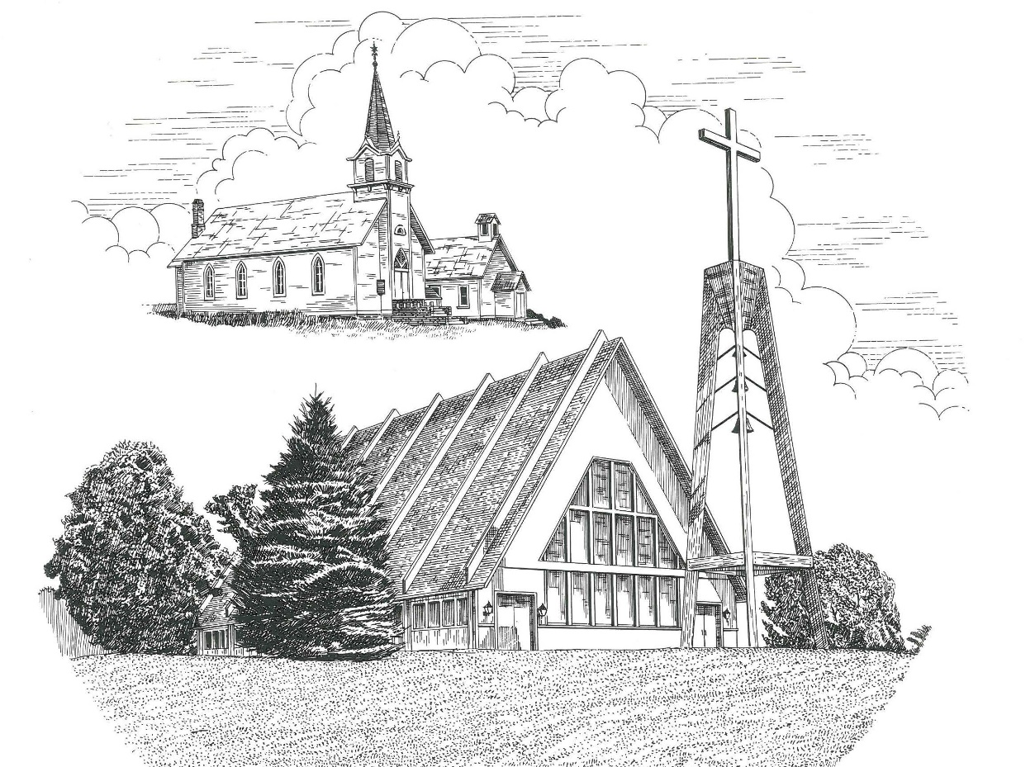

Third Sunday after Epiphany January 23rd, 2022

WELCOME
Thanks for joining us!
Pastor Jacob Sherry Missouri Synod

~~PLEASE NOTE~~
Calling on the name of the Lord
Does not include the use of cell phones in the worship sanctuary.
Please check yours before the service begins. Thank you for your courtesy.
~~TO OUR GUESTS AND VISITORS~~
Please sign our guest book located on the stand at the church entrance. During the service, we ask you to sign the attendance booklet located at the end of each pew. If you need assistance or have questions about our worship service, please talk to an elder or any one of our church family. We are glad you could join us and hope to have you worship with us again soon.

~~ATTENDING HOLY COMMUNION~~
By checking the “Communing Today” box on the registration form found in the attendance booklet, you are agreeing with the following statements:

- I am a baptized Christian who believes Jesus Christ is my Lord and Savior.
- I believe that I am a sinner in need of Christ freely offered forgiveness.
- I believe that in the Lord’s Supper the body and blood of Jesus Christ
are truly present in, with, and under the bread and wine.
- I believe that my participation in Holy Communion grants me forgiveness
of my sins, new spiritual life, and eternal salvation.
- With God’s help, I sincerely seek to repent of my sins, live in service
to my Lord, and await His return.

If you agree with the above statements, you are welcome to attend the Lord’s Supper with us. May God bless your worship time with us.
We do offer gluten-free wafers, please quietly ask an elder to help you.

Order of Divine Service Setting Three

Pre-Service Music……………..Call to Worship………………….Greeting

OPENING HYMN: “Lord, Open Now My Heart to Hear”.....................LSB #908

OPENING LITURGY:
Confession & Absolution………..………………………………LSB pp. 184-185
Kyrie…………………………………….………………………..LSB p. 186
Gloria in Excelsis……...…………………………………………LSB pp. 187-188
Salutation….……………………………….…………………….LSB p. 189

Collect Prayer
Almighty and everlasting God, mercifully look upon our infirmities and stretch forth the hand of Your majesty to heal and defend us; through Jesus Christ, Your Son, our Lord, who lives and reigns with You and the Holy Spirit, one God, now and forever.

THE HOLY SCRIPTURES

OLD TESTAMENT: (Nehemiah 8:1-3, 5-6, 8-10)
And all the people gathered as one man into the square before the Water Gate. And they told Ezra the scribe to bring the Book of the Law of Moses that the Lord had commanded Israel. ² So Ezra the priest brought the Law before the assembly, both men and women and all who could understand what they heard, on the first day of the seventh month. ³ And he read from it facing the square before the Water Gate from early morning until midday, in the presence of the men and the women and those who could understand. And the ears of all the people were attentive to the Book of the Law. ⁵ And Ezra opened the book in the sight of all the people, for he was above all the people, and as he opened it all the people stood. ⁶ And Ezra blessed the Lord, the great God, and all the people answered, “Amen, Amen,” lifting up their hands. And they bowed their heads and worshiped the Lord with their faces to the ground. ⁸ They read from the book, from the Law of God, clearly, and they gave the sense, so that the people understood the reading.
⁹ And Nehemiah, who was the governor, and Ezra the priest and scribe, and the Levites who taught the people said to all the people, “This day is holy to the Lord your God; do not mourn or weep.” For all the people wept as they heard the words of the Law. ¹⁰ Then he said to them, “Go your way. Eat the fat and drink sweet wine and send portions to anyone who has nothing ready, for this day is holy to our Lord. And do not be grieved, for the joy of the Lord is your strength.”
R: This is the Word of the Lord. Cong: Thanks be to God.

GRADUAL
Reader: Praise the Lord, all nations!
Cong.: Extol him, all peoples!
Reader: For great is his steadfast love toward us,
Cong.: and the faithfulness of the Lord endures forever.
Reader: Ascribe to the Lord the glory due his name;
Cong.: bring an offering, and come into his courts!

EPISTLE: (1 Corinthians 12:12-31a)
¹² For just as the body is one and has many members, and all the members of the body, though many, are one body, so it is with Christ. ¹³ For in one Spirit we were all baptized into one body—Jews or Greeks, slaves or free—and all were made to drink of one Spirit. ¹⁴ For the body does not consist of one member but of many. ¹⁵ If the foot should say, “Because I am not a hand, I do not belong to the body,” that would not make it any less a part of the body. ¹⁶ And if the ear should say, “Because I am not an eye, I do not belong to the body,” that would not make it any less a part of the body. ¹⁷ If the whole body were an eye, where would be the sense of hearing? If the whole body were an ear, where would be the sense of smell? ¹⁸ But as it is, God arranged the members in the body, each one of them, as he chose. ¹⁹ If all were a single member, where would the body be? ²⁰ As it is, there are many parts, yet one body.
²¹ The eye cannot say to the hand, “I have no need of you,” nor again the head to the feet, “I have no need of you.” ²² On the contrary, the parts of the body that seem to be weaker are indispensable, ²³ and on those parts of the body that we think less honorable we bestow the greater honor, and our unpresentable parts are treated with greater modesty, ²⁴ which our more presentable parts do not require. But God has so composed the body, giving greater honor to the part that lacked it, ²⁵ that there may be no division in the body, but that the members may have the same care for one another. ²⁶ If one member suffers, all suffer together; if one member is honored, all rejoice together.
²⁷ Now you are the body of Christ and individually members of it. ²⁸ And God has appointed in the church first apostles, second prophets, third teachers, then miracles, then gifts of healing, helping, administrating, and various kinds of tongues. ²⁹ Are all apostles? Are all prophets? Are all teachers? Do all work miracles? ³⁰ Do all possess gifts of healing? Do all speak with tongues? Do all interpret? ³¹ But earnestly desire the higher gifts.

R: This is the Word of the Lord. Cong: Thanks be to God.
(PLEASE RISE for the reading of the Gospel)

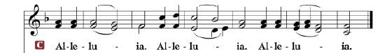

R: The Holy Gospel according to St. Luke, the 4th chapter.

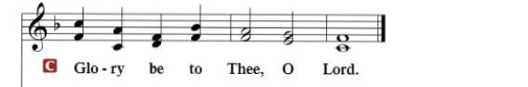

HOLY GOSPEL: (Luke 4:16-30)
¹⁶ And Jesus came to Nazareth, where he had been brought up. And as was his custom, he went to the synagogue on the Sabbath day, and he stood up to read. ¹⁷ And the scroll of the prophet Isaiah was given to him. He unrolled the scroll and found the place where it was written,
¹⁸ “The Spirit of the Lord is upon me,
because he has anointed me
to proclaim good news to the poor.
He has sent me to proclaim liberty to the captives
and recovering of sight to the blind,
to set at liberty those who are oppressed,
¹⁹ to proclaim the year of the Lord's favor.”

²⁰ And he rolled up the scroll and gave it back to the attendant and sat down. And the eyes of all in the synagogue were fixed on him. ²¹ And he began to say to them, “Today this Scripture has been fulfilled in your hearing.” ²² And all spoke well of him and marveled at the gracious words that were coming from his mouth. And they said, “Is not this Joseph's son?” ²³ And he said to them, “Doubtless you will quote to me this proverb, ‘“Physician, heal yourself.” What we have heard you did at Capernaum, do here in your hometown as well.’” ²⁴ And he said, “Truly, I say to you, no prophet is acceptable in his hometown. ²⁵ But in truth, I tell you, there were many widows in Israel in the days of Elijah, when the heavens were shut up three years and six months, and a great famine came over all the land, ²⁶ and Elijah was sent to none of them but only to Zarephath, in the land of Sidon, to a woman who was a widow. ²⁷ And there were many lepers in Israel in the time of the prophet Elisha, and none of them was cleansed, but only Naaman the Syrian.” ²⁸ When they heard these things, all in the synagogue were filled with wrath. ²⁹ And they rose up and drove him out of the town and brought him to the brow of the hill on which their town was built, so that they could throw him down the cliff. ³⁰ But passing through their midst, he went away.

R: This is the Gospel of the Lord.

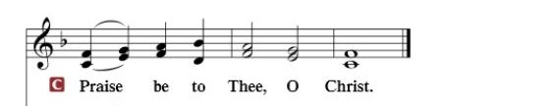

Nicene Creed
I believe in one God, the Father Almighty, maker of heaven and earth and of all things visible and invisible.
And in one Lord Jesus Christ, the only-begotten Son of God, begotten of His Father before all worlds, God of God, Light of Light, very God of very God, begotten, not made, being of one substance with the Father, by whom all things were made; who for us men and for our salvation came down from heaven and was incarnate by the Holy Spirit of the virgin Mary and was made man; and was crucified also for us under Pontius Pilate. He suffered and was buried. And the third day He rose again according to the Scriptures and ascended into heaven and sits at the right hand of the Father. And He will come again with glory to judge both the living and the dead, whose kingdom will have no end.
And I believe in the Holy Spirit, the Lord and giver of life, who proceeds from the Father and the Son, who with the Father and the Son together is worshiped and glorified, who spoke by the prophets. And I believe in one holy Christian and apostolic Church, I acknowledge one Baptism for the remission of sins, and I look for the resurrection of the dead and the life of the world to come. Amen.
SERMON HYMN: “O Christ, Our True and Only Light”.....................LSB #839

SERMON

OFFERTORY……………………………………………………..……LSB pp. 192-193

THE GENERAL PRAYERS OF THE CHURCH

INSTITUTION OF THE LORD’S SUPPER
Preface…………………………………….…………….……….LSB p. 194

Proper Preface
It is truly good, right, and salutary that we should at all times and in all places give thanks to You, holy Lord, almighty Father, everlasting God, through Jesus Christ, our Lord, who, out of love for His fallen creation, humbled Himself by taking on the form of a servant, becoming obedient unto death, even death upon a cross. Risen from the dead, He has freed us from eternal death and given us life everlasting. Therefore, with angels and archangels and with all the company of heaven we laud and magnify Your glorious name, ever more praising You and saying:
Sanctus, Lord’s Prayer, The Words of Our Lord………………….....LSB pp. 195-197
Agnus Dei………………………………………………………………..LSB p. 198
If you are not communing, it is acceptable to remain seated.

COMMUNION DISTRIBUTION HYMNS:
LSB #623 “Lord Jesus Christ, We Humbly Pray”
LSB #809 “Great Is Thy Faithfulness”
LSB #688 “Come, Follow Me, the Savior Spake”

NUNC DIMITTIS………………………………………………………LSB pp. 199-200

BENEDICTION

CLOSING HYMN: “The People That in Darkness Sat”........................LSB #412

The Mission of Trinity Onekama Is To SERVE

For even the Son of Man did not come to be served
but to serve and to give his life as a ransom for many.
Mark 10:45

S haring Jesus’s truth
E quipping for life
R eaching Out
V aluing each other
E vangelizing all ages
Mission Statement
The mission of Trinity Onekama is to SERVE
For even the Son of Man did not come to be served, but to serve,
and to give his life as a ransom for many. Mark 10:45
S haring Jesus’ ruth
E quipping for life
R eaching Out
V aluing each other
E vangelizing all age

CHURCH INFORMATION
Church Office: (231) 889-4429 Website: www.trinityonekama.org
E-mail: trinityonekama@sbcglobal.net
Address: P.O. Box 119, 5471 Fairview Street, Onekama, MI 49675
Adult Bible Study: Sunday @ 11:30 am (year round)
Worship: Sunday @ 10:30 am The Lord’s Supper: Celebrated 2nd & 4th Sundays
Pastoral Hours: Wednesday and Friday 9:00am – Noon
Pastor Phone: 231-655-2680 Pastor Email: trinityonekama@gmail.com

Copyright licensing covered under CCLI #2802932

