231-889-4429 5471 Fairview Street, Box 119 Onekama, MI

TRINITY LUTHERAN CHURCH
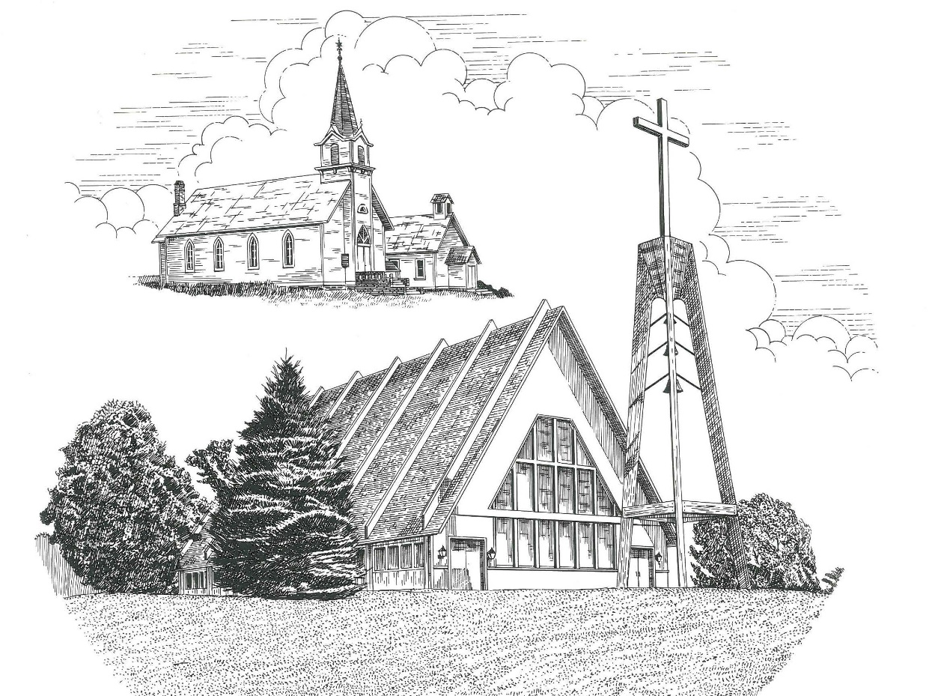

The Third Sunday after Epiphany January 24th, 2021

WELCOME
Thanks for joining us!
Pastor Jacob Sherry Missouri Synod

~~PLEASE NOTE~~
Calling on the name of the Lord
Does not include the use of cell phones in the worship sanctuary.
Please check yours before the service begins. Thank you for your courtesy.
~~TO OUR GUESTS AND VISITORS~~
Please sign our guest book located on the stand at the church entrance. During the service, we ask you to sign the attendance booklet located at the end of each pew. If you need assistance or have questions about our worship service, please talk to an elder or any one of our church family. We are glad you could join us and hope to have you worship with us again soon.

~~ATTENDING HOLY COMMUNION~~
By checking the “Communing Today” box on the registration form found in the attendance booklet, you are agreeing with the following statements:

- I am a baptized Christian who believes Jesus Christ is my Lord and Savior.
- I believe that I am a sinner in need of Christ freely offered forgiveness.
- I believe that in the Lord’s Supper the body and blood of Jesus Christ
are truly present in, with, and under the bread and wine.
- I believe that my participation in Holy Communion grants me forgiveness
of my sins, new spiritual life, and eternal salvation.
- With God’s help, I sincerely seek to repent of my sins, live in service
to my Lord, and await His return.

If you agree with the above statements, you are welcome to attend the Lord’s Supper with us. May God bless your worship time with us.
We do offer gluten-free wafers, please quietly ask an elder to help you.

Covid-19 Guidance for Worship
* Masks are to be properly worn during worship.
* Please sit on the ends of the pews and not directly behind someone.
* Maintain social distancing with other members even at the communion rail.
* If you are feeling ill, please remain home and watch the service online.
Order of Divine Service Setting Three

Pre-Service Music……………..Call to Worship………………….Greeting

OPENING HYMN: “Let Us Ever Walk with Jesus”...............................LSB #685
OPENING LITURGY:
Confession & Absolution……………….……………………….LSB pp. 184-185
Kyrie…………………………………….………………………..LSB p. 186
Gloria in Excelsis………………………….……………………..LSB pp. 187-189
Salutation….……………………………….…………………….LSB p. 189

Collect Prayer
Almighty and everlasting God, mercifully look upon our infirmities and stretch forth the hand of Your majesty to heal and defend us; through Jesus Christ, Your Son, our Lord, who lives and reigns with You and the Holy Spirit, one God, now and forever.

THE HOLY SCRIPTURES

OLD TESTAMENT: (Jonah 3:1-5, 10)
Then the word of the Lord came to Jonah the second time, saying, ² “Arise, go to Nineveh, that great city, and call out against it the message that I tell you.” ³ So Jonah arose and went to Nineveh, according to the word of the Lord. Now Nineveh was an exceedingly great city, three days' journey in breadth. ⁴ Jonah began to go into the city, going a day's journey. And he called out, “Yet forty days, and Nineveh shall be overthrown!” ⁵ And the people of Nineveh believed God. They called for a fast and put on sackcloth, from the greatest of them to the least of them. ¹⁰ When God saw what they did, how they turned from their evil way, God relented of the disaster that he had said he would do to them, and he did not do it.

R: This is the Word of the Lord. Cong: Thanks be to God.

GRADUAL
Reader: Praise the Lord, all nations!
Cong.: Extol him, all peoples!
Reader: For great us his steadfast love toward us,
Cong.: and the faithfulness of the Lord endures forever.
Reader: Ascribe to the Lord the glory due his name;
Cong.: bring an offering, and come into his courts!
EPISTLE: (1 Corinthians 7:29-35)
²⁹ This is what I mean, brothers: the appointed time has grown very short. From now on, let those who have wives live as though they had none, ³⁰ and those who mourn as though they were not mourning, and those who rejoice as though they were not rejoicing, and those who buy as though they had no goods, ³¹ and those who deal with the world as though they had no dealings with it. For the present form of this world is passing away. ³² I want you to be free from anxieties. The unmarried man is anxious about the things of the Lord, how to please the Lord. ³³ But the married man is anxious about worldly things, how to please his wife, ³⁴ and his interests are divided. And the unmarried or betrothed woman is anxious about the things of the Lord, how to be holy in body and spirit. But the married woman is anxious about worldly things, how to please her husband. ³⁵ I say this for your own benefit, not to lay any restraint upon you, but to promote good order and to secure your undivided devotion to the Lord.

R: This is the Word of the Lord. Cong: Thanks be to God.

(PLEASE RISE for the reading of the Gospel)

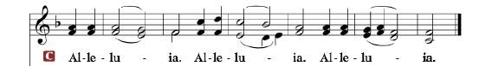

R: The Holy Gospel according to St. Mark, the 1st chapter.

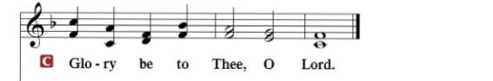

HOLY GOSPEL: (Mark 1:14-20)
¹⁴ Now after John was arrested, Jesus came into Galilee, proclaiming the gospel of God, ¹⁵ and saying, “The time is fulfilled, and the kingdom of God is at hand; repent and believe in the gospel.”
¹⁶ Passing alongside the Sea of Galilee, he saw Simon and Andrew the brother of Simon casting a net into the sea, for they were fishermen. ¹⁷ And Jesus said to them, “Follow me, and I will make you become fishers of men.” ¹⁸ And immediately they left their nets and followed him. ¹⁹ And going on a little farther, he saw James the son of Zebedee and John his brother, who were in their boat mending the nets. ²⁰ And immediately he called them, and they left their father Zebedee in the boat with the hired servants and followed him.

R: This is the Gospel of the Lord.

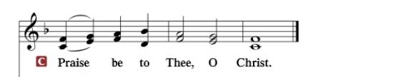

Nicene Creed…...……………………………………………………..…LSB p. 191
I believe in one God, the Father Almighty, maker of heaven and earth and of all things visible and invisible.
And in one Lord Jesus Christ, the only-begotten Son of God, begotten of His Father before all worlds, God of God, Light of Light, very God of very God, begotten, not made, being of one substance with the Father, by whom all things were made; who for us men and for our salvation came down from heaven and was incarnate by the Holy Spirit of the virgin Mary and was made man; and was crucified also for us under Pontius Pilate. He suffered and was buried. And the third day He rose again according to the Scriptures and ascended into heaven and sits at the right hand of the Father. And He will come again with glory to judge both the living and the dead, whose kingdom will have no end.
And I believe in the Holy Spirit, the Lord and giver of life, who proceeds from the Father and the Son, who with the Father and the Son together is worshiped and glorified, who spoke by the prophets. And I believe in one holy Christian and apostolic Church, I acknowledge one Baptism for the remission of sins, and I look for the resurrection of the dead and the life of the world to come. Amen.
SERMON HYMN: “O Christ, Who Called the Twelve”………….........LSB #856

SERMON

GATHERING OF OUR FIRST FRUITS & OFFERTORY…………LSB pp. 192-193

THE GENERAL PRAYERS OF THE CHURCH

INSTITUTION OF THE LORD’S SUPPER
Preface…………………………………….…………….……….LSB p. 194

Proper Preface
It is truly good, right, and salutary that we should at all times and in all places give thanks to You, holy Lord, almighty Father, everlasting God, through Jesus Christ, our Lord, for what had been hidden from before the foundation of the world You have made known to the nations in Your Son. In Him, being found in the substance of our mortal nature, You have manifested the fullness of Your glory. Therefore, with angels and archangels and with all the company of heaven we laud and magnify Your glorious name, ever more praising You and saying:

Sanctus, Lord’s Prayer, The Words of Our Lord………………….....LSB pp. 195-197
Agnus Dei………………………………………………………………..LSB p. 198
If you are not communing it is acceptable to remain seated.

COMMUNION DISTRIBUTION HYMNS:
LSB #629 “What Is This Bread”
LSB #618 “I Come, O Savior, to Thy Table”

NUNC DIMITTIS………………………………………………………LSB pp. 199-200

BENEDICTION

CLOSING HYMN: “Songs of Thankfulness and Praise”.......................LSB #394

Special Prayers

Morris Armbruster Margaret Meachum Barbara Potter
Kaydence Devenport Rita Merkey Steve Schimke
Dylan Gladding Lavonne Miller Julia Schoedel (Foot)
Jill Hoseler (Cancer) Pam Monroe Rev. Jeff Walsh (Cancer)
Kipp Kline Jim Poellet Sandy Wing
Shirley Poellet Thelma Zalud

Prayers for Our Military
Andrew Burch, Jr., grandson of John & Loree Sprawka.
Mark Granzotto with U.S. Navy in Bahrain, grandson of Rita Merkey
Army Major Riley Morgan Kennedy, stationed in Washington, DC, George & Margaret Punches’ grand-niece
Steve & Carol Sprawka, son & daughter-in-law of John & Loree Sprawka
Derek Sprawka, grandson of John & Loree Sprawka
Alyssa Eisenlohr with the U.S. Navy in Japan, friend of Janette & Fred May
Ian Nelson, nephew of Jack and Pebbla Nelson
Tyge Nelson & family, nephew of Jack and Pebbla Nelson
Lt. Tim Brandt at Uniformed Services University, Bethesda, MD, son of Bruce & Debbie Brandt

If you wish to add someone’s name, please call or e-mail the church office.
When someone’s name is placed on prayer lists,
his or her name will remain until instructed to remove it. Thank you!

The Mission of Trinity Onekama Is To SERVE

For even the Son of Man did not come to be served
but to serve and to give his life as a ransom for many.
Mark 10:45

S haring Jesus’s truth
E quipping for life
R eaching Out
V aluing each other
E vangelizing all ages
Mission Statement
The mission of Trinity Onekama is to SERVE
For even the Son of Man did not come to be served, but to serve,
and to give his life as a ransom for many. Mark 10:45
S haring Jesus’ ruth
E quipping for life
R eaching Out
V aluing each other
E vangelizing all age

CHURCH INFORMATION
Church Office: (231) 889-4429 Website: www.trinityonekama.org
E-mail: trinityonekama@sbcglobal.net
Address: P.O. Box 119, 5471 Fairview Street, Onekama, MI 49675
Adult Bible Study: Sunday @ 9:15 am (year round)
Worship: Sunday @ 10:30 am The Lord’s Supper: Celebrated 2nd & 4th Sundays
Pastoral Hours: Wednesday and Friday 8:30am – Noon
Pastor Phone: 231-655-2680 Pastor Email: trinityonekama@gmail.com

Copyright licensing covered under CCLI #2802932

