231-889-4429 5471 Fairview Street, Box 119 Onekama, MI

TRINITY LUTHERAN CHURCH
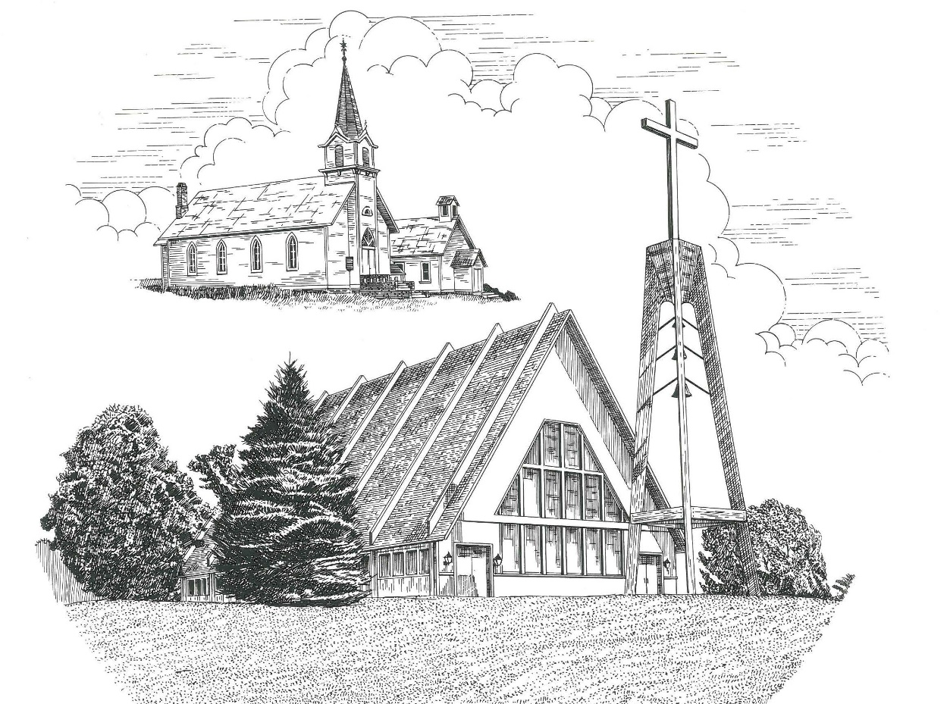

Fourth Sunday after the Epiphany January 28th, 2024

WELCOME
Thanks for joining us!
Pastor Jacob Sherry Missouri Synod

~~PLEASE NOTE~~
Calling on the name of the Lord
Does not include the use of cell phones in the worship sanctuary.
Please check yours before the service begins. Thank you for your courtesy.
~~TO OUR GUESTS AND VISITORS~~
Please sign our guest book located on the stand at the church entrance. During the service, we ask you to sign the attendance sheet in your bulletin and leave it on the pew as you leave. If you need assistance or have questions about our worship service, please talk to an elder or any one of our church family. We are glad you could join us and hope to have you worship with us again soon.

~~ATTENDING HOLY COMMUNION~~
By checking the “Communing Today” box on the registration form found on the attendance sheet in your bulletin, you are agreeing with the following statements:

- I am a baptized Christian who believes Jesus Christ is my Lord and Savior.
- I believe that I am a sinner in need of Christ’s freely offered forgiveness.
- I believe that in the Lord’s Supper the body and blood of Jesus Christ
are truly present in, with, and under the bread and wine.
- I believe that my participation in Holy Communion grants me forgiveness
of my sins, new spiritual life, and eternal salvation.
- With God’s help, I sincerely seek to repent of my sins, live in service
to my Lord, and await His return.

If you agree with the above statements, you are welcome to attend the Lord’s Supper with us. May God bless your worship time with us.
We do offer gluten-free wafers, please quietly ask an elder to help you.

Order of Divine Service Setting Four

Pre-Service Music……………..Call to Worship………………….Greeting

OPENING HYMN: “Christ Is Our Cornerstone”……………………..LSB #912

CONFESSION & ABSOLUTION……….…………………………….LSB p. 203

INTROIT
P: Many are the sorrows of the wicked,
C: but steadfast love surrounds the one who trusts in the Lord.
P: Blessed is the one whose transgression is forgiven,
C: whose sin is covered.
P: Blessed is the man against whom the Lord counts no iniquity,
C: in whose spirit there is no deceit.
P: I acknowledged my sin to you, and I did not cover my iniquity;
C: I said, “I will confess my transgressions to the Lord,” and
you forgave the iniquity of my sin.
P: Therefore, let everyone who is godly offer prayer to you
at a time when you may be found;
C: surely in the rush of great waters, they shall not reach him.
P: You are a hiding place for me; you preserve me from trouble;
C: you surround me with shouts of deliverance.
ALL: Glory be to the Father and to the Son and to the Holy Spirit; as it was in the
beginning, is now and will be forever. Amen.

KYRIE…………………………………………………………………….LSB p. 204
GLORIA IN EXCELSIS…………………………………………………LSB p. 204
SALUTATION.…………………………………………………………...LSB p. 205

Collect Prayer
Almighty God, You know we live in the midst of so many dangers that in our frailty we cannot stand upright. Grant strength and protection to support us in all dangers and carry us through all temptations; through Jesus Christ, Your Son, our Lord, who lives and reigns with You and the Holy Spirit, one God, now and forever.
THE HOLY SCRIPTURES

OLD TESTAMENT: (Deuteronomy 18:15-20)
¹⁵ “The Lord your God will raise up for you a prophet like me from among you, from your brothers—it is to him you shall listen— ¹⁶ just as you desired of the Lord your God at Horeb on the day of the assembly, when you said, ‘Let me not hear again the voice of the Lord my God or see this great fire any more, lest I die.’ ¹⁷ And the Lord said to me, ‘They are right in what they have spoken. ¹⁸ I will raise up for them a prophet like you from among their brothers. And I will put my words in his mouth, and he shall speak to them all that I command him. ¹⁹ And whoever will not listen to my words that he shall speak in my name, I myself will require it of him. ²⁰ But the prophet who presumes to speak a word in my name that I have not commanded him to speak, or who speaks in the name of other gods, that same prophet shall die.’

R: This is the Word of the Lord. Cong: Thanks be to God.

GRADUAL
Reader: Praise the Lord, all nations!
Cong.: Extol him, all peoples!
Reader: For great is his steadfast love toward us,
Cong.: and the faithfulness of the Lord endures forever.
Reader: Ascribe to the Lord the glory due his name;
Cong.: bring an offering, and come into his courts!

EPISTLE: (1 Corinthians 8:1-13)
Now concerning food offered to idols: we know that “all of us possess knowledge.” This “knowledge” puffs up, but love builds up. ² If anyone imagines that he knows something, he does not yet know as he ought to know. ³ But if anyone loves God, he is known by God.
⁴ Therefore, as to the eating of food offered to idols, we know that “an idol has no real existence,” and that “there is no God but one.” ⁵ For although there may be so-called gods in heaven or on earth—as indeed there are many “gods” and many “lords”— ⁶yet for us there is one God, the Father, from whom are all things and for whom we exist, and one Lord, Jesus Christ, through whom are all things and through whom we exist. ⁷ However, not all possess this knowledge. But some, through former association with idols, eat food as really offered to an idol, and their conscience, being weak, is defiled. ⁸ Food will not commend us to God. We are no worse off if we do not eat, and no better off if we do. ⁹ But take care that this right of yours does not somehow become a stumbling block to the weak. ¹⁰ For if anyone sees you who have knowledge eating in an idol's temple, will he not be encouraged, if his conscience is weak, to eat food offered to idols? ¹¹ And so by your knowledge this weak person is destroyed, the brother for whom Christ died. ¹² Thus, sinning against your brothers and wounding their conscience when it is weak, you sin against Christ. ¹³ Therefore, if food makes my brother stumble, I will never eat meat, lest I make my brother stumble.

R: This is the Word of the Lord. Cong: Thanks be to God.

(PLEASE RISE for the reading of the Gospel)

R: The Holy Gospel according to St. Mark, the 1st chapter.
Cong: Glory to You, O Lord

HOLY GOSPEL: (Mark 1:21-28)
²¹ And they went into Capernaum, and immediately on the Sabbath Jesus entered the synagogue and was teaching. ²² And they were astonished at his teaching, for he taught them as one who had authority, and not as the scribes. ²³ And immediately there was in their synagogue a man with an unclean spirit. And he cried out, ²⁴ “What have you to do with us, Jesus of Nazareth? Have you come to destroy us? I know who you are—the Holy One of God.” ²⁵ But Jesus rebuked him, saying, “Be silent, and come out of him!” ²⁶ And the unclean spirit, convulsing him and crying out with a loud voice, came out of him. ²⁷ And they were all amazed, so that they questioned among themselves, saying, “What is this? A new teaching with authority! He commands even the unclean spirits, and they obey him.” ²⁸ And at once his fame spread everywhere throughout all the surrounding region of Galilee.

R: This is the Gospel of the Lord. Cong: Praise to You, O Christ.

NICENE CREED
I believe in one God, the Father Almighty, maker of heaven and earth and of all things visible and invisible.
And in one Lord Jesus Christ, the only-begotten Son of God, begotten of His Father before all worlds, God of God, Light of Light, very God of very God, begotten, not made, being of one substance with the Father, by whom all things were made; who for us men and for our salvation came down from heaven and was incarnate by the Holy Spirit of the virgin Mary and was made man; and was crucified also for us under Pontius Pilate. He suffered and was buried. And the third day He rose again according to the Scriptures and ascended into heaven and sits at the right hand of the Father. And He will come again with glory to judge both the living and the dead, whose kingdom will have no end.
And I believe in the Holy Spirit, the Lord and giver of life, who proceeds from the Father and the Son, who with the Father and the Son together is worshiped and glorified, who spoke by the prophets. And I believe in one holy Christian and apostolic Church, I acknowledge one Baptism for the remission of sins, and I look for the resurrection of the dead and the life of the world to come. Amen.

SERMON HYMN: “Son of God, Eternal Savior”……….…………………….LSB #842

SERMON

THE GENERAL PRAYERS

COLLECTION OF THE OFFERING
OFFERTORY HYMN: “We Give Thee But Thine Own”……………………..LSB #781
verse 1

Sharing the Peace of the Lord

SERVICE OF THE SACRAMENT
Preface…………………………………….…………….………..LSB p. 208
Proper Preface
It is truly good, right, and salutary that we should at all times and in all places give thanks to You, O Lord, holy Father, almighty and everlasting God, for the countless blessings You so freely bestow on us and all creation. Above all, we give thanks for Your boundless love shown to us when You sent Your only-begotten Son, Jesus Christ, into our flesh and laid on Him our sin, giving Him into death that we might not die eternally. Because He is now risen from the dead and lives and reigns to all eternity, all who believe in Him will overcome sin and death and will rise again to new life. Therefore, with angels and archangels and with all the company of heaven we laud and magnify Your glorious name, ever more praising You and saying:

Sanctus, Lord’s Prayer, The Words of Our Lord………………….....LSB pp. 208-209
Agnus Dei………………………………………………………………..LSB p. 210
If you are not communing, it is acceptable to remain seated.

COMMUNION DISTRIBUTION HYMNS:
LSB #623 “Lord Jesus Christ, We Humbly Pray”
LSB #629 “What Is This Bread”
LSB #736 “Consider How the Birds Above”

CLOSING LITURGY:………………………………………………....LSB pp. 211-212

CLOSING HYMN: “Lord, Dismiss Us with Your Blessing”..................LSB #924

The Mission of Trinity Onekama Is To SERVE

For even the Son of Man did not come to be served
but to serve and to give his life as a ransom for many.
Mark 10:45

S haring Jesus’s truth
E quipping for life
R eaching Out
V aluing each other
E vangelizing all ages
Mission Statement
The mission of Trinity Onekama is to SERVE
For even the Son of Man did not come to be served, but to serve,
and to give his life as a ransom for many. Mark 10:45
S haring Jesus’ ruth
E quipping for life
R eaching Out
V aluing each other
E vangelizing all age

CHURCH INFORMATION
Church Office: (231) 889-4429 Website: www.trinityonekama.org
E-mail: trinityonekama@sbcglobal.net
Address: P.O. Box 119, 5471 Fairview Street, Onekama, MI 49675
Sunday School & Adult Bible Study: Sunday @ 9:30am
Worship: Sunday @ 10:30 am The Lord’s Supper: Celebrated 2nd & 4th Sundays
Pastoral Hours: Wednesday and Friday 9:00am – Noon
Pastor Phone: 231-655-2680 Pastor Email: trinityonekama@gmail.com

Copyright licensing covered under CCLI #2802932

