231-889-4429 5471 Fairview Street, Box 119 Onekama, MI

TRINITY LUTHERAN CHURCH
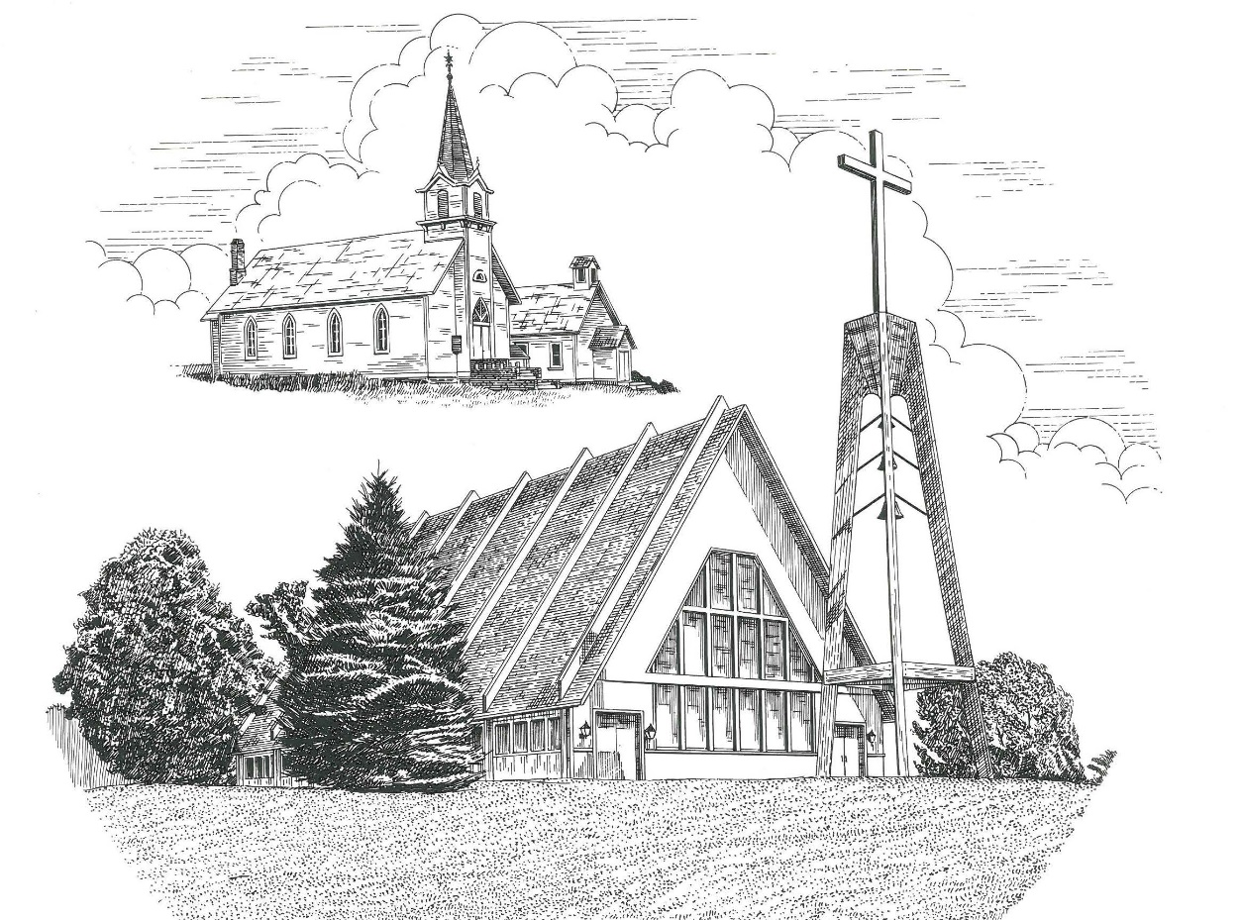

Fourth Sunday after Epiphany January 29th, 2023

WELCOME
Thanks for joining us!
Pastor Jacob Sherry Missouri Synod

~~PLEASE NOTE~~
Calling on the name of the Lord
Does not include the use of cell phones in the worship sanctuary.
Please check yours before the service begins. Thank you for your courtesy.
~~TO OUR GUESTS AND VISITORS~~
Please sign our guest book located on the stand at the church entrance. During the service, we ask you to sign the attendance sheet located in your bulletin and place it on the pew when you leave. If you need assistance or have questions about our worship service, please talk to an elder or any one of our church family. We are glad you could join us and hope to have you worship with us again soon.

~~ATTENDING HOLY COMMUNION~~
By checking the “Communing Today” box on the registration form found on the attendance sheet, you are agreeing with the following statements:

- I am a baptized Christian who believes Jesus Christ is my Lord and Savior.
- I believe that I am a sinner in need of Christ’s freely offered forgiveness.
- I believe that in the Lord’s Supper the body and blood of Jesus Christ
are truly present in, with, and under the bread and wine.
- I believe that my participation in Holy Communion grants me forgiveness
of my sins, new spiritual life, and eternal salvation.
- With God’s help, I sincerely seek to repent of my sins, live in service
to my Lord, and await His return.

If you agree with the above statements, you are welcome to attend the Lord’s Supper with us. May God bless your worship time with us.
We do offer gluten-free wafers, please quietly ask an elder to help you.

Order of Divine Service Setting Three

Pre-Service Music……………..Call to Worship………………….Greeting

OPENING HYMN: “On Eagles’ Wings”................................................LSB #727
OPENING LITURGY:
Confession & Absolution………..………………………………LSB pp. 184-185
Kyrie…………………………………….………………………..LSB p. 186
Gloria in Excelsis………………………………………………...LSB pp. 187-189
Salutation….……………………………….…………………….LSB p. 189

Collect Prayer
Almighty God, You know we live in the midst of so many dangers that in our frailty we cannot stand upright. Grant strength and protection to support us in all dangers and carry us through all temptations: through Jesus Christ, Your Son, our Lord, who lives and reigns with You and the Holy Spirit, one God, now and forever.

THE HOLY SCRIPTURES

OLD TESTAMENT: (Micah 6:1-8)
Hear what the Lord says:
Arise, plead your case before the mountains,
and let the hills hear your voice.
² Hear, you mountains, the indictment of the Lord,
and you enduring foundations of the earth,
for the Lord has an indictment against his people,
and he will contend with Israel.
³ “O my people, what have I done to you?
How have I wearied you? Answer me!
⁴ For I brought you up from the land of Egypt
and redeemed you from the house of slavery,
and I sent before you Moses,
Aaron, and Miriam.
⁵ O my people, remember what Balak king of Moab devised,
and what Balaam the son of Beor answered him,
and what happened from Shittim to Gilgal,
that you may know the righteous acts of the Lord.”
⁶ “With what shall I come before the Lord,
and bow myself before God on high?
Shall I come before him with burnt offerings,
with calves a year old?
⁷ Will the Lord be pleased with thousands of rams,
with ten thousands of rivers of oil?
Shall I give my firstborn for my transgression,
the fruit of my body for the sin of my soul?”
⁸ He has told you, O man, what is good;
and what does the Lord require of you
but to do justice, and to love kindness,
and to walk humbly with your God?

R: This is the Word of the Lord. Cong: Thanks be to God.

GRADUAL
Reader: Praise the Lord, all nations!
Cong.: Extol him, all peoples!
Reader: For great is his steadfast love toward us,
Cong.: and the faithfulness of the Lord endures forever.
Reader: Ascribe to the Lord the glory due his name;
Cong.: bring an offering, and come into his courts!

EPISTLE: (1 Corinthians 1:18-31)
¹⁸ For the word of the cross is folly to those who are perishing, but to us who are being saved it is the power of God. ¹⁹ For it is written,
“I will destroy the wisdom of the wise,
and the discernment of the discerning I will thwart.”
²⁰ Where is the one who is wise? Where is the scribe? Where is the debater of this age? Has not God made foolish the wisdom of the world? ²¹ For since, in the wisdom of God, the world did not know God through wisdom, it pleased God through the folly of what we preach to save those who believe. ²² For Jews demand signs and Greeks seek wisdom, ²³ but we preach Christ crucified, a stumbling block to Jews and folly to Gentiles, ²⁴ but to those who are called, both Jews and Greeks, Christ the power of God and the wisdom of God. ²⁵ For the foolishness of God is wiser than men, and the weakness of God is stronger than men.
²⁶ For consider your calling, brothers: not many of you were wise according to worldly standards, not many were powerful, not many were of noble birth. ²⁷ But God chose what is foolish in the world to shame the wise; God chose what is weak in the world to shame the strong; ²⁸ God chose what is low and despised in the world, even things that are not, to bring to nothing things that are, ²⁹ so that no human being might boast in the presence of God. ³⁰ And because of him you are in Christ Jesus, who became to us wisdom from God, righteousness and sanctification and redemption, ³¹ so that, as it is written, “Let the one who boasts, boast in the Lord.”

R: This is the Word of the Lord. Cong: Thanks be to God.

(PLEASE RISE for the reading of the Gospel)

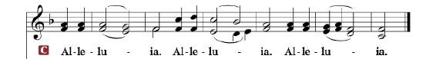

R: The Holy Gospel according to St. Matthew, the 5th chapter.

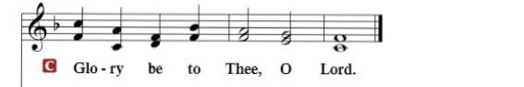

HOLY GOSPEL: (Matthew 5:1-12)
Seeing the crowds, Jesus went up on the mountain, and when he sat down, his disciples came to him. ² And he opened his mouth and taught them, saying:
³ “Blessed are the poor in spirit, for theirs is the kingdom of heaven.
⁴ “Blessed are those who mourn, for they shall be comforted.
⁵ “Blessed are the meek, for they shall inherit the earth.
⁶ “Blessed are those who hunger and thirst for righteousness, for they shall be satisfied.
⁷ “Blessed are the merciful, for they shall receive mercy.
⁸ “Blessed are the pure in heart, for they shall see God.
⁹ “Blessed are the peacemakers, for they shall be called sons of God.
¹⁰ “Blessed are those who are persecuted for righteousness' sake, for theirs is the kingdom of heaven.
¹¹ “Blessed are you when others revile you and persecute you and utter all kinds of evil against you falsely on my account. ¹² Rejoice and be glad, for your reward is great in heaven, for so they persecuted the prophets who were before you.

R: This is the Gospel of the Lord.

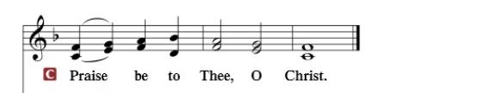

Nicene Creed
I believe in one God, the Father Almighty, maker of heaven and earth and of all things visible and invisible.
And in one Lord Jesus Christ, the only-begotten Son of God, begotten of His Father before all worlds, God of God, Light of Light, very God of very God, begotten, not made, being of one substance with the Father, by whom all things were made; who for us men and for our salvation came down from heaven and was incarnate by the Holy Spirit of the virgin Mary and was made man; and was crucified also for us under Pontius Pilate. He suffered and was buried. And the third day He rose again according to the Scriptures and ascended into heaven and sits at the right hand of the Father. And He will come again with glory to judge both the living and the dead, whose kingdom will have no end.
And I believe in the Holy Spirit, the Lord and giver of life, who proceeds from the Father and the Son, who with the Father and the Son together is worshiped and glorified, who spoke by the prophets. And I believe in one holy Christian and apostolic Church, I acknowledge one Baptism for the remission of sins, and I look for the resurrection of the dead and the life of the world to come. Amen.

SERMON HYMN: “Son of God, Eternal Savior”……………...LSB #842

SERMON

OFFERTORY…………………………………………………………...LSB pp. 192-193

INSTALLATION OF OFFICERS & BOARD MEMBERS
(Please come forward to the chancel rail)

GENERAL PRAYERS OF THE CHURCH

Sharing the Peace of the Lord

SERVICE OF THE SACRAMENT
Preface…………………………………….…………….……….LSB p. 194
Proper Preface
It is truly good, right, and salutary that we should at all times and in all places give thanks to You, holy Lord, almighty Father, everlasting God, through Jesus Christ, our Lord, who, having created all things, took on human flesh and was born of the virgin Mary. For our sake He died on the cross and rose from the dead to put an end to death, thus fulfilling Your will and gaining for You a holy people. Therefore, with angels and archangels and with all the company of heaven we laud and magnify Your glorious name, ever more praising You and saying:

Sanctus, Lord’s Prayer, The Words of Our Lord………………….....LSB pp. 195-197
Agnus Dei………………………………………………………………..LSB p. 198
If you are not communing, it is acceptable to remain seated.

COMMUNION DISTRIBUTION HYMNS:
LSB #618 “I Come, O Savior, to Thy Table”
LSB #704 “Renew Me, O Eternal Light”
LSB #651 “I Love Your Kingdom, Lord”

NUNC DIMITTIS………………………………………………………LSB pp. 199-200

BENEDICTION

CLOSING HYMN: “Beautiful Savior”..................................................LSB #537

The Mission of Trinity Onekama Is To SERVE

For even the Son of Man did not come to be served
but to serve and to give his life as a ransom for many.
Mark 10:45

S haring Jesus’s truth
E quipping for life
R eaching Out
V aluing each other
E vangelizing all ages
Mission Statement
The mission of Trinity Onekama is to SERVE
For even the Son of Man did not come to be served, but to serve,
and to give his life as a ransom for many. Mark 10:45
S haring Jesus’ ruth
E quipping for life
R eaching Out
V aluing each other
E vangelizing all age

CHURCH INFORMATION
Church Office: (231) 889-4429 Website: www.trinityonekama.org
E-mail: trinityonekama@sbcglobal.net
Address: P.O. Box 119, 5471 Fairview Street, Onekama, MI 49675
Adult Bible Study: Sunday @ 9:30am (year round)
Worship: Sunday @ 10:30 am The Lord’s Supper: Celebrated 2nd & 4th Sundays
Pastoral Hours: Wednesday and Friday 9:00am – Noon
Pastor Phone: 231-655-2680 Pastor Email: trinityonekama@gmail.com

Copyright licensing covered under CCLI #2802932

