231-889-4429 5471 Fairview Street, Box 119 Onekama, MI

TRINITY LUTHERAN CHURCH
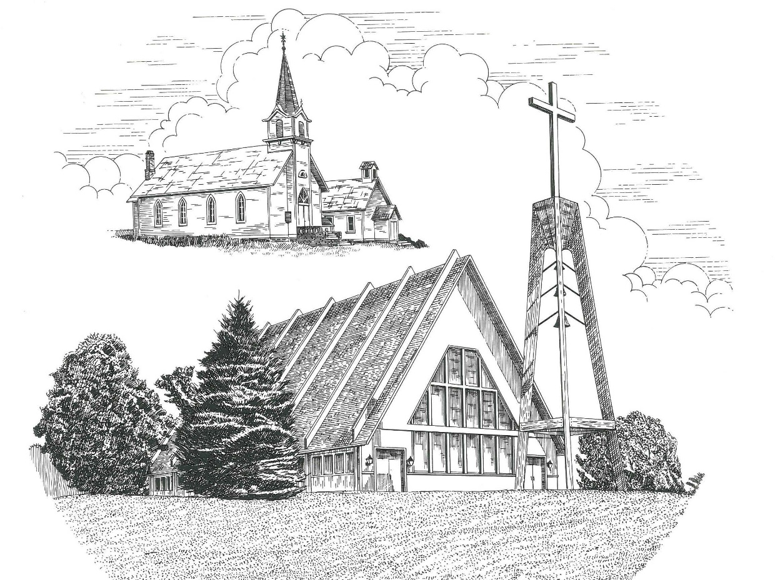

The Baptism of Our Lord January 8th, 2023

WELCOME
Thanks for joining us!
Pastor Jacob Sherry Missouri Synod

~~PLEASE NOTE~~
Calling on the name of the Lord
Does not include the use of cell phones in the worship sanctuary.
Please check yours before the service begins. Thank you for your courtesy.
~~TO OUR GUESTS AND VISITORS~~
Please sign our guest book located on the stand at the church entrance. During the service, we ask you to sign the attendance sheet located in your bulletin and place it on the pew when you leave. If you need assistance or have questions about our worship service, please talk to an elder or any one of our church family. We are glad you could join us and hope to have you worship with us again soon.

~~ATTENDING HOLY COMMUNION~~
By checking the “Communing Today” box on the registration form found on the attendance sheet, you are agreeing with the following statements:

- I am a baptized Christian who believes Jesus Christ is my Lord and Savior.
- I believe that I am a sinner in need of Christ’s freely offered forgiveness.
- I believe that in the Lord’s Supper the body and blood of Jesus Christ
are truly present in, with, and under the bread and wine.
- I believe that my participation in Holy Communion grants me forgiveness
of my sins, new spiritual life, and eternal salvation.
- With God’s help, I sincerely seek to repent of my sins, live in service
to my Lord, and await His return.

If you agree with the above statements, you are welcome to attend the Lord’s Supper with us. May God bless your worship time with us.
We do offer gluten-free wafers, please quietly ask an elder to help you.

Order of Divine Service Setting Three

Pre-Service Music……………..Call to Worship………………….Greeting

OPENING HYMN: “Songs of Thankfulness and Praise”.......................LSB #394
OPENING LITURGY:
Confession & Absolution………..………………………………LSB pp. 184-185
Kyrie…………………………………….………………………..LSB p. 186
Gloria in Excelsis………………………………………………...LSB pp. 187-189
Salutation….……………………………….…………………….LSB p. 189

Collect Prayer
Father in heaven, at the Baptism of Jesus in the Jordan River You proclaimed Him Your beloved Son and anointed Him with the Holy Spirit. Make all who are baptized in His name faithful in their calling as Your children and inheritors with Him of everlasting life; through the same Jesus Christ, our Lord, who lives and reigns with You and the Holy Spirit, one God, now and forever.

THE HOLY SCRIPTURES

OLD TESTAMENT: (Isaiah 42:1-9)
Behold my servant, whom I uphold,
my chosen, in whom my soul delights;
I have put my Spirit upon him;
he will bring forth justice to the nations.
² He will not cry aloud or lift up his voice,
or make it heard in the street;
³ a bruised reed he will not break,
and a faintly burning wick he will not quench;
he will faithfully bring forth justice.
⁴ He will not grow faint or be discouraged
till he has established justice in the earth;
and the coastlands wait for his law.
⁵ Thus says God, the Lord,
who created the heavens and stretched them out,
who spread out the earth and what comes from it,
who gives breath to the people on it
and spirit to those who walk in it:
⁶ “I am the Lord; I have called you in righteousness;
I will take you by the hand and keep you;
I will give you as a covenant for the people,
a light for the nations,
⁷ to open the eyes that are blind,
to bring out the prisoners from the dungeon,
from the prison those who sit in darkness.
⁸ I am the Lord; that is my name;
my glory I give to no other,
nor my praise to carved idols.
⁹ Behold, the former things have come to pass,
and new things I now declare;
before they spring forth
I tell you of them.”

R: This is the Word of the Lord. Cong: Thanks be to God.

GRADUAL
Reader: Praise the Lord, all nations!
Cong.: Extol him, all peoples!
Reader: For great is his steadfast love toward us,
Cong.: and the faithfulness of the Lord endures forever.
Reader: Ascribe to the Lord the glory due his name;
Cong.: bring an offering, and come into his courts!

EPISTLE: (Romans 6:1-11)
What shall we say then? Are we to continue in sin that grace may abound? ² By no means! How can we who died to sin still live in it? ³ Do you not know that all of us who have been baptized into Christ Jesus were baptized into his death? ⁴ We were buried therefore with him by baptism into death, in order that, just as Christ was raised from the dead by the glory of the Father, we too might walk in newness of life.
⁵ For if we have been united with him in a death like his, we shall certainly be united with him in a resurrection like his. ⁶ We know that our old self was crucified with him in order that the body of sin might be brought to nothing, so that we would no longer be enslaved to sin. ⁷ For one who has died has been set free from sin. ⁸ Now if we have died with Christ, we believe that we will also live with him. ⁹ We know that Christ, being raised from the dead, will never die again; death no longer has dominion over him. ¹⁰ For the death he died he died to sin, once for all, but the life he lives he lives to God. ¹¹ So you also must consider yourselves dead to sin and alive to God in Christ Jesus.

R: This is the Word of the Lord. Cong: Thanks be to God.

(PLEASE RISE for the reading of the Gospel)

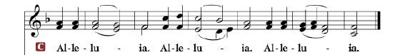

R: The Holy Gospel according to St. Matthew, the 3rd chapter.

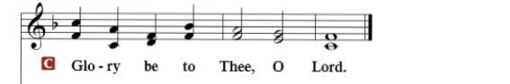

HOLY GOSPEL: (Matthew 3:13-17)
¹³ Then Jesus came from Galilee to the Jordan to John, to be baptized by him. ¹⁴ John would have prevented him, saying, “I need to be baptized by you, and do you come to me?” ¹⁵ But Jesus answered him, “Let it be so now, for thus it is fitting for us to fulfill all righteousness.” Then he consented. ¹⁶ And when Jesus was baptized, immediately he went up from the water, and behold, the heavens were opened to him, and he saw the Spirit of God descending like a dove and coming to rest on him; ¹⁷ and behold, a voice from heaven said, “This is my beloved Son, with whom I am well pleased.”

R: This is the Gospel of the Lord.

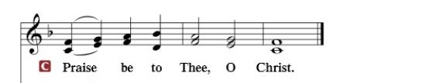

Nicene Creed
I believe in one God, the Father Almighty, maker of heaven and earth and of all things visible and invisible.
And in one Lord Jesus Christ, the only-begotten Son of God, begotten of His Father before all worlds, God of God, Light of Light, very God of very God, begotten, not made, being of one substance with the Father, by whom all things were made; who for us men and for our salvation came down from heaven and was incarnate by the Holy Spirit of the virgin Mary and was made man; and was crucified also for us under Pontius Pilate. He suffered and was buried. And the third day He rose again according to the Scriptures and ascended into heaven and sits at the right hand of the Father. And He will come again with glory to judge both the living and the dead, whose kingdom will have no end.
And I believe in the Holy Spirit, the Lord and giver of life, who proceeds from the Father and the Son, who with the Father and the Son together is worshiped and glorified, who spoke by the prophets. And I believe in one holy Christian and apostolic Church, I acknowledge one Baptism for the remission of sins, and I look for the resurrection of the dead and the life of the world to come. Amen.

SERMON HYMN: “To Jordan’s River Came Our Lord”……………...LSB #405

SERMON

OFFERTORY…………………………………………………………...LSB pp. 192-193

GENERAL PRAYERS OF THE CHURCH

Sharing the Peace of the Lord

SERVICE OF THE SACRAMENT
Preface…………………………………….…………….……….LSB p. 194
Proper Preface
It is truly good, right, and salutary that we should at all times and in all places give thanks to You, holy Lord, almighty Father, everlasting God, through Jesus Christ, our Lord, for at His Baptism Your voice from heaven revealed Him as Your beloved Son, and the Holy Spirit descended on Him, confirming Him to be the Christ. Therefore, with angels and archangels and with all the company of heaven we laud and magnify Your glorious name, ever more praising You and saying:

Sanctus, Lord’s Prayer, The Words of Our Lord………………….....LSB pp. 195-197
Agnus Dei………………………………………………………………..LSB p. 198
If you are not communing, it is acceptable to remain seated.

COMMUNION DISTRIBUTION HYMNS:
LSB #605 “Father Welcomes”
LSB #594 “God’s Own Child, I Gladly Say It”
LSB #590 “Baptized into Your Name Most Holy”

NUNC DIMITTIS………………………………………………………LSB pp. 199-200

BENEDICTION

CLOSING HYMN: “Go. My Children. With My Blessing”...................LSB #922

The Mission of Trinity Onekama Is To SERVE

For even the Son of Man did not come to be served
but to serve and to give his life as a ransom for many.
Mark 10:45

S haring Jesus’s truth
E quipping for life
R eaching Out
V aluing each other
E vangelizing all ages
Mission Statement
The mission of Trinity Onekama is to SERVE
For even the Son of Man did not come to be served, but to serve,
and to give his life as a ransom for many. Mark 10:45
S haring Jesus’ ruth
E quipping for life
R eaching Out
V aluing each other
E vangelizing all age

CHURCH INFORMATION
Church Office: (231) 889-4429 Website: www.trinityonekama.org
E-mail: trinityonekama@sbcglobal.net
Address: P.O. Box 119, 5471 Fairview Street, Onekama, MI 49675
Adult Bible Study: Sunday @ 9:30am (year round)
Worship: Sunday @ 10:30 am The Lord’s Supper: Celebrated 2nd & 4th Sundays
Pastoral Hours: Wednesday and Friday 9:00am – Noon
Pastor Phone: 231-655-2680 Pastor Email: trinityonekama@gmail.com

Copyright licensing covered under CCLI #2802932

