231-889-4429 5471 Fairview Street, Box 119 Onekama, MI

TRINITY LUTHERAN CHURCH
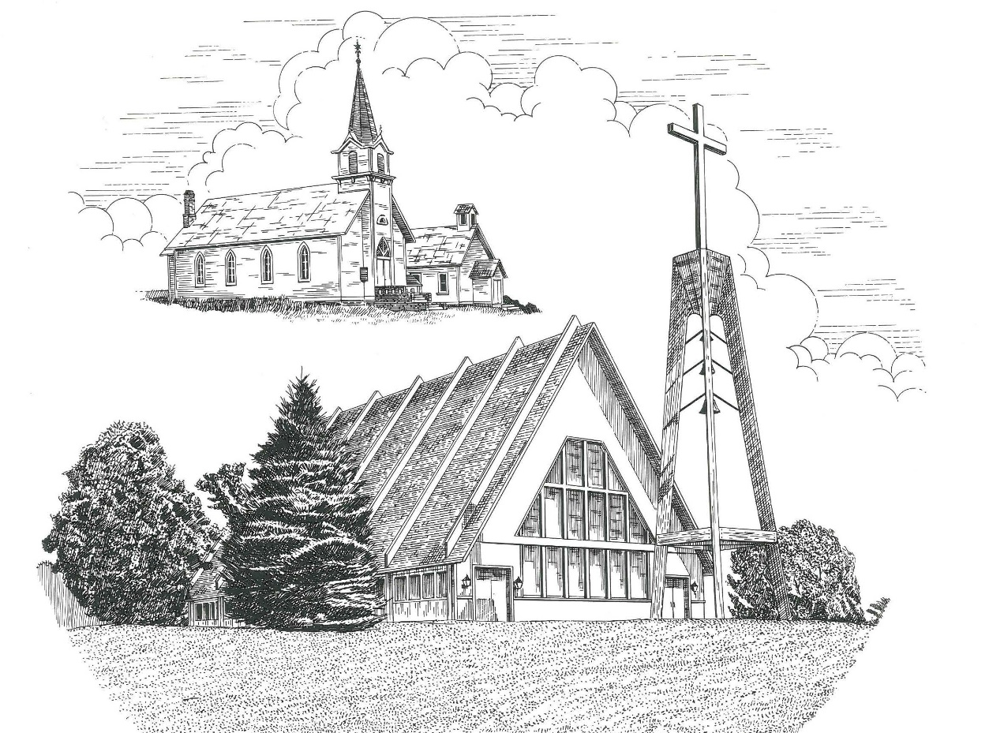

Seventh Sunday after Pentecost July 11th, 2021

WELCOME
Thanks for joining us!
Pastor Jacob Sherry Missouri Synod

~~PLEASE NOTE~~
Calling on the name of the Lord
Does not include the use of cell phones in the worship sanctuary.
Please check yours before the service begins. Thank you for your courtesy.
~~TO OUR GUESTS AND VISITORS~~
Please sign our guest book located on the stand at the church entrance. During the service, we ask you to sign the attendance booklet located at the end of each pew. If you need assistance or have questions about our worship service, please talk to an elder or any one of our church family. We are glad you could join us and hope to have you worship with us again soon.

~~ATTENDING HOLY COMMUNION~~
By checking the “Communing Today” box on the registration form found in the attendance booklet, you are agreeing with the following statements:

- I am a baptized Christian who believes Jesus Christ is my Lord and Savior.
- I believe that I am a sinner in need of Christ freely offered forgiveness.
- I believe that in the Lord’s Supper the body and blood of Jesus Christ
are truly present in, with, and under the bread and wine.
- I believe that my participation in Holy Communion grants me forgiveness
of my sins, new spiritual life, and eternal salvation.
- With God’s help, I sincerely seek to repent of my sins, live in service
to my Lord, and await His return.

If you agree with the above statements, you are welcome to attend the Lord’s Supper with us. May God bless your worship time with us.
We do offer gluten-free wafers, please quietly ask an elder to help you.

Order of Divine Service Setting Four

Pre-Service Music……………..Call to Worship………………….Greeting

OPENING HYMN: “Christ, Whose Glory Fills the Skies”……………LSB #873

OPENING LITURGY:
Confession & Absolution……………………………………….LSB p. 203
Kyrie……………………………………………………………..LSB p. 204
Gloria in Excelsis………………………………………………..LSB p. 204
Salutation….…………………………………………………….LSB p. 205

Collect Prayer
O Lord, You granted Your prophets strength to resist the temptations of the devil and courage to proclaim repentance. Give us pure hearts and minds to follow Your Son faithfully even into suffering and death; through the same Jesus Christ, our Lord, who lives and reigns with You and the Holy Spirit, one God, now and forever.

THE HOLY SCRIPTURES

OLD TESTAMENT: (Amos 7:7-15)
⁷ This is what he showed me: behold, the Lord was standing beside a wall built with a plumb line, with a plumb line in his hand. ⁸ And the Lord said to me, “Amos, what do you see?” And I said, “A plumb line.” Then the Lord said,
“Behold, I am setting a plumb line
in the midst of my people Israel;
I will never again pass by them;
⁹ the high places of Isaac shall be made desolate,
and the sanctuaries of Israel shall be laid waste,
and I will rise against the house of Jeroboam with the sword.”
¹⁰ Then Amaziah the priest of Bethel sent to Jeroboam king of Israel, saying, “Amos has conspired against you in the midst of the house of Israel. The land is not able to bear all his words. ¹¹ For thus Amos has said,
“‘Jeroboam shall die by the sword,
and Israel must go into exile
away from his land.’”
¹² And Amaziah said to Amos, “O seer, go, flee away to the land of Judah, and eat bread there, and prophesy there, ¹³ but never again prophesy at Bethel, for it is the king's sanctuary, and it is a temple of the kingdom.”
¹⁴ Then Amos answered and said to Amaziah, “I was no prophet, nor a prophet's son, but I was a herdsman and a dresser of sycamore figs. ¹⁵ But the Lord took me from following the flock, and the Lord said to me, ‘Go, prophesy to my people Israel.’

R: This is the Word of the Lord. Cong: Thanks be to God.

GRADUAL
Reader: Oh, the depth of the riches and wisdom and knowledge of God!
Cong.: How unsearchable are his judgments and how inscrutable his ways!
Reader: For from him and through him and to him are all things.
Cong.: To him be glory forever. Amen.

EPISTLE: (Ephesians 1:3-14)
³ Blessed be the God and Father of our Lord Jesus Christ, who has blessed us in Christ with every spiritual blessing in the heavenly places, ⁴ even as he chose us in him before the foundation of the world, that we should be holy and blameless before him. In love ⁵ he predestined us for adoption to himself as sons through Jesus Christ, according to the purpose of his will, ⁶ to the praise of his glorious grace, with which he has blessed us in the Beloved. ⁷ In him we have redemption through his blood, the forgiveness of our trespasses, according to the riches of his grace, ⁸ which he lavished upon us, in all wisdom and insight ⁹ making known to us the mystery of his will, according to his purpose, which he set forth in Christ ¹⁰ as a plan for the fullness of time, to unite all things in him, things in heaven and things on earth.
¹¹ In him we have obtained an inheritance, having been predestined according to the purpose of him who works all things according to the counsel of his will, ¹² so that we who were the first to hope in Christ might be to the praise of his glory. ¹³ In him you also, when you heard the word of truth, the gospel of your salvation, and believed in him, were sealed with the promised Holy Spirit, ¹⁴ who is the guarantee of our inheritance until we acquire possession of it, to the praise of his glory.

R: This is the Word of the Lord. Cong: Thanks be to God.

(PLEASE RISE for the reading of the Gospel)

R: The Holy Gospel according to St. Mark, the 6th chapter.
Cong: Glory to You, O Lord

HOLY GOSPEL: (Mark 6:14-29)
¹⁴ King Herod heard of it, for Jesus' name had become known. Some said, “John the Baptist has been raised from the dead. That is why these miraculous powers are at work in him.” ¹⁵ But others said, “He is Elijah.” And others said, “He is a prophet, like one of the prophets of old.” ¹⁶ But when Herod heard of it, he said, “John, whom I beheaded, has been raised.” ¹⁷ For it was Herod who had sent and seized John and bound him in prison for the sake of Herodias, his brother Philip's wife, because he had married her. ¹⁸ For John had been saying to Herod, “It is not lawful for you to have your brother's wife.” ¹⁹ And Herodias had a grudge against him and wanted to put him to death. But she could not, ²⁰ for Herod feared John, knowing that he was a righteous and holy man, and he kept him safe. When he heard him, he was greatly perplexed, and yet he heard him gladly.
²¹ But an opportunity came when Herod on his birthday gave a banquet for his nobles and military commanders and the leading men of Galilee. ²² For when Herodias's daughter came in and danced, she pleased Herod and his guests. And the king said to the girl, “Ask me for whatever you wish, and I will give it to you.” ²³ And he vowed to her, “Whatever you ask me, I will give you, up to half of my kingdom.” ²⁴ And she went out and said to her mother, “For what should I ask?” And she said, “The head of John the Baptist.” ²⁵ And she came in immediately with haste to the king and asked, saying, “I want you to give me at once the head of John the Baptist on a platter.” ²⁶ And the king was exceedingly sorry, but because of his oaths and his guests he did not want to break his word to her. ²⁷ And immediately the king sent an executioner with orders to bring John's head. He went and beheaded him in the prison ²⁸ and brought his head on a platter and gave it to the girl, and the girl gave it to her mother. ²⁹ When his disciples heard of it, they came and took his body and laid it in a tomb.

R: This is the Gospel of the Lord. Cong: Praise to You, O Christ.

Nicene Creed
I believe in one God, the Father Almighty, maker of heaven and earth and of all things visible and invisible.
And in one Lord Jesus Christ, the only-begotten Son of God, begotten of His Father before all worlds, God of God, Light of Light, very God of very God, begotten, not made, being of one substance with the Father, by whom all things were made; who for us men and for our salvation came down from heaven and was incarnate by the Holy Spirit of the virgin Mary and was made man; and was crucified also for us under Pontius Pilate. He suffered and was buried. And the third day He rose again according to the Scriptures and ascended into heaven and sits at the right hand of the Father. And He will come again with glory to judge both the living and the dead, whose kingdom will have no end.
And I believe in the Holy Spirit, the Lord and giver of life, who proceeds from the Father and the Son, who with the Father and the Son together is worshiped and glorified, who spoke by the prophets. And I believe in one holy Christian and apostolic Church, I acknowledge one Baptism for the remission of sins, and I look for the resurrection of the dead and the life of the world to come. Amen.

SERMON HYMN: “Jesus, Priceless Treasure”……………………………..LSB #743
SERMON

THE GENERAL PRAYERS

INSTITUTION OF THE LORD’S SUPPER
Preface…………………………………….…………….…………….LSB p. 208
Proper Preface
It is truly good, right, and salutary that we should at all times and in all places give thanks to You, O Lord, holy Father, almighty and everlasting God, for the countless blessings You so freely bestow on us and all creation. Above all, we give thanks for Your boundless love shown to us when You sent Your only-begotten Son, Jesus Christ, into our flesh and laid on Him our sin, giving Him into death that we might not die eternally. Because He is now risen from the dead and lives and reigns to all eternity, all who believe in Him will overcome sin and death and will rise again to new life. Therefore, with angels and archangels and with all the company of heaven we laud and magnify Your glorious name, ever more praising You and saying:
Sanctus, Lord’s Prayer, The Words of Our Lord………………….....LSB pp. 208-209
Agnus Dei………………………………………………………………..LSB p. 210
If you are not communing it is acceptable to remain seated.

COMMUNION DISTRIBUTION HYMNS:
LSB #619 “Thy Body, Given to Me, O Savior”
LSB #725 “Children of the Heavenly Father”

CLOSING LITURGY:………………………………………………....LSB pp. 211-212

CLOSING HYMN: “Savior, Again to Thy Dear Name We Raise”........LSB #917

The Mission of Trinity Onekama Is To SERVE

For even the Son of Man did not come to be served
but to serve and to give his life as a ransom for many.
Mark 10:45

S haring Jesus’s truth
E quipping for life
R eaching Out
V aluing each other
E vangelizing all ages
Mission Statement
The mission of Trinity Onekama is to SERVE
For even the Son of Man did not come to be served, but to serve,
and to give his life as a ransom for many. Mark 10:45
S haring Jesus’ ruth
E quipping for life
R eaching Out
V aluing each other
E vangelizing all age

CHURCH INFORMATION
Church Office: (231) 889-4429 Website: www.trinityonekama.org
E-mail: trinityonekama@sbcglobal.net
Address: P.O. Box 119, 5471 Fairview Street, Onekama, MI 49675
Adult Bible Study: Sunday @ 9:15 am (year round)
Worship: Sunday @ 10:30 am The Lord’s Supper: Celebrated 2nd & 4th Sundays
Pastoral Hours: Wednesday and Friday 8:30am – Noon
Pastor Phone: 231-655-2680 Pastor Email: trinityonekama@gmail.com

Copyright licensing covered under CCLI #2802932

