231-889-4429 5471 Fairview Street, Box 119 Onekama, MI

TRINITY LUTHERAN CHURCH
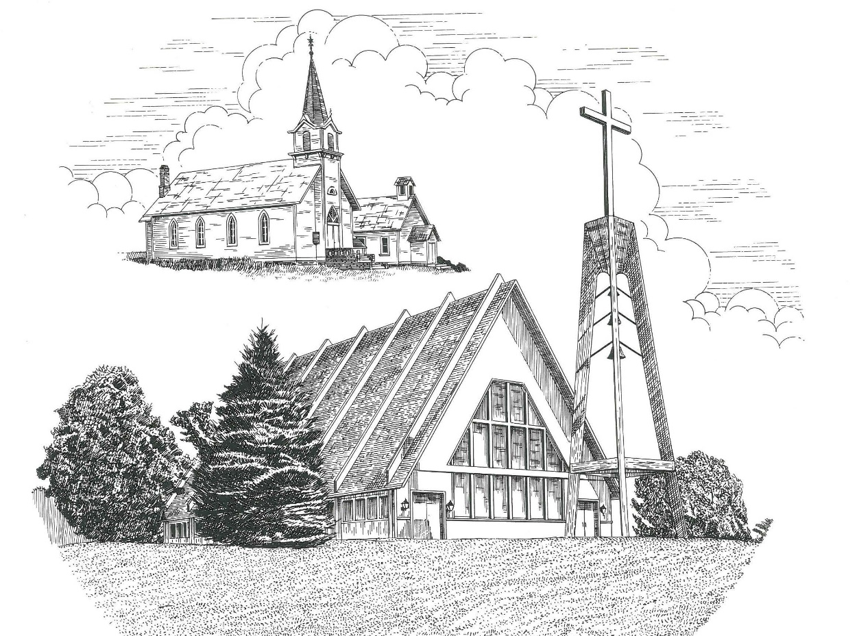

Seventh Sunday after Pentecost July 24th, 2022

WELCOME
Thanks for joining us!
Pastor Jacob Sherry Missouri Synod

~~PLEASE NOTE~~
Calling on the name of the Lord
Does not include the use of cell phones in the worship sanctuary.
Please check yours before the service begins. Thank you for your courtesy.
~~TO OUR GUESTS AND VISITORS~~
Please sign our guest book located on the stand at the church entrance. During the service, we ask you to sign the attendance sheet located in your bulletin and place it on the pew when you leave. If you need assistance or have questions about our worship service, please talk to an elder or any one of our church family. We are glad you could join us and hope to have you worship with us again soon.

~~ATTENDING HOLY COMMUNION~~
By checking the “Communing Today” box on the registration form found on the attendance sheet, you are agreeing with the following statements:

- I am a baptized Christian who believes Jesus Christ is my Lord and Savior.
- I believe that I am a sinner in need of Christ freely offered forgiveness.
- I believe that in the Lord’s Supper the body and blood of Jesus Christ
are truly present in, with, and under the bread and wine.
- I believe that my participation in Holy Communion grants me forgiveness
of my sins, new spiritual life, and eternal salvation.
- With God’s help, I sincerely seek to repent of my sins, live in service
to my Lord, and await His return.

If you agree with the above statements, you are welcome to attend the Lord’s Supper with us. May God bless your worship time with us.
We do offer gluten-free wafers, please quietly ask an elder to help you.

Order of Divine Service Setting Three

Pre-Service Music……………..Call to Worship………………….Greeting

OPENING HYMN: “Christ Is Our Cornerstone”...................................LSB #912
OPENING LITURGY:
Confession & Absolution………..………………………………LSB pp. 184-185
Kyrie…………………………………….………………………..LSB p. 186
Gloria in Excelsis………………………………………………...LSB pp. 187-189
Salutation….……………………………….…………………….LSB p. 189

Collect Prayer
O Lord, let Your merciful ears be attentive to the prayers of Your servants, and by Your Word and Spirit teach us how to pray that our petitions may be pleasing before You; through Jesus Christ, Your Son, our Lord, who lives and reigns with You and the Holy Spirit, one God, now and forever.

THE HOLY SCRIPTURES

OLD TESTAMENT: (Genesis 18:20-33)
²⁰ Then the Lord said, “Because the outcry against Sodom and Gomorrah is great and their sin is very grave, ²¹ I will go down to see whether they have done altogether according to the outcry that has come to me. And if not, I will know.”
²² So the men turned from there and went toward Sodom, but Abraham still stood before the Lord. ²³ Then Abraham drew near and said, “Will you indeed sweep away the righteous with the wicked? ²⁴ Suppose there are fifty righteous within the city. Will you then sweep away the place and not spare it for the fifty righteous who are in it? ²⁵ Far be it from you to do such a thing, to put the righteous to death with the wicked, so that the righteous fare as the wicked! Far be that from you! Shall not the Judge of all the earth do what is just?” ²⁶ And the Lord said, “If I find at Sodom fifty righteous in the city, I will spare the whole place for their sake.”
²⁷ Abraham answered and said, “Behold, I have undertaken to speak to the Lord, I who am but dust and ashes. ²⁸ Suppose five of the fifty righteous are lacking. Will you destroy the whole city for lack of five?” And he said, “I will not destroy it if I find forty-five there.” ²⁹ Again he spoke to him and said, “Suppose forty are found there.” He answered, “For the sake of forty I will not do it.” ³⁰ Then he said, “Oh let not the Lord be angry, and I will speak. Suppose thirty are found there.” He answered, “I will not do it, if I find thirty there.” ³¹ He said, “Behold, I have undertaken to speak to the Lord. Suppose twenty are found there.” He answered, “For the sake of twenty I will not destroy it.” ³² Then he said, “Oh let not the Lord be angry, and I will speak again but this once. Suppose ten are found there.” He answered, “For the sake of ten I will not destroy it.” ³³ And the Lord went his way, when he had finished speaking to Abraham, and Abraham returned to his place.

R: This is the Word of the Lord. Cong: Thanks be to God.

GRADUAL
Reader: How beautiful are the feet of those who preach the good news,
Cong.: who publish peace and bring good news of salvation.
Reader: Their voice has gone out to all the earth,
Cong.: and their words to the ends of the world.

EPISTLE: (Colossians 2:6-15)
⁶ Therefore, as you received Christ Jesus the Lord, so walk in him, ⁷ rooted and built up in him and established in the faith, just as you were taught, abounding in thanksgiving. ⁸ See to it that no one takes you captive by philosophy and empty deceit, according to human tradition, according to the elemental spirits of the world, and not according to Christ. ⁹ For in him the whole fullness of deity dwells bodily, ¹⁰ and you have been filled in him, who is the head of all rule and authority. ¹¹ In him also you were circumcised with a circumcision made without hands, by putting off the body of the flesh, by the circumcision of Christ, ¹² having been buried with him in baptism, in which you were also raised with him through faith in the powerful working of God, who raised him from the dead. ¹³ And you, who were dead in your trespasses and the uncircumcision of your flesh, God made alive together with him, having forgiven us all our trespasses, ¹⁴by canceling the record of debt that stood against us with its legal demands. This he set aside, nailing it to the cross. ¹⁵ He disarmed the rulers and authorities and put them to open shame, by triumphing over them in him.

R: This is the Word of the Lord. Cong: Thanks be to God.

(PLEASE RISE for the reading of the Gospel)

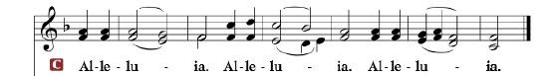

R: The Holy Gospel according to St. Luke, the 11th chapter.

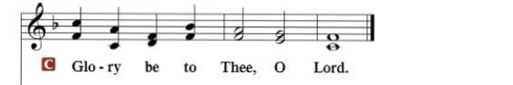

HOLY GOSPEL: (Luke 11:1-13)
Now Jesus was praying in a certain place, and when he finished, one of his disciples said to him, “Lord, teach us to pray, as John taught his disciples.” ² And he said to them, “When you pray, say:
“Father, hallowed be your name.
Your kingdom come.
³ Give us each day our daily bread,
⁴ and forgive us our sins,
for we ourselves forgive everyone who is indebted to us.
And lead us not into temptation.”
⁵ And he said to them, “Which of you who has a friend will go to him at midnight and say to him, ‘Friend, lend me three loaves, ⁶ for a friend of mine has arrived on a journey, and I have nothing to set before him’; ⁷ and he will answer from within, ‘Do not bother me; the door is now shut, and my children are with me in bed. I cannot get up and give you anything’? ⁸ I tell you, though he will not get up and give him anything because he is his friend, yet because of his impudence he will rise and give him whatever he needs. ⁹ And I tell you, ask, and it will be given to you; seek, and you will find; knock, and it will be opened to you. ¹⁰ For everyone who asks receives, and the one who seeks finds, and to the one who knocks it will be opened. ¹¹ What father among you, if his son asks for a fish, will instead of a fish give him a serpent; ¹² or if he asks for an egg, will give him a scorpion? ¹³ If you then, who are evil, know how to give good gifts to your children, how much more will the heavenly Father give the Holy Spirit to those who ask him!”
R: This is the Gospel of the Lord.

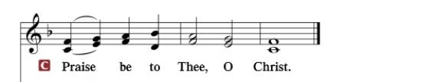

Nicene Creed…...……………………………………………………..…LSB p. 191
I believe in one God, the Father Almighty, maker of heaven and earth and of all things visible and invisible.
And in one Lord Jesus Christ, the only-begotten Son of God, begotten of His Father before all worlds, God of God, Light of Light, very God of very God, begotten, not made, being of one substance with the Father, by whom all things were made; who for us men and for our salvation came down from heaven and was incarnate by the Holy Spirit of the virgin Mary and was made man; and was crucified also for us under Pontius Pilate. He suffered and was buried. And the third day He rose again according to the Scriptures and ascended into heaven and sits at the right hand of the Father. And He will come again with glory to judge both the living and the dead, whose kingdom will have no end.
And I believe in the Holy Spirit, the Lord and giver of life, who proceeds from the Father and the Son, who with the Father and the Son together is worshiped and glorified, who spoke by the prophets. And I believe in one holy Christian and apostolic Church, I acknowledge one Baptism for the remission of sins, and I look for the resurrection of the dead and the life of the world to come. Amen.

SERMON HYMN: “The Lamb”………..................................................LSB #547

SERMON

OFFERTORY…………………………………………………………...LSB pp. 192-193

GENERAL PRAYERS OF THE CHURCH

Sharing the Peace of the Lord

SERVICE OF THE SACRAMENT
Preface…………………………………….…………….……….LSB p. 194
Proper Preface
It is truly good, right, and salutary that we should at all times and in all places give thanks to You, holy Lord, almighty Father, everlasting God, through Jesus Christ, our Lord, who, out of love for His fallen creation, humbled Himself by taking on the form of a servant, becoming obedient unto death, even death upon a cross. Risen from the dead, He has freed us from eternal death and given us life everlasting. Therefore, with angels and archangels and with all the company of heaven we laud and magnify Your glorious name, ever more praising You and saying:

Sanctus, Lord’s Prayer, The Words of Our Lord………………….....LSB pp. 195-197
Agnus Dei………………………………………………………………..LSB p. 198
If you are not communing, it is acceptable to remain seated.

COMMUNION DISTRIBUTION HYMNS:
LSB #740 “I Am Jesus’ Little Lamb”
LSB #680 “Thine the Amen, Thine the Praise”
LSB #766 “Our Father, Who from Heaven Above”

NUNC DIMITTIS………………………………………………………LSB pp. 199-200

BENEDICTION

CLOSING HYMN: “All Hail the Power of Jesus’ Name”.....................LSB #549

The Mission of Trinity Onekama Is To SERVE

For even the Son of Man did not come to be served
but to serve and to give his life as a ransom for many.
Mark 10:45

S haring Jesus’s truth
E quipping for life
R eaching Out
V aluing each other
E vangelizing all ages
Mission Statement
The mission of Trinity Onekama is to SERVE
For even the Son of Man did not come to be served, but to serve,
and to give his life as a ransom for many. Mark 10:45
S haring Jesus’ ruth
E quipping for life
R eaching Out
V aluing each other
E vangelizing all age

CHURCH INFORMATION
Church Office: (231) 889-4429 Website: www.trinityonekama.org
E-mail: trinityonekama@sbcglobal.net
Address: P.O. Box 119, 5471 Fairview Street, Onekama, MI 49675
Adult Bible Study: Sunday @ 11:30 am (year round)
Worship: Sunday @ 10:30 am The Lord’s Supper: Celebrated 2nd & 4th Sundays
Pastoral Hours: Wednesday and Friday 9:00am – Noon
Pastor Phone: 231-655-2680 Pastor Email: trinityonekama@gmail.com

Copyright licensing covered under CCLI #2802932

