231-889-4429 5471 Fairview Street, Box 119 Onekama, MI

TRINITY LUTHERAN CHURCH
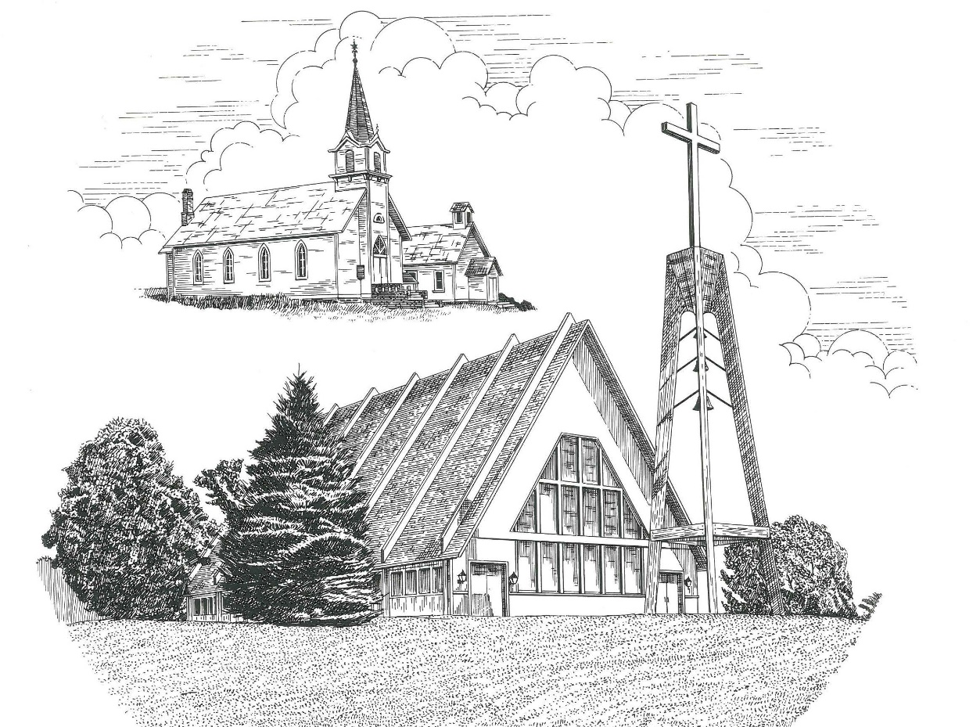

Holy Trinity Sunday June 12th, 2022

WELCOME
Thanks for joining us!
Pastor Jacob Sherry Missouri Synod

~~PLEASE NOTE~~
Calling on the name of the Lord
Does not include the use of cell phones in the worship sanctuary.
Please check yours before the service begins. Thank you for your courtesy.
~~TO OUR GUESTS AND VISITORS~~
Please sign our guest book located on the stand at the church entrance. During the service, we ask you to sign the attendance sheet in your bulletin and leave it on the pew as you leave. If you need assistance or have questions about our worship service, please talk to an elder or any one of our church family. We are glad you could join us and hope to have you worship with us again soon.

~~ATTENDING HOLY COMMUNION~~
By checking the “Communing Today” box on the registration form found on the attendance sheet, you are agreeing with the following statements:

- I am a baptized Christian who believes Jesus Christ is my Lord and Savior.
- I believe that I am a sinner in need of Christ freely offered forgiveness.
- I believe that in the Lord’s Supper the body and blood of Jesus Christ
are truly present in, with, and under the bread and wine.
- I believe that my participation in Holy Communion grants me forgiveness
of my sins, new spiritual life, and eternal salvation.
- With God’s help, I sincerely seek to repent of my sins, live in service
to my Lord, and await His return.

If you agree with the above statements, you are welcome to attend the Lord’s Supper with us. May God bless your worship time with us.
We do offer gluten-free wafers, please quietly ask an elder to help you.

Order of Divine Service Setting Four

Pre-Service Music……………..Call to Worship………………….Greeting

OPENING HYMN: “We All Believe in One True God”……………….LSB #953

OPENING LITURGY
Confession & Absolution……………………………………….LSB p. 203
Kyrie……………………………………………………………..LSB p. 204
Gloria in Excelsis………………………………………………..LSB p. 204
Salutation….…………………………………………………….LSB p. 205

Collect Prayer
Almighty and everlasting God, You have given us grace to acknowledge the glory of the eternal Trinity by the confession of a true faith and to worship the Unity in the power of the Divine Majesty. Keep us steadfast in this faith and defend us from all adversities; for You, O Father, Son, and Holy Spirit, live and reign, one God, now and forever.

THE HOLY SCRIPTURES

FIRST READING: (Proverbs 8:1-4, 22-31)
Does not wisdom call?
Does not understanding raise her voice?
² On the heights beside the way,
at the crossroads she takes her stand;
³ beside the gates in front of the town,
at the entrance of the portals she cries aloud:
⁴ “To you, O men, I call,
and my cry is to the children of man.
²² “The Lord possessed me at the beginning of his work,
the first of his acts of old.
²³ Ages ago I was set up,
at the first, before the beginning of the earth.
²⁴ When there were no depths I was brought forth,
when there were no springs abounding with water.
²⁵ Before the mountains had been shaped,
before the hills, I was brought forth,
²⁶ before he had made the earth with its fields,
or the first of the dust of the world.
²⁷ When he established the heavens, I was there;
when he drew a circle on the face of the deep,
²⁸ when he made firm the skies above,
when he established the fountains of the deep,
²⁹ when he assigned to the sea its limit,
so that the waters might not transgress his command,
when he marked out the foundations of the earth,
³⁰ then I was beside him, like a master workman,
and I was daily his^{[e]} delight,
rejoicing before him always,
³¹ rejoicing in his inhabited world
and delighting in the children of man.

R: This is the Word of the Lord. Cong: Thanks be to God.

GRADUAL
Reader: The word is near you, in your mouth and in your heart,
Cong.: the word of faith that we proclaim.
Reader: For with the heart one believes and is justified,
Cong.: and with the mouth one confesses and is saved.

SECOND READING: (Acts 2:14a, 22-36)
¹⁴ But Peter, standing with the eleven, lifted up his voice and addressed them:
²² “Men of Israel, hear these words: Jesus of Nazareth, a man attested to you by God with mighty works and wonders and signs that God did through him in your midst, as you yourselves know— ²³ this Jesus, delivered up according to the definite plan and foreknowledge of God, you crucified and killed by the hands of lawless men. ²⁴ God raised him up, loosing the pangs of death, because it was not possible for him to be held by it. ²⁵ For David says concerning him,

“‘I saw the Lord always before me,
for he is at my right hand that I may not be shaken;
²⁶ therefore my heart was glad, and my tongue rejoiced;
my flesh also will dwell in hope.
²⁷ For you will not abandon my soul to Hades,
or let your Holy One see corruption.
²⁸ You have made known to me the paths of life;
you will make me full of gladness with your presence.’

²⁹ “Brothers, I may say to you with confidence about the patriarch David that he both died and was buried, and his tomb is with us to this day. ³⁰ Being therefore a prophet, and knowing that God had sworn with an oath to him that he would set one of his descendants on his throne, ³¹ he foresaw and spoke about the resurrection of the Christ, that he was not abandoned to Hades, nor did his flesh see corruption. ³² This Jesus God raised up, and of that we all are witnesses. ³³ Being therefore exalted at the right hand of God, and having received from the Father the promise of the Holy Spirit, he has poured out this that you yourselves are seeing and hearing. ³⁴ For David did not ascend into the heavens, but he himself says,
“‘The Lord said to my Lord,
“Sit at my right hand,
³⁵ until I make your enemies your footstool.”’

³⁶ Let all the house of Israel therefore know for certain that God has made him both Lord and Christ, this Jesus whom you crucified.”

R: This is the Word of the Lord. Cong: Thanks be to God.

(PLEASE RISE for the reading of the Gospel)

R: The Holy Gospel according to St. John, the 8th chapter.
Cong: Glory to You, O Lord

HOLY GOSPEL: (John 8:48-59)
⁴⁸ The Jews answered him, “Are we not right in saying that you are a Samaritan and have a demon?” ⁴⁹ Jesus answered, “I do not have a demon, but I honor my Father, and you dishonor me. ⁵⁰ Yet I do not seek my own glory; there is One who seeks it, and he is the judge. ⁵¹ Truly, truly, I say to you, if anyone keeps my word, he will never see death.” ⁵² The Jews said to him, “Now we know that you have a demon! Abraham died, as did the prophets, yet you say, ‘If anyone keeps my word, he will never taste death.’ ⁵³ Are you greater than our father Abraham, who died? And the prophets died! Who do you make yourself out to be?” ⁵⁴ Jesus answered, “If I glorify myself, my glory is nothing. It is my Father who glorifies me, of whom you say, ‘He is our God.’ ⁵⁵ But you have not known him. I know him. If I were to say that I do not know him, I would be a liar like you, but I do know him and I keep his word. ⁵⁶ Your father Abraham rejoiced that he would see my day. He saw it and was glad.” ⁵⁷ So the Jews said to him, “You are not yet fifty years old, and have you seen Abraham?” ⁵⁸ Jesus said to them, “Truly, truly, I say to you, before Abraham was, I am.” ⁵⁹ So they picked up stones to throw at him, but Jesus hid himself and went out of the temple.

R: This is the Gospel of the Lord. Cong: Praise to You, O Christ.

ATHANASIAN CREED
(P): Whoever desires to be saved must, above all, hold the catholic faith.
(C): Whoever does not keep it whole and undefiled will without doubt perish
eternally.
(P): And the catholic faith is this,
(C): that we worship one God in Trinity and Trinity in Unity, neither confusing the
persons nor dividing the substance.
(P): For the Father is one person, the Son is another, and the Holy Spirit is another.
(C): But the Godhead of the Father and of the Son and of the Holy Spirit is one: the
glory equal, the majesty coeternal.
(P): Such as the Father is, such is the Son, and such is the Holy Spirit:
(C): the Father uncreated, the Son uncreated, the Holy Spirit uncreated;
(P): the Father infinite, the Son infinite, the Holy Spirit infinite;
(C): the Father eternal, the Son eternal, the Holy Spirit eternal.
(P): And yet there are not three Eternals, but one Eternal,
(C): just as there are not three Uncreated or three Infinities, but one Uncreated and
one Infinite.
(P): In the same way, the Father is almighty, the Son almighty, the Holy Spirit almighty;
(C): and yet there are not three Almighties, but one Almighty.
(P): So the Father is God, the Son is God, the Holy Spirit is God;
(C): and yet there are not three Gods, but one God.
(P): So the Father is Lord, the Son is Lord, the Holy Spirit is Lord;
(C): and yet there are not three Lords, but one Lord.
(P): Just as we are compelled by the Christian truth to acknowledge each distinct person
as God and Lord, so also are we prohibited by the catholic religion to say that there
are three Gods or Lords.
(C): The Father is not made nor created nor begotten by anyone.
(P): The Son is neither made nor created, but begotten of the Father alone.
(C): The Holy Spirit is of the Father and of the Son, neither made nor created nor
begotten but proceeding.
(P): Thus, there is one Father, not three Fathers; one Son, not three Sons; one Holy Spirit,
not three Holy Spirits.
(C): And in this Trinity none is before or after another; none is greater or less than
another;
(P): but the whole three persons are coeternal with each other and coequal, so that in all
things, as has been stated above, the Trinity in Unity and Unity in Trinity is to be
worshiped.
(C): Therefore, whoever desires to be saved must think thus about the Trinity.
(P): But it is also necessary for everlasting salvation that one faithfully believe the
incarnation of our Lord Jesus Christ.
(C): Therefore, it is the right faith that we believe and confess that our Lord Jesus
Christ, the Son of God, is at the same time both God and man.
(P): He is God, begotten from the substance of the Father before all ages; and He is man,
born from the substance of His mother in this age:
(C): perfect God and perfect man, composed of a rational soul and human flesh;
(P): equal to the Father with respect to His divinity, less than the Father with respect to
His humanity.
(C): Although He is God and man, He is not two, but one Christ:
(P): one, however, not by the conversion of the divinity into flesh, but by the assumption
of the humanity into God;
(C): one altogether, not by confusion of substance, but by unity of person.
(P): For as the rational soul and flesh is one man, so God and man is one Christ,
(C): who suffered for our salvation, descended into hell, rose again the third day
from the dead,
(P): ascended into heaven, and is seated at the right hand of the Father, God Almighty,
from whence He will come to judge the living and the dead.
(C): At His coming all people will rise again with their bodies and give an account
concerning their own deeds.
(P): And those who have done good will enter into eternal life, and those who have done
evil into eternal fire.
(C): This is the catholic faith; whoever does not believe it faithfully and firmly
cannot be saved.

SERMON HYMN: “Father Most Holy”………………………………..LSB #504

SERMON

THE GENERAL PRAYERS

OFFERTORY HYMN: “Let the Vineyards Be Fruitful”………………LSB #955
Sharing the Peace of the Lord

SERVICE OF THE SACRAMENT
Preface…………………………………….…………….………..LSB p. 208
Proper Preface
It is truly good, right, and salutary that we should at all times and in all places give thanks to You, O Lord, holy Father, almighty and everlasting God, for the countless blessings You so freely bestow on us and all creation. Above all, we give thanks for Your boundless love shown to us when You sent Your only-begotten Son, Jesus Christ, into our flesh and laid on Him our sin, giving Him into death that we might not die eternally. Because He is now risen from the dead and lives and reigns to all eternity, all who believe in Him will overcome sin and death and will rise again to new life. Therefore, with angels and archangels and with all the company of heaven we laud and magnify Your glorious name, ever more praising You and saying:

Sanctus, Lord’s Prayer, The Words of Our Lord………………….....LSB pp. 208-209
Agnus Dei………………………………………………………………..LSB p. 210
If you are not communing, it is acceptable to remain seated.

COMMUNION DISTRIBUTION HYMNS:
LSB #506 “Glory Be to God the Father”
LSB #617 “O Lord, We Praise Thee”
LSB #588“Jesus Loves Me”

CLOSING LITURGY:………………………………………………....LSB pp. 211-212

CLOSING HYMN: “Holy, Holy, Holy”.................................................LSB #507

The Mission of Trinity Onekama Is To SERVE

For even the Son of Man did not come to be served
but to serve and to give his life as a ransom for many.
Mark 10:45

S haring Jesus’s truth
E quipping for life
R eaching Out
V aluing each other
E vangelizing all ages
Mission Statement
The mission of Trinity Onekama is to SERVE
For even the Son of Man did not come to be served, but to serve,
and to give his life as a ransom for many. Mark 10:45
S haring Jesus’ ruth
E quipping for life
R eaching Out
V aluing each other
E vangelizing all age

CHURCH INFORMATION
Church Office: (231) 889-4429 Website: www.trinityonekama.org
E-mail: trinityonekama@sbcglobal.net
Address: P.O. Box 119, 5471 Fairview Street, Onekama, MI 49675
Adult Bible Study: Sunday @ 11:30 am (year round)
Worship: Sunday @ 10:30 am The Lord’s Supper: Celebrated 2nd & 4th Sundays
Pastoral Hours: Wednesday and Friday 9:00am – Noon
Pastor Phone: 231-655-2680 Pastor Email: trinityonekama@gmail.com

Copyright licensing covered under CCLI #2802932

