231-889-4429 5471 Fairview Street, Box 119 Onekama, MI

TRINITY LUTHERAN CHURCH
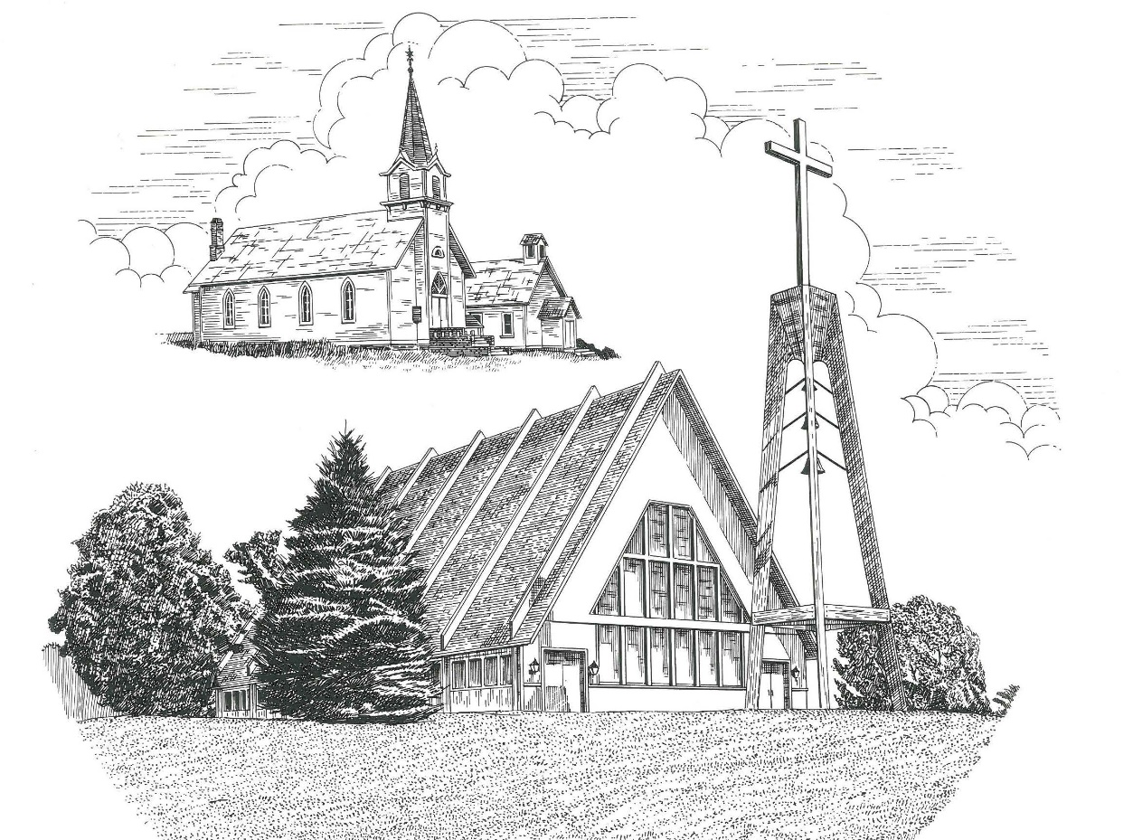

Fourth Sunday after Pentecost June 20th, 2021

WELCOME
Thanks for joining us!
Pastor Jacob Sherry Missouri Synod

~~PLEASE NOTE~~
Calling on the name of the Lord
Does not include the use of cell phones in the worship sanctuary.
Please check yours before the service begins. Thank you for your courtesy.
~~TO OUR GUESTS AND VISITORS~~
Please sign our guest book located on the stand at the church entrance. During the service, we ask you to sign the attendance booklet located at the end of each pew. If you need assistance or have questions about our worship service, please talk to an elder or any one of our church family. We are glad you could join us and hope to have you worship with us again soon.

~~ATTENDING HOLY COMMUNION~~
By checking the “Communing Today” box on the registration form found in the attendance booklet, you are agreeing with the following statements:

- I am a baptized Christian who believes Jesus Christ is my Lord and Savior.
- I believe that I am a sinner in need of Christ freely offered forgiveness.
- I believe that in the Lord’s Supper the body and blood of Jesus Christ
are truly present in, with, and under the bread and wine.
- I believe that my participation in Holy Communion grants me forgiveness
of my sins, new spiritual life, and eternal salvation.
- With God’s help, I sincerely seek to repent of my sins, live in service
to my Lord, and await His return.

If you agree with the above statements, you are welcome to attend the Lord’s Supper with us. May God bless your worship time with us.
We do offer gluten-free wafers, please quietly ask an elder to help you.

Order of Divine Service Setting Three

Pre-Service Music……………..Call to Worship………………….Greeting

OPENING HYMN: “Praise to the Lord, the Almighty”..........................LSB #790

OPENING LITURGY:
Confession & Absolution………..………………………………LSB pp. 184-185
Kyrie…………………………………….………………………..LSB p. 186
Gloria in Excelsis……...…………………………………………LSB pp. 187-188
Salutation….……………………………….…………………….LSB p. 189

Collect Prayer
Almighty God, in Your mercy guide the course of this world so that Your Church may joyfully serve You in godly peace and quietness; through Jesus Christ, Your Son, our Lord, who lives and reigns with You and the Holy Spirit, one God, now and forever.

THE HOLY SCRIPTURES

OLD TESTAMENT READING: (Job 38:1-11)
Then the Lord answered Job out of the whirlwind and said:
² “Who is this that darkens counsel by words without knowledge?
³ Dress for action like a man;
I will question you, and you make it known to me.
⁴ “Where were you when I laid the foundation of the earth?
Tell me, if you have understanding.
⁵ Who determined its measurements—surely you know!
Or who stretched the line upon it?
⁶ On what were its bases sunk,
or who laid its cornerstone,
⁷ when the morning stars sang together
and all the sons of God shouted for joy?
⁸ “Or who shut in the sea with doors
when it burst out from the womb,
⁹ when I made clouds its garment
and thick darkness its swaddling band,
¹⁰ and prescribed limits for it
and set bars and doors,
¹¹ and said, ‘Thus far shall you come, and no farther,
and here shall your proud waves be stayed’?

R: This is the Word of the Lord. Cong: Thanks be to God.

GRADUAL
Reader: Great is the Lord, and greatly to be praised,
Cong.: and his greatness is unsearchable.
Reader: On your wondrous works, I will meditate,
Cong.: and I will declare your greatness.

EPISTLE READING: (2 Corinthians 6:1-13)
6 Working together with him, then, we appeal to you not to receive the grace of God in vain. ² For he says,
“In a favorable time I listened to you,
and in a day of salvation I have helped you.”
Behold, now is the favorable time; behold, now is the day of salvation. ³ We put no obstacle in anyone's way, so that no fault may be found with our ministry, ⁴ but as servants of God we commend ourselves in every way: by great endurance, in afflictions, hardships, calamities, ⁵ beatings, imprisonments, riots, labors, sleepless nights, hunger; ⁶ by purity, knowledge, patience, kindness, the Holy Spirit, genuine love; ⁷ by truthful speech, and the power of God; with the weapons of righteousness for the right hand and for the left; ⁸ through honor and dishonor, through slander and praise. We are treated as impostors, and yet are true; ⁹ as unknown, and yet well known; as dying, and behold, we live; as punished, and yet not killed; ¹⁰ as sorrowful, yet always rejoicing; as poor, yet making many rich; as having nothing, yet possessing everything. ¹¹ We have spoken freely to you, Corinthians; our heart is wide open. ¹² You are not restricted by us, but you are restricted in your own affections. ¹³ In return (I speak as to children) widen your hearts also.

R: This is the Word of the Lord. Cong: Thanks be to God.

(PLEASE RISE for the reading of the Gospel)

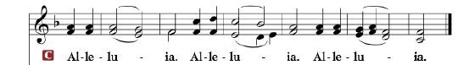

R: The Holy Gospel according to St. Mark, the 4th chapter.

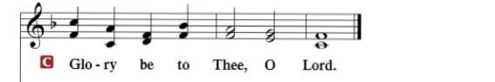

HOLY GOSPEL: (Mark 4:35-41)
³⁵ On that day, when evening had come, Jesus said to them, “Let us go across to the other side.” ³⁶ And leaving the crowd, they took him with them in the boat, just as he was. And other boats were with him. ³⁷ And a great windstorm arose, and the waves were breaking into the boat, so that the boat was already filling. ³⁸ But he was in the stern, asleep on the cushion. And they woke him and said to him, “Teacher, do you not care that we are perishing?” ³⁹ And he awoke and rebuked the wind and said to the sea, “Peace! Be still!” And the wind ceased, and there was a great calm. ⁴⁰ He said to them, “Why are you so afraid? Have you still no faith?” ⁴¹ And they were filled with great fear and said to one another, “Who then is this, that even the wind and the sea obey him?”

R: This is the Gospel of the Lord.

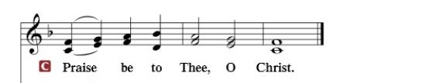

Nicene Creed
I believe in one God, the Father Almighty, maker of heaven and earth and of all things visible and invisible.
And in one Lord Jesus Christ, the only-begotten Son of God, begotten of His Father before all worlds, God of God, Light of Light, very God of very God, begotten, not made, being of one substance with the Father, by whom all things were made; who for us men and for our salvation came down from heaven and was incarnate by the Holy Spirit of the virgin Mary and was made man; and was crucified also for us under Pontius Pilate. He suffered and was buried. And the third day He rose again according to the Scriptures and ascended into heaven and sits at the right hand of the Father. And He will come again with glory to judge both the living and the dead, whose kingdom will have no end.
And I believe in the Holy Spirit, the Lord and giver of life, who proceeds from the Father and the Son, who with the Father and the Son together is worshiped and glorified, who spoke by the prophets. And I believe in one holy Christian and apostolic Church, I acknowledge one Baptism for the remission of sins, and I look for the resurrection of the dead and the life of the world to come. Amen.

SERMON HYMN: “On Eagles’ Wings”.................................................LSB #727

SERMON

OFFERTORY……………………………………………………..……LSB pp. 192-193

THE GENERAL PRAYERS OF THE CHURCH

INSTITUTION OF THE LORD’S SUPPER
Preface…………………………………….…………….……….LSB p. 194

Proper Preface
It is truly good, right, and salutary that we should at all times and in all places give thanks to You, holy Lord, almighty Father, everlasting God, through Jesus Christ, our Lord, who, out of love for His fallen creation, humbled Himself by taking on the form of a servant, becoming obedient unto death, even death upon a cross. Risen from the dead, He has freed us from eternal death and given us life everlasting. Therefore, with angels and archangels and with all the company of heaven we laud and magnify Your glorious name, ever more praising You and saying:
Sanctus, Lord’s Prayer, The Words of Our Lord………………….....LSB pp. 195-197
Agnus Dei………………………………………………………………..LSB p. 198
If you are not communing it is acceptable to remain seated.

COMMUNION DISTRIBUTION HYMNS:
LSB #717 “Eternal Father, Strong to Save”
LSB #752 “Be Still, My Soul”

NUNC DIMITTIS………………………………………………………LSB pp. 199-200

BENEDICTION

CLOSING HYMN: “What a Friend We Have in Jesus”........................LSB #770

The Mission of Trinity Onekama Is To SERVE

For even the Son of Man did not come to be served
but to serve and to give his life as a ransom for many.
Mark 10:45

S haring Jesus’s truth
E quipping for life
R eaching Out
V aluing each other
E vangelizing all ages
Mission Statement
The mission of Trinity Onekama is to SERVE
For even the Son of Man did not come to be served, but to serve,
and to give his life as a ransom for many. Mark 10:45
S haring Jesus’ ruth
E quipping for life
R eaching Out
V aluing each other
E vangelizing all age

CHURCH INFORMATION
Church Office: (231) 889-4429 Website: www.trinityonekama.org
E-mail: trinityonekama@sbcglobal.net
Address: P.O. Box 119, 5471 Fairview Street, Onekama, MI 49675
Adult Bible Study: Sunday @ 9:15 am (year round)
Worship: Sunday @ 10:30 am The Lord’s Supper: Celebrated 2nd & 4th Sundays
Pastoral Hours: Wednesday and Friday 8:30am – Noon
Pastor Phone: 231-655-2680 Pastor Email: trinityonekama@gmail.com

Copyright licensing covered under CCLI #2802932

