231-889-4429 5471 Fairview Street, Box 119 Onekama, MI

TRINITY LUTHERAN CHURCH
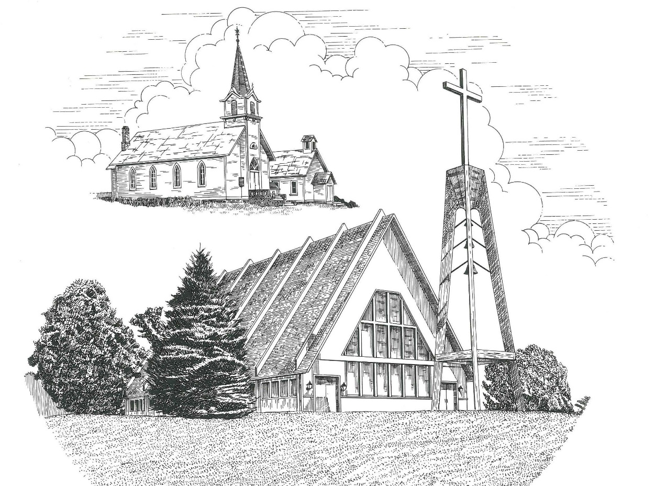

Third Sunday after Pentecost June 26th, 2022

WELCOME
Thanks for joining us!
Pastor Jacob Sherry Missouri Synod

~~PLEASE NOTE~~
Calling on the name of the Lord
Does not include the use of cell phones in the worship sanctuary.
Please check yours before the service begins. Thank you for your courtesy.
~~TO OUR GUESTS AND VISITORS~~
Please sign our guest book located on the stand at the church entrance. During the service, we ask you to sign the attendance sheet located in your bulletin and place it on the pew when you leave. If you need assistance or have questions about our worship service, please talk to an elder or any one of our church family. We are glad you could join us and hope to have you worship with us again soon.

~~ATTENDING HOLY COMMUNION~~
By checking the “Communing Today” box on the registration form found on the attendance sheet, you are agreeing with the following statements:

- I am a baptized Christian who believes Jesus Christ is my Lord and Savior.
- I believe that I am a sinner in need of Christ freely offered forgiveness.
- I believe that in the Lord’s Supper the body and blood of Jesus Christ
are truly present in, with, and under the bread and wine.
- I believe that my participation in Holy Communion grants me forgiveness
of my sins, new spiritual life, and eternal salvation.
- With God’s help, I sincerely seek to repent of my sins, live in service
to my Lord, and await His return.

If you agree with the above statements, you are welcome to attend the Lord’s Supper with us. May God bless your worship time with us.
We do offer gluten-free wafers, please quietly ask an elder to help you.

Order of Divine Service Setting Three

Pre-Service Music……………..Call to Worship………………….Greeting

OPENING HYMN: “Christ Is Made the Sure Foundation”...................LSB #909
OPENING LITURGY:
Confession & Absolution………..………………………………LSB pp. 184-185
Kyrie…………………………………….………………………..LSB p. 186
Gloria in Excelsis………………………………………………...LSB pp. 187-189
Salutation….……………………………….…………………….LSB p. 189

Collect Prayer
Lord of all power and might, author and giver of all good things, graft into our hearts the love of Your name and nourish us with all goodness that we may love and serve our neighbor; through Jesus Christ, Your Son, our Lord, who lives and reigns with You and the Holy Spirit, one God, now and forever.

THE HOLY SCRIPTURES

OLD TESTAMENT: (1 Kings 19:9b-21)
⁹ And behold, the word of the Lord came to him, and he said to him, “What are you doing here, Elijah?” ¹⁰ He said, “I have been very jealous for the Lord, the God of hosts. For the people of Israel have forsaken your covenant, thrown down your altars, and killed your prophets with the sword, and I, even I only, am left, and they seek my life, to take it away.” ¹¹ And he said, “Go out and stand on the mount before the Lord.” And behold, the Lord passed by, and a great and strong wind tore the mountains and broke in pieces the rocks before the Lord, but the Lord was not in the wind. And after the wind an earthquake, but the Lord was not in the earthquake. ¹² And after the earthquake a fire, but the Lord was not in the fire. And after the fire the sound of a low whisper. ¹³ And when Elijah heard it, he wrapped his face in his cloak and went out and stood at the entrance of the cave. And behold, there came a voice to him and said, “What are you doing here, Elijah?” ¹⁴ He said, “I have been very jealous for the Lord, the God of hosts. For the people of Israel have forsaken your covenant, thrown down your altars, and killed your prophets with the sword, and I, even I only, am left, and they seek my life, to take it away.” ¹⁵ And the Lord said to him, “Go, return on your way to the wilderness of Damascus. And when you arrive, you shall anoint Hazael to be king over Syria. ¹⁶ And Jehu the son of Nimshi you shall anoint to be king over Israel, and Elisha the son of Shaphat of Abel-meholah you shall anoint to be prophet in your place. ¹⁷ And the one who escapes from the sword of Hazael shall Jehu put to death, and the one who escapes from the sword of Jehu shall Elisha put to death. ¹⁸ Yet I will leave seven thousand in Israel, all the knees that have not bowed to Baal, and every mouth that has not kissed him.”
¹⁹ So he departed from there and found Elisha the son of Shaphat, who was plowing with twelve yoke of oxen in front of him, and he was with the twelfth. Elijah passed by him and cast his cloak upon him. ²⁰ And he left the oxen and ran after Elijah and said, “Let me kiss my father and my mother, and then I will follow you.” And he said to him, “Go back again, for what have I done to you?” ²¹ And he returned from following him and took the yoke of oxen and sacrificed them and boiled their flesh with the yokes of the oxen and gave it to the people, and they ate. Then he arose and went after Elijah and assisted him.

R: This is the Word of the Lord. Cong: Thanks be to God.

GRADUAL
Reader: How beautiful are the feet of those who preach the good news,
Cong.: who publish peace and bring good news of salvation.
Reader: Their voice has gone out to all the earth,
Cong.: and their words to the ends of the world.

EPISTLE: (Galatians 51, 13-25)
For freedom Christ has set us free; stand firm therefore, and do not submit again to a yoke of slavery. ¹³ For you were called to freedom, brothers. Only do not use your freedom as an opportunity for the flesh, but through love serve one another. ¹⁴ For the whole law is fulfilled in one word: “You shall love your neighbor as yourself.” ¹⁵ But if you bite and devour one another, watch out that you are not consumed by one another. ¹⁶ But I say, walk by the Spirit, and you will not gratify the desires of the flesh. ¹⁷ For the desires of the flesh are against the Spirit, and the desires of the Spirit are against the flesh, for these are opposed to each other, to keep you from doing the things you want to do. ¹⁸ But if you are led by the Spirit, you are not under the law. ¹⁹ Now the works of the flesh are evident: sexual immorality, impurity, sensuality, ²⁰ idolatry, sorcery, enmity, strife, jealousy, fits of anger, rivalries, dissensions, divisions, ²¹ envy, drunkenness, orgies, and things like these. I warn you, as I warned you before, that those who do such things will not inherit the kingdom of God. ²² But the fruit of the Spirit is love, joy, peace, patience, kindness, goodness, faithfulness, ²³ gentleness, self-control; against such things there is no law. ²⁴ And those who belong to Christ Jesus have crucified the flesh with its passions and desires. ²⁵ If we live by the Spirit, let us also keep in step with the Spirit.

R: This is the Word of the Lord. Cong: Thanks be to God.

(PLEASE RISE for the reading of the Gospel)

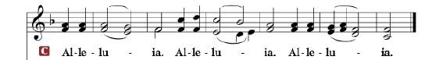

R: The Holy Gospel according to St. Luke, the 9th chapter.

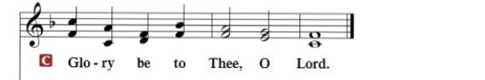

HOLY GOSPEL: (Luke 9:51-62)
⁵¹ When the days drew near for him to be taken up, Jesus set his face to go to Jerusalem. ⁵² And he sent messengers ahead of him, who went and entered a village of the Samaritans, to make preparations for him. ⁵³ But the people did not receive him, because his face was set toward Jerusalem. ⁵⁴ And when his disciples James and John saw it, they said, “Lord, do you want us to tell fire to come down from heaven and consume them?” ⁵⁵ But he turned and rebuked them. ⁵⁶ And they went on to another village.
⁵⁷ As they were going along the road, someone said to him, “I will follow you wherever you go.” ⁵⁸ And Jesus said to him, “Foxes have holes, and birds of the air have nests, but the Son of Man has nowhere to lay his head.” ⁵⁹ To another he said, “Follow me.” But he said, “Lord, let me first go and bury my father.” ⁶⁰ And Jesus said to him, “Leave the dead to bury their own dead. But as for you, go and proclaim the kingdom of God.” ⁶¹Yet another said, “I will follow you, Lord, but let me first say farewell to those at my home.” ⁶² Jesus said to him, “No one who puts his hand to the plow and looks back is fit for the kingdom of God.”

R: This is the Gospel of the Lord.

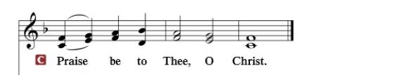

Nicene Creed…...……………………………………………………..…LSB p. 191
I believe in one God, the Father Almighty, maker of heaven and earth and of all things visible and invisible.
And in one Lord Jesus Christ, the only-begotten Son of God, begotten of His Father before all worlds, God of God, Light of Light, very God of very God, begotten, not made, being of one substance with the Father, by whom all things were made; who for us men and for our salvation came down from heaven and was incarnate by the Holy Spirit of the virgin Mary and was made man; and was crucified also for us under Pontius Pilate. He suffered and was buried. And the third day He rose again according to the Scriptures and ascended into heaven and sits at the right hand of the Father. And He will come again with glory to judge both the living and the dead, whose kingdom will have no end.
And I believe in the Holy Spirit, the Lord and giver of life, who proceeds from the Father and the Son, who with the Father and the Son together is worshiped and glorified, who spoke by the prophets. And I believe in one holy Christian and apostolic Church, I acknowledge one Baptism for the remission of sins, and I look for the resurrection of the dead and the life of the world to come. Amen.

SERMON HYMN: “Come, Follow Me, The Savior Spake”………........LSB #688

SERMON

OFFERTORY…………………………………………………………...LSB pp. 192-193

GENERAL PRAYERS OF THE CHURCH

Sharing the Peace of the Lord

SERVICE OF THE SACRAMENT
Preface…………………………………….…………….……….LSB p. 194
Proper Preface
It is truly good, right, and salutary that we should at all times and in all places give thanks to You, holy Lord, almighty Father, everlasting God, through Jesus Christ, our Lord, who, out of love for His fallen creation, humbled Himself by taking on the form of a servant, becoming obedient unto death, even death upon a cross. Risen from the dead, He has freed us from eternal death and given us life everlasting. Therefore, with angels and archangels and with all the company of heaven we laud and magnify Your glorious name, ever more praising You and saying:

Sanctus, Lord’s Prayer, The Words of Our Lord………………….....LSB pp. 195-197
Agnus Dei………………………………………………………………..LSB p. 198
If you are not communing, it is acceptable to remain seated.

COMMUNION DISTRIBUTION HYMNS:
LSB #550 “Lamb of God”
LSB #621 “Let All Mortal Flesh Keep Silence”
LSB #712 “Seek Ye First”

NUNC DIMITTIS………………………………………………………LSB pp. 199-200

BENEDICTION

CLOSING HYMN: “Thee Will I Love, My Strength, My Tower”..........LSB #694

The Mission of Trinity Onekama Is To SERVE

For even the Son of Man did not come to be served
but to serve and to give his life as a ransom for many.
Mark 10:45

S haring Jesus’s truth
E quipping for life
R eaching Out
V aluing each other
E vangelizing all ages
Mission Statement
The mission of Trinity Onekama is to SERVE
For even the Son of Man did not come to be served, but to serve,
and to give his life as a ransom for many. Mark 10:45
S haring Jesus’ ruth
E quipping for life
R eaching Out
V aluing each other
E vangelizing all age

CHURCH INFORMATION
Church Office: (231) 889-4429 Website: www.trinityonekama.org
E-mail: trinityonekama@sbcglobal.net
Address: P.O. Box 119, 5471 Fairview Street, Onekama, MI 49675
Adult Bible Study: Sunday @ 11:30 am (year round)
Worship: Sunday @ 10:30 am The Lord’s Supper: Celebrated 2nd & 4th Sundays
Pastoral Hours: Wednesday and Friday 9:00am – Noon
Pastor Phone: 231-655-2680 Pastor Email: trinityonekama@gmail.com

Copyright licensing covered under CCLI #2802932

