**231-889-4429 5471 Fairview Street, Box 119 Onekama, MI**

**TRINITY LUTHERAN CHURCH**

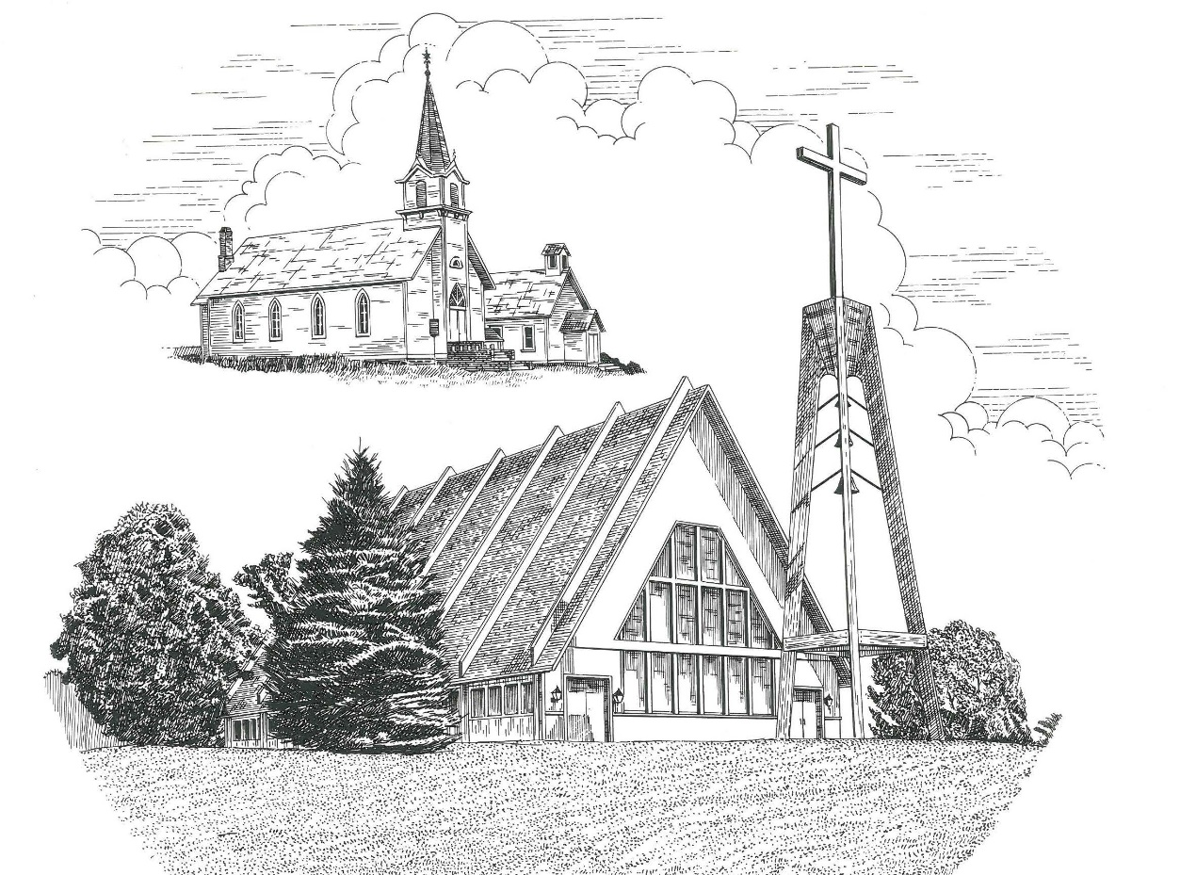

**Second Sunday after Pentecost June 6th, 2021**

**WELCOME**

**Thanks for joining us!**

**Pastor Jacob Sherry Missouri Synod**

**~~PLEASE NOTE~~Calling on the name of the Lord**

Does not include the use of cell phones in the worship sanctuary.

Please check yours before the service begins. Thank you for your courtesy.

**~~TO OUR GUESTS AND VISITORS~~**

Please sign our guest book located on the stand at the church entrance. During the service, we ask you to sign the attendance booklet located at the end of each pew. If you need assistance or have questions about our worship service, please talk to an elder or any one of our church family. We are glad you could join us and hope to have you worship with us again soon.

**~~ATTENDING HOLY COMMUNION~~**

By checking the “Communing Today” box on the registration form found in the attendance booklet, you are agreeing with the following statements:

* **I am a baptized Christian who believes Jesus Christ is my Lord and Savior.**
* **I believe that I am a sinner in need of Christ freely offered forgiveness.**
* **I believe that in the Lord’s Supper the body and blood of Jesus Christ**

**are truly present in, with, and under the bread and wine.**

* **I believe that my participation in Holy Communion grants me forgiveness**

**of my sins, new spiritual life, and eternal salvation.**

* **With God’s help, I sincerely seek to repent of my sins, live in service**

**to my Lord, and await His return.**

**If you agree with the above statements, you are welcome to attend the Lord’s Supper with us. May God bless your worship time with us.**

We do offer gluten-free wafers, please quietly ask an elder to help you.

**Covid-19 Guidance for Worship**

* Masks are to be properly worn during worship.

* Please sit on the ends of the pews and not directly behind someone.

* Maintain social distancing with other members even at the communion rail.

* If you are feeling ill, please remain home and watch the service online.

**Order of Divine Service Setting One**

**Pre-Service Music……………..Call to Worship………………….Greeting**

**OPENING HYMN:** *“The Tree of Life”*………………….......................LSB #561

**CONFESSION & ABSOLUTION**……………………………………..LSB p. 151

**KYRIE**…………………………………………………………………...LSB pp. 152-153

**THIS IS THE FEAST**…………………………………………………...LSB p. 155

**SALUTATION**…………………………………………………………..LSB p. 156

**Collect Prayer**

Almighty and eternal God, Your Son Jesus triumphed over the prince of demons and freed us from bondage to sin. Help us to stand firm against every assault of Satan, and enable us always to do Your will; through Jesus Christ, our Lord, who lives and reign with You and the Holy Spirit, one God, now and forever.

**THE HOLY SCRIPTURES**

**OLD TESTAMENT READING:** (Genesis 3:8-15)

**8**And they heard the sound of the Lord God walking in the garden in the cool of the day, and the man and his wife hid themselves from the presence of the Lord God among the trees of the garden.  **9**But the Lord God called to the man and said to him, “Where are you?”  **10**And he said, “I heard the sound of you in the garden, and I was afraid, because I was naked, and I hid myself.”  **11**He said, “Who told you that you were naked? Have you eaten of the tree of which I commanded you not to eat?”  **12**The man said, “The woman whom you gave to be with me, she gave me fruit of the tree, and I ate.”  **13**Then the Lord God said to the woman, “What is this that you have done?” The woman said, “The serpent deceived me, and I ate.”

**14**The Lord God said to the serpent,

“Because you have done this, cursed are you above all livestock  
    and above all beasts of the field; on your belly you shall go,  
    and dust you shall eat all the days of your life.  
**15**I will put enmity between you and the woman,  
    and between your offspring and her offspring;  
 he shall bruise your head, and you shall bruise his heel.”

**R:** This is the Word of the Lord**.** **Cong: Thanks be to God.**

**GRADUAL**

Reader: Great is the Lord, and greatly to be praised,

**Cong.: and his greatness is unsearchable.**

Reader: On your wondrous works, I will meditate,

**Cong.: and I will declare your greatness.**

**EPISTLE READING:** (2 Corinthians 4:13 - 5:1)

**13**Since we have the same spirit of faith according to what has been written, “I believed, and so I spoke,” we also believe, and so we also speak, **14**knowing that he who raised the Lord Jesus will raise us also with Jesus and bring us with you into his presence.  **15**For it is all for your sake, so that as grace extends to more and more people it may increase thanksgiving, to the glory of God. **16**So we do not lose heart.  Though our outer self is wasting away, our inner self is being renewed day by day.  **17**For this light momentary affliction is preparing for us an eternal weight of glory beyond all comparison, **18**as we look not to the things that are seen but to the things that are unseen. For the things that are seen are transient, but the things that are unseen are eternal. For we know that if the tent that is our earthly home is destroyed, we have a building from God, a house not made with hands, eternal in the heavens.

**R:** This is the Word of the Lord. **Cong: Thanks be to God.**

**(PLEASE RISE for the reading of the Gospel)**



**R:** The Holy Gospel according to St. Mark, the 3rd chapter.



**HOLY GOSPEL:** (Mark 3:20-35)

**20**Then Jesus went home, and the crowd gathered again, so that they could not even eat. **21**And when his family heard it, they went out to seize him, for they were saying, “He is out of his mind.” **22**And the scribes who came down from Jerusalem were saying, “He is possessed by Beelzebul,” and “by the prince of demons he casts out the demons.”  **23**And Jesus called them to him and said to them in parables, “How can Satan cast out Satan? **24**If a kingdom is divided against itself, that kingdom cannot stand.  **25**And if a house is divided against itself, that house will not be able to stand.  **26**And if Satan has risen up against himself and is divided, he cannot stand, but is coming to an end.  **27**But no one can enter a strong man's house and plunder his goods, unless he first binds the strong man. Then indeed he may plunder his house. **28**“Truly, I say to you, all sins will be forgiven the children of man, and whatever blasphemies they utter, **29**but whoever blasphemes against the Holy Spirit never has forgiveness, but is guilty of an eternal sin”— **30**for they were saying, “He has an unclean spirit.”

**31**And his mother and his brothers came, and standing outside they sent to him and called him.  **32**And a crowd was sitting around him, and they said to him, “Your mother and your brothers are outside, seeking you.”  **33**And he answered them, “Who are my mother and my brothers?”  **34**And looking about at those who sat around him, he said, “Here are my mother and my brothers!  **35**For whoever does the will of God, he is my brother and sister and mother.”

**R:** This is the Gospel of the Lord.



**SERMON HYMN**: *“Rise! To Arms! With Prayer Employ You”*……………..LSB #668

**SERMON**

**NICENE CREED**

I believe in one God, the Father Almighty, maker of heaven and earth and of all things visible and invisible.

And in one Lord Jesus Christ, the only-begotten Son of God, begotten of His Father before all worlds, God of God, Light of Light, very God of very God, begotten, not made, being of one substance with the Father, by whom all things were made; who for us men and for our salvation came down from heaven and was incarnate by the Holy Spirit of the virgin Mary and was made man; and was crucified also for us under Pontius Pilate. He suffered and was buried. And the third day He rose again according to the Scriptures and ascended into heaven and sits at the right hand of the Father. And He will come again with glory to judge both the living and the dead, whose kingdom will have no end.

And I believe in the Holy Spirit, the Lord and giver of life, who proceeds from the Father and the Son, who with the Father and the Son together is worshiped and glorified, who spoke by the prophets. And I believe in one holy Christian and apostolic Church, I acknowledge one Baptism for the remission of sins, and I look for the resurrection of the dead and the life of the world to come. Amen.

**THE GENERAL PRAYERS OF THE CHURCH**

**OFFERTORY**…………………………………………………………...LSB pp. 159-160

**SERVICE OF THE SACRAMENT**

**PREFACE**……………………………………………………………….LSB p. 160

**Proper Preface**

It is truly good, right, and salutary that we should at all times and in all places give thanks to You, holy Lord, almighty Father, everlasting God, through Jesus Christ, our Lord, who, out of love for His fallen creation, humbled Himself by taking on the form of a servant, becoming obedient unto death, even death upon a cross. Risen from the dead, He has freed us from eternal death and given us life everlasting. Therefore, with angels and archangels and with all the company of heaven we laud and magnify Your glorious name, ever more praising You and saying:

**SANCTUS**……………………………………………………………….LSB p. 161

**THE WORDS OF OUR LORD**………………………………………..LSB p. 162

**AGNUS DEI**…………………………………………………………….LSB p. 163

*If you are not communing it is acceptable to remain seated.*

**COMMUNION DISTRIBUTION HYMNS**

LSB #645 *“Built on the Rock”*

LSB #629 *“What Is This Bread”*

**THANK THE LORD**………………………………………………………….LSB p. 164

**POST-COMMUNION COLLECT PRAYER**……………………………….LSB p. 166

**BENEDICTION**……………………………………………………………….LSB p. 166

**CLOSING HYMN:** *“Have No Fear, Little Flock”*……..…………………….LSB #735

The Mission of Trinity Onekama Is To **SERVE**

For even the Son of Man did not come to be served

but to serve and to give his life as a ransom for many.            
                                                                       Mark 10:45



**S**haring Jesus’s **t**ruth

**E**quipping for life

**R**eaching Out

**V**aluing each other

**E**vangelizing all ages

Mission Statement

The mission of Trinity Onekama is to SERVE

For even the Son of Man did not come to be served, but to serve,

and to give his life as a ransom for many. Mark 10:45

S haring Jesus’ ruth

E quipping for life

R eaching Out

V aluing each other

E vangelizing all age

**CHURCH INFORMATION**

**Church Office:** (231) 889-4429 **Website:** www.trinityonekama.org

**E-mail:** [trinityonekama@sbcglobal.net](mailto:trinityonekama@sbcglobal.net)

**Address:** P.O. Box 119, 5471 Fairview Street, Onekama, MI 49675

**Adult Bible Study**: Sunday @ 9:15 am (year round)

**Worship:** Sunday @ 10:30 am **The Lord’s Supper:**  Celebrated 2nd & 4th Sundays

**Pastoral Hours:** Wednesday and Friday 8:30am – Noon

**Pastor Phone:** 231-655-2680 **Pastor Email:** trinityonekama@gmail.com

**Copyright licensing covered under CCLI #2802932**