**231-889-4429 5471 Fairview Street, Box 119 Onekama, MI**

**TRINITY LUTHERAN CHURCH**

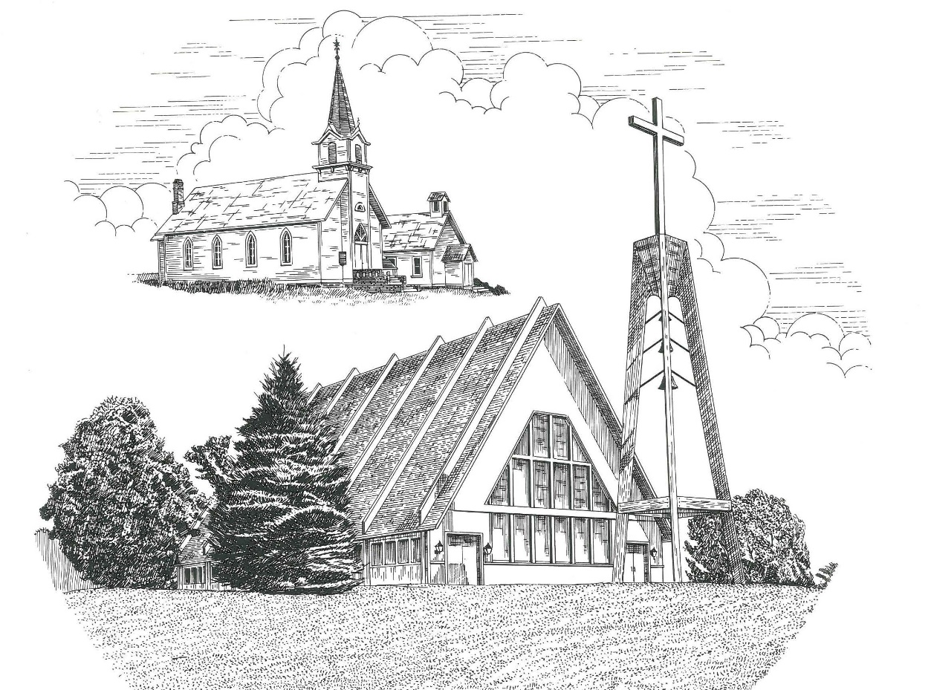

**Third Sunday in Lent March 12th, 2023**

**WELCOME**

**Thanks for joining us!**

**Pastor Jacob Sherry Missouri Synod**

**~~PLEASE NOTE~~Calling on the name of the Lord**

Does not include the use of cell phones in the worship sanctuary.

Please check yours before the service begins. Thank you for your courtesy.

**~~TO OUR GUESTS AND VISITORS~~**

Please sign our guest book located on the stand at the church entrance. During the service, we ask you to sign the attendance sheets located inside your bulletin and leave them on the pew as you leave. If you need assistance or have questions about our worship service, please talk to an elder or any one of our church family. We are glad you could join us and hope to have you worship with us again soon.

**~~ATTENDING HOLY COMMUNION~~**

By checking the “Communing Today” box on the registration form on the attendance sheet, you are agreeing with the following statements:

* **I am a baptized Christian who believes Jesus Christ is my Lord and Savior.**
* **I believe that I am a sinner in need of Christ’s freely offered forgiveness.**
* **I believe that in the Lord’s Supper the body and blood of Jesus Christ**

**are truly present in, with, and under the bread and wine.**

* **I believe that my participation in Holy Communion grants me forgiveness**

**of my sins, new spiritual life, and eternal salvation.**

* **With God’s help, I sincerely seek to repent of my sins, live in service**

**to my Lord, and await His return.**

**If you agree with the above statements, you are welcome to attend the Lord’s Supper with us. May God bless your worship time with us.**

We do offer gluten-free wafers, please quietly ask an elder to help you.

**Order of Divine Service Setting One**

**Pre-Service Music……………..Call to Worship………………….Greeting**

**OPENING HYMN:** *“I Lay My Sins on Jesus”*…………………............LSB #606

**CONFESSION & ABSOLUTION**……………………………………..LSB p. 151

**KYRIE**…………………………………………………………………...LSB pp. 152-153

**SALUTATION**…………………………………………………………..LSB p. 156

**Collect Prayer**

O God, whose glory it is always to have mercy, be gracious to all who have gone astray from Your ways and bring them again with penitent hearts and steadfast faith to embrace and hold fast the unchangeable truth of Your Word; through Jesus Christ, Your Son, our Lord, who lives and reigns with the You and the Holy Spirit, one God, now and forever.

**THE HOLY SCRIPTURES**

**OLD TESTAMENT:** (Exodus 17:1-7)

All the congregation of the people of Israel moved on from the wilderness of Sin by stages, according to the commandment of the Lord, and camped at Rephidim, but there was no water for the people to drink. **2**Therefore the people quarreled with Moses and said, “Give us water to drink.” And Moses said to them, “Why do you quarrel with me? Why do you test the Lord?” **3**But the people thirsted there for water, and the people grumbled against Moses and said, “Why did you bring us up out of Egypt, to kill us and our children and our livestock with thirst?” **4**So Moses cried to the Lord, “What shall I do with this people? They are almost ready to stone me.” **5**And the Lord said to Moses, “Pass on before the people, taking with you some of the elders of Israel, and take in your hand the staff with which you struck the Nile, and go. **6**Behold, I will stand before you there on the rock at Horeb, and you shall strike the rock, and water shall come out of it, and the people will drink.” And Moses did so, in the sight of the elders of Israel. **7**And he called the name of the place Massah and Meribah, because of the quarreling of the people of Israel, and because they tested the Lord by saying, “Is the Lord among us or not?”

**R:** This is the Word of the Lord**.** **Cong: Thanks be to God.**

**GRADUAL**

Reader: O come, let us fix our eyes on Jesus,

**Cong.: the founder and perfecter of our faith,**

Reader: who for the joy that was set before him endured the cross, despising the shame,

**Cong.: and is seated at the right hand of the throne of God.**

**EPISTLE:** (Romans 5:1-8)

Therefore, since we have been justified by faith, we have peace with God through our Lord Jesus Christ. **2**Through him we have also obtained access by faith into this grace in which we stand, and we rejoice in hope of the glory of God. **3**Not only that, but we rejoice in our sufferings, knowing that suffering produces endurance, **4**and endurance produces character, and character produces hope, **5**and hope does not put us to shame, because God's love has been poured into our hearts through the Holy Spirit who has been given to us. **6**For while we were still weak, at the right time Christ died for the ungodly. **7**For one will scarcely die for a righteous person—though perhaps for a good person one would dare even to die— **8**but God shows his love for us in that while we were still sinners, Christ died for us.

**R:** This is the Word of the Lord. **Cong: Thanks be to God.**

**(PLEASE RISE for the reading of the Gospel)**

**R:** The Holy Gospel according to St. John, the 4th chapter.



**HOLY GOSPEL:** (John 4:5-26)

**5**So Jesus came to a town of Samaria called Sychar, near the field that Jacob had given to his son Joseph. **6**Jacob's well was there; so Jesus, wearied as he was from his journey, was sitting beside the well. It was about the sixth hour. **7**A woman from Samaria came to draw water. Jesus said to her, “Give me a drink.” **8**(For his disciples had gone away into the city to buy food.) **9**The Samaritan woman said to him, “How is it that you, a Jew, ask for a drink from me, a woman of Samaria?” (For Jews have no dealings with Samaritans.) **10**Jesus answered her, “If you knew the gift of God, and who it is that is saying to you, ‘Give me a drink,’ you would have asked him, and he would have given you living water.” **11**The woman said to him, “Sir, you have nothing to draw water with, and the well is deep. Where do you get that living water? **12**Are you greater than our father Jacob? He gave us the well and drank from it himself, as did his sons and his livestock.” **13**Jesus said to her, “Everyone who drinks of this water will be thirsty again, **14**but whoever drinks of the water that I will give him will never be thirsty again. The water that I will give him will become in him a spring of water welling up to eternal life.” **15**The woman said to him, “Sir, give me this water, so that I will not be thirsty or have to come here to draw water.”

**16**Jesus said to her, “Go, call your husband, and come here.” **17**The woman answered him, “I have no husband.” Jesus said to her, “You are right in saying, ‘I have no husband’; **18**for you have had five husbands, and the one you now have is not your husband. What you have said is true.” **19**The woman said to him, “Sir, I perceive that you are a prophet. **20**Our fathers worshiped on this mountain, but you say that in Jerusalem is the place where people ought to worship.” **21**Jesus said to her, “Woman, believe me, the hour is coming when neither on this mountain nor in Jerusalem will you worship the Father. **22**You worship what you do not know; we worship what we know, for salvation is from the Jews. **23**But the hour is coming, and is now here, when the true worshipers will worship the Father in spirit and truth, for the Father is seeking such people to worship him. **24**God is spirit, and those who worship him must worship in spirit and truth.” **25**The woman said to him, “I know that Messiah is coming (he who is called Christ). When he comes, he will tell us all things.” **26**Jesus said to her, “I who speak to you am he.”

**R:** This is the Gospel of the Lord.



**SERMON HYMN**: *“May God Bestow on Us His Grace”*…………………...LSB #823

**SERMON**

**NICENE CREED**

I believe in one God, the Father Almighty, maker of heaven and earth and of all things visible and invisible.

And in one Lord Jesus Christ, the only-begotten Son of God, begotten of His Father before all worlds, God of God, Light of Light, very God of very God, begotten, not made, being of one substance with the Father, by whom all things were made; who for us men and for our salvation came down from heaven and was incarnate by the Holy Spirit of the virgin Mary and was made man; and was crucified also for us under Pontius Pilate. He suffered and was buried. And the third day He rose again according to the Scriptures and ascended into heaven and sits at the right hand of the Father. And He will come again with glory to judge both the living and the dead, whose kingdom will have no end.

And I believe in the Holy Spirit, the Lord and giver of life, who proceeds from the Father and the Son, who with the Father and the Son together is worshiped and glorified, who spoke by the prophets. And I believe in one holy Christian and apostolic Church, I acknowledge one Baptism for the remission of sins, and I look for the resurrection of the dead and the life of the world to come. Amen.

**THE GENERAL PRAYERS OF THE CHURCH**

**OFFERTORY**…………………………………………………………...LSB pp. 159-160

**Sharing the Peace of the Lord**

**SERVICE OF THE SACRAMENT**

**PREFACE**……………………………………………………………………..LSB p. 160

**Proper Preface**

It is truly good, right, and salutary that we should at all times and in all places give thanks to You, holy Lord, almighty Father, everlasting God, through Jesus Christ, our Lord, who overcame the assaults of the devil and gave His life as a ransom for many that with cleansed hearts we might be prepared joyfully to celebrate the paschal feast in sincerity and truth. Therefore, with angels and archangels and with all the company of heaven we laud and magnify Your glorious name, ever more praising You and saying:

**SANCTUS**……………………………………………………………………...LSB p. 161

**THE WORDS OF OUR LORD**……………………………………………….LSB p. 162

**AGNUS DEI**……………………………………………………………………LSB p. 163

*If you are not communing, it is acceptable to remain seated.*

**COMMUNION DISTRIBUTION HYMNS**

LSB #637 *“Draw Near and Take the Body of the Lord”*

LSB #623 *“Lord Jesus Christ, We Humbly Pray”*

LSB #850 *“God of Grace and God of Glory”*

**NUNC DIMITTIS – *“Song of Simeon”***……………………………………...LSB p. 165

**POST-COMMUNION COLLECT PRAYER**………………………………LSB p. 166

**BENEDICTION**……………………………………………………………….LSB p. 166

**CLOSING HYMN:** *“Lift Every Voice and Sing”*……..……………………...LSB #964

The Mission of Trinity Onekama Is To **SERVE**

For even the Son of Man did not come to be served

but to serve and to give his life as a ransom for many.            
                                                                       Mark 10:45



**S**haring Jesus’s **t**ruth

**E**quipping for life

**R**eaching Out

**V**aluing each other

**E**vangelizing all ages

Mission Statement

The mission of Trinity Onekama is to SERVE

For even the Son of Man did not come to be served, but to serve,

and to give his life as a ransom for many. Mark 10:45

S haring Jesus’ ruth

E quipping for life

R eaching Out

V aluing each other

E vangelizing all age

**CHURCH INFORMATION**

**Church Office:** (231) 889-4429 **Website:** www.trinityonekama.org

**E-mail:** [trinityonekama@sbcglobal.net](mailto:trinityonekama@sbcglobal.net)

**Address:** P.O. Box 119, 5471 Fairview Street, Onekama, MI 49675

**Sunday School & Adult Bible Study**: Sunday @ 9:30am

**Worship:** Sunday @ 10:30 am **The Lord’s Supper:**  Celebrated 2nd & 4th Sundays

**Pastoral Hours:** Wednesday and Friday 9:00am – Noon

**Pastor Phone:** 231-655-2680 **Pastor Email:** trinityonekama@gmail.com

**Copyright licensing covered under CCLI #2802932**