231-889-4429 5471 Fairview Street, Box 119 Onekama, MI

TRINITY LUTHERAN CHURCH
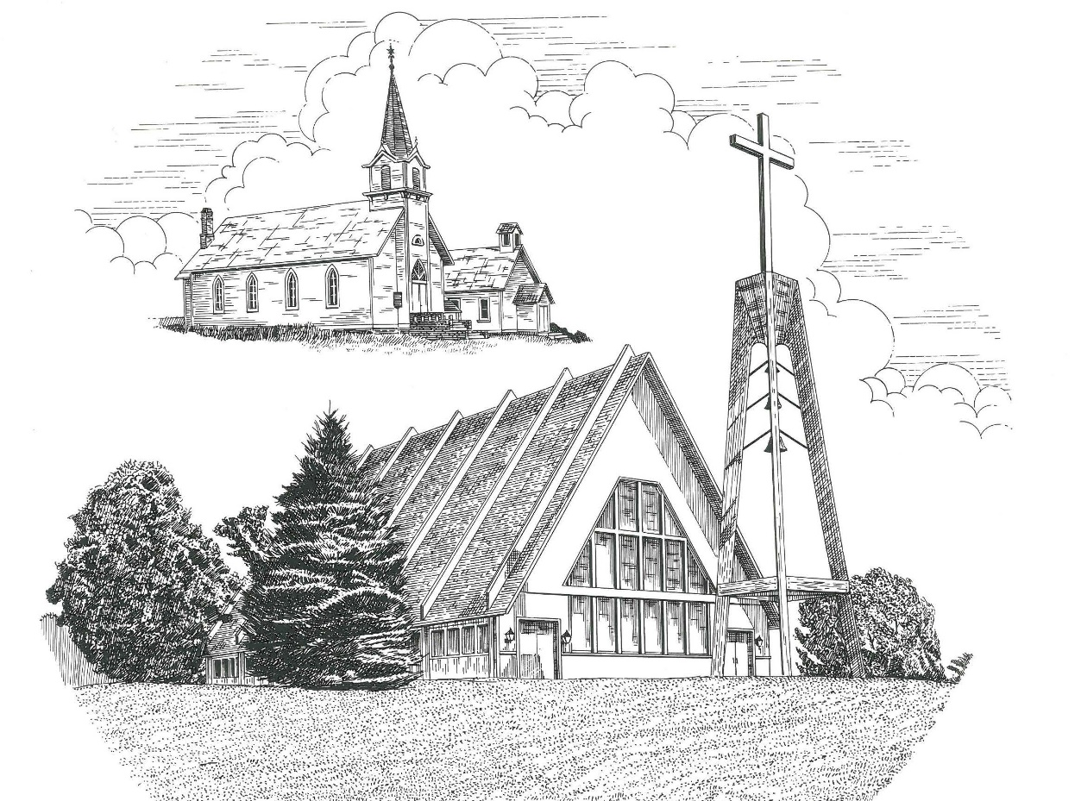

Second Sunday in Lent March 13th, 2022

WELCOME
Thanks for joining us!
Pastor Jacob Sherry Missouri Synod

~~PLEASE NOTE~~
Calling on the name of the Lord
Does not include the use of cell phones in the worship sanctuary.
Please check yours before the service begins. Thank you for your courtesy.
~~TO OUR GUESTS AND VISITORS~~
Please sign our guest book located on the stand at the church entrance. During the service, we ask you to sign the attendance sheet located in your bulletin and place it on the pew when you leave. If you need assistance or have questions about our worship service, please talk to an elder or any one of our church family. We are glad you could join us and hope to have you worship with us again soon.

~~ATTENDING HOLY COMMUNION~~
By checking the “Communing Today” box on the registration form found on the attendance sheet, you are agreeing with the following statements:

- I am a baptized Christian who believes Jesus Christ is my Lord and Savior.
- I believe that I am a sinner in need of Christ freely offered forgiveness.
- I believe that in the Lord’s Supper the body and blood of Jesus Christ
are truly present in, with, and under the bread and wine.
- I believe that my participation in Holy Communion grants me forgiveness
of my sins, new spiritual life, and eternal salvation.
- With God’s help, I sincerely seek to repent of my sins, live in service
to my Lord, and await His return.

If you agree with the above statements, you are welcome to attend the Lord’s Supper with us. May God bless your worship time with us.
We do offer gluten-free wafers, please quietly ask an elder to help you.

Order of Divine Service Setting Three

Pre-Service Music……………..Call to Worship………………….Greeting

OPENING HYMN: “When I Survey the Wondrous Cross”.....................LSB #425
OPENING LITURGY:
Confession & Absolution………..………………………………LSB pp. 184-185
Kyrie…………………………………….………………………..LSB p. 186
Salutation….……………………………….…………………….LSB p. 189

Collect Prayer
O God, You see that of ourselves we have no strength. By Your mighty power defend us from all adversities that may happen to the body and from all evil thoughts that may assault and hurt the soul; through Jesus Christ, Your Son, our Lord, who lives and reigns with You and the Holy Spirit, one God, now and forever.

THE HOLY SCRIPTURES

OLD TESTAMENT: (Jeremiah 26:8-15)
⁸ And when Jeremiah had finished speaking all that the Lord had commanded him to speak to all the people, then the priests and the prophets and all the people laid hold of him, saying, “You shall die! ⁹ Why have you prophesied in the name of the Lord, saying, ‘This house shall be like Shiloh, and this city shall be desolate, without inhabitant’?” And all the people gathered around Jeremiah in the house of the Lord. ¹⁰When the officials of Judah heard these things, they came up from the king's house to the house of the Lord and took their seat in the entry of the New Gate of the house of the Lord. ¹¹ Then the priests and the prophets said to the officials and to all the people, “This man deserves the sentence of death, because he has prophesied against this city, as you have heard with your own ears.”
¹² Then Jeremiah spoke to all the officials and all the people, saying, “The Lord sent me to prophesy against this house and this city all the words you have heard. ¹³ Now therefore mend your ways and your deeds, and obey the voice of the Lord your God, and the Lord will relent of the disaster that he has pronounced against you. ¹⁴ But as for me, behold, I am in your hands. Do with me as seems good and right to you. ¹⁵ Only know for certain that if you put me to death, you will bring innocent blood upon yourselves and upon this city and its inhabitants, for in truth the Lord sent me to you to speak all these words in your ears.”
R: This is the Word of the Lord. Cong: Thanks be to God.

GRADUAL
Reader: O come, let us fix our eyes on Jesus,
Cong.: the founder and perfecter of our faith,
Reader: who for the joy that was set before him endured the cross, despising the shame,
Cong.: and is seated at the right hand of the throne of God.

EPISTLE: (Philippians 3:17 – 4:1)
¹⁷ Brothers, join in imitating me, and keep your eyes on those who walk according to the example you have in us. ¹⁸ For many, of whom I have often told you and now tell you even with tears, walk as enemies of the cross of Christ. ¹⁹ Their end is destruction, their god is their belly, and they glory in their shame, with minds set on earthly things. ²⁰But our citizenship is in heaven, and from it we await a Savior, the Lord Jesus Christ, ²¹ who will transform our lowly body to be like his glorious body, by the power that enables him even to subject all things to himself. Therefore, my brothers, whom I love and long for, my joy and crown, stand firm thus in the Lord, my beloved.

R: This is the Word of the Lord. Cong: Thanks be to God.

(PLEASE RISE for the reading of the Gospel)

R: The Holy Gospel according to St. Luke, the 13th chapter.

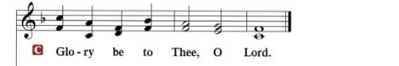

HOLY GOSPEL: (Luke 13:31-35)
³¹ At that very hour some Pharisees came and said to him, “Get away from here, for Herod wants to kill you.” ³² And he said to them, “Go and tell that fox, ‘Behold, I cast out demons and perform cures today and tomorrow, and the third day I finish my course. ³³ Nevertheless, I must go on my way today and tomorrow and the day following, for it cannot be that a prophet should perish away from Jerusalem.’ ³⁴ O Jerusalem, Jerusalem, the city that kills the prophets and stones those who are sent to it! How often would I have gathered your children together as a hen gathers her brood under her wings, and you were not willing! ³⁵ Behold, your house is forsaken. And I tell you, you will not see me until you say, ‘Blessed is he who comes in the name of the Lord!’”

R: This is the Gospel of the Lord.

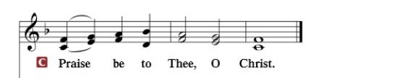

Nicene Creed…...……………………………………………………..…LSB p. 191
I believe in one God, the Father Almighty, maker of heaven and earth and of all things visible and invisible.
And in one Lord Jesus Christ, the only-begotten Son of God, begotten of His Father before all worlds, God of God, Light of Light, very God of very God, begotten, not made, being of one substance with the Father, by whom all things were made; who for us men and for our salvation came down from heaven and was incarnate by the Holy Spirit of the virgin Mary and was made man; and was crucified also for us under Pontius Pilate. He suffered and was buried. And the third day He rose again according to the Scriptures and ascended into heaven and sits at the right hand of the Father. And He will come again with glory to judge both the living and the dead, whose kingdom will have no end.
And I believe in the Holy Spirit, the Lord and giver of life, who proceeds from the Father and the Son, who with the Father and the Son together is worshiped and glorified, who spoke by the prophets. And I believe in one holy Christian and apostolic Church, I acknowledge one Baptism for the remission of sins, and I look for the resurrection of the dead and the life of the world to come. Amen.

SERMON HYMN: “Lord, Thee I Love with All My Heart”…………....LSB #708

SERMON

THE GENERAL PRAYERS OF THE CHURCH

SERVICE OF THE SACRAMENT
Preface…………………………………….…………….……….LSB p. 194

Proper Preface
It is truly good, right, and salutary that we should at all times and in all places give thanks to You, holy Lord, almighty Father, everlasting God, through Jesus Christ, our Lord, who overcame the assaults of the devil and gave His life as a ransom for many that with cleansed hearts we might be prepared joyfully to celebrate the paschal feast in sincerity and truth. Therefore, with angels and archangels and with all the company of heaven we laud and magnify Your glorious name, ever more praising You and saying:

Sanctus, Lord’s Prayer, The Words of Our Lord………………….....LSB pp. 195-197
Agnus Dei………………………………………………………………..LSB p. 198
If you are not communing, it is acceptable to remain seated.

COMMUNION DISTRIBUTION HYMNS:
LSB #420 “Christ, the Life of All the Living”
LSB #673 “Jerusalem, My Happy Home”

NUNC DIMITTIS………………………………………………………LSB pp. 199-200

BENEDICTION

CLOSING HYMN: “Amazing Grace”....................................................LSB #744

Lenten & Holy Week Services

March 13th Sunday Worship w/Communion 10:30am

March 16th Lenten Service 7pm

March 20th Sunday Worship 10:30am

March 23rd Lenten Service 7pm

March 27th Sunday Worship w/Communion 10:30am

March 30th Lenten Service 7pm

April 3rd Sunday Worship & Examination of Confirmands 10:30am

April 6th Lenten Service 7pm

April 10th Palm Sunday & Confirmation w/Communion 10:30am

April 14th Maundy Thursday Service w/Communion 7pm

April 15th Good Friday Service at Norwalk 7pm

April 17th Easter Sunday Worship w/Communion 10:30am

The Mission of Trinity Onekama Is To SERVE

For even the Son of Man did not come to be served
but to serve and to give his life as a ransom for many.
Mark 10:45

S haring Jesus’s truth
E quipping for life
R eaching Out
V aluing each other
E vangelizing all ages
Mission Statement
The mission of Trinity Onekama is to SERVE
For even the Son of Man did not come to be served, but to serve,
and to give his life as a ransom for many. Mark 10:45
S haring Jesus’ ruth
E quipping for life
R eaching Out
V aluing each other
E vangelizing all age

CHURCH INFORMATION
Church Office: (231) 889-4429 Website: www.trinityonekama.org
E-mail: trinityonekama@sbcglobal.net
Address: P.O. Box 119, 5471 Fairview Street, Onekama, MI 49675
Adult Bible Study: Sunday @ 11:30 am (year round)
Worship: Sunday @ 10:30 am The Lord’s Supper: Celebrated 2nd & 4th Sundays
Pastoral Hours: Wednesday and Friday 9:00am – Noon
Pastor Phone: 231-655-2680 Pastor Email: trinityonekama@gmail.com

Copyright licensing covered under CCLI #2802932

