231-889-4429 5471 Fairview Street Onekama, MI

TRINITY LUTHERAN CHURCH
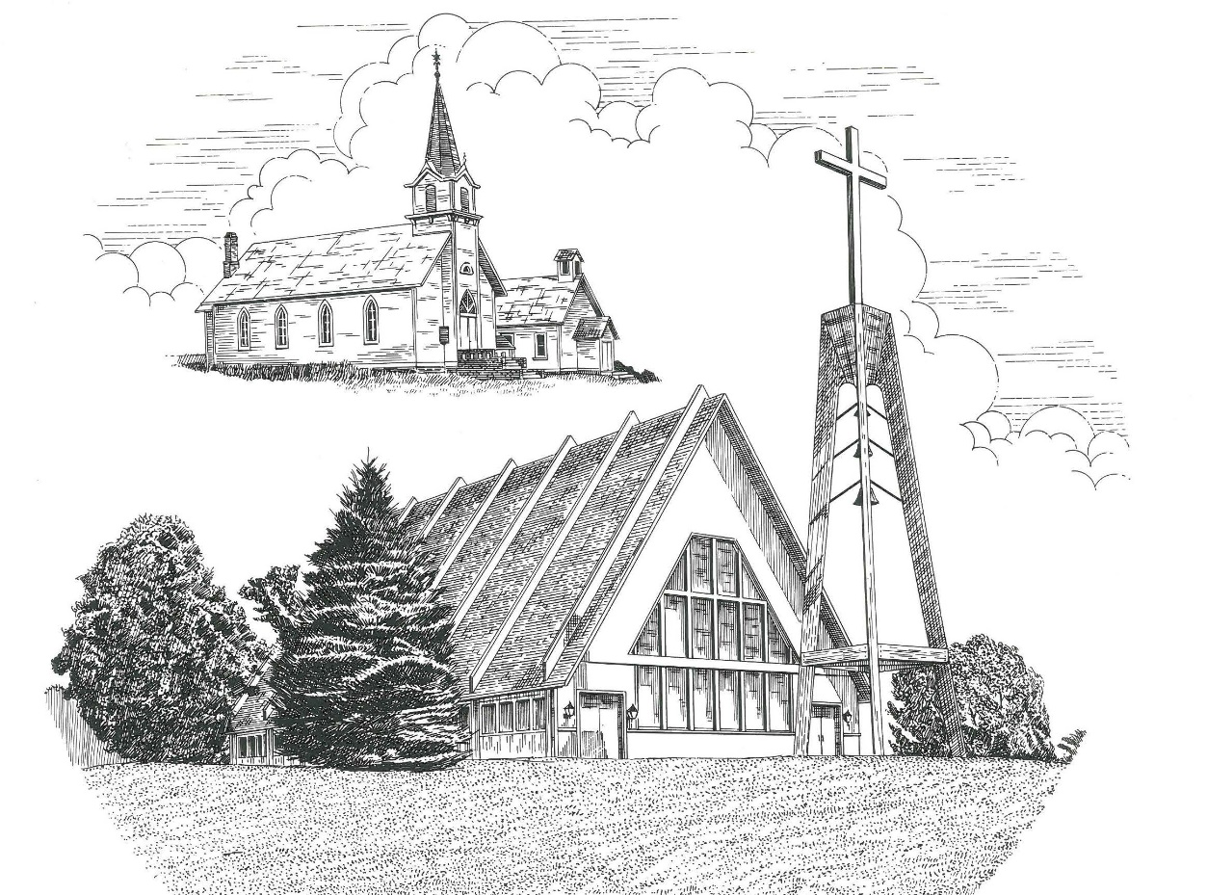

Palm Sunday March 24th, 2024

WELCOME
Thanks for joining us!
Pastor Jacob Sherry Missouri Synod

~~PLEASE NOTE~~
Calling on the name of the Lord
Does not include the use of cell phones in the worship sanctuary.
Please check yours before the service begins. Thank you for your courtesy.
~~TO OUR GUESTS AND VISITORS~~
Please sign our guest book located on the stand at the church entrance. During the service, we ask you to sign the attendance sheet located in your bulletin and place it on the pew when you leave. If you need assistance or have questions about our worship service, please talk to an elder or any one of our church family. We are glad you could join us and hope to have you worship with us again soon.

~~ATTENDING HOLY COMMUNION~~
By checking the “Communing Today” box on the registration form found on the attendance sheet, you are agreeing with the following statements:

- I am a baptized Christian who believes Jesus Christ is my Lord and Savior.
- I believe that I am a sinner in need of Christ’s freely offered forgiveness.
- I believe that in the Lord’s Supper the body and blood of Jesus Christ
are truly present in, with, and under the bread and wine.
- I believe that my participation in Holy Communion grants me forgiveness
of my sins, new spiritual life, and eternal salvation.
- With God’s help, I sincerely seek to repent of my sins, live in service
to my Lord, and await His return.

If you agree with the above statements, you are welcome to attend the Lord’s Supper with us. May God bless your worship time with us.
We do offer gluten-free wafers, please quietly ask an elder to help you.

Order of Divine Service Setting Three

Pre-Service Music……………..Call to Worship………………….Greeting

OPENING HYMN: “Hosanna, Loud Hosanna”................................................LSB #443

CONFESSION & ABSOLUTION
P: In the name of the Father and of the Son and of the Holy Spirit.
C: Amen.

P: Beloved in the Lord! Let us draw near with a true heart and confess our sins unto God our Father, beseeching Him in the name of our Lord Jesus Christ to grant us forgiveness.

P: Our help is in the name of the Lord,
C: who made heaven and earth.
P: I said, I will confess my transgressions unto the Lord,
C: and You forgave the iniquity of my sin.

P: O almighty God, merciful Father,
C: I, a poor, miserable sinner, confess unto You all my sins and iniquities with which I have ever offended You and justly deserve Your temporal and eternal punishment. But I am heartily sorry for them and sincerely repent of them, and I pray You of Your boundless mercy and for the sake of the holy, innocent, bitter sufferings and death of Your beloved Son, Jesus Christ, to be gracious and merciful to me, a poor, sinful being.

P: Upon this your confession, I, by virtue of my office, as a called and ordained servant of the Word, announce the grace of God unto all of you, and in the stead and by the command of my Lord Jesus Christ I forgive you all your sins in the name of the Father and of the Son and of the Holy Spirit.
C: Amen.

INTROIT
P: Blessed is he who comes in the name of the Lord!
C: We bless you from the house of the Lord.
P: Lift up your heads, O gates! And be lifted up, O ancient doors,
C: that the King of glory may come in.
P: Who is this King of glory?
C: The Lord, strong and mighty, the Lord, mighty in battle!
P: Lift up your heads, O gates! And be lifted up, O ancient doors,
C: that the King of glory may come in.
P: Who is this King of glory?
C: The Lord of hosts, he is the King of glory!
ALL: Glory be to the Father and to the Son and to the Holy Spirit; as it was in the
beginning, is now, and will be forever. Amen.
P: Blessed is he who comes in the name of the Lord!
C: We bless you from the house of the Lord.

KYRIE…………………………………….……………………………..LSB p. 186
SALUTATION….……………………………….………………………LSB p. 189

Collect Prayer
Almighty and everlasting God, You sent Your Son, our Savior Jesus Christ, to take upon Himself our flesh and to suffer death upon the cross. Mercifully grant that we may follow the example of His great humility and patience and be made partakers of His resurrection; through the same Jesus Christ, our Lord, who lives and reigns with You and the Holy Spirit, one God, now and forever.

Baptismal Hymn: “Dearest Jesus, We Are Here”……………………...LSB #592
Verses 1-3

THE BAPTISM OF NOELLE DAPHNE GILLESPIE………….......LSB pp. 268-271

Baptismal Hymn: “Dearest Jesus, We Are Here”……………………...LSB #592
Verses 4-5

THE HOLY SCRIPTURES

OLD TESTAMENT: (Zechariah 9:9-12)
⁹ Rejoice greatly, O daughter of Zion!
Shout aloud, O daughter of Jerusalem!
Behold, your king is coming to you;
righteous and having salvation is he,
humble and mounted on a donkey,
on a colt, the foal of a donkey.
¹⁰ I will cut off the chariot from Ephraim
and the war horse from Jerusalem;
and the battle bow shall be cut off,
and he shall speak peace to the nations;
his rule shall be from sea to sea,
and from the River to the ends of the earth.
¹¹ As for you also, because of the blood of my covenant with you,
I will set your prisoners free from the waterless pit.
¹² Return to your stronghold, O prisoners of hope;
today I declare that I will restore to you double.

R: This is the Word of the Lord. Cong: Thanks be to God.

GRADUAL
Reader: Christ entered once for all into the holy places, by means of his own blood,
Cong.: thus securing an eternal redemption.
Reader: Therefore he is the mediator of a new covenant,
Cong.: so that those who are called may receive the promised eternal inheritance.
Reader: He sent redemption to his people;
Cong.: he has commanded his covenant forever.

EPISTLE: (Philippians 2:5-11)
⁵ Have this mind among yourselves, which is yours in Christ Jesus, ⁶ who, though he was in the form of God, did not count equality with God a thing to be grasped, ⁷ but emptied himself, by taking the form of a servant, being born in the likeness of men. ⁸ And being found in human form, he humbled himself by becoming obedient to the point of death, even death on a cross. ⁹ Therefore God has highly exalted him and bestowed on him the name that is above every name, ¹⁰ so that at the name of Jesus every knee should bow, in heaven and on earth and under the earth, ¹¹ and every tongue confess that Jesus Christ is Lord, to the glory of God the Father.

R: This is the Word of the Lord. Cong: Thanks be to God.

(PLEASE RISE for the reading of the Gospel)

R: The Holy Gospel according to St. Mark, the 11th chapter.

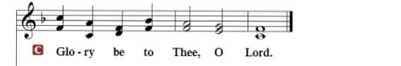

HOLY GOSPEL: (Mark 11:1-11)
Now when they drew near to Jerusalem, to Bethphage and Bethany, at the Mount of Olives, Jesus sent two of his disciples ² and said to them, “Go into the village in front of you, and immediately as you enter it you will find a colt tied, on which no one has ever sat. Untie it and bring it. ³ If anyone says to you, ‘Why are you doing this?’ say, ‘The Lord has need of it and will send it back here immediately.’” ⁴ And they went away and found a colt tied at a door outside in the street, and they untied it. ⁵ And some of those standing there said to them, “What are you doing, untying the colt?” ⁶ And they told them what Jesus had said, and they let them go. ⁷ And they brought the colt to Jesus and threw their cloaks on it, and he sat on it. ⁸ And many spread their cloaks on the road, and others spread leafy branches that they had cut from the fields. ⁹ And those who went before and those who followed were shouting, “Hosanna! Blessed is he who comes in the name of the Lord! ¹⁰ Blessed is the coming kingdom of our father David! Hosanna in the highest!”
¹¹ And he entered Jerusalem and went into the temple. And when he had looked around at everything, as it was already late, he went out to Bethany with the twelve.

R: This is the Gospel of the Lord.

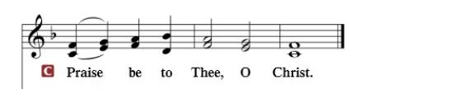

Nicene Creed
I believe in one God, the Father Almighty, maker of heaven and earth and of all things visible and invisible.
And in one Lord Jesus Christ, the only-begotten Son of God, begotten of His Father before all worlds, God of God, Light of Light, very God of very God, begotten, not made, being of one substance with the Father, by whom all things were made; who for us men and for our salvation came down from heaven and was incarnate by the Holy Spirit of the virgin Mary and was made man; and was crucified also for us under Pontius Pilate. He suffered and was buried. And the third day He rose again according to the Scriptures and ascended into heaven and sits at the right hand of the Father. And He will come again with glory to judge both the living and the dead, whose kingdom will have no end.
And I believe in the Holy Spirit, the Lord and giver of life, who proceeds from the Father and the Son, who with the Father and the Son together is worshiped and glorified, who spoke by the prophets. And I believe in one holy Christian and apostolic Church, I acknowledge one Baptism for the remission of sins, and I look for the resurrection of the dead and the life of the world to come. Amen.

SERMON HYMN: “No Tramp of Soldiers’ Marching Feet”.………….LSB #444

SERMON

COLLECTION OF THE OFFERING
OFFERTORY…………………………………………………………...LSB pp. 192-193

GENERAL PRAYERS OF THE CHURCH

Sharing the Peace of the Lord

SERVICE OF THE SACRAMENT
Preface…………………………………….…………….……….LSB p. 194
Proper Preface
It is truly good, right, and salutary that we should at all times and in all places give thanks to You, holy Lord, almighty Father, everlasting God, through Jesus Christ, our Lord, who accomplished the salvation of mankind by the tree of the cross that, where death arose, there life also might rise again and that the serpent who overcame by the tree of the garden might likewise by the tree of the cross be overcome. Therefore, with angels and archangels and with all the company of heaven we laud and magnify Your glorious name, ever more praising You and saying:
Sanctus, Lord’s Prayer, The Words of Our Lord………………….....LSB pp. 195-197
Agnus Dei………………………………………………………………..LSB p. 198
If you are not communing, it is acceptable to remain seated.

COMMUNION DISTRIBUTION HYMNS:
LSB #440 “Jesus, I Will Ponder Now”
LSB #560 “Drawn to the Cross, Which Thou Hast Blessed”
LSB #637 “Draw Near and Take the Body of the Lord”

NUNC DIMITTIS………………………………………………………LSB pp. 199-200

BENEDICTION

CLOSING HYMN: “Ride On, Ride On in Majesty”..............................LSB #441

CHURCH INFORMATION
Church Office: (231) 889-4429 Website: www.trinityonekama.org
E-mail: trinityonekama@sbcglobal.net
Address: 5471 Fairview Street, Onekama, MI 49675
Mailing Address: P.O. Box 119, Onekama, MI 49675
Sunday School & Adult Bible Study: Sunday @ 9:30am
Worship: Sunday @ 10:30 am The Lord’s Supper: Celebrated 2nd & 4th Sundays
Pastoral Hours: Wednesday and Friday 9:00am – Noon
Pastor’s Phone: 231-655-2680 Pastor’s Email: trinityonekama@gmail.com

Copyright licensing covered under CCLI #2802932

