231-889-4429 5471 Fairview Street, Box 119 Onekama, MI

TRINITY LUTHERAN CHURCH
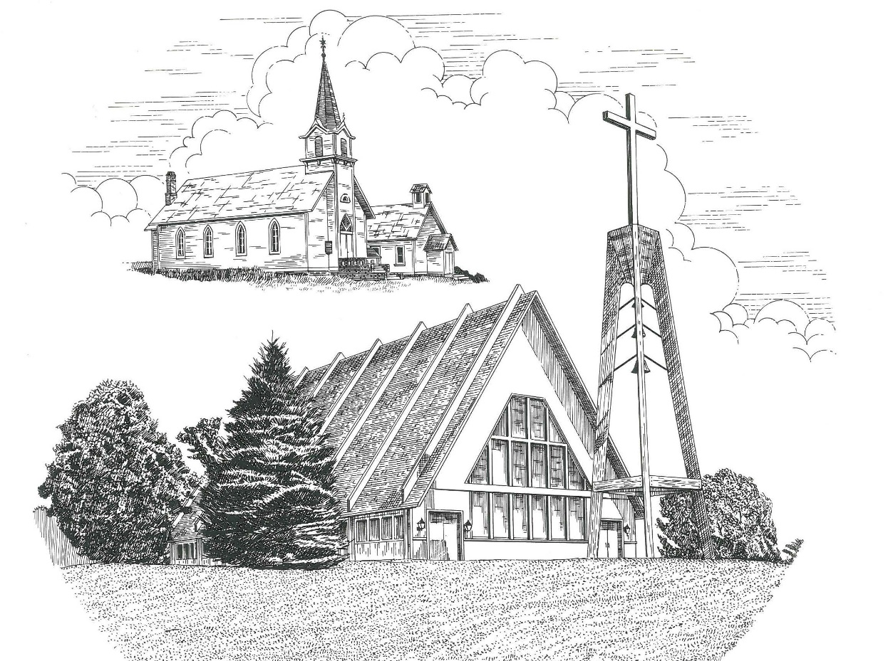

Fourth Sunday in Lent March 27th, 2022

WELCOME
Thanks for joining us!
Pastor Jacob Sherry Missouri Synod

~~PLEASE NOTE~~
Calling on the name of the Lord
Does not include the use of cell phones in the worship sanctuary.
Please check yours before the service begins. Thank you for your courtesy.
~~TO OUR GUESTS AND VISITORS~~
Please sign our guest book located on the stand at the church entrance. During the service, we ask you to sign the attendance sheet located in your bulletin and place it on the pew when you leave. If you need assistance or have questions about our worship service, please talk to an elder or any one of our church family. We are glad you could join us and hope to have you worship with us again soon.

~~ATTENDING HOLY COMMUNION~~
By checking the “Communing Today” box on the registration form found on the attendance sheet, you are agreeing with the following statements:

- I am a baptized Christian who believes Jesus Christ is my Lord and Savior.
- I believe that I am a sinner in need of Christ freely offered forgiveness.
- I believe that in the Lord’s Supper the body and blood of Jesus Christ
are truly present in, with, and under the bread and wine.
- I believe that my participation in Holy Communion grants me forgiveness
of my sins, new spiritual life, and eternal salvation.
- With God’s help, I sincerely seek to repent of my sins, live in service
to my Lord, and await His return.

If you agree with the above statements, you are welcome to attend the Lord’s Supper with us. May God bless your worship time with us.
We do offer gluten-free wafers, please quietly ask an elder to help you.

Order of Divine Service Setting Three

Pre-Service Music……………..Call to Worship………………….Greeting

OPENING HYMN: “Today Your Mercy Calls Us”................................LSB #915
OPENING LITURGY:
Confession & Absolution………..………………………………LSB pp. 184-185
Kyrie…………………………………….………………………..LSB p. 186
Salutation….……………………………….…………………….LSB p. 189

Collect Prayer
Almighty God, our heavenly Father, Your mercies are new every morning; and though we deserve only punishment, You receive us as Your children and provide for all our needs of body and soul. Grant that we may heartily acknowledge Your merciful goodness, give thanks for all Your benefits, and serve You in willing obedience; through Jesus Christ, Your Son, our Lord, who lives and reigns with You and the Holy Spirit, one God, now and forever.

THE HOLY SCRIPTURES

OLD TESTAMENT: (Isaiah 12:1-6)
You will say in that day:
“I will give thanks to you, O Lord,
for though you were angry with me,
your anger turned away,
that you might comfort me.
² “Behold, God is my salvation;
I will trust, and will not be afraid;
for the Lord God is my strength and my song,
and he has become my salvation.”
³ With joy you will draw water from the wells of salvation. ⁴ And you will say in that day:
“Give thanks to the Lord,
call upon his name,
make known his deeds among the peoples,
proclaim that his name is exalted.
⁵ “Sing praises to the Lord, for he has done gloriously;
let this be made known in all the earth.
⁶ Shout, and sing for joy, O inhabitant of Zion,
for great in your midst is the Holy One of Israel.”
R: This is the Word of the Lord. Cong: Thanks be to God.

GRADUAL
Reader: O come, let us fix our eyes on Jesus,
Cong.: the founder and perfecter of our faith,
Reader: who for the joy that was set before him endured the cross, despising the shame,
Cong.: and is seated at the right hand of the throne of God.

EPISTLE: (2 Corinthians 5:16-21)
¹⁶ From now on, therefore, we regard no one according to the flesh. Even though we once regarded Christ according to the flesh, we regard him thus no longer. ¹⁷ Therefore, if anyone is in Christ, he is a new creation. The old has passed away; behold, the new has come. ¹⁸ All this is from God, who through Christ reconciled us to himself and gave us the ministry of reconciliation; ¹⁹ that is, in Christ God was reconciling the world to himself, not counting their trespasses against them, and entrusting to us the message of reconciliation. ²⁰ Therefore, we are ambassadors for Christ, God making his appeal through us. We implore you on behalf of Christ, be reconciled to God. ²¹ For our sake he made him to be sin who knew no sin, so that in him we might become the righteousness of God.

R: This is the Word of the Lord. Cong: Thanks be to God.

(PLEASE RISE for the reading of the Gospel)

R: The Holy Gospel according to St. Luke, the 15th chapter.

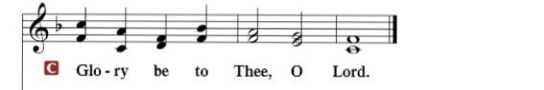

HOLY GOSPEL: (Luke 15:1-3, 11-32)
15 Now the tax collectors and sinners were all drawing near to hear Jesus. ² And the Pharisees and the scribes grumbled, saying, “This man receives sinners and eats with them.” ³ So he told them this parable:
¹¹ And he said, “There was a man who had two sons. ¹² And the younger of them said to his father, ‘Father, give me the share of property that is coming to me.’ And he divided his property between them. ¹³ Not many days later, the younger son gathered all he had and took a journey into a far country, and there he squandered his property in reckless living. ¹⁴ And when he had spent everything, a severe famine arose in that country, and he began to be in need. ¹⁵ So he went and hired himself out to one of the citizens of that country, who sent him into his fields to feed pigs. ¹⁶ And he was longing to be fed with the pods that the pigs ate, and no one gave him anything.
¹⁷ “But when he came to himself, he said, ‘How many of my father's hired servants have more than enough bread, but I perish here with hunger! ¹⁸ I will arise and go to my father, and I will say to him, “Father, I have sinned against heaven and before you. ¹⁹ I am no longer worthy to be called your son. Treat me as one of your hired servants.”’ ²⁰ And he arose and came to his father. But while he was still a long way off, his father saw him and felt compassion, and ran and embraced him and kissed him. ²¹ And the son said to him, ‘Father, I have sinned against heaven and before you. I am no longer worthy to be called your son.’ ²² But the father said to his servants, ‘Bring quickly the best robe, and put it on him, and put a ring on his hand, and shoes on his feet. ²³ And bring the fattened calf and kill it, and let us eat and celebrate. ²⁴ For this my son was dead, and is alive again; he was lost, and is found.’ And they began to celebrate.
²⁵ “Now his older son was in the field, and as he came and drew near to the house, he heard music and dancing. ²⁶ And he called one of the servants and asked what these things meant. ²⁷ And he said to him, ‘Your brother has come, and your father has killed the fattened calf, because he has received him back safe and sound.’ ²⁸ But he was angry and refused to go in. His father came out and entreated him, ²⁹ but he answered his father, ‘Look, these many years I have served you, and I never disobeyed your command, yet you never gave me a young goat, that I might celebrate with my friends. ³⁰ But when this son of yours came, who has devoured your property with prostitutes, you killed the fattened calf for him!’ ³¹ And he said to him, ‘Son, you are always with me, and all that is mine is yours. ³² It was fitting to celebrate and be glad, for this your brother was dead, and is alive; he was lost, and is found.’”

R: This is the Gospel of the Lord.

Nicene Creed…...……………………………………………………..…LSB p. 191
I believe in one God, the Father Almighty, maker of heaven and earth and of all things visible and invisible.
And in one Lord Jesus Christ, the only-begotten Son of God, begotten of His Father before all worlds, God of God, Light of Light, very God of very God, begotten, not made, being of one substance with the Father, by whom all things were made; who for us men and for our salvation came down from heaven and was incarnate by the Holy Spirit of the virgin Mary and was made man; and was crucified also for us under Pontius Pilate. He suffered and was buried. And the third day He rose again according to the Scriptures and ascended into heaven and sits at the right hand of the Father. And He will come again with glory to judge both the living and the dead, whose kingdom will have no end.
And I believe in the Holy Spirit, the Lord and giver of life, who proceeds from the Father and the Son, who with the Father and the Son together is worshiped and glorified, who spoke by the prophets. And I believe in one holy Christian and apostolic Church, I acknowledge one Baptism for the remission of sins, and I look for the resurrection of the dead and the life of the world to come. Amen.

SERMON HYMN: “God Loved the World So That He Gave”………...LSB #571

SERMON

THE GENERAL PRAYERS OF THE CHURCH

SERVICE OF THE SACRAMENT
Preface…………………………………….…………….……….LSB p. 194
Proper Preface
It is truly good, right, and salutary that we should at all times and in all places give thanks to You, holy Lord, almighty Father, everlasting God, through Jesus Christ, our Lord, who overcame the assaults of the devil and gave His life as a ransom for many that with cleansed hearts we might be prepared joyfully to celebrate the paschal feast in sincerity and truth. Therefore, with angels and archangels and with all the company of heaven we laud and magnify Your glorious name, ever more praising You and saying:

Sanctus, Lord’s Prayer, The Words of Our Lord………………….....LSB pp. 195-197
Agnus Dei………………………………………………………………..LSB p. 198
If you are not communing, it is acceptable to remain seated.

COMMUNION DISTRIBUTION HYMNS:
LSB #609 “Jesus Sinners Doth Receive”
LSB #426 “When I Survey the Wondrous Cross”

NUNC DIMITTIS………………………………………………………LSB pp. 199-200

BENEDICTION

CLOSING HYMN: “Not All the Blood of Beasts”.................................LSB #431

The Mission of Trinity Onekama Is To SERVE

For even the Son of Man did not come to be served
but to serve and to give his life as a ransom for many.
Mark 10:45

S haring Jesus’s truth
E quipping for life
R eaching Out
V aluing each other
E vangelizing all ages
Mission Statement
The mission of Trinity Onekama is to SERVE
For even the Son of Man did not come to be served, but to serve,
and to give his life as a ransom for many. Mark 10:45
S haring Jesus’ ruth
E quipping for life
R eaching Out
V aluing each other
E vangelizing all age

CHURCH INFORMATION
Church Office: (231) 889-4429 Website: www.trinityonekama.org
E-mail: trinityonekama@sbcglobal.net
Address: P.O. Box 119, 5471 Fairview Street, Onekama, MI 49675
Adult Bible Study: Sunday @ 11:30 am (year round)
Worship: Sunday @ 10:30 am The Lord’s Supper: Celebrated 2nd & 4th Sundays
Pastoral Hours: Wednesday and Friday 9:00am – Noon
Pastor Phone: 231-655-2680 Pastor Email: trinityonekama@gmail.com

Copyright licensing covered under CCLI #2802932

