231-889-4429 5471 Fairview Street Onekama, MI

TRINITY LUTHERAN CHURCH
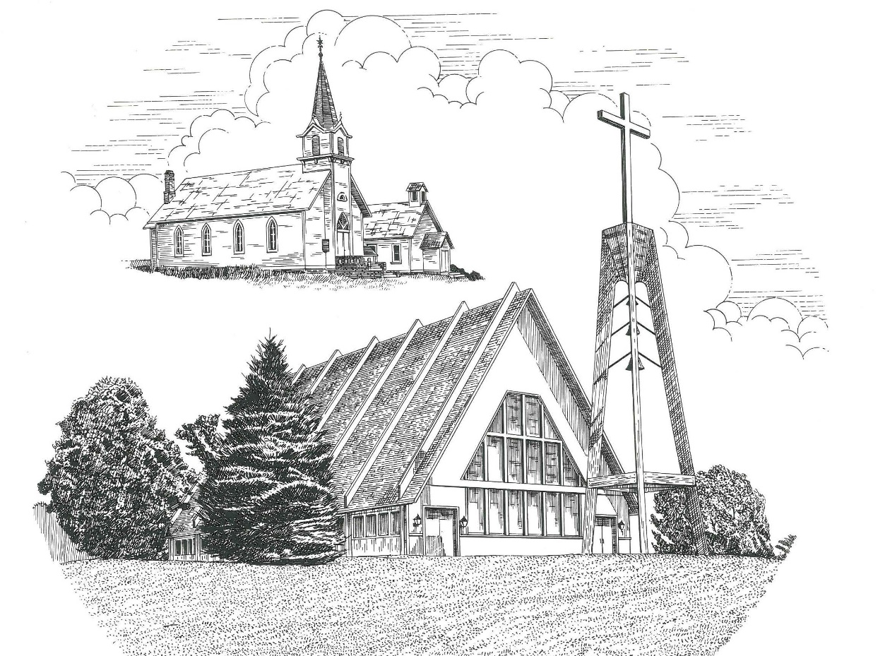

Maundy Thursday March 28th, 2024

WELCOME
Thanks for joining us!
Pastor Jacob Sherry Missouri Synod

~~PLEASE NOTE~~
Calling on the name of the Lord
Does not include the use of cell phones in the worship sanctuary.
Please check yours before the service begins. Thank you for your courtesy.
~~TO OUR GUESTS AND VISITORS~~
Please sign our guest book located on the stand at the church entrance. During the service, we ask you to sign the attendance sheet located in your bulletin and place it on the pew when you leave. If you need assistance or have questions about our worship service, please talk to an elder or any one of our church family. We are glad you could join us and hope to have you worship with us again soon.

~~ATTENDING HOLY COMMUNION~~
By checking the “Communing Today” box on the registration form found on the attendance sheet, you are agreeing with the following statements:

- I am a baptized Christian who believes Jesus Christ is my Lord and Savior.
- I believe that I am a sinner in need of Christ’s freely offered forgiveness.
- I believe that in the Lord’s Supper the body and blood of Jesus Christ
are truly present in, with, and under the bread and wine.
- I believe that my participation in Holy Communion grants me forgiveness
of my sins, new spiritual life, and eternal salvation.
- With God’s help, I sincerely seek to repent of my sins, live in service
to my Lord, and await His return.

If you agree with the above statements, you are welcome to attend the Lord’s Supper with us. May God bless your worship time with us.
We do offer gluten-free wafers, please quietly ask an elder to help you.

Order of Divine Service Setting Three

Pre-Service Music……………..Call to Worship………………….Greeting

OPENING HYMN: “Alas! And Did My Savior Bleed”.........................LSB #437

CORPORATE CONFESSION & ABSOLUTION…………………...LSB pp. 290-291

INTROIT
P: Gracious is the Lord, and righteous;
C: our God is merciful.
P: I love the Lord, because he has heard
C: my voice and my pleas for mercy.
P: Because he inclined his ear to me,
C: therefore I will call upon him as long as I live.
P: The snares of death encompassed me; the pangs of Sheol laid hold on me;
C: I suffered distress and anguish.
P: Then I called on the name of the Lord:
C: “O Lord, I pray, deliver my soul!”
P: Gracious is the Lord, and righteous;
C: our God is merciful.

KYRIE…………………………………….……………………………..LSB p. 186
SALUTATION….……………………………….………………………LSB p. 189

Collect Prayer
O Lord, in this wondrous Sacrament You have left us a remembrance of Your passion. Grant that we may so receive the sacred mystery of Your body and blood that the fruits of Your redemption may continually be manifest in us; for You live and reign with the Father and the Holy Spirit, one God, now and forever.

THE HOLY SCRIPTURES

OLD TESTAMENT: (Exodus 24:3-11)
³ Moses came and told the people all the words of the Lord and all the rules. And all the people answered with one voice and said, “All the words that the Lord has spoken we will do.” ⁴ And Moses wrote down all the words of the Lord. He rose early in the morning and built an altar at the foot of the mountain, and twelve pillars, according to the twelve tribes of Israel. ⁵ And he sent young men of the people of Israel, who offered burnt offerings and sacrificed peace offerings of oxen to the Lord. ⁶ And Moses took half of the blood and put it in basins, and half of the blood he threw against the altar. ⁷ Then he took the Book of the Covenant and read it in the hearing of the people. And they said, “All that the Lord has spoken we will do, and we will be obedient.” ⁸ And Moses took the blood and threw it on the people and said, “Behold the blood of the covenant that the Lord has made with you in accordance with all these words.” ⁹ Then Moses and Aaron, Nadab, and Abihu, and seventy of the elders of Israel went up, ¹⁰ and they saw the God of Israel. There was under his feet as it were a pavement of sapphire stone, like the very heaven for clearness. ¹¹ And he did not lay his hand on the chief men of the people of Israel; they beheld God, and ate and drank.

R: This is the Word of the Lord. Cong: Thanks be to God.

GRADUAL
Reader: Christ entered once for all into the holy places, by means of his own blood,
Cong.: thus securing an eternal redemption.
Reader: Therefore he is the mediator of a new covenant,
Cong.: so that those who are called may receive the promised eternal inheritance.
Reader: He sent redemption to his people;
Cong.: he has commanded his covenant forever.

EPISTLE: (Revelation 3:14-22)
¹⁴ “And to the angel of the church in Laodicea write: ‘The words of the Amen, the faithful and true witness, the beginning of God's creation.
¹⁵ “‘I know your works: you are neither cold nor hot. Would that you were either cold or hot! ¹⁶ So, because you are lukewarm, and neither hot nor cold, I will spit you out of my mouth. ¹⁷ For you say, I am rich, I have prospered, and I need nothing, not realizing that you are wretched, pitiable, poor, blind, and naked. ¹⁸ I counsel you to buy from me gold refined by fire, so that you may be rich, and white garments so that you may clothe yourself and the shame of your nakedness may not be seen, and salve to anoint your eyes, so that you may see. ¹⁹ Those whom I love, I reprove and discipline, so be zealous and repent. ²⁰ Behold, I stand at the door and knock. If anyone hears my voice and opens the door, I will come in to him and eat with him, and he with me. ²¹ The one who conquers, I will grant him to sit with me on my throne, as I also conquered and sat down with my Father on his throne. ²² He who has an ear, let him hear what the Spirit says to the churches.’”

R: This is the Word of the Lord. Cong: Thanks be to God.

(PLEASE RISE for the reading of the Gospel)

R: The Holy Gospel according to St. Mark, the 14th chapter.

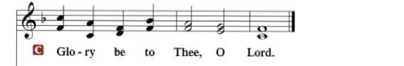

HOLY GOSPEL: (Mark 14:12-26)
¹² And on the first day of Unleavened Bread, when they sacrificed the Passover lamb, his disciples said to him, “Where will you have us go and prepare for you to eat the Passover?” ¹³ And he sent two of his disciples and said to them, “Go into the city, and a man carrying a jar of water will meet you. Follow him, ¹⁴ and wherever he enters, say to the master of the house, ‘The Teacher says, Where is my guest room, where I may eat the Passover with my disciples?’ ¹⁵ And he will show you a large upper room furnished and ready; there prepare for us.” ¹⁶ And the disciples set out and went to the city and found it just as he had told them, and they prepared the Passover.
¹⁷ And when it was evening, he came with the twelve. ¹⁸ And as they were reclining at table and eating, Jesus said, “Truly, I say to you, one of you will betray me, one who is eating with me.” ¹⁹ They began to be sorrowful and to say to him one after another, “Is it I?” ²⁰ He said to them, “It is one of the twelve, one who is dipping bread into the dish with me. ²¹ For the Son of Man goes as it is written of him, but woe to that man by whom the Son of Man is betrayed! It would have been better for that man if he had not been born.”
²² And as they were eating, he took bread, and after blessing it broke it and gave it to them, and said, “Take; this is my body.” ²³ And he took a cup, and when he had given thanks he gave it to them, and they all drank of it. ²⁴ And he said to them, “This is my blood of the covenant, which is poured out for many. ²⁵ Truly, I say to you, I will not drink again of the fruit of the vine until that day when I drink it new in the kingdom of God.”
²⁶ And when they had sung a hymn, they went out to the Mount of Olives.

R: This is the Gospel of the Lord.

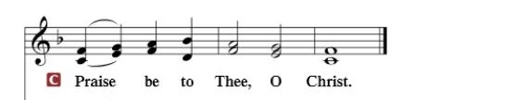

Nicene Creed
I believe in one God, the Father Almighty, maker of heaven and earth and of all things visible and invisible.
And in one Lord Jesus Christ, the only-begotten Son of God, begotten of His Father before all worlds, God of God, Light of Light, very God of very God, begotten, not made, being of one substance with the Father, by whom all things were made; who for us men and for our salvation came down from heaven and was incarnate by the Holy Spirit of the virgin Mary and was made man; and was crucified also for us under Pontius Pilate. He suffered and was buried. And the third day He rose again according to the Scriptures and ascended into heaven and sits at the right hand of the Father. And He will come again with glory to judge both the living and the dead, whose kingdom will have no end.
And I believe in the Holy Spirit, the Lord and giver of life, who proceeds from the Father and the Son, who with the Father and the Son together is worshiped and glorified, who spoke by the prophets. And I believe in one holy Christian and apostolic Church, I acknowledge one Baptism for the remission of sins, and I look for the resurrection of the dead and the life of the world to come. Amen.

SERMON HYMN: “Go to Dark Gethsemane”.………………………...LSB #436

SERMON

COLLECTION OF THE OFFERING
OFFERTORY…………………………………………………………...LSB pp. 192-193

GENERAL PRAYERS OF THE CHURCH

Sharing the Peace of the Lord

SERVICE OF THE SACRAMENT
Preface…………………………………….…………….……….LSB p. 194
Proper Preface
It is truly good, right, and salutary that we should at all times and in all places give thanks to You, holy Lord, almighty Father, everlasting God, through Jesus Christ, our Lord, who accomplished the salvation of mankind by the tree of the cross that, where death arose, there life also might rise again and that the serpent who overcame by the tree of the garden might likewise by the tree of the cross be overcome. Therefore, with angels and archangels and with all the company of heaven we laud and magnify Your glorious name, ever more praising You and saying:
Sanctus, Lord’s Prayer, The Words of Our Lord………………….....LSB pp. 195-197
Agnus Dei………………………………………………………………..LSB p. 198
If you are not communing, it is acceptable to remain seated.

COMMUNION DISTRIBUTION HYMNS:
LSB #629 “What Is This Bread”
LSB #622 “Lord Jesus Christ, You Have Prepared”
LSB #642 “O Living Bread from Heaven”

NUNC DIMITTIS………………………………………………………LSB pp. 199-200

BENEDICTION

Please remain seated while the altar is stripped then leave in silence.

The Mission of Trinity Onekama Is To SERVE

For even the Son of Man did not come to be served
but to serve and to give his life as a ransom for many.
Mark 10:45

S haring Jesus’s truth
E quipping for life
R eaching Out
V aluing each other
E vangelizing all ages
Mission Statement
The mission of Trinity Onekama is to SERVE
For even the Son of Man did not come to be served, but to serve,
and to give his life as a ransom for many. Mark 10:45
S haring Jesus’ ruth
E quipping for life
R eaching Out
V aluing each other
E vangelizing all age

CHURCH INFORMATION
Church Office: (231) 889-4429 Website: www.trinityonekama.org
E-mail: trinityonekama@sbcglobal.net
Address: 5471 Fairview Street, Onekama, MI 49675
Mailing Address: P.O. Box 119, Onekama, MI 49675
Sunday School & Adult Bible Study: Sunday @ 9:30am
Worship: Sunday @ 10:30 am The Lord’s Supper: Celebrated 2nd & 4th Sundays
Pastoral Hours: Wednesday and Friday 9:00am – Noon
Pastor Phone: 231-655-2680 Pastor Email: trinityonekama@gmail.com

Copyright licensing covered under CCLI #2802932

