231-889-4429 5471 Fairview Street, Box 119 Onekama, MI

TRINITY LUTHERAN CHURCH
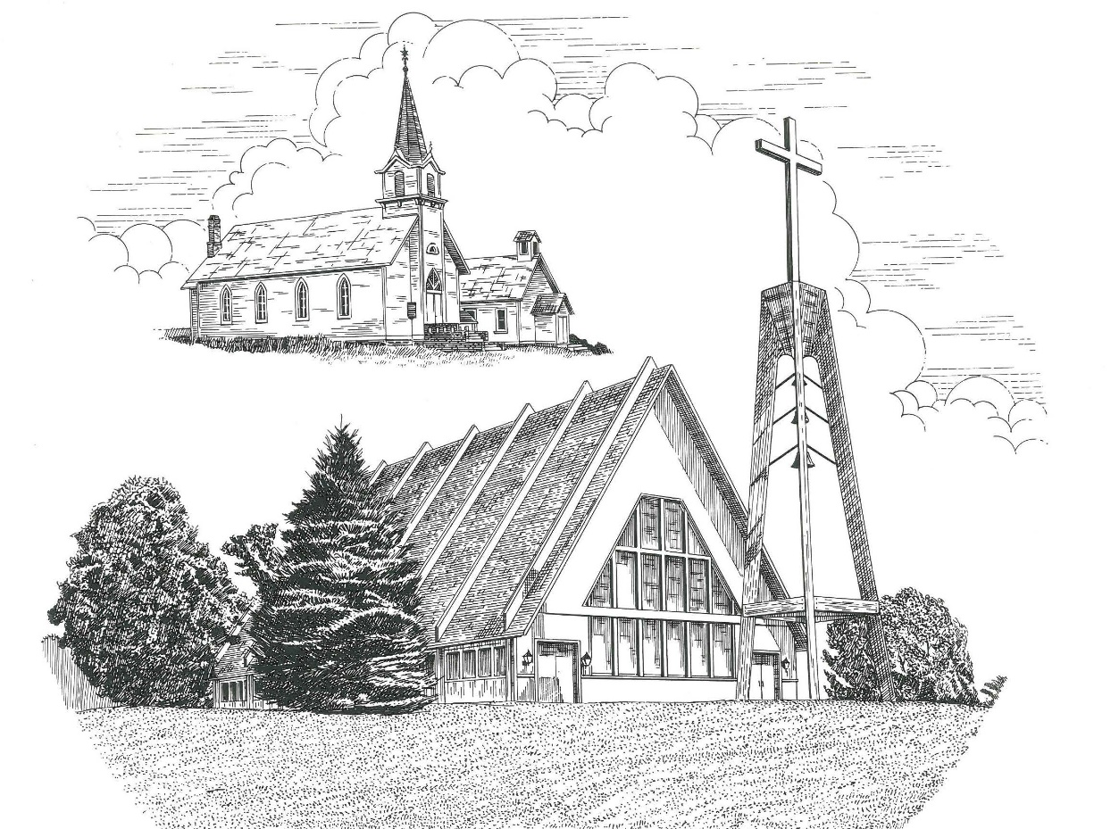

Ash Wednesday March 2nd, 2022

WELCOME
Thanks for joining us!
Pastor Jacob Sherry Missouri Synod

~~PLEASE NOTE~~
Calling on the name of the Lord
Does not include the use of cell phones in the worship sanctuary.
Please check yours before the service begins. Thank you for your courtesy.
~~TO OUR GUESTS AND VISITORS~~
Please sign our guest book located on the stand at the church entrance. During the service, we ask you to sign the attendance sheet located in your bulletin. If you need assistance or have questions about our worship service, please talk to an elder or any one of our church family. We are glad you could join us and hope to have you worship with us again soon.

~~ATTENDING HOLY COMMUNION~~
By checking the “Communing Today” box on the registration form found on the attendance sheet, you are agreeing with the following statements:

- I am a baptized Christian who believes Jesus Christ is my Lord and Savior.
- I believe that I am a sinner in need of Christ freely offered forgiveness.
- I believe that in the Lord’s Supper the body and blood of Jesus Christ
are truly present in, with, and under the bread and wine.
- I believe that my participation in Holy Communion grants me forgiveness
of my sins, new spiritual life, and eternal salvation.
- With God’s help, I sincerely seek to repent of my sins, live in service
to my Lord, and await His return.

If you agree with the above statements, you are welcome to attend the Lord’s Supper with us. May God bless your worship time with us.
We do offer gluten-free wafers, please quietly ask an elder to help you.

Order of Divine Service Setting Three

Pre-Service Music……………..Call to Worship………………….Greeting

OPENING HYMN: “Chief of Sinners Though I Be”...............................LSB #611
OPENING LITURGY:
Corporate Confession & Absolution………..………………….LSB pp. 290-291
Kyrie…………………………………….………………………..LSB p. 186
Salutation….……………………………….…………………….LSB p. 189

Collect Prayer
Almighty and everlasting God, You despise nothing You have made and forgive the sins of all who are penitent. Create in us new and contrite hearts that lamenting our sins and acknowledging our wretchedness we may receive from You full pardon and forgiveness; through Jesus Christ, Your Son, our Lord, who lives and reigns with You and the Holy Spirit, one God, now and forever.

THE HOLY SCRIPTURES

OLD TESTAMENT: (Joel 2:12-19)
¹² “Yet even now,” declares the Lord,
“return to me with all your heart,
with fasting, with weeping, and with mourning;
¹³ and rend your hearts and not your garments.”
Return to the Lord your God,
for he is gracious and merciful,
slow to anger, and abounding in steadfast love;
and he relents over disaster.
¹⁴ Who knows whether he will not turn and relent,
and leave a blessing behind him,
a grain offering and a drink offering
for the Lord your God?
¹⁵ Blow the trumpet in Zion;
consecrate a fast;
call a solemn assembly;
¹⁶ gather the people.
Consecrate the congregation;
assemble the elders;
gather the children,
even nursing infants.
Let the bridegroom leave his room,
and the bride her chamber.
¹⁷ Between the vestibule and the altar
let the priests, the ministers of the Lord, weep
and say, “Spare your people, O Lord,
and make not your heritage a reproach,
a byword among the nations.
Why should they say among the peoples,
‘Where is their God?’”
¹⁸ Then the Lord became jealous for his land
and had pity on his people.
¹⁹ The Lord answered and said to his people,
“Behold, I am sending to you
grain, wine, and oil,
and you will be satisfied;
and I will no more make you
a reproach among the nations.

R: This is the Word of the Lord. Cong: Thanks be to God.

GRADUAL
Reader: O come, let us fix our eyes on Jesus,
Cong.: the founder and perfecter of our faith,
Reader: who for the joy that was set before him endured the cross, despising the shame,
Cong.: and is seated at the right hand of the throne of God.

EPISTLE: (2 Corinthians 5:20b-6:10)
We implore you on behalf of Christ, be reconciled to God. ²¹ For our sake he made him to be sin who knew no sin, so that in him we might become the righteousness of God. Working together with him, then, we appeal to you not to receive the grace of God in vain. ² For he says,
“In a favorable time I listened to you,
and in a day of salvation I have helped you.”
Behold, now is the favorable time; behold, now is the day of salvation. ³ We put no obstacle in anyone's way, so that no fault may be found with our ministry, ⁴ but as servants of God we commend ourselves in every way: by great endurance, in afflictions, hardships, calamities, ⁵ beatings, imprisonments, riots, labors, sleepless nights, hunger; ⁶ by purity, knowledge, patience, kindness, the Holy Spirit, genuine love; ⁷ by truthful speech, and the power of God; with the weapons of righteousness for the right hand and for the left; ⁸ through honor and dishonor, through slander and praise. We are treated as impostors, and yet are true; ⁹ as unknown, and yet well known; as dying, and behold, we live; as punished, and yet not killed; ¹⁰ as sorrowful, yet always rejoicing; as poor, yet making many rich; as having nothing, yet possessing everything.

R: This is the Word of the Lord. Cong: Thanks be to God.

(PLEASE RISE for the reading of the Gospel)

R: The Holy Gospel according to St. Matthew, the 6th chapter.

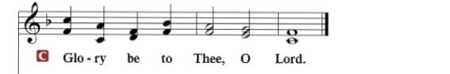

HOLY GOSPEL: (Matthew 6:1-9, 16-21)
“Beware of practicing your righteousness before other people in order to be seen by them, for then you will have no reward from your Father who is in heaven. ² “Thus, when you give to the needy, sound no trumpet before you, as the hypocrites do in the synagogues and in the streets, that they may be praised by others. Truly, I say to you, they have received their reward. ³ But when you give to the needy, do not let your left hand know what your right hand is doing, ⁴ so that your giving may be in secret. And your Father who sees in secret will reward you. ⁵ “And when you pray, you must not be like the hypocrites. For they love to stand and pray in the synagogues and at the street corners, that they may be seen by others. Truly, I say to you, they have received their reward. ⁶ But when you pray, go into your room and shut the door and pray to your Father who is in secret. And your Father who sees in secret will reward you. ¹⁶ “And when you fast, do not look gloomy like the hypocrites, for they disfigure their faces that their fasting may be seen by others. Truly, I say to you, they have received their reward. ¹⁷ But when you fast, anoint your head and wash your face, ¹⁸ that your fasting may not be seen by others but by your Father who is in secret. And your Father who sees in secret will reward you. ¹⁹ “Do not lay up for yourselves treasures on earth, where moth and rust destroy and where thieves break in and steal, ²⁰ but lay up for yourselves treasures in heaven, where neither moth nor rust destroys and where thieves do not break in and steal. ²¹ For where your treasure is, there your heart will be also.

R: This is the Gospel of the Lord.

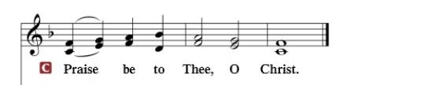

Nicene Creed…...……………………………………………………..…LSB p. 191
I believe in one God, the Father Almighty, maker of heaven and earth and of all things visible and invisible.
And in one Lord Jesus Christ, the only-begotten Son of God, begotten of His Father before all worlds, God of God, Light of Light, very God of very God, begotten, not made, being of one substance with the Father, by whom all things were made; who for us men and for our salvation came down from heaven and was incarnate by the Holy Spirit of the virgin Mary and was made man; and was crucified also for us under Pontius Pilate. He suffered and was buried. And the third day He rose again according to the Scriptures and ascended into heaven and sits at the right hand of the Father. And He will come again with glory to judge both the living and the dead, whose kingdom will have no end.
And I believe in the Holy Spirit, the Lord and giver of life, who proceeds from the Father and the Son, who with the Father and the Son together is worshiped and glorified, who spoke by the prophets. And I believe in one holy Christian and apostolic Church, I acknowledge one Baptism for the remission of sins, and I look for the resurrection of the dead and the life of the world to come. Amen.

SERMON HYMN: “Savior, When in Dust to Thee”…………...............LSB #419

SERMON

THE GENERAL PRAYERS OF THE CHURCH

SERVICE OF THE SACRAMENT
Preface…………………………………….…………….……….LSB p. 194

Proper Preface
It is truly good, right, and salutary that we should at all times and in all places give thanks to You, holy Lord, almighty Father, everlasting God, through Jesus Christ, our Lord, who overcame the assaults of the devil and gave His life as a ransom for many that with cleansed hearts we might be prepared joyfully to celebrate the paschal feast in sincerity and truth. Therefore, with angels and archangels and with all the company of heaven we laud and magnify Your glorious name, ever more praising You and saying:

Sanctus, Lord’s Prayer, The Words of Our Lord………………….....LSB pp. 195-197
Agnus Dei………………………………………………………………..LSB p. 198
If you are not communing, it is acceptable to remain seated.

COMMUNION DISTRIBUTION HYMNS:
LSB #547 “The Lamb”
LSB #615 “When in the Hour of Deepest Need”

NUNC DIMITTIS………………………………………………………LSB pp. 199-200

BENEDICTION

CLOSING HYMN: “O Lord, throughout These Forty Days”................LSB #418

The Mission of Trinity Onekama Is To SERVE

For even the Son of Man did not come to be served
but to serve and to give his life as a ransom for many.
Mark 10:45

S haring Jesus’s truth
E quipping for life
R eaching Out
V aluing each other
E vangelizing all ages
Mission Statement
The mission of Trinity Onekama is to SERVE
For even the Son of Man did not come to be served, but to serve,
and to give his life as a ransom for many. Mark 10:45
S haring Jesus’ ruth
E quipping for life
R eaching Out
V aluing each other
E vangelizing all age

CHURCH INFORMATION
Church Office: (231) 889-4429 Website: www.trinityonekama.org
E-mail: trinityonekama@sbcglobal.net
Address: P.O. Box 119, 5471 Fairview Street, Onekama, MI 49675
Adult Bible Study: Sunday @ 11:30 am (year round)
Worship: Sunday @ 10:30 am The Lord’s Supper: Celebrated 2nd & 4th Sundays
Pastoral Hours: Wednesday and Friday 9:00am – Noon
Pastor Phone: 231-655-2680 Pastor Email: trinityonekama@gmail.com

Copyright licensing covered under CCLI #2802932

