**231-889-4429 5471 Fairview Street, Box 119 Onekama, MI**

**TRINITY LUTHERAN CHURCH**

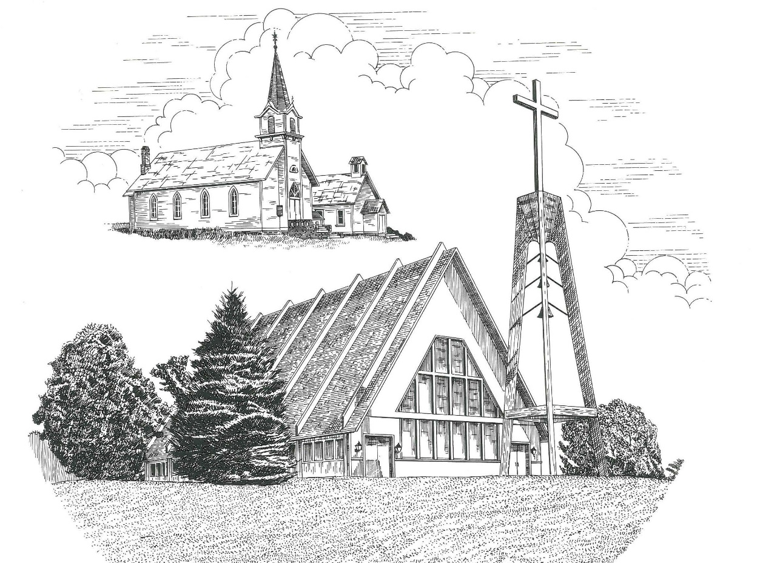

Fifth Sunday of Easter May 10th, 2020

**WELCOME**

**Thanks for joining us!**

**Pastor Jacob Sherry Missouri Synod**

**~~PLEASE NOTE~~Calling on the name of the Lord**

Does not include the use of cell phones in the worship sanctuary.

Please check yours before the service begins. Thank you for your courtesy.

**~~TO OUR GUESTS AND VISITORS~~**

Please sign our guest book located on the stand at the church entrance. During the service, we ask you to sign the attendance booklet located at the end of each pew. If you need assistance or have questions about our worship service, please talk to an elder or any one of our church family. We are glad you could join us and hope to have you worship with us again soon.

**~~ATTENDING HOLY COMMUNION~~**

By checking the “Communing Today” box on the registration form found in the attendance booklet, you are agreeing with the following statements:

* **I am a baptized Christian who believes Jesus Christ is my Lord and Savior.**
* **I believe that I am a sinner in need of Christ freely offered forgiveness.**
* **I believe that in the Lord’s Supper the body and blood of Jesus Christ**

**are truly present in, with, and under the bread and wine.**

* **I believe that my participation in Holy Communion grants me forgiveness**

**of my sins, new spiritual life, and eternal salvation.**

* **With God’s help, I sincerely seek to repent of my sins, live in service**

**to my Lord, and await His return.**

**If you agree with the above statements, you are welcome to attend the Lord’s Supper with us. May God bless your worship time with us.**

We do offer gluten-free wafers, please quietly ask an elder to help you.

Order of Divine Service Setting Three

**Pre-Service Music……………..Call to Worship………………….Greeting**

**OPENING HYMN:** *“Sing Praise to God, the Highest Good”*…………LSB #819

**OPENING LITURGY:**

**Confession & Absolution**……………………………………….LSB pp. 184-185

**Kyrie**……………………………………………………………..LSB p. 186

**Gloria In Excelsis**……………………………………………….LSB pp. 187-189

**Salutation**….…………………………………………………….LSB p. 189

**Collect Prayer**

O God, You make the minds of Your faithful to be of one will. Grant that we may love what You have commanded and desire what You promise, that among the many changes of this world our hearts may be fixed where true joys are found; through Jesus Christ, Your Son, our Lord, who lives and reigns with You and the Holy Spirit, one God, now and forever.

**THE HOLY SCRIPTURES**

**FIRST READING:** (Acts 6:1-9; 7:2a, 51-60)

Now in these days when the disciples were increasing in number, a complaint by the Hellenists arose against the Hebrews because their widows were being neglected in the daily distribution. **2**And the twelve summoned the full number of the disciples and said, “It is not right that we should give up preaching the word of God to serve tables. **3**Therefore, brothers, pick out from among you seven men of good repute, full of the Spirit and of wisdom, whom we will appoint to this duty. **4**But we will devote ourselves to prayer and to the ministry of the word.” **5**And what they said pleased the whole gathering, and they chose Stephen, a man full of faith and of the Holy Spirit, and Philip, and Prochorus, and Nicanor, and Timon, and Parmenas, and Nicolaus, a proselyte of Antioch. **6**These they set before the apostles, and they prayed and laid their hands on them. **7**And the word of God continued to increase, and the number of the disciples multiplied greatly in Jerusalem, and a great many of the priests became obedient to the faith.

**8**And Stephen, full of grace and power, was doing great wonders and signs among the people. **9**Then some of those who belonged to the synagogue of the Freedmen (as it was called), and of the Cyrenians, and of the Alexandrians, and of those from Cilicia and Asia, rose up and disputed with Stephen.  **2**And Stephen said: “Brothers and fathers, hear me. **51**“You stiff-necked people, uncircumcised in heart and ears, you always resist the Holy Spirit. As your fathers did, so do you. **52**Which of the prophets did your fathers not persecute? And they killed those who announced beforehand the coming of the Righteous One, whom you have now betrayed and murdered, **53**you who received the law as delivered by angels and did not keep it.”

**54**Now when they heard these things they were enraged, and they ground their teeth at him. **55**But he, full of the Holy Spirit, gazed into heaven and saw the glory of God, and Jesus standing at the right hand of God. **56**And he said, “Behold, I see the heavens opened, and the Son of Man standing at the right hand of God.” **57**But they cried out with a loud voice and stopped their ears and rushed together at him. **58**Then they cast him out of the city and stoned him. And the witnesses laid down their garments at the feet of a young man named Saul. **59**And as they were stoning Stephen, he called out, “Lord Jesus, receive my spirit.” **60**And falling to his knees he cried out with a loud voice, “Lord, do not hold this sin against them.” And when he had said this, he fell asleep.

**R:** This is the Word of the Lord**.** **Cong: Thanks be to God.**

**GRADUAL**

Reader: Christ has risen from the dead.

**Cong.: God the Father has crowned him with glory and honor,**

Reader: He has given him dominion over the works of his hands;

**Cong.: he has put all things under his feet.**

**EPISTLE:** (1 Peter 2:2-10)

**2**Like newborn infants, long for the pure spiritual milk, that by it you may grow up into salvation— **3**if indeed you have tasted that the Lord is good. **4**As you come to him, a living stone rejected by men but in the sight of God chosen and precious, **5**you yourselves like living stones are being built up as a spiritual house, to be a holy priesthood, to offer spiritual sacrifices acceptable to God through Jesus Christ. **6**For it stands in Scripture:

“Behold, I am laying in Zion a stone,  
  a cornerstone chosen and precious,  
 and whoever believes in him will not be put to shame.”

**7**So the honor is for you who believe, but for those who do not believe,

“The stone that the builders rejected  
  has become the cornerstone,”

**8**and

“A stone of stumbling,  
  and a rock of offense.”

They stumble because they disobey the word, as they were destined to do. **9**But you are a chosen race, a royal priesthood, a holy nation, a people for his own possession, that you may proclaim the excellencies of him who called you out of darkness into his marvelous light. **10**Once you were not a people, but now you are God's people; once you had not received mercy, but now you have received mercy.

**R:** This is the Word of the Lord. **Cong: Thanks be to God.**

**(PLEASE RISE for the reading of the Gospel)**



**R:** The Holy Gospel according to St. John, the 14th chapter.

# download (2)

**HOLY GOSPEL:** (John 14:1-14)

“Let not your hearts be troubled. Believe in God; believe also in me. **2**In my Father's house are many rooms. If it were not so, would I have told you that I go to prepare a place for you? **3**And if I go and prepare a place for you, I will come again and will take you to myself, that where I am you may be also. **4**And you know the way to where I am going.” **5**Thomas said to him, “Lord, we do not know where you are going. How can we know the way?” **6**Jesus said to him, “I am the way, and the truth, and the life. No one comes to the Father except through me. **7**If you had known me, you would have known my Father also. From now on you do know him and have seen him.” **8**Philip said to him, “Lord, show us the Father, and it is enough for us.” **9**Jesus said to him, “Have I been with you so long, and you still do not know me, Philip? Whoever has seen me has seen the Father. How can you say, ‘Show us the Father’? **10**Do you not believe that I am in the Father and the Father is in me? The words that I say to you I do not speak on my own authority, but the Father who dwells in me does his works. **11**Believe me that I am in the Father and the Father is in me, or else believe on account of the works themselves. **12**“Truly, truly, I say to you, whoever believes in me will also do the works that I do; and greater works than these will he do, because I am going to the Father. **13**Whatever you ask in my name, this I will do, that the Father may be glorified in the Son. **14**If you ask me anything in my name, I will do it.

**R:** This is the Gospel of the Lord.

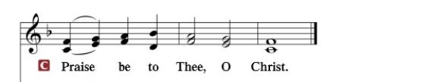

**Nicene Creed**…...……………………………………………………..…LSB p. 191

I believe in one God, the Father Almighty, maker of heaven and earth and of all things visible and invisible.

And in one Lord Jesus Christ, the only-begotten Son of God, begotten of His Father before all worlds, God of God, Light of Light, very God of very God, begotten, not made, being of one substance with the Father, by whom all things were made; who for us men and for our salvation came down from heaven and was incarnate by the Holy Spirit of the virgin Mary and was made man; and was crucified also for us under Pontius Pilate. He suffered and was buried. And the third day He rose again according to the Scriptures and ascended into heaven and sits at the right hand of the Father. And He will come again with glory to judge both the living and the dead, whose kingdom will have no end.

And I believe in the Holy Spirit, the Lord and giver of life, who proceeds from the Father and the Son, who with the Father and the Son together is worshiped and glorified, who spoke by the prophets. And I believe in one holy Christian and apostolic Church, I acknowledge one Baptism for the remission of sins, and I look for the resurrection of the dead and the life of the world to come. Amen.

**SERMON HYMN**: *“Church of God, Elect and Glorious”*……………..LSB #646

**SERMON**

**GATHERING OF OUR FIRST FRUITS & OFFERTORY**…………LSB pp. 192-193

**THE GENERAL PRAYERS**

**INSTITUTION OF THE LORD’S SUPPER**

**Preface**…………………………………….…………….………..LSB p. 194

**Proper Preface**

It is truly good, right, and salutary that we should at all times and in all places give thanks to You, holy Lord, almighty Father, everlasting God, through Jesus Christ, our Lord, who, out of love for His fallen creation, humbled Himself by taking on the form of a servant, becoming obedient unto death, even death upon a cross. Risen from the dead, He has freed us from eternal death and given us life everlasting. Therefore, with angels and archangels and with all the company of heaven we laud and magnify Your glorious name, ever more praising You and saying:

**Sanctus, Lord’s Prayer, The Words of Our Lord**………………….....LSB pp. 195-197

**Agnus Dei**………………………………………………………………..LSB p. 198

*If you are not communing, it is acceptable to remain seated.*

**COMMUNION DISTRIBUTION HYMNS:**

LSB #633 *“At the Lamb’s High Feast We Sing”*

LSB #722 *“Lord, Take My Hand and Lead Me”*

**CLOSING LITURGY:**………………………………………………....LSB pp. 199-202

**CLOSING HYMN:** *“Now Thank We All Our God”*...............................LSB #895

The Mission of Trinity Onekama Is To **SERVE**

For even the Son of Man did not come to be served

but to serve and to give his life as a ransom for many.            
                                                                       Mark 10:45



**S**haring Jesus’s **t**ruth

**E**quipping for life

**R**eaching Out

**V**aluing each other

**E**vangelizing all ages

Mission Statement

The mission of Trinity Onekama is to SERVE

For even the Son of Man did not come to be served, but to serve,

and to give his life as a ransom for many. Mark 10:45

S haring Jesus’ ruth

E quipping for life

R eaching Out

V aluing each other

E vangelizing all age

**CHURCH INFORMATION**

**Church Office:** (231) 889-4429 **Website:** www.trinityonekama.org

**E-mail:** [trinityonekama@sbcglobal.net](mailto:trinityonekama@sbcglobal.net)

**Address:** P.O. Box 119, 5471 Fairview Street, Onekama, MI 49675

**Adult Bible Study**: Sunday @ 9:15 am (year round)

**Worship:** Sunday @ 10:30 am **The Lord’s Supper:**  Celebrated 2nd & 4th Sundays

**Pastoral Hours:** Wednesday and Friday 8:30am – Noon

**Pastor Phone:** 231-655-2680 **Pastor Email:** trinityonekama@gmail.com

**Copyright licensing covered under CCLI #2802932**