**231-889-4429 5471 Fairview Street, Box 119 Onekama, MI**

**TRINITY LUTHERAN CHURCH**

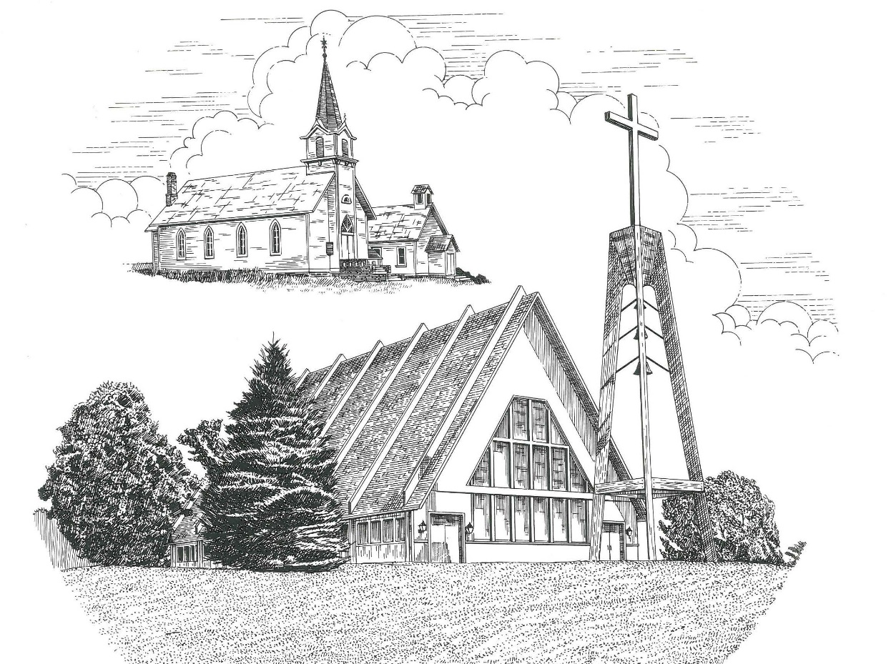

**Sixth Sunday of Easter May 14th, 2023**

**WELCOME**

**Thanks for joining us!**

**Pastor Jacob Sherry Missouri Synod**

**~~PLEASE NOTE~~Calling on the name of the Lord**

Does not include the use of cell phones in the worship sanctuary.

Please check yours before the service begins. Thank you for your courtesy.

**~~TO OUR GUESTS AND VISITORS~~**

Please sign our guest book located on the stand at the church entrance. During the service, we ask you to sign the attendance sheets located inside your bulletin and leave them on the pew as you leave. If you need assistance or have questions about our worship service, please talk to an elder or any one of our church family. We are glad you could join us and hope to have you worship with us again soon.

**~~ATTENDING HOLY COMMUNION~~**

By checking the “Communing Today” box on the registration form on the attendance sheet, you are agreeing with the following statements:

* **I am a baptized Christian who believes Jesus Christ is my Lord and Savior.**
* **I believe that I am a sinner in need of Christ’s freely offered forgiveness.**
* **I believe that in the Lord’s Supper the body and blood of Jesus Christ**

**are truly present in, with, and under the bread and wine.**

* **I believe that my participation in Holy Communion grants me forgiveness**

**of my sins, new spiritual life, and eternal salvation.**

* **With God’s help, I sincerely seek to repent of my sins, live in service**

**to my Lord, and await His return.**

**If you agree with the above statements, you are welcome to attend the Lord’s Supper with us. May God bless your worship time with us.**

We do offer gluten-free wafers, please quietly ask an elder to help you.

**Order of Divine Service Setting One**

**Pre-Service Music……………..Call to Worship………………….Greeting**

**OPENING HYMN:** *“Open Now Thy Gates of Beauty”*………………..LSB #901

**CONFESSION & ABSOLUTION**……………………………………..LSB p. 151

**KYRIE**…………………………………………………………………...LSB pp. 152-153

**THIS IS THE FEAST**…………………………………………………...LSB p. 155

**SALUTATION**…………………………………………………………..LSB p. 156

**Collect Prayer**

O God, the giver of all that is good, by Your holy inspiration grant that we may think those things that are right and by Your merciful guiding accomplish them: through Jesus Christ, Your Son, our Lord, who lives and reigns with the You and the Holy Spirit, one God, now and forever.

**THE HOLY SCRIPTURES**

**FIRST READING:** (Acts 17:16-31)

**16**Now while Paul was waiting for them at Athens, his spirit was provoked within him as he saw that the city was full of idols. **17**So he reasoned in the synagogue with the Jews and the devout persons, and in the marketplace every day with those who happened to be there. **18**Some of the Epicurean and Stoic philosophers also conversed with him. And some said, “What does this babbler wish to say?” Others said, “He seems to be a preacher of foreign divinities”—because he was preaching Jesus and the resurrection. **19**And they took him and brought him to the Areopagus, saying, “May we know what this new teaching is that you are presenting? **20**For you bring some strange things to our ears. We wish to know therefore what these things mean.” **21**Now all the Athenians and the foreigners who lived there would spend their time in nothing except telling or hearing something new.

**22**So Paul, standing in the midst of the Areopagus, said: “Men of Athens, I perceive that in every way you are very religious. **23**For as I passed along and observed the objects of your worship, I found also an altar with this inscription: ‘To the unknown god.’ What therefore you worship as unknown, this I proclaim to you. **24**The God who made the world and everything in it, being Lord of heaven and earth, does not live in temples made by man, **25**nor is he served by human hands, as though he needed anything, since he himself gives to all mankind life and breath and everything. **26**And he made from one man every nation of mankind to live on all the face of the earth, having determined allotted periods and the boundaries of their dwelling place, **27**that they should seek God, and perhaps feel their way toward him and find him. Yet he is actually not far from each one of us, **28**for

“‘In him we live and move and have our being’;

as even some of your own poets have said,

“‘For we are indeed his offspring.’

**29**Being then God's offspring, we ought not to think that the divine being is like gold or silver or stone, an image formed by the art and imagination of man. **30**The times of ignorance God overlooked, but now he commands all people everywhere to repent, **31**because he has fixed a day on which he will judge the world in righteousness by a man whom he has appointed; and of this he has given assurance to all by raising him from the dead.”

**R:** This is the Word of the Lord**.** **Cong: Thanks be to God.**

**GRADUAL**

Reader: Christ has risen from the dead.

**Cong.: God the Father has crowned him with glory and honor,**

Reader: He has given him dominion over the works of his hands;

**Cong.: he has put all things under his feet.**

**EPISTLE:** (1 Peter 3:13-22)

**3**Now who is there to harm you if you are zealous for what is good? **14**But even if you should suffer for righteousness' sake, you will be blessed. Have no fear of them, nor be troubled, **15**but in your hearts honor Christ the Lord as holy, always being prepared to make a defense to anyone who asks you for a reason for the hope that is in you; yet do it with gentleness and respect, **16**having a good conscience, so that, when you are slandered, those who revile your good behavior in Christ may be put to shame. **17**For it is better to suffer for doing good, if that should be God's will, than for doing evil. **18**For Christ also suffered once for sins, the righteous for the unrighteous, that he might bring us to God, being put to death in the flesh but made alive in the spirit, **19**in which he went and proclaimed to the spirits in prison, **20**because they formerly did not obey, when God's patience waited in the days of Noah, while the ark was being prepared, in which a few, that is, eight persons, were brought safely through water. **21**Baptism, which corresponds to this, now saves you, not as a removal of dirt from the body but as an appeal to God for a good conscience, through the resurrection of Jesus Christ, **22**who has gone into heaven and is at the right hand of God, with angels, authorities, and powers having been subjected to him.

**R:** This is the Word of the Lord. **Cong: Thanks be to God.**

**(PLEASE RISE for the reading of the Gospel)**



**R:** The Holy Gospel according to St. John, the 14th chapter.



**HOLY GOSPEL:** (John 14:15-21)

**15**“If you love me, you will keep my commandments. **16**And I will ask the Father, and he will give you another Helper, to be with you forever, **17**even the Spirit of truth, whom the world cannot receive, because it neither sees him nor knows him. You know him, for he dwells with you and will be in you. **18**“I will not leave you as orphans; I will come to you. **19**Yet a little while and the world will see me no more, but you will see me. Because I live, you also will live. **20**In that day you will know that I am in my Father, and you in me, and I in you. **21**Whoever has my commandments and keeps them, he it is who loves me. And he who loves me will be loved by my Father, and I will love him and manifest myself to him.”

**R:** This is the Gospel of the Lord.



**SERMON HYMN**: *“Lord, ‘Tis Not That I Did Choose Thee”*……………....LSB #573

**SERMON**

**NICENE CREED**

I believe in one God, the Father Almighty, maker of heaven and earth and of all things visible and invisible.

And in one Lord Jesus Christ, the only-begotten Son of God, begotten of His Father before all worlds, God of God, Light of Light, very God of very God, begotten, not made, being of one substance with the Father, by whom all things were made; who for us men and for our salvation came down from heaven and was incarnate by the Holy Spirit of the virgin Mary and was made man; and was crucified also for us under Pontius Pilate. He suffered and was buried. And the third day He rose again according to the Scriptures and ascended into heaven and sits at the right hand of the Father. And He will come again with glory to judge both the living and the dead, whose kingdom will have no end.

And I believe in the Holy Spirit, the Lord and giver of life, who proceeds from the Father and the Son, who with the Father and the Son together is worshiped and glorified, who spoke by the prophets. And I believe in one holy Christian and apostolic Church, I acknowledge one Baptism for the remission of sins, and I look for the resurrection of the dead and the life of the world to come. Amen.

**THE GENERAL PRAYERS OF THE CHURCH**

**OFFERTORY:** *“We Give Thee But Thy Own”*……………………………….LSB #781

verse 1

**Sharing the Peace of the Lord**

**SERVICE OF THE SACRAMENT**

**PREFACE**……………………………………………………………………..LSB p. 160

**Proper Preface**

It is truly good, right, and salutary that we should at all times and in all places give thanks to You, holy Lord, almighty Father, everlasting God, through Jesus Christ, our Lord, who, out of love for His fallen creation, humbled Himself by taking on the form of a servant, becoming obedient unto death, even death upon a cross. Risen from the dead, He has freed us from eternal death and given us life everlasting. Therefore, with angels and archangels and with all the company of heaven we laud and magnify Your glorious name, ever more praising You and saying:

**SANCTUS**……………………………………………………………………...LSB p. 161

**THE WORDS OF OUR LORD**……………………………………………….LSB p. 162

**AGNUS DEI**……………………………………………………………………LSB p. 163

*If you are not communing, it is acceptable to remain seated.*

**COMMUNION DISTRIBUTION HYMNS**

LSB #770 *“What a Friend We Have in Jesus”*

LSB #556 *“Dear Christians, One and All, Rejoice”*

**POST COMMUNION CANTICLE:** *“Thank the Lord”*………………….....LSB p. 164

**POST-COMMUNION COLLECT PRAYER**………………………………LSB p. 166

**BENEDICTION**……………………………………………………………….LSB p. 166

**CLOSING HYMN:** *“Go, My Children, with My Blessing”*……..……………LSB #922

**CHURCH INFORMATION**

**Church Office:** (231) 889-4429 **Website:** www.trinityonekama.org

**E-mail:** [trinityonekama@sbcglobal.net](mailto:trinityonekama@sbcglobal.net)

**Address:** P.O. Box 119, 5471 Fairview Street, Onekama, MI 49675

**Sunday School & Adult Bible Study**: Sunday @ 9:30am

**Worship:** Sunday @ 10:30 am **The Lord’s Supper:**  Celebrated 2nd & 4th Sundays

**Pastoral Hours:** Wednesday and Friday 9:00am – Noon

**Pastor Phone:** 231-655-2680 **Pastor Email:** trinityonekama@gmail.com

**Copyright licensing covered under CCLI #2802932**