231-889-4429 5471 Fairview Street, Box 119 Onekama, MI

TRINITY LUTHERAN CHURCH
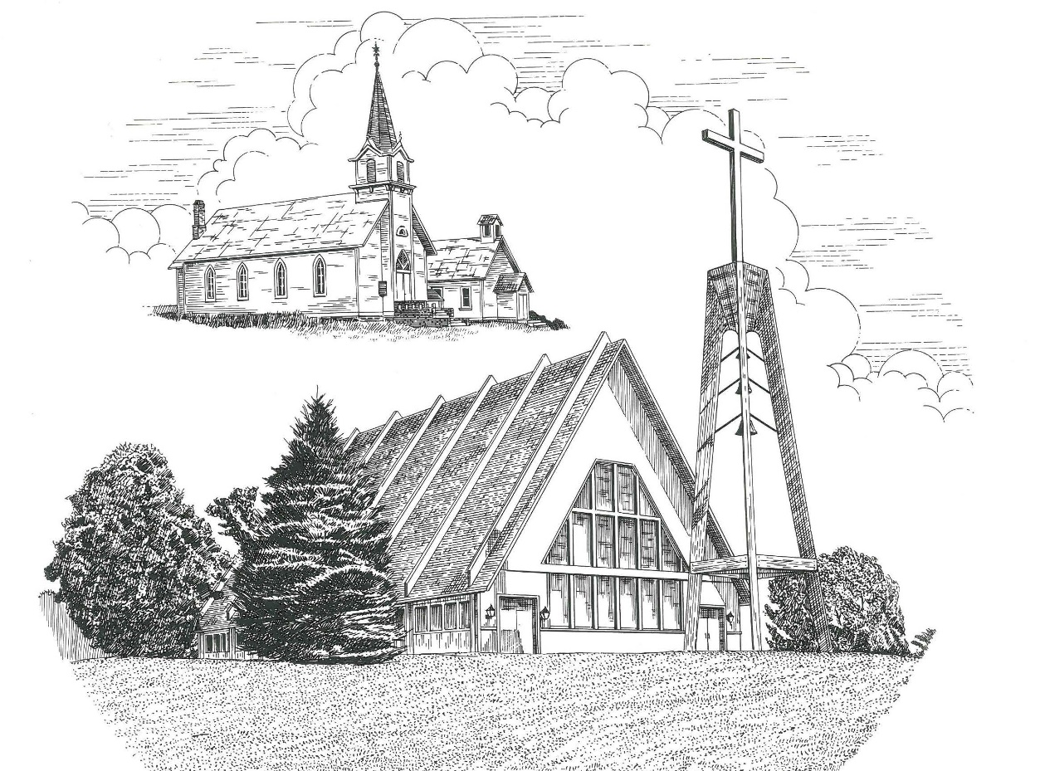

The Day of Pentecost May 23rd, 2021

WELCOME
Thanks for joining us!
Pastor Jacob Sherry Missouri Synod

~~PLEASE NOTE~~
Calling on the name of the Lord
Does not include the use of cell phones in the worship sanctuary.
Please check yours before the service begins. Thank you for your courtesy.
~~TO OUR GUESTS AND VISITORS~~
Please sign our guest book located on the stand at the church entrance. During the service, we ask you to sign the attendance booklet located at the end of each pew. If you need assistance or have questions about our worship service, please talk to an elder or any one of our church family. We are glad you could join us and hope to have you worship with us again soon.

~~ATTENDING HOLY COMMUNION~~
By checking the “Communing Today” box on the registration form found in the attendance booklet, you are agreeing with the following statements:

- I am a baptized Christian who believes Jesus Christ is my Lord and Savior.
- I believe that I am a sinner in need of Christ freely offered forgiveness.
- I believe that in the Lord’s Supper the body and blood of Jesus Christ
are truly present in, with, and under the bread and wine.
- I believe that my participation in Holy Communion grants me forgiveness
of my sins, new spiritual life, and eternal salvation.
- With God’s help, I sincerely seek to repent of my sins, live in service
to my Lord, and await His return.

If you agree with the above statements, you are welcome to attend the Lord’s Supper with us. May God bless your worship time with us.
We do offer gluten-free wafers, please quietly ask an elder to help you.

Covid-19 Guidance for Worship
* Masks are to be properly worn during worship.
* Please sit on the ends of the pews and not directly behind someone.
* Maintain social distancing with other members even at the communion rail.
* If you are feeling ill, please remain home and watch the service online.
Order of Divine Service Setting Four

Pre-Service Music……………..Call to Worship………………….Greeting

OPENING HYMN: “Holy Spirit, Light Divine”……………………….LSB #496

OPENING LITURGY:
Confession & Absolution……………………………………….LSB p. 203
Kyrie……………………………………………………………..LSB p. 204
Gloria in Excelsis………………………………………………..LSB p. 204
Salutation….…………………………………………………….LSB p. 205

Collect Prayer
O God, on this day You once taught the hearts of Your faithful people by sending them the light of Your Holy Spirit. Grant us in our day by the same Holy Spirit to have a right understanding in all things and evermore to rejoice in His holy consolation; through Jesus Christ, Your Son, our Lord, who lives and reigns with You and the Holy Spirit, one God, now and forever.

THE HOLY SCRIPTURES

OLD TESTAMENT: (Ezekiel 37:1-14)
The hand of the Lord was upon me, and he brought me out in the Spirit of the Lord and set me down in the middle of the valley; it was full of bones. ² And he led me around among them, and behold, there were very many on the surface of the valley, and behold, they were very dry. ³ And he said to me, “Son of man, can these bones live?” And I answered, “O Lord God, you know.” ⁴ Then he said to me, “Prophesy over these bones, and say to them, O dry bones, hear the word of the Lord. ⁵ Thus says the Lord God to these bones: Behold, I will cause breath to enter you, and you shall live. ⁶ And I will lay sinews upon you, and will cause flesh to come upon you, and cover you with skin, and put breath in you, and you shall live, and you shall know that I am the Lord.”
⁷ So I prophesied as I was commanded. And as I prophesied, there was a sound, and behold, a rattling, and the bones came together, bone to its bone. ⁸ And I looked, and behold, there were sinews on them, and flesh had come upon them, and skin had covered them. But there was no breath in them. ⁹ Then he said to me, “Prophesy to the breath; prophesy, son of man, and say to the breath, Thus says the Lord God: Come from the four winds, O breath, and breathe on these slain, that they may live.” ¹⁰ So I prophesied as he commanded me, and the breath came into them, and they lived and stood on their feet, an exceedingly great army.
¹¹ Then he said to me, “Son of man, these bones are the whole house of Israel. Behold, they say, ‘Our bones are dried up, and our hope is lost; we are indeed cut off.’ ¹²Therefore prophesy, and say to them, Thus says the Lord God: Behold, I will open your graves and raise you from your graves, O my people. And I will bring you into the land of Israel. ¹³ And you shall know that I am the Lord, when I open your graves, and raise you from your graves, O my people. ¹⁴ And I will put my Spirit within you, and you shall live, and I will place you in your own land. Then you shall know that I am the Lord; I have spoken, and I will do it, declares the Lord.”

R: This is the Word of the Lord. Cong: Thanks be to God.

GRADUAL
Reader: I will pour out my Spirit on all flesh,
Cong.: and your sons and your daughters shall prophesy.
Reader: With the heart one believes and is justified,
Cong.: and with the mouth one confesses and is saved.

EPISTLE: (Acts 2:1-21)
When the day of Pentecost arrived, they were all together in one place. ² And suddenly there came from heaven a sound like a mighty rushing wind, and it filled the entire house where they were sitting. ³ And divided tongues as of fire appeared to them and rested on each one of them. ⁴ And they were all filled with the Holy Spirit and began to speak in other tongues as the Spirit gave them utterance.
⁵ Now there were dwelling in Jerusalem Jews, devout men from every nation under heaven. ⁶ And at this sound the multitude came together, and they were bewildered, because each one was hearing them speak in his own language. ⁷ And they were amazed and astonished, saying, “Are not all these who are speaking Galileans? ⁸ And how is it that we hear, each of us in his own native language? ⁹ Parthians and Medes and Elamites and residents of Mesopotamia, Judea and Cappadocia, Pontus and Asia, ¹⁰ Phrygia and Pamphylia, Egypt and the parts of Libya belonging to Cyrene, and visitors from Rome, ¹¹ both Jews and proselytes, Cretans and Arabians—we hear them telling in our own tongues the mighty works of God.” ¹² And all were amazed and perplexed, saying to one another, “What does this mean?” ¹³ But others mocking said, “They are filled with new wine.”
¹⁴ But Peter, standing with the eleven, lifted up his voice and addressed them: “Men of Judea and all who dwell in Jerusalem, let this be known to you, and give ear to my words. ¹⁵ For these people are not drunk, as you suppose, since it is only the third hour of the day. ¹⁶ But this is what was uttered through the prophet Joel:
¹⁷ “‘And in the last days it shall be, God declares,
that I will pour out my Spirit on all flesh,
and your sons and your daughters shall prophesy,
and your young men shall see visions,
and your old men shall dream dreams;
¹⁸ even on my male servants and female servants
in those days I will pour out my Spirit, and they shall prophesy.
¹⁹ And I will show wonders in the heavens above
and signs on the earth below,
blood, and fire, and vapor of smoke;
²⁰ the sun shall be turned to darkness
and the moon to blood,
before the day of the Lord comes, the great and magnificent day.
²¹ And it shall come to pass that everyone who calls upon the name of the Lord shall be saved.’

R: This is the Word of the Lord. Cong: Thanks be to God.

(PLEASE RISE for the reading of the Gospel)

R: The Holy Gospel according to St. John, the 15th and 16th chapters.
Cong: Glory to You, O Lord

HOLY GOSPEL: (John 15:26-27; 16:4b-15)
²⁶ “But when the Helper comes, whom I will send to you from the Father, the Spirit of truth, who proceeds from the Father, he will bear witness about me. ²⁷ And you also will bear witness, because you have been with me from the beginning.
“I did not say these things to you from the beginning, because I was with you. ⁵ But now I am going to him who sent me, and none of you asks me, ‘Where are you going?’ ⁶ But because I have said these things to you, sorrow has filled your heart. ⁷ Nevertheless, I tell you the truth: it is to your advantage that I go away, for if I do not go away, the Helper will not come to you. But if I go, I will send him to you. ⁸ And when he comes, he will convict the world concerning sin and righteousness and judgment: ⁹ concerning sin, because they do not believe in me; ¹⁰ concerning righteousness, because I go to the Father, and you will see me no longer; ¹¹ concerning judgment, because the ruler of this world is judged.
¹² “I still have many things to say to you, but you cannot bear them now. ¹³ When the Spirit of truth comes, he will guide you into all the truth, for he will not speak on his own authority, but whatever he hears he will speak, and he will declare to you the things that are to come. ¹⁴ He will glorify me, for he will take what is mine and declare it to you. ¹⁵ All that the Father has is mine; therefore I said that he will take what is mine and declare it to you.
R: This is the Gospel of the Lord. Cong: Praise to You, O Christ.

Nicene Creed
I believe in one God, the Father Almighty, maker of heaven and earth and of all things visible and invisible.
And in one Lord Jesus Christ, the only-begotten Son of God, begotten of His Father before all worlds, God of God, Light of Light, very God of very God, begotten, not made, being of one substance with the Father, by whom all things were made; who for us men and for our salvation came down from heaven and was incarnate by the Holy Spirit of the virgin Mary and was made man; and was crucified also for us under Pontius Pilate. He suffered and was buried. And the third day He rose again according to the Scriptures and ascended into heaven and sits at the right hand of the Father. And He will come again with glory to judge both the living and the dead, whose kingdom will have no end.
And I believe in the Holy Spirit, the Lord and giver of life, who proceeds from the Father and the Son, who with the Father and the Son together is worshiped and glorified, who spoke by the prophets. And I believe in one holy Christian and apostolic Church, I acknowledge one Baptism for the remission of sins, and I look for the resurrection of the dead and the life of the world to come. Amen.

SERMON HYMN: “Creator Spirit, by Whose Aid”…………………………LSB #500

SERMON

THE GENERAL PRAYERS

INSTITUTION OF THE LORD’S SUPPER
Preface…………………………………….…………….…………….LSB p. 208
Proper Preface
It is truly good, right, and salutary that we should at all times and in all places give thanks to You, O Lord, holy Father, almighty and everlasting God, for the countless blessings You so freely bestow on us and all creation. Above all, we give thanks for Your boundless love shown to us when You sent Your only-begotten Son, Jesus Christ, into our flesh and laid on Him our sin, giving Him into death that we might not die eternally. Because He is now risen from the dead and lives and reigns to all eternity, all who believe in Him will overcome sin and death and will rise again to new life. Therefore, with angels and archangels and with all the company of heaven we laud and magnify Your glorious name, ever more praising You and saying:
Sanctus, Lord’s Prayer, The Words of Our Lord………………….....LSB pp. 208-209
Agnus Dei………………………………………………………………..LSB p. 210
If you are not communing it is acceptable to remain seated.

COMMUNION DISTRIBUTION HYMNS:
LSB #497 “Come, Holy Ghost, God and Lord”
LSB #620 “Jesus Comes Today with Healing”

CLOSING LITURGY:………………………………………………....LSB pp. 211-212

CLOSING HYMN: “Lord, Dismiss Us with Your Blessing”..................LSB #924

CHURCH INFORMATION
Church Office: (231) 889-4429 Website: www.trinityonekama.org
E-mail: trinityonekama@sbcglobal.net
Address: P.O. Box 119, 5471 Fairview Street, Onekama, MI 49675
Adult Bible Study: Sunday @ 9:15 am (year round)
Worship: Sunday @ 10:30 am The Lord’s Supper: Celebrated 2nd & 4th Sundays
Pastoral Hours: Wednesday and Friday 8:30am – Noon
Pastor Phone: 231-655-2680 Pastor Email: trinityonekama@gmail.com

Copyright licensing covered under CCLI #2802932

