**231-889-4429 5471 Fairview Street, Box 119 Onekama, MI**

**TRINITY LUTHERAN CHURCH**

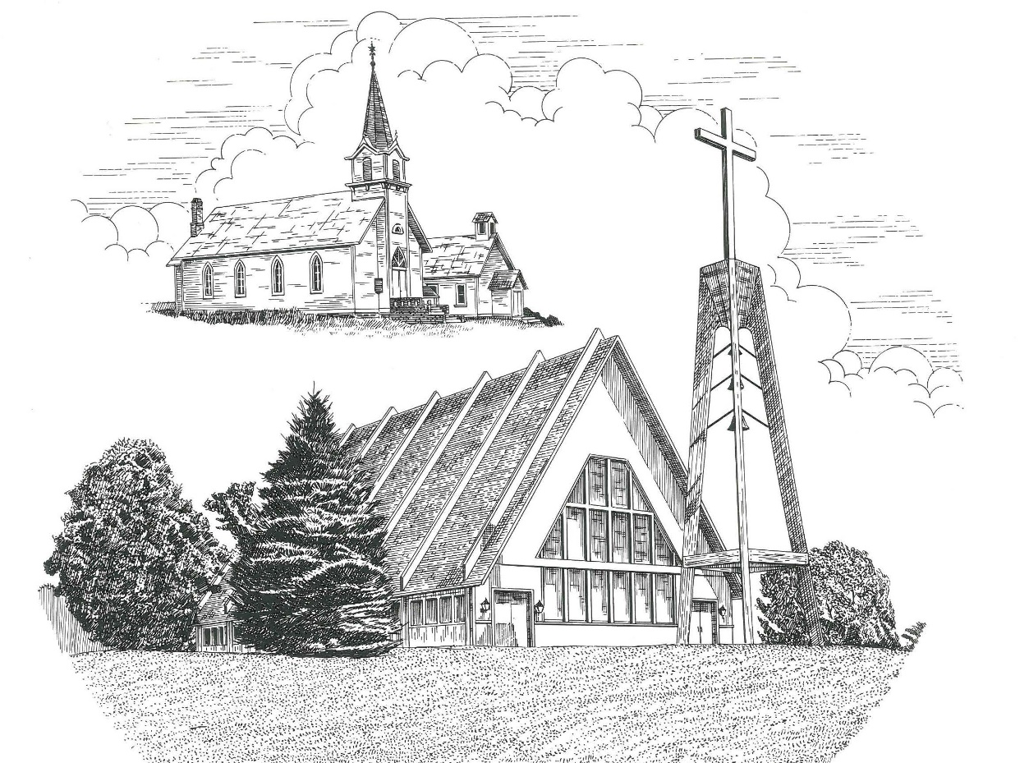

**Observance of The Ascension of Our Lord May 29th, 2022**

**WELCOME**

**Thanks for joining us!**

**Pastor Jacob Sherry Missouri Synod**

**~~PLEASE NOTE~~Calling on the name of the Lord**

Does not include the use of cell phones in the worship sanctuary.

Please check yours before the service begins. Thank you for your courtesy.

**~~TO OUR GUESTS AND VISITORS~~**

Please sign our guest book located on the stand at the church entrance. During the service, we ask you to sign the attendance sheets located inside your bulletin and leave them on the pew as you leave. If you need assistance or have questions about our worship service, please talk to an elder or any one of our church family. We are glad you could join us and hope to have you worship with us again soon.

**~~ATTENDING HOLY COMMUNION~~**

By checking the “Communing Today” box on the registration form on the attendance sheet, you are agreeing with the following statements:

* **I am a baptized Christian who believes Jesus Christ is my Lord and Savior.**
* **I believe that I am a sinner in need of Christ freely offered forgiveness.**
* **I believe that in the Lord’s Supper the body and blood of Jesus Christ**

**are truly present in, with, and under the bread and wine.**

* **I believe that my participation in Holy Communion grants me forgiveness**

**of my sins, new spiritual life, and eternal salvation.**

* **With God’s help, I sincerely seek to repent of my sins, live in service**

**to my Lord, and await His return.**

**If you agree with the above statements, you are welcome to attend the Lord’s Supper with us. May God bless your worship time with us.**

We do offer gluten-free wafers, please quietly ask an elder to help you.

**Order of Divine Service Setting One**

**Pre-Service Music……………..Call to Worship………………….Greeting**

**OPENING HYMN:** *“See, the Lord Ascends in Triumph”*……………..LSB #494

**CONFESSION & ABSOLUTION**……………………………………..LSB p. 151

**KYRIE**…………………………………………………………………...LSB pp. 152-153

**THIS IS THE FEAST**…………………………………………………...LSB p. 155

**SALUTATION**…………………………………………………………..LSB p. 156

**Collect Prayer**

Almighty God, as Your only-begotten Son, our Lord Jesus Christ, ascended into the heavens, so may we also ascend in heart and mind and continually dwell there with Him, who lives and reigns with You and the Holy Spirit, one God, now and forever.

**THE HOLY SCRIPTURES**

**FIRST READING:** (Acts 1:1-11)

In the first book, O Theophilus, I have dealt with all that Jesus began to do and teach, **2**until the day when he was taken up, after he had given commands through the Holy Spirit to the apostles whom he had chosen.  **3**He presented himself alive to them after his suffering by many proofs, appearing to them during forty days and speaking about the kingdom of God. **4**And while staying with them he ordered them not to depart from Jerusalem, but to wait for the promise of the Father, which, he said, “you heard from me; **5**for John baptized with water, but you will be baptized with the Holy Spirit not many days from now.”

**6**So when they had come together, they asked him, “Lord, will you at this time restore the kingdom to Israel?”  **7**He said to them, “It is not for you to know times or seasons that the Father has fixed by his own authority.  **8**But you will receive power when the Holy Spirit has come upon you, and you will be my witnesses in Jerusalem and in all Judea and Samaria, and to the end of the earth.”  **9**And when he had said these things, as they were looking on, he was lifted up, and a cloud took him out of their sight.  **10**And while they were gazing into heaven as he went, behold, two men stood by them in white robes, **11**and said, “Men of Galilee, why do you stand looking into heaven? This Jesus, who was taken up from you into heaven, will come in the same way as you saw him go into heaven.”

**R:** This is the Word of the Lord**.** **Cong: Thanks be to God.**

**GRADUAL**

Reader: Christ has risen from the dead.

**Cong.: God the Father has crowned him with glory and honor,**

Reader: He has given him dominion over the works of his hands;

**Cong.: he has put all things under his feet.**

**SECOND READING:** (Ephesians 1:15-23)

**15**For this reason, because I have heard of your faith in the Lord Jesus and your love toward all the saints, **16**I do not cease to give thanks for you, remembering you in my prayers, **17**that the God of our Lord Jesus Christ, the Father of glory, may give you the Spirit of wisdom and of revelation in the knowledge of him, **18**having the eyes of your hearts enlightened, that you may know what is the hope to which he has called you, what are the riches of his glorious inheritance in the saints, **19**and what is the immeasurable greatness of his power toward us who believe, according to the working of his great might **20**that he worked in Christ when he raised him from the dead and seated him at his right hand in the heavenly places, **21**far above all rule and authority and power and dominion, and above every name that is named, not only in this age but also in the one to come.  **22**And he put all things under his feet and gave him as head over all things to the church, **23**which is his body, the fullness of him who fills all in all.

**R:** This is the Word of the Lord. **Cong: Thanks be to God.**

**(PLEASE RISE for the reading of the Gospel)**



**R:** The Holy Gospel according to St. Luke, the 24th chapter.



**HOLY GOSPEL:** (Luke 24:44-53)

**44**Then Jesus said to them, “These are my words that I spoke to you while I was still with you, that everything written about me in the Law of Moses and the Prophets and the Psalms must be fulfilled.”  **45**Then he opened their minds to understand the Scriptures, **46**and said to them, “Thus it is written, that the Christ should suffer and on the third day rise from the dead, **47**and that repentance for the forgiveness of sins should be proclaimed in his name to all nations, beginning from Jerusalem.  **48**You are witnesses of these things. **49**And behold, I am sending the promise of my Father upon you. But stay in the city until you are clothed with power from on high.”

**50**And he led them out as far as Bethany, and lifting up his hands he blessed them. **51**While he blessed them, he parted from them and was carried up into heaven. **52**And they worshiped him and returned to Jerusalem with great joy, **53**and were continually in the temple blessing God.

**R:** This is the Gospel of the Lord.



**SERMON HYMN**: *“Up through Endless Ranks of Angels”*…………………...LSB #491

**SERMON**

**NICENE CREED**

I believe in one God, the Father Almighty, maker of heaven and earth and of all things visible and invisible.

And in one Lord Jesus Christ, the only-begotten Son of God, begotten of His Father before all worlds, God of God, Light of Light, very God of very God, begotten, not made, being of one substance with the Father, by whom all things were made; who for us men and for our salvation came down from heaven and was incarnate by the Holy Spirit of the virgin Mary and was made man; and was crucified also for us under Pontius Pilate. He suffered and was buried. And the third day He rose again according to the Scriptures and ascended into heaven and sits at the right hand of the Father. And He will come again with glory to judge both the living and the dead, whose kingdom will have no end.

And I believe in the Holy Spirit, the Lord and giver of life, who proceeds from the Father and the Son, who with the Father and the Son together is worshiped and glorified, who spoke by the prophets. And I believe in one holy Christian and apostolic Church, I acknowledge one Baptism for the remission of sins, and I look for the resurrection of the dead and the life of the world to come. Amen.

**THE GENERAL PRAYERS OF THE CHURCH**

**SERVICE OF THE SACRAMENT**

**PREFACE**……………………………………………………………………..LSB p. 160

**Proper Preface**

It is truly good, right, and salutary that we should at all times and in all places give thanks to You, holy Lord, almighty Father, everlasting God, through Jesus Christ, our Lord, who, out of love for His fallen creation, humbled Himself by taking on the form of a servant, becoming obedient unto death, even death upon a cross. Risen from the dead, He has freed us from eternal death and given us life everlasting. Therefore, with angels and archangels and with all the company of heaven we laud and magnify Your glorious name, ever more praising You and saying:

**SANCTUS**……………………………………………………………………...LSB p. 161

**THE WORDS OF OUR LORD**……………………………………………….LSB p. 162

**AGNUS DEI**……………………………………………………………………LSB p. 163

*If you are not communing, it is acceptable to remain seated.*

**COMMUNION DISTRIBUTION HYMNS**

LSB #492 *“On Christ’s Ascension I Now Build”*

LSB #636 *“Soul, Adorn Yourself with Gladness”*

LSB #711 *“Savior, like a Shepherd Lead Us”*

**THANK THE LORD**………………………………………………………….LSB p. 164

**POST-COMMUNION COLLECT PRAYER**……………………………….LSB p. 166

**BENEDICTION**……………………………………………………………….LSB p. 166

**CLOSING HYMN:** *“A Hymn of Glory Let Us Sing”*……..…………………..LSB #493

The Mission of Trinity Onekama Is To **SERVE**

For even the Son of Man did not come to be served

but to serve and to give his life as a ransom for many.            
                                                                       Mark 10:45



**S**haring Jesus’s **t**ruth

**E**quipping for life

**R**eaching Out

**V**aluing each other

**E**vangelizing all ages

Mission Statement

The mission of Trinity Onekama is to SERVE

For even the Son of Man did not come to be served, but to serve,

and to give his life as a ransom for many. Mark 10:45

S haring Jesus’ ruth

E quipping for life

R eaching Out

V aluing each other

E vangelizing all age

**CHURCH INFORMATION**

**Church Office:** (231) 889-4429 **Website:** www.trinityonekama.org

**E-mail:** [trinityonekama@sbcglobal.net](mailto:trinityonekama@sbcglobal.net)

**Address:** P.O. Box 119, 5471 Fairview Street, Onekama, MI 49675

**Adult Bible Study**: Sunday @ 11:30 am (year round)

**Worship:** Sunday @ 10:30 am **The Lord’s Supper:**  Celebrated 2nd & 4th Sundays

**Pastoral Hours:** Wednesday and Friday 9:00am – Noon

**Pastor Phone:** 231-655-2680 **Pastor Email:** trinityonekama@gmail.com

**Copyright licensing covered under CCLI #2802932**