**231-889-4429 5471 Fairview Street, Box 119 Onekama, MI**

**TRINITY LUTHERAN CHURCH**

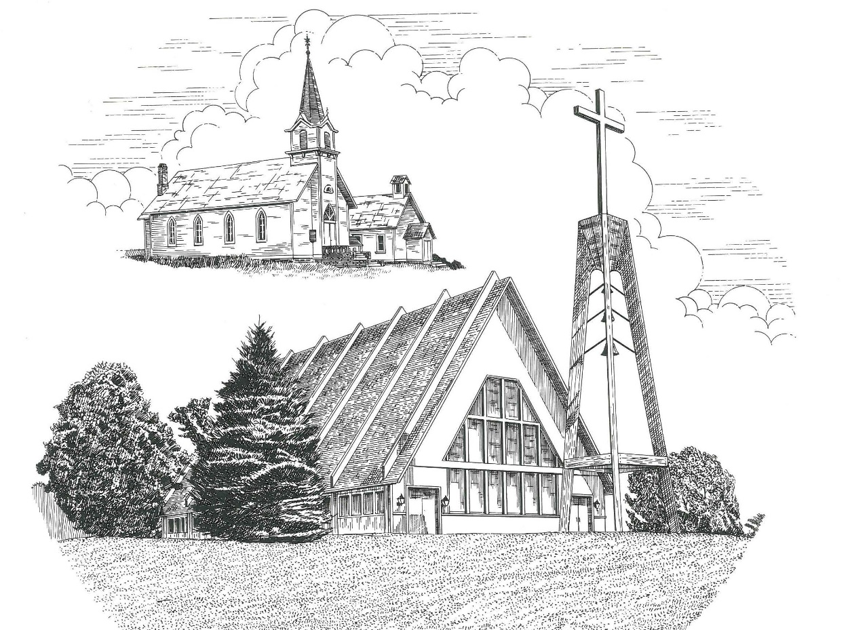

**Fourth Sunday of Easter May 8th, 2022**

**WELCOME**

**Thanks for joining us!**

**Pastor Jacob Sherry Missouri Synod**

**~~PLEASE NOTE~~Calling on the name of the Lord**

Does not include the use of cell phones in the worship sanctuary.

Please check yours before the service begins. Thank you for your courtesy.

**~~TO OUR GUESTS AND VISITORS~~**

Please sign our guest book located on the stand at the church entrance. During the service, we ask you to sign the attendance sheets located inside your bulletin and leave them on the pew as you leave. If you need assistance or have questions about our worship service, please talk to an elder or any one of our church family. We are glad you could join us and hope to have you worship with us again soon.

**~~ATTENDING HOLY COMMUNION~~**

By checking the “Communing Today” box on the registration form on the attendance sheet, you are agreeing with the following statements:

* **I am a baptized Christian who believes Jesus Christ is my Lord and Savior.**
* **I believe that I am a sinner in need of Christ freely offered forgiveness.**
* **I believe that in the Lord’s Supper the body and blood of Jesus Christ**

**are truly present in, with, and under the bread and wine.**

* **I believe that my participation in Holy Communion grants me forgiveness**

**of my sins, new spiritual life, and eternal salvation.**

* **With God’s help, I sincerely seek to repent of my sins, live in service**

**to my Lord, and await His return.**

**If you agree with the above statements, you are welcome to attend the Lord’s Supper with us. May God bless your worship time with us.**

We do offer gluten-free wafers, please quietly ask an elder to help you.

**Order of Divine Service Setting One**

**Pre-Service Music……………..Call to Worship………………….Greeting**

**OPENING HYMN:** *“This Joyful Eastertide”*…………………………..LSB #482

**CONFESSION & ABSOLUTION**……………………………………..LSB p. 151

**KYRIE**…………………………………………………………………...LSB pp. 152-153

**THIS IS THE FEAST**…………………………………………………...LSB p. 155

**SALUTATION**…………………………………………………………..LSB p. 156

**Collect Prayer**

Almighty God, merciful Father, since You have wakened from death the Shepherd of Your sheep, grant us Your Holy Spirit that when we hear the voice of our Shepherd, we may know Him who calls us each by name and follow where He leads; through the same Jesus Christ, Your Son, our Lord, who lives and reigns with You and the Holy Spirit, one God, now and forever.

**THE HOLY SCRIPTURES**

**FIRST READING:** (Acts 20:17-35)

**17**Now from Miletus he sent to Ephesus and called the elders of the church to come to him.  **18**And when they came to him, he said to them:

“You yourselves know how I lived among you the whole time from the first day that I set foot in Asia, **19**serving the Lord with all humility and with tears and with trials that happened to me through the plots of the Jews; **20**how I did not shrink from declaring to you anything that was profitable, and teaching you in public and from house to house, **21**testifying both to Jews and to Greeks of repentance toward God and of faith in our Lord Jesus Christ.  **22**And now, behold, I am going to Jerusalem, constrained by the Spirit, not knowing what will happen to me there, **23**except that the Holy Spirit testifies to me in every city that imprisonment and afflictions await me.  **24**But I do not account my life of any value nor as precious to myself, if only I may finish my course and the ministry that I received from the Lord Jesus, to testify to the gospel of the grace of God.  **25**And now, behold, I know that none of you among whom I have gone about proclaiming the kingdom will see my face again.  **26**Therefore I testify to you this day that I am innocent of the blood of all, **27**for I did not shrink from declaring to you the whole counsel of God. **28**Pay careful attention to yourselves and to all the flock, in which the Holy Spirit has made you overseers, to care for the church of God, which he obtained with his own blood.  **29**I know that after my departure fierce wolves will come in among you, not sparing the flock; **30**and from among your own selves will arise men speaking twisted things, to draw away the disciples after them.  **31**Therefore be alert, remembering that for three years I did not cease night or day to admonish every one with tears.  **32**And now I commend you to God and to the word of his grace, which is able to build you up and to give you the inheritance among all those who are sanctified.  **33**I coveted no one's silver or gold or apparel.  **34**You yourselves know that these hands ministered to my necessities and to those who were with me.  **35**In all things I have shown you that by working hard in this way we must help the weak and remember the words of the Lord Jesus, how he himself said, ‘It is more blessed to give than to receive.’”

**R:** This is the Word of the Lord**.** **Cong: Thanks be to God.**

**GRADUAL**

Reader: Christ has risen from the dead.

**Cong.: God the Father has crowned him with glory and honor,**

Reader: He has given him dominion over the works of his hands;

**Cong.: he has put all things under his feet.**

**SECOND READING:** (Revelation 7:9-17)

**9**After this I looked, and behold, a great multitude that no one could number, from every nation, from all tribes and peoples and languages, standing before the throne and before the Lamb, clothed in white robes, with palm branches in their hands, **10**and crying out with a loud voice, “Salvation belongs to our God who sits on the throne, and to the Lamb!” **11**And all the angels were standing around the throne and around the elders and the four living creatures, and they fell on their faces before the throne and worshiped God, **12**saying, “Amen! Blessing and glory and wisdom and thanksgiving and honor and power and might be to our God forever and ever! Amen.”

**13**Then one of the elders addressed me, saying, “Who are these, clothed in white robes, and from where have they come?”  **14**I said to him, “Sir, you know.” And he said to me, “These are the ones coming out of the great tribulation.  They have washed their robes and made them white in the blood of the Lamb.

**15**“Therefore they are before the throne of God,  
    and serve him day and night in his temple;  
    and he who sits on the throne will shelter them with his presence.  
**16**They shall hunger no more, neither thirst anymore;  
    the sun shall not strike them,  
    nor any scorching heat.  
**17**For the Lamb in the midst of the throne will be their shepherd,  
    and he will guide them to springs of living water,  
and God will wipe away every tear from their eyes.”

**R:** This is the Word of the Lord. **Cong: Thanks be to God.**

**(PLEASE RISE for the reading of the Gospel)**



**R:** The Holy Gospel according to St. John, the 10th chapter.



**HOLY GOSPEL:** (John 10:22-30)

**22**At that time the Feast of Dedication took place at Jerusalem. It was winter, **23**and Jesus was walking in the temple, in the colonnade of Solomon.  **24**So the Jews gathered around him and said to him, “How long will you keep us in suspense? If you are the Christ, tell us plainly.”  **25**Jesus answered them, “I told you, and you do not believe.  The works that I do in my Father's name bear witness about me, **26**but you do not believe because you are not among my sheep.  **27**My sheep hear my voice, and I know them, and they follow me. **28**I give them eternal life, and they will never perish, and no one will snatch them out of my hand.  **29**My Father, who has given them to me, is greater than all, and no one is able to snatch them out of the Father's hand.  **30**I and the Father are one.”

**R:** This is the Gospel of the Lord.



**SERMON HYMN**: *“The King of Love My Shepherd Is”*…………………........LSB #709

**SERMON**

**NICENE CREED**

I believe in one God, the Father Almighty, maker of heaven and earth and of all things visible and invisible.

And in one Lord Jesus Christ, the only-begotten Son of God, begotten of His Father before all worlds, God of God, Light of Light, very God of very God, begotten, not made, being of one substance with the Father, by whom all things were made; who for us men and for our salvation came down from heaven and was incarnate by the Holy Spirit of the virgin Mary and was made man; and was crucified also for us under Pontius Pilate. He suffered and was buried. And the third day He rose again according to the Scriptures and ascended into heaven and sits at the right hand of the Father. And He will come again with glory to judge both the living and the dead, whose kingdom will have no end.

And I believe in the Holy Spirit, the Lord and giver of life, who proceeds from the Father and the Son, who with the Father and the Son together is worshiped and glorified, who spoke by the prophets. And I believe in one holy Christian and apostolic Church, I acknowledge one Baptism for the remission of sins, and I look for the resurrection of the dead and the life of the world to come. Amen.

**THE GENERAL PRAYERS OF THE CHURCH**

**SERVICE OF THE SACRAMENT**

**PREFACE**……………………………………………………………………..LSB p. 160

**Proper Preface**

It is truly good, right, and salutary that we should at all times and in all places give thanks to You, holy Lord, almighty Father, everlasting God, through Jesus Christ, our Lord, who, out of love for His fallen creation, humbled Himself by taking on the form of a servant, becoming obedient unto death, even death upon a cross. Risen from the dead, He has freed us from eternal death and given us life everlasting. Therefore, with angels and archangels and with all the company of heaven we laud and magnify Your glorious name, ever more praising You and saying:

**SANCTUS**……………………………………………………………………...LSB p. 161

**THE WORDS OF OUR LORD**……………………………………………….LSB p. 162

**AGNUS DEI**……………………………………………………………………LSB p. 163

*If you are not communing, it is acceptable to remain seated.*

**COMMUNION DISTRIBUTION HYMNS**

LSB #470 *“O Sons and Daughters of the King”*

LSB #628 *“Your Table I Approach”*

**THANK THE LORD**………………………………………………………….LSB p. 164

**POST-COMMUNION COLLECT PRAYER**……………………………….LSB p. 166

**BENEDICTION**……………………………………………………………….LSB p. 166

**CLOSING HYMN:** *“When Peace, like a River”*……..………………………LSB #763

The Mission of Trinity Onekama Is To **SERVE**

For even the Son of Man did not come to be served

but to serve and to give his life as a ransom for many.            
                                                                       Mark 10:45



**S**haring Jesus’s **t**ruth

**E**quipping for life

**R**eaching Out

**V**aluing each other

**E**vangelizing all ages

Mission Statement

The mission of Trinity Onekama is to SERVE

For even the Son of Man did not come to be served, but to serve,

and to give his life as a ransom for many. Mark 10:45

S haring Jesus’ ruth

E quipping for life

R eaching Out

V aluing each other

E vangelizing all age

**CHURCH INFORMATION**

**Church Office:** (231) 889-4429 **Website:** www.trinityonekama.org

**E-mail:** [trinityonekama@sbcglobal.net](mailto:trinityonekama@sbcglobal.net)

**Address:** P.O. Box 119, 5471 Fairview Street, Onekama, MI 49675

**Adult Bible Study**: Sunday @ 11:30 am (year round)

**Worship:** Sunday @ 10:30 am **The Lord’s Supper:**  Celebrated 2nd & 4th Sundays

**Pastoral Hours:** Wednesday and Friday 9:00am – Noon

**Pastor Phone:** 231-655-2680 **Pastor Email:** trinityonekama@gmail.com

**Copyright licensing covered under CCLI #2802932**