231-889-4429 5471 Fairview Street, Box 119 Onekama, MI

TRINITY LUTHERAN CHURCH
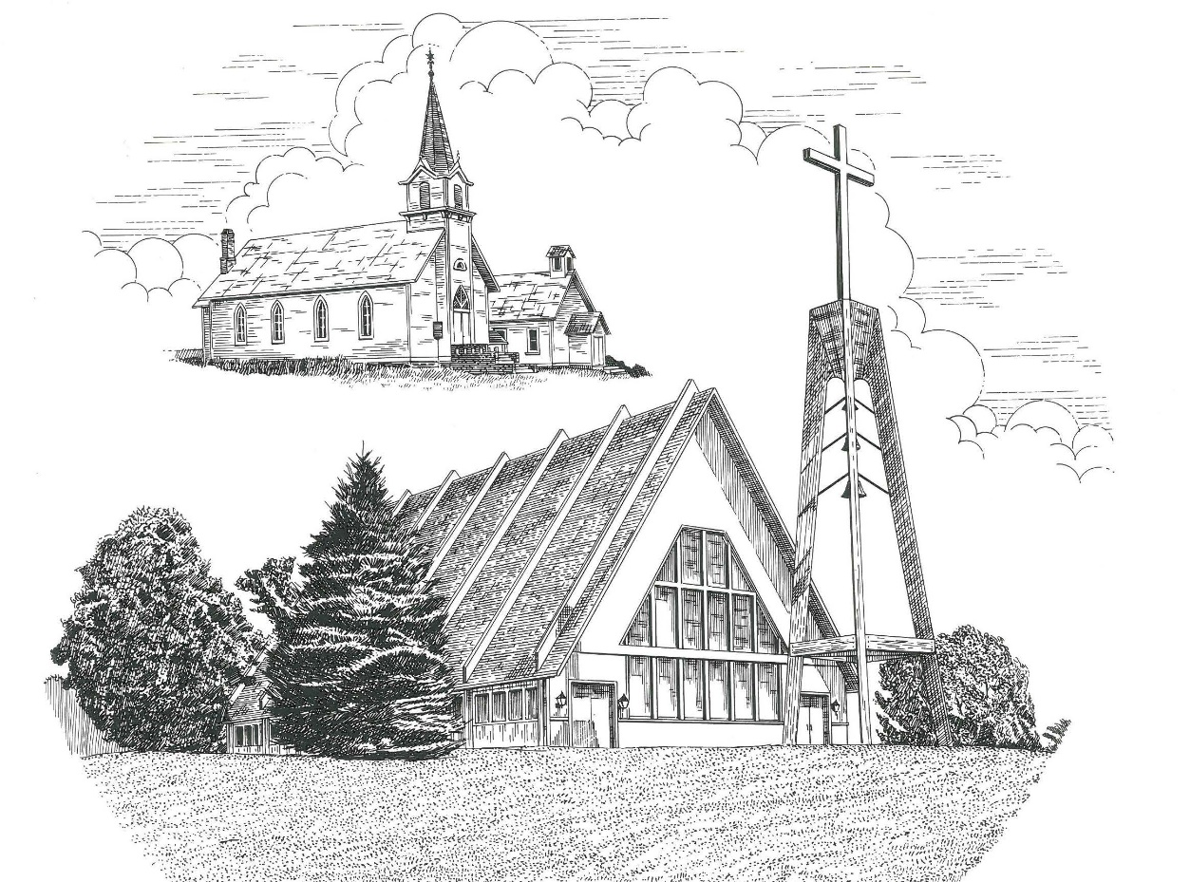

Sixth Sunday of Easter May 9th, 2021

WELCOME
Thanks for joining us!
Pastor Jacob Sherry Missouri Synod

~~PLEASE NOTE~~
Calling on the name of the Lord
Does not include the use of cell phones in the worship sanctuary.
Please check yours before the service begins. Thank you for your courtesy.
~~TO OUR GUESTS AND VISITORS~~
Please sign our guest book located on the stand at the church entrance. During the service, we ask you to sign the attendance booklet located at the end of each pew. If you need assistance or have questions about our worship service, please talk to an elder or any one of our church family. We are glad you could join us and hope to have you worship with us again soon.

~~ATTENDING HOLY COMMUNION~~
By checking the “Communing Today” box on the registration form found in the attendance booklet, you are agreeing with the following statements:

- I am a baptized Christian who believes Jesus Christ is my Lord and Savior.
- I believe that I am a sinner in need of Christ freely offered forgiveness.
- I believe that in the Lord’s Supper the body and blood of Jesus Christ
are truly present in, with, and under the bread and wine.
- I believe that my participation in Holy Communion grants me forgiveness
of my sins, new spiritual life, and eternal salvation.
- With God’s help, I sincerely seek to repent of my sins, live in service
to my Lord, and await His return.

If you agree with the above statements, you are welcome to attend the Lord’s Supper with us. May God bless your worship time with us.
We do offer gluten-free wafers, please quietly ask an elder to help you.

Covid-19 Guidance for Worship
* Masks are to be properly worn during worship.
* Please sit on the ends of the pews and not directly behind someone.
* Maintain social distancing with other members even at the communion rail.
* If you are feeling ill, please remain home and watch the service online.
Order of Divine Service Setting Three

Pre-Service Music……………..Call to Worship………………….Greeting

OPENING HYMN: “Come, Thou Almighty King”.................................LSB #905

OPENING LITURGY:
Confession & Absolution………..………………………………LSB pp. 184-185
Kyrie…………………………………….………………………..LSB p. 186
Gloria in Excelsis……...…………………………………………LSB pp. 187-188
Salutation….……………………………….…………………….LSB p. 189

Collect Prayer
O God, the giver of all that is good, by Your holy inspiration grant that we may think those things that are right and by Your merciful guiding accomplish them; through Jesus Christ, Your Son, our Lord, who lives and reigns with You and the Holy Spirit, one God, now and forever.

THE HOLY SCRIPTURES

FIRST READING: (Acts 10:34-48)
³⁴ So Peter opened his mouth and said: “Truly I understand that God shows no partiality, ³⁵ but in every nation anyone who fears him and does what is right is acceptable to him. ³⁶ As for the word that he sent to Israel, preaching good news of peace through Jesus Christ (he is Lord of all), ³⁷ you yourselves know what happened throughout all Judea, beginning from Galilee after the baptism that John proclaimed: ³⁸ how God anointed Jesus of Nazareth with the Holy Spirit and with power. He went about doing good and healing all who were oppressed by the devil, for God was with him. ³⁹ And we are witnesses of all that he did both in the country of the Jews and in Jerusalem. They put him to death by hanging him on a tree, ⁴⁰ but God raised him on the third day and made him to appear, ⁴¹ not to all the people but to us who had been chosen by God as witnesses, who ate and drank with him after he rose from the dead. ⁴² And he commanded us to preach to the people and to testify that he is the one appointed by God to be judge of the living and the dead. ⁴³ To him all the prophets bear witness that everyone who believes in him receives forgiveness of sins through his name.”
⁴⁴ While Peter was still saying these things, the Holy Spirit fell on all who heard the word. ⁴⁵ And the believers from among the circumcised who had come with Peter were amazed, because the gift of the Holy Spirit was poured out even on the Gentiles. ⁴⁶ For they were hearing them speaking in tongues and extolling God. Then Peter declared, ⁴⁷ “Can anyone withhold water for baptizing these people, who have received the Holy Spirit just as we have?” ⁴⁸ And he commanded them to be baptized in the name of Jesus Christ. Then they asked him to remain for some days.

R: This is the Word of the Lord. Cong: Thanks be to God.

GRADUAL
Reader: Christ has risen from the dead.
Cong.: God the Father has crowned him with glory and honor,
Reader: He has given him dominion over the works of his hands;
Cong.: he has put all things under his feet.

SECOND READING: (1 John 5:1-8)
Everyone who believes that Jesus is the Christ has been born of God, and everyone who loves the Father loves whoever has been born of him. ² By this we know that we love the children of God, when we love God and obey his commandments. ³ For this is the love of God, that we keep his commandments. And his commandments are not burdensome. ⁴ For everyone who has been born of God overcomes the world. And this is the victory that has overcome the world—our faith. ⁵ Who is it that overcomes the world except the one who believes that Jesus is the Son of God?
⁶ This is he who came by water and blood—Jesus Christ; not by the water only but by the water and the blood. And the Spirit is the one who testifies, because the Spirit is the truth. ⁷ For there are three that testify: ⁸ the Spirit and the water and the blood; and these three agree.

R: This is the Word of the Lord. Cong: Thanks be to God.

(PLEASE RISE for the reading of the Gospel)

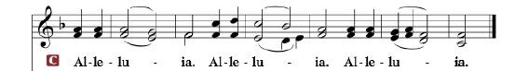
R: The Holy Gospel according to St. John, the 15th chapter.

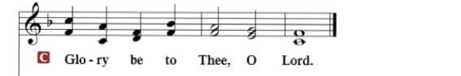

HOLY GOSPEL: (John 15:9-17)
⁹ As the Father has loved me, so have I loved you. Abide in my love. ¹⁰ If you keep my commandments, you will abide in my love, just as I have kept my Father's commandments and abide in his love. ¹¹ These things I have spoken to you, that my joy may be in you, and that your joy may be full.
¹² “This is my commandment, that you love one another as I have loved you. ¹³ Greater love has no one than this, that someone lay down his life for his friends. ¹⁴ You are my friends if you do what I command you. ¹⁵ No longer do I call you servants, for the servant does not know what his master is doing; but I have called you friends, for all that I have heard from my Father I have made known to you. ¹⁶ You did not choose me, but I chose you and appointed you that you should go and bear fruit and that your fruit should abide, so that whatever you ask the Father in my name, he may give it to you. ¹⁷ These things I command you, so that you will love one another.

R: This is the Gospel of the Lord.

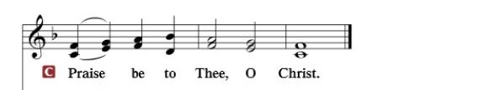

Nicene Creed…...……………………………………………………..…LSB p. 191
I believe in one God, the Father Almighty, maker of heaven and earth and of all things visible and invisible.
And in one Lord Jesus Christ, the only-begotten Son of God, begotten of His Father before all worlds, God of God, Light of Light, very God of very God, begotten, not made, being of one substance with the Father, by whom all things were made; who for us men and for our salvation came down from heaven and was incarnate by the Holy Spirit of the virgin Mary and was made man; and was crucified also for us under Pontius Pilate. He suffered and was buried. And the third day He rose again according to the Scriptures and ascended into heaven and sits at the right hand of the Father. And He will come again with glory to judge both the living and the dead, whose kingdom will have no end.
And I believe in the Holy Spirit, the Lord and giver of life, who proceeds from the Father and the Son, who with the Father and the Son together is worshiped and glorified, who spoke by the prophets. And I believe in one holy Christian and apostolic Church, I acknowledge one Baptism for the remission of sins, and I look for the resurrection of the dead and the life of the world to come. Amen.

SERMON HYMN: “Lord, Take My Hand and Lead Me”......................LSB #722

SERMON

OFFERTORY……………………………………………………..……LSB pp. 192-193

THE GENERAL PRAYERS OF THE CHURCH

INSTITUTION OF THE LORD’S SUPPER
Preface…………………………………….…………….……….LSB p. 194

Proper Preface
It is truly good, right, and salutary that we should at all times and in all places give thanks to You, holy Lord, almighty Father, everlasting God, through Jesus Christ, our Lord, who, out of love for His fallen creation, humbled Himself by taking on the form of a servant, becoming obedient unto death, even death upon a cross. Risen from the dead, He has freed us from eternal death and given us life everlasting. Therefore, with angels and archangels and with all the company of heaven we laud and magnify Your glorious name, ever more praising You and saying:
Sanctus, Lord’s Prayer, The Words of Our Lord………………….....LSB pp. 195-197
Agnus Dei………………………………………………………………..LSB p. 198
If you are not communing it is acceptable to remain seated.

COMMUNION DISTRIBUTION HYMNS:
LSB #556 “Dear Christians, One and All, Rejoice”
LSB #588 “Jesus Loves Me”

NUNC DIMITTIS………………………………………………………LSB pp. 199-200

BENEDICTION

CLOSING HYMN: “Crown Him with Many Crowns”...........................LSB #525

The Mission of Trinity Onekama Is To SERVE

For even the Son of Man did not come to be served
but to serve and to give his life as a ransom for many.
Mark 10:45

S haring Jesus’s truth
E quipping for life
R eaching Out
V aluing each other
E vangelizing all ages
Mission Statement
The mission of Trinity Onekama is to SERVE
For even the Son of Man did not come to be served, but to serve,
and to give his life as a ransom for many. Mark 10:45
S haring Jesus’ ruth
E quipping for life
R eaching Out
V aluing each other
E vangelizing all age

CHURCH INFORMATION
Church Office: (231) 889-4429 Website: www.trinityonekama.org
E-mail: trinityonekama@sbcglobal.net
Address: P.O. Box 119, 5471 Fairview Street, Onekama, MI 49675
Adult Bible Study: Sunday @ 9:15 am (year round)
Worship: Sunday @ 10:30 am The Lord’s Supper: Celebrated 2nd & 4th Sundays
Pastoral Hours: Wednesday and Friday 8:30am – Noon
Pastor Phone: 231-655-2680 Pastor Email: trinityonekama@gmail.com

Copyright licensing covered under CCLI #2802932

