231-889-4429 5471 Fairview Street, Box 119 Onekama, MI

TRINITY LUTHERAN CHURCH
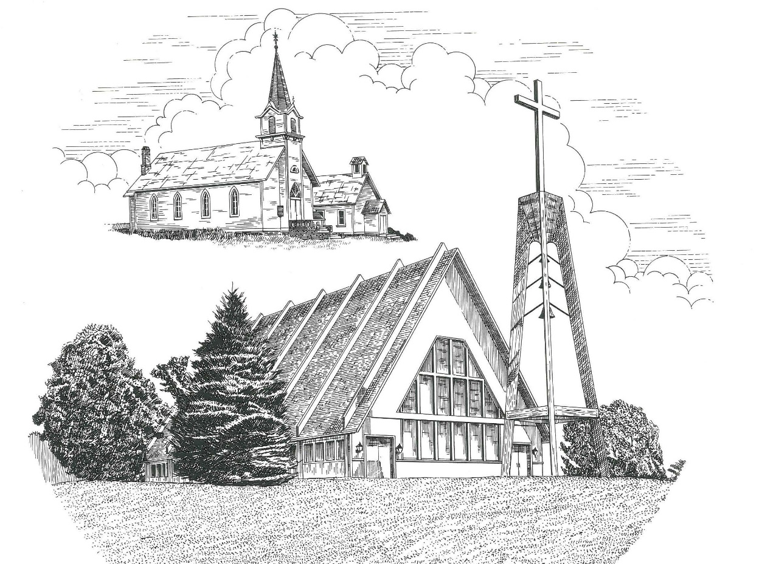

Twenty-Fourth Sunday after Pentecost November 12th, 2023

WELCOME
Thanks for joining us!
Pastor Jacob Sherry Missouri Synod

~~PLEASE NOTE~~
Calling on the name of the Lord
Does not include the use of cell phones in the worship sanctuary.
Please check yours before the service begins. Thank you for your courtesy.
~~TO OUR GUESTS AND VISITORS~~
Please sign our guest book located on the stand at the church entrance. During the service, we ask you to sign the attendance sheet located in your bulletin and place it on the pew when you leave. If you need assistance or have questions about our worship service, please talk to an elder or any one of our church family. We are glad you could join us and hope to have you worship with us again soon.

~~ATTENDING HOLY COMMUNION~~
By checking the “Communing Today” box on the registration form found on the attendance sheet, you are agreeing with the following statements:

- I am a baptized Christian who believes Jesus Christ is my Lord and Savior.
- I believe that I am a sinner in need of Christ’s freely offered forgiveness.
- I believe that in the Lord’s Supper the body and blood of Jesus Christ
are truly present in, with, and under the bread and wine.
- I believe that my participation in Holy Communion grants me forgiveness
of my sins, new spiritual life, and eternal salvation.
- With God’s help, I sincerely seek to repent of my sins, live in service
to my Lord, and await His return.

If you agree with the above statements, you are welcome to attend the Lord’s Supper with us. May God bless your worship time with us.
We do offer gluten-free wafers, please quietly ask an elder to help you.

Order of Divine Service Setting Three

Pre-Service Music……………..Call to Worship………………….Greeting

OPENING HYMN: “O Day of Rest and Gladness”...........................................LSB #906

CONFESSION & ABSOLUTION
P: In the name of the Father and of the Son and of the Holy Spirit.
C: Amen.

P: Beloved in the Lord! Let us draw near with a true heart and confess our sins unto God our Father, beseeching Him in the name of our Lord Jesus Christ to grant us forgiveness.

P: Our help is in the name of the Lord,
C: who made heaven and earth.
P: I said, I will confess my transgressions unto the Lord,
C: and You forgave the iniquity of my sin.

P: O almighty God, merciful Father,
C: I, a poor, miserable sinner, confess unto You all my sins and iniquities with which I have ever offended You and justly deserve Your temporal and eternal punishment. But I am heartily sorry for them and sincerely repent of them, and I pray You of Your boundless mercy and for the sake of the holy, innocent, bitter sufferings and death of Your beloved Son, Jesus Christ, to be gracious and merciful to me, a poor, sinful being.

P: Upon this your confession, I, by virtue of my office, as a called and ordained servant of the Word, announce the grace of God unto all of you, and in the stead and by the command of my Lord Jesus Christ I forgive you all your sins in the name of the Father and of the Son and of the Holy Spirit.
C: Amen.

INTROIT
P: Even the sparrow finds a home, and the swallow a nest for herself,
where she may lay her young,
C: at your altars, O Lord of hosts, my King and my God.
P: How lovely is your dwelling place,
C: O Lord of hosts!
P: Behold our shield, O God;
C: look on the face of your anointed!
P: For a day in your courts is better than a thousand elsewhere.
C: I would rather be a doorkeeper in the house of my God
than dwell in the tents of wickedness.
P: For the Lord God is a sun and shield; the Lord bestows favor and honor.
C: No good thing does he withhold from those who walk uprightly.
P: O Lord of hosts,
C: blessed is the one who trusts in you!
ALL: Glory be to the Father and to the Son and to the Holy Spirit; as it was in the
beginning, is now, and will be forever. Amen.
P: Even the sparrow finds a home, and the swallow a nest for herself,
where she may lay her young,
C: at your altars, O Lord of hosts, my King and my God.

KYRIE…………………………………….…………………………..LSB p. 186
GLORIA IN EXCELSIS……………………………………………..LSB pp. 187-189
SALUTATION….……………………………….……………………LSB p. 189

Collect Prayer
Lord God, heavenly Father, send forth Your Son to lead home His bride, the Church, that with all the company of the redeemed we may finally enter into His eternal wedding feast; through the same Jesus Christ, our Lord, who lives and reigns with You and the Holy Spirit, one God, now and forever.

THE HOLY SCRIPTURES

OLD TESTAMENT: (Amos 5:18-24)
¹⁸ Woe to you who desire the day of the Lord!
Why would you have the day of the Lord?
It is darkness, and not light,
¹⁹ as if a man fled from a lion,
and a bear met him,
or went into the house and leaned his hand against the wall,
and a serpent bit him.
²⁰ Is not the day of the Lord darkness, and not light,
and gloom with no brightness in it?
²¹ “I hate, I despise your feasts,
and I take no delight in your solemn assemblies.
²² Even though you offer me your burnt offerings and grain offerings,
I will not accept them;
and the peace offerings of your fattened animals,
I will not look upon them.
²³ Take away from me the noise of your songs;
to the melody of your harps I will not listen.
²⁴ But let justice roll down like waters,
and righteousness like an ever-flowing stream.

R: This is the Word of the Lord. Cong: Thanks be to God.

GRADUAL
Reader: These are the ones coming out of the great tribulation.
C: They have washed their robes and made them white in the blood of the Lamb.
Reader: Blessed are those whose strength is in you,
C: in whose hearts are the highways to Zion.

EPISTLE: (1 Thessalonians 4:13-18)
¹³ But we do not want you to be uninformed, brothers, about those who are asleep, that you may not grieve as others do who have no hope. ¹⁴ For since we believe that Jesus died and rose again, even so, through Jesus, God will bring with him those who have fallen asleep. ¹⁵ For this we declare to you by a word from the Lord, that we who are alive, who are left until the coming of the Lord, will not precede those who have fallen asleep. ¹⁶ For the Lord himself will descend from heaven with a cry of command, with the voice of an archangel, and with the sound of the trumpet of God. And the dead in Christ will rise first. ¹⁷ Then we who are alive, who are left, will be caught up together with them in the clouds to meet the Lord in the air, and so we will always be with the Lord. ¹⁸ Therefore encourage one another with these words.

R: This is the Word of the Lord. Cong: Thanks be to God.

(PLEASE RISE for the reading of the Gospel)

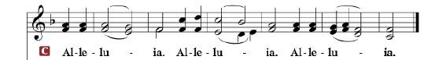

R: The Holy Gospel according to St. Matthew, the 25th chapter.

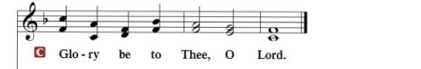

HOLY GOSPEL: (Matthew 25:1-13)
“Then the kingdom of heaven will be like ten virgins who took their lamps and went to meet the bridegroom. ² Five of them were foolish, and five were wise. ³ For when the foolish took their lamps, they took no oil with them, ⁴ but the wise took flasks of oil with their lamps. ⁵ As the bridegroom was delayed, they all became drowsy and slept. ⁶ But at midnight there was a cry, ‘Here is the bridegroom! Come out to meet him.’ ⁷ Then all those virgins rose and trimmed their lamps. ⁸ And the foolish said to the wise, ‘Give us some of your oil, for our lamps are going out.’ ⁹ But the wise answered, saying, ‘Since there will not be enough for us and for you, go rather to the dealers and buy for yourselves.’ ¹⁰ And while they were going to buy, the bridegroom came, and those who were ready went in with him to the marriage feast, and the door was shut. ¹¹ Afterward the other virgins came also, saying, ‘Lord, lord, open to us.’ ¹² But he answered, ‘Truly, I say to you, I do not know you.’ ¹³ Watch therefore, for you know neither the day nor the hour.

R: This is the Gospel of the Lord.

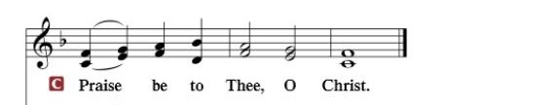

Nicene Creed
I believe in one God, the Father Almighty, maker of heaven and earth and of all things visible and invisible.
And in one Lord Jesus Christ, the only-begotten Son of God, begotten of His Father before all worlds, God of God, Light of Light, very God of very God, begotten, not made, being of one substance with the Father, by whom all things were made; who for us men and for our salvation came down from heaven and was incarnate by the Holy Spirit of the virgin Mary and was made man; and was crucified also for us under Pontius Pilate. He suffered and was buried. And the third day He rose again according to the Scriptures and ascended into heaven and sits at the right hand of the Father. And He will come again with glory to judge both the living and the dead, whose kingdom will have no end.
And I believe in the Holy Spirit, the Lord and giver of life, who proceeds from the Father and the Son, who with the Father and the Son together is worshiped and glorified, who spoke by the prophets. And I believe in one holy Christian and apostolic Church, I acknowledge one Baptism for the remission of sins, and I look for the resurrection of the dead and the life of the world to come. Amen.

SERMON HYMN: “Wake, Awake, for Night Is Flying”……….………LSB #516

SERMON

COLLECTION OF THE OFFERING
OFFERTORY…………………………………………………………...LSB pp. 192-193

GENERAL PRAYERS OF THE CHURCH

Sharing the Peace of the Lord

SERVICE OF THE SACRAMENT
Preface…………………………………….…………….……….LSB p. 194
Proper Preface
It is truly good, right, and salutary that we should at all times and in all places give thanks to You, holy Lord, almighty Father, everlasting God, through Jesus Christ, our Lord, who, having created all things, took on human flesh and was born of the virgin Mary. For our sake He died on the cross and rose from the dead to put an end to death, thus fulfilling Your will and gaining for You a holy people. Therefore, with angels and archangels and with all the company of heaven we laud and magnify Your glorious name, ever more praising You and saying:

Sanctus, Lord’s Prayer, The Words of Our Lord………………….....LSB pp. 195-197
Agnus Dei………………………………………………………………..LSB p. 198
If you are not communing, it is acceptable to remain seated.

COMMUNION DISTRIBUTION HYMNS:
LSB #729 “I Am Trusting Thee, Lord Jesus”
LSB #633 “At the Lamb’s High Feast We Sing”
LSB #643 “Sent Forth by God’s Blessing”

NUNC DIMITTIS………………………………………………………LSB pp. 199-200

BENEDICTION

CLOSING HYMN: “Almighty Father, Bless the Word”........................LSB #923

CHURCH INFORMATION
Church Office: (231) 889-4429 Website: www.trinityonekama.org
E-mail: trinityonekama@sbcglobal.net
Address: P.O. Box 119, 5471 Fairview Street, Onekama, MI 49675
Sunday School & Adult Bible Study: Sunday @ 9:30 am
Worship: Sunday @ 10:30 am The Lord’s Supper: Celebrated 2nd & 4th Sundays
Pastoral Hours: Wednesday and Friday 9:00am – Noon
Pastor Phone: 231-655-2680 Pastor Email: trinityonekama@gmail.com

Copyright licensing covered under CCLI #2802932

