**231-889-4429 5471 Fairview Street, Box 119 Onekama, MI**

**TRINITY LUTHERAN CHURCH**

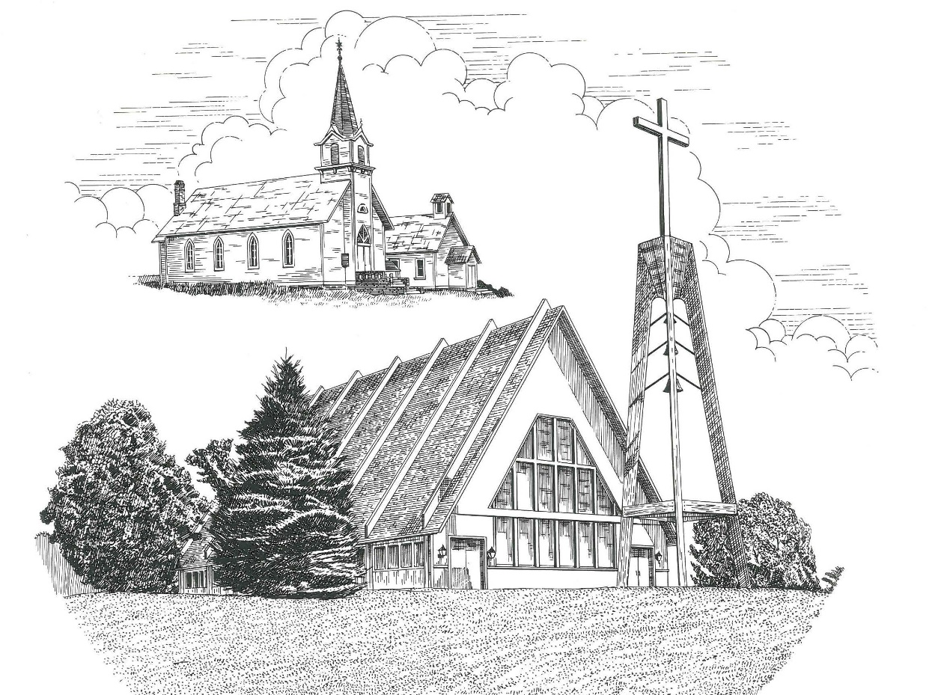

**Twenty-Third Sunday after Pentecost November 13th, 2022**

**WELCOME**

**Thanks for joining us!**

**Pastor Jacob Sherry Missouri Synod**

**~~PLEASE NOTE~~Calling on the name of the Lord**

Does not include the use of cell phones in the worship sanctuary.

Please check yours before the service begins. Thank you for your courtesy.

**~~TO OUR GUESTS AND VISITORS~~**

Please sign our guest book located on the stand at the church entrance. During the service, we ask you to sign the attendance sheets located inside your bulletin and leave them on the pew as you leave. If you need assistance or have questions about our worship service, please talk to an elder or any one of our church family. We are glad you could join us and hope to have you worship with us again soon.

**~~ATTENDING HOLY COMMUNION~~**

By checking the “Communing Today” box on the registration form on the attendance sheet, you are agreeing with the following statements:

* **I am a baptized Christian who believes Jesus Christ is my Lord and Savior.**
* **I believe that I am a sinner in need of Christ’s freely offered forgiveness.**
* **I believe that in the Lord’s Supper the body and blood of Jesus Christ**

**are truly present in, with, and under the bread and wine.**

* **I believe that my participation in Holy Communion grants me forgiveness**

**of my sins, new spiritual life, and eternal salvation.**

* **With God’s help, I sincerely seek to repent of my sins, live in service**

**to my Lord, and await His return.**

**If you agree with the above statements, you are welcome to attend the Lord’s Supper with us. May God bless your worship time with us.**

We do offer gluten-free wafers, please quietly ask an elder to help you.

**Order of Divine Service Setting One**

**Pre-Service Music……………..Call to Worship………………….Greeting**

**OPENING HYMN:** *“Rejoice, Rejoice, Believers”*…………………......LSB #515

**CONFESSION & ABSOLUTION**……………………………………..LSB p. 151

**KYRIE**…………………………………………………………………...LSB pp. 152-153

**THIS IS THE FEAST**…………………………………………………...LSB p. 155

**SALUTATION**…………………………………………………………..LSB p. 156

**Collect Prayer**

O Lord, almighty and everlasting God, You have given exceedingly great and precious promises to those who trust in You. Rule and govern our hearts and minds by Your Holy Spirit that we may live and abide forever in Your Son, who lives and reigns with the You and the Holy Spirit, one God, now and forever.

**THE HOLY SCRIPTURES**

**OLD TESTAMENT:** (Malachi 4:1-6)

“For behold, the day is coming, burning like an oven, when all the arrogant and all evildoers will be stubble. The day that is coming shall set them ablaze, says the Lord of hosts, so that it will leave them neither root nor branch.  **2**But for you who fear my name, the sun of righteousness shall rise with healing in its wings. You shall go out leaping like calves from the stall.  **3**And you shall tread down the wicked, for they will be ashes under the soles of your feet, on the day when I act, says the Lord of hosts. **4**“Remember the law of my servant Moses, the statutes and rules that I commanded him at Horeb for all Israel. **5**“Behold, I will send you Elijah the prophet before the great and awesome day of the Lord comes.  **6**And he will turn the hearts of fathers to their children and the hearts of children to their fathers, lest I come and strike the land with a decree of utter destruction.”

**R:** This is the Word of the Lord**.** **Cong: Thanks be to God.**

**GRADUAL**

Reader: These are the ones coming out of the great tribulation.

**Cong.: They have washed their robes and made them**

**white in the blood of the Lamb.**

Reader: Blessed are those whose strength is in you,

**Cong.: in whose heart are the highways to Zion.**

**EPISTLE:** (2 Thessalonians 3:6-13)

**6**Now we command you, brothers, in the name of our Lord Jesus Christ, that you keep away from any brother who is walking in idleness and not in accord with the tradition that you received from us.  **7**For you yourselves know how you ought to imitate us, because we were not idle when we were with you, **8**nor did we eat anyone's bread without paying for it, but with toil and labor we worked night and day, that we might not be a burden to any of you.  **9**It was not because we do not have that right, but to give you in ourselves an example to imitate.  **10**For even when we were with you, we would give you this command: If anyone is not willing to work, let him not eat.  **11**For we hear that some among you walk in idleness, not busy at work, but busybodies.  **12**Now such persons we command and encourage in the Lord Jesus Christ to do their work quietly and to earn their own living. **13**As for you, brothers, do not grow weary in doing good.

**R:** This is the Word of the Lord. **Cong: Thanks be to God.**

**(PLEASE RISE for the reading of the Gospel)**



**R:** The Holy Gospel according to St. Luke, the 21st chapter.



**HOLY GOSPEL:** (Luke 21:5-28)

**5**And while some were speaking of the temple, how it was adorned with noble stones and offerings, Jesus said, **6**“As for these things that you see, the days will come when there will not be left here one stone upon another that will not be thrown down.”  **7**And they asked him, “Teacher, when will these things be, and what will be the sign when these things are about to take place?”  **8**And he said, “See that you are not led astray. For many will come in my name, saying, ‘I am he!’ and, ‘The time is at hand!’ Do not go after them. **9**And when you hear of wars and tumults, do not be terrified, for these things must first take place, but the end will not be at once.”

**10**Then he said to them, “Nation will rise against nation, and kingdom against kingdom. **11**There will be great earthquakes, and in various places famines and pestilences. And there will be terrors and great signs from heaven.  **12**But before all this they will lay their hands on you and persecute you, delivering you up to the synagogues and prisons, and you will be brought before kings and governors for my name's sake.  **13**This will be your opportunity to bear witness.  **14**Settle it therefore in your minds not to meditate beforehand how to answer, **15**for I will give you a mouth and wisdom, which none of your adversaries will be able to withstand or contradict.  **16**You will be delivered up even by parents and brothers and relatives and friends, and some of you they will put to death. **17**You will be hated by all for my name's sake.  **18**But not a hair of your head will perish. **19**By your endurance you will gain your lives.

**20**“But when you see Jerusalem surrounded by armies, then know that its desolation has come near.  **21**Then let those who are in Judea flee to the mountains, and let those who are inside the city depart, and let not those who are out in the country enter it, **22**for these are days of vengeance, to fulfill all that is written.  **23**Alas for women who are pregnant and for those who are nursing infants in those days! For there will be great distress upon the earth and wrath against this people.  **24**They will fall by the edge of the sword and be led captive among all nations, and Jerusalem will be trampled underfoot by the Gentiles, until the times of the Gentiles are fulfilled. **25**“And there will be signs in sun and moon and stars, and on the earth distress of nations in perplexity because of the roaring of the sea and the waves, **26**people fainting with fear and with foreboding of what is coming on the world. For the powers of the heavens will be shaken.  **27**And then they will see the Son of Man coming in a cloud with power and great glory.  **28**Now when these things begin to take place, straighten up and raise your heads, because your redemption is drawing near.”

**R:** This is the Gospel of the Lord.



**SERMON HYMN**: *“The Day Is Surely Drawing Near”*…………………...LSB #508

**SERMON**

**NICENE CREED**

I believe in one God, the Father Almighty, maker of heaven and earth and of all things visible and invisible.

And in one Lord Jesus Christ, the only-begotten Son of God, begotten of His Father before all worlds, God of God, Light of Light, very God of very God, begotten, not made, being of one substance with the Father, by whom all things were made; who for us men and for our salvation came down from heaven and was incarnate by the Holy Spirit of the virgin Mary and was made man; and was crucified also for us under Pontius Pilate. He suffered and was buried. And the third day He rose again according to the Scriptures and ascended into heaven and sits at the right hand of the Father. And He will come again with glory to judge both the living and the dead, whose kingdom will have no end.

And I believe in the Holy Spirit, the Lord and giver of life, who proceeds from the Father and the Son, who with the Father and the Son together is worshiped and glorified, who spoke by the prophets. And I believe in one holy Christian and apostolic Church, I acknowledge one Baptism for the remission of sins, and I look for the resurrection of the dead and the life of the world to come. Amen.

**THE GENERAL PRAYERS OF THE CHURCH**

**OFFERTORY**…………………………………………………………...LSB pp. 159-160

**Sharing the Peace of the Lord**

**SERVICE OF THE SACRAMENT**

**PREFACE**……………………………………………………………………..LSB p. 160

**Proper Preface**

It is truly good, right, and salutary that we should at all times and in all places give thanks to You, holy Lord, almighty Father, everlasting God, through Jesus Christ, our Lord, who, out of love for His fallen creation, humbled Himself by taking on the form of a servant, becoming obedient unto death, even death upon a cross. Risen from the dead, He has freed us from eternal death and given us life everlasting. Therefore, with angels and archangels and with all the company of heaven we laud and magnify Your glorious name, ever more praising You and saying:

**SANCTUS**……………………………………………………………………...LSB p. 161

**THE WORDS OF OUR LORD**……………………………………………….LSB p. 162

**AGNUS DEI**……………………………………………………………………LSB p. 163

*If you are not communing, it is acceptable to remain seated.*

**COMMUNION DISTRIBUTION HYMNS**

LSB #685 *“Let Us Ever Walk with Jesus”*

LSB #615 *“When in the Hour of Deepest Need”*

LSB #740 *“I Am Jesus’ Little Lamb”*

**THANK THE LORD**………………………………………………………….LSB p. 164

**POST-COMMUNION COLLECT PRAYER**……………………………….LSB p. 166

**BENEDICTION**……………………………………………………………….LSB p. 166

**CLOSING HYMN:** *“Go, My Children, with My Blessing”*……..……………LSB #922

The Mission of Trinity Onekama Is To **SERVE**

For even the Son of Man did not come to be served

but to serve and to give his life as a ransom for many.            
                                                                       Mark 10:45



**S**haring Jesus’s **t**ruth

**E**quipping for life

**R**eaching Out

**V**aluing each other

**E**vangelizing all ages

Mission Statement

The mission of Trinity Onekama is to SERVE

For even the Son of Man did not come to be served, but to serve,

and to give his life as a ransom for many. Mark 10:45

S haring Jesus’ ruth

E quipping for life

R eaching Out

V aluing each other

E vangelizing all age

**CHURCH INFORMATION**

**Church Office:** (231) 889-4429 **Website:** www.trinityonekama.org

**E-mail:** [trinityonekama@sbcglobal.net](mailto:trinityonekama@sbcglobal.net)

**Address:** P.O. Box 119, 5471 Fairview Street, Onekama, MI 49675

**Adult Bible Study**: Sunday @ 11:30 am (year round)

**Worship:** Sunday @ 10:30 am **The Lord’s Supper:**  Celebrated 2nd & 4th Sundays

**Pastoral Hours:** Wednesday and Friday 9:00am – Noon

**Pastor Phone:** 231-655-2680 **Pastor Email:** trinityonekama@gmail.com

**Copyright licensing covered under CCLI #2802932**