**231-889-4429 5471 Fairview Street, Box 119 Onekama, MI**

**TRINITY LUTHERAN CHURCH**

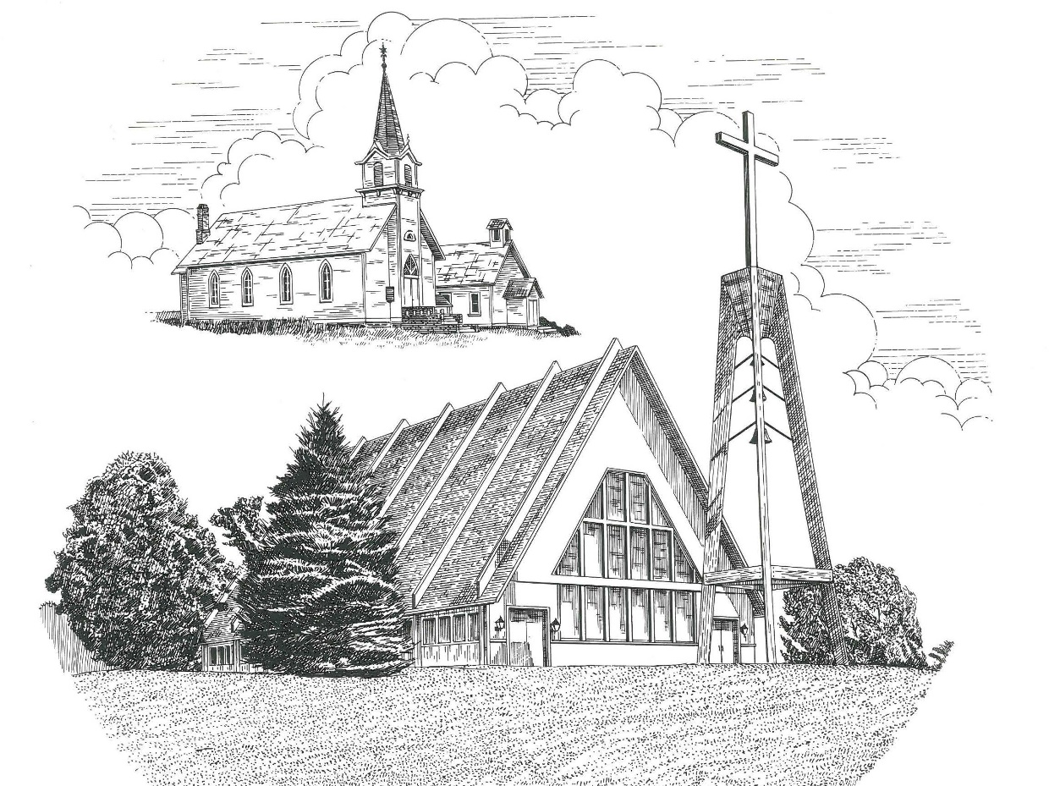

**First Sunday in Advent November 28th, 2021**

**WELCOME**

**Thanks for joining us!**

**Pastor Jacob Sherry Missouri Synod**

**~~PLEASE NOTE~~Calling on the name of the Lord**

Does not include the use of cell phones in the worship sanctuary.

Please check yours before the service begins. Thank you for your courtesy.

**~~TO OUR GUESTS AND VISITORS~~**

Please sign our guest book located on the stand at the church entrance. During the service, we ask you to sign the attendance sheets located inside your bulletin and leave them on the pew as you leave. If you need assistance or have questions about our worship service, please talk to an elder or any one of our church family. We are glad you could join us and hope to have you worship with us again soon.

**~~ATTENDING HOLY COMMUNION~~**

By checking the “Communing Today” box on the registration form found in the attendance booklet, you are agreeing with the following statements:

* **I am a baptized Christian who believes Jesus Christ is my Lord and Savior.**
* **I believe that I am a sinner in need of Christ freely offered forgiveness.**
* **I believe that in the Lord’s Supper the body and blood of Jesus Christ**

**are truly present in, with, and under the bread and wine.**

* **I believe that my participation in Holy Communion grants me forgiveness**

**of my sins, new spiritual life, and eternal salvation.**

* **With God’s help, I sincerely seek to repent of my sins, live in service**

**to my Lord, and await His return.**

**If you agree with the above statements, you are welcome to attend the Lord’s Supper with us. May God bless your worship time with us.**

We do offer gluten-free wafers, please quietly ask an elder to help you.

**Order of Divine Service Setting One**

**Pre-Service Music……………..Call to Worship………………….Greeting**

**OPENING HYMN:** *“The Advent of Our King”*………………………..LSB #331

**CONFESSION & ABSOLUTION**……………………………………..LSB p. 151

**KYRIE**…………………………………………………………………...LSB pp. 152-153

**THIS IS THE FEAST**…………………………………………………..LSB p. 155

**SALUTATION**………………………………………………………….LSB p. 156

**Collect Prayer**

Stir up Your power, O Lord, and come, that by Your protection we may be rescued from the threatening perils of our sins and saved by Your mighty deliverance; for You live and reign with the Father and the Holy Spirit, one God, now and forever.

**THE HOLY SCRIPTURES**

**OLD TESTAMENT:** (Jeremiah 33:14-16)

**14**“Behold, the days are coming, declares the Lord, when I will fulfill the promise I made to the house of Israel and the house of Judah.  **15**In those days and at that time I will cause a righteous Branch to spring up for David, and he shall execute justice and righteousness in the land.  **16**In those days Judah will be saved, and Jerusalem will dwell securely. And this is the name by which it will be called: ‘The Lord is our righteousness.

**R:** This is the Word of the Lord**.** **Cong: Thanks be to God.**

**GRADUAL**

Reader: Rejoice greatly, O daughter of Zion.

**Cong.: Shout aloud, O daughter of Jerusalem.**

Reader: Behold, your king is coming to you;

**Cong.: righteous and having salvation.**

Reader: Blessed is he who comes in the name of the Lord.

**Cong.: From the house of the Lord we bless you.**

**EPISTLE:** (1 Thessalonians 3:9-13)

**9**For what thanksgiving can we return to God for you, for all the joy that we feel for your sake before our God, **10**as we pray most earnestly night and day that we may see you face to face and supply what is lacking in your faith? **11**Now may our God and Father himself, and our Lord Jesus, direct our way to you, **12**and may the Lord make you increase and abound in love for one another and for all, as we do for you, **13**so that he may establish your hearts blameless in holiness before our God and Father, at the coming of our Lord Jesus with all his saints.

**R:** This is the Word of the Lord. **Cong: Thanks be to God.**

**(PLEASE RISE for the reading of the Gospel)**



**R:** The Holy Gospel according to St. Luke, the 19th chapter.



**HOLY GOSPEL:** (Luke 19:28-40)

**28**And when Jesus had said these things, he went on ahead, going up to Jerusalem. **29**When he drew near to Bethphage and Bethany, at the mount that is called Olivet, he sent two of the disciples, **30**saying, “Go into the village in front of you, where on entering you will find a colt tied, on which no one has ever yet sat. Untie it and bring it here.  **31**If anyone asks you, ‘Why are you untying it?’ you shall say this: ‘The Lord has need of it.’”  **32**So those who were sent went away and found it just as he had told them.  **33**And as they were untying the colt, its owners said to them, “Why are you untying the colt?” **34**And they said, “The Lord has need of it.”  **35**And they brought it to Jesus, and throwing their cloaks on the colt, they set Jesus on it.  **36**And as he rode along, they spread their cloaks on the road.  **37**As he was drawing near—already on the way down the Mount of Olives—the whole multitude of his disciples began to rejoice and praise God with a loud voice for all the mighty works that they had seen, **38**saying, “Blessed is the King who comes in the name of the Lord! Peace in heaven and glory in the highest!”  **39**And some of the Pharisees in the crowd said to him, “Teacher, rebuke your disciples.”  **40**He answered, “I tell you, if these were silent, the very stones would cry out.”

**R:** This is the Gospel of the Lord.



**SERMON HYMN**: *“Once He Came in Blessing”*…………………………......LSB #333

**SERMON**

**NICENE CREED**

I believe in one God, the Father Almighty, maker of heaven and earth and of all things visible and invisible.

And in one Lord Jesus Christ, the only-begotten Son of God, begotten of His Father before all worlds, God of God, Light of Light, very God of very God, begotten, not made, being of one substance with the Father, by whom all things were made; who for us men and for our salvation came down from heaven and was incarnate by the Holy Spirit of the virgin Mary and was made man; and was crucified also for us under Pontius Pilate. He suffered and was buried. And the third day He rose again according to the Scriptures and ascended into heaven and sits at the right hand of the Father. And He will come again with glory to judge both the living and the dead, whose kingdom will have no end.

And I believe in the Holy Spirit, the Lord and giver of life, who proceeds from the Father and the Son, who with the Father and the Son together is worshiped and glorified, who spoke by the prophets. And I believe in one holy Christian and apostolic Church, I acknowledge one Baptism for the remission of sins, and I look for the resurrection of the dead and the life of the world to come. Amen.

**THE GENERAL PRAYERS OF THE CHURCH**

**OFFERTORY**…………………………………………………………...LSB pp. 159-160

**SERVICE OF THE SACRAMENT**

**PREFACE**……………………………………………………………….LSB p. 160

**Proper Preface**

It is truly good, right, and salutary that we should at all times and in all places give thanks to You, holy Lord, almighty Father, everlasting God, through Jesus Christ, our Lord, whose way John the Baptist prepared, proclaiming Him the promised Messiah, the very Lamb of God who takes away the sin of the world, and calling sinners to repentance that they might escape from the wrath to be revealed when He comes again in glory. Therefore, with angels and archangels and with all the company of heaven we laud and magnify Your glorious name, ever more praising You and saying:

**SANCTUS**……………………………………………………………………...LSB p. 161

**THE WORDS OF OUR LORD**……………………………………………….LSB p. 162

**AGNUS DEI**……………………………………………………………………LSB p. 163

*If you are not communing it is acceptable to remain seated.*

**COMMUNION DISTRIBUTION HYMNS**

LSB #332 *“Savior of the Nations, Come”*

LSB #727 *“On Eagles’ Wings”*

**THANK THE LORD**………………………………………………………….LSB p. 164

**POST-COMMUNION COLLECT PRAYER**……………………………….LSB p. 166

**BENEDICTION**……………………………………………………………….LSB p. 166

**CLOSING HYMN:** *“Almighty Father, Bless the Word”*……..………………LSB #923

The Mission of Trinity Onekama Is To **SERVE**

For even the Son of Man did not come to be served

but to serve and to give his life as a ransom for many.            
                                                                       Mark 10:45



**S**haring Jesus’s **t**ruth

**E**quipping for life

**R**eaching Out

**V**aluing each other

**E**vangelizing all ages

Mission Statement

The mission of Trinity Onekama is to SERVE

For even the Son of Man did not come to be served, but to serve,

and to give his life as a ransom for many. Mark 10:45

S haring Jesus’ ruth

E quipping for life

R eaching Out

V aluing each other

E vangelizing all age

**CHURCH INFORMATION**

**Church Office:** (231) 889-4429 **Website:** www.trinityonekama.org

**E-mail:** [trinityonekama@sbcglobal.net](mailto:trinityonekama@sbcglobal.net)

**Address:** P.O. Box 119, 5471 Fairview Street, Onekama, MI 49675

**Adult Bible Study**: Sunday @ 11:30 am (year round)

**Worship:** Sunday @ 10:30 am **The Lord’s Supper:**  Celebrated 2nd & 4th Sundays

**Pastoral Hours:** Wednesday and Friday 9:00am – Noon

**Pastor Phone:** 231-655-2680 **Pastor Email:** trinityonekama@gmail.com

**Copyright licensing covered under CCLI #2802932**