231-889-4429 5471 Fairview Street, Box 119 Onekama, MI

TRINITY LUTHERAN CHURCH
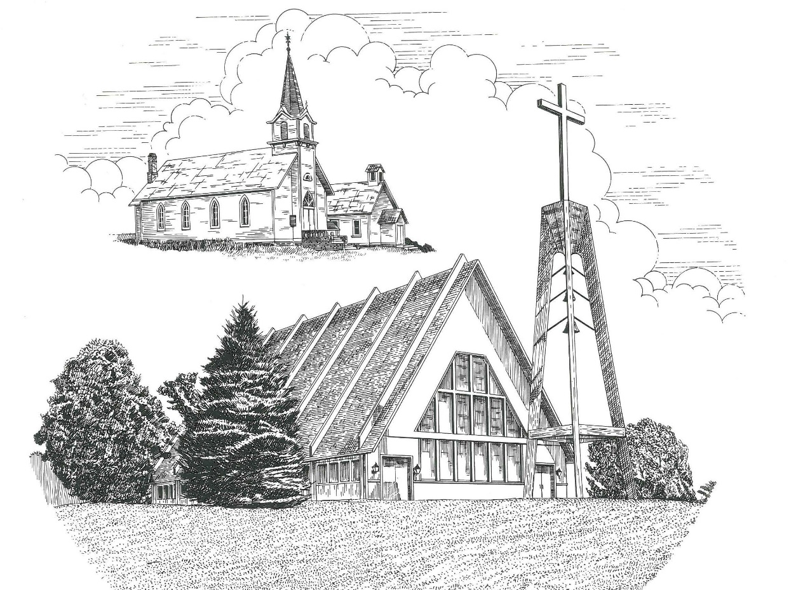

Twentieth Sunday after Pentecost October 10th, 2021

WELCOME
Thanks for joining us!
Pastor Jacob Sherry Missouri Synod

~~PLEASE NOTE~~
Calling on the name of the Lord
Does not include the use of cell phones in the worship sanctuary.
Please check yours before the service begins. Thank you for your courtesy.
~~TO OUR GUESTS AND VISITORS~~
Please sign our guest book located on the stand at the church entrance. During the service, we ask you to sign the attendance booklet located at the end of each pew. If you need assistance or have questions about our worship service, please talk to an elder or any one of our church family. We are glad you could join us and hope to have you worship with us again soon.

~~ATTENDING HOLY COMMUNION~~
By checking the “Communing Today” box on the registration form found in the attendance booklet, you are agreeing with the following statements:

- I am a baptized Christian who believes Jesus Christ is my Lord and Savior.
- I believe that I am a sinner in need of Christ freely offered forgiveness.
- I believe that in the Lord’s Supper the body and blood of Jesus Christ
are truly present in, with, and under the bread and wine.
- I believe that my participation in Holy Communion grants me forgiveness
of my sins, new spiritual life, and eternal salvation.
- With God’s help, I sincerely seek to repent of my sins, live in service
to my Lord, and await His return.

If you agree with the above statements, you are welcome to attend the Lord’s Supper with us. May God bless your worship time with us.
We do offer gluten-free wafers, please quietly ask an elder to help you.

Order of Divine Service Setting Four

Pre-Service Music……………..Call to Worship………………….Greeting

OPENING HYMN: “Christ, Whose Glory Fills the Skies”……………LSB #873

OPENING LITURGY:
Confession & Absolution……………………………………….LSB p. 203
Kyrie……………………………………………………………..LSB p. 204
Gloria in Excelsis………………………………………………..LSB p. 204
Salutation….…………………………………………………….LSB p. 205

Collect Prayer
Lord Jesus Christ, whose grace always precedes and follows us, help us to forsake all trust in earthly gain and to find in You our heavenly treasure; for You live and reign with the Father and the Holy Spirit, one God, now and forever.

THE HOLY SCRIPTURES

OLD TESTAMENT: (Amos 5:6-7, 10-15)
⁶ Seek the Lord and live,
lest he break out like fire in the house of Joseph,
and it devour, with none to quench it for Bethel,
⁷ O you who turn justice to wormwood
and cast down righteousness to the earth!
¹⁰ They hate him who reproves in the gate,
and they abhor him who speaks the truth.
¹¹ Therefore because you trample on the poor
and you exact taxes of grain from him,
you have built houses of hewn stone,
but you shall not dwell in them;
you have planted pleasant vineyards,
but you shall not drink their wine.
¹² For I know how many are your transgressions
and how great are your sins—
you who afflict the righteous, who take a bribe,
and turn aside the needy in the gate.
¹³ Therefore he who is prudent will keep silent in such a time,
for it is an evil time.
¹⁴ Seek good, and not evil,
that you may live;
and so the Lord, the God of hosts, will be with you,
as you have said.
¹⁵ Hate evil, and love good,
and establish justice in the gate;
it may be that the Lord, the God of hosts,
will be gracious to the remnant of Joseph.

R: This is the Word of the Lord. Cong: Thanks be to God.

GRADUAL
Reader: He will command his angels concerning you
Cong.: to guard you in all your ways.
Reader: Bless the Lord, O my soul,
Cong.: and all that is within me, bless his holy name!

EPISTLE: (Hebrews 3:12-19)
¹² Take care, brothers, lest there be in any of you an evil, unbelieving heart, leading you to fall away from the living God. ¹³ But exhort one another every day, as long as it is called “today,” that none of you may be hardened by the deceitfulness of sin. ¹⁴ For we have come to share in Christ, if indeed we hold our original confidence firm to the end. ¹⁵ As it is said,
“Today, if you hear his voice,
do not harden your hearts as in the rebellion.”
¹⁶ For who were those who heard and yet rebelled? Was it not all those who left Egypt led by Moses? ¹⁷ And with whom was he provoked for forty years? Was it not with those who sinned, whose bodies fell in the wilderness? ¹⁸ And to whom did he swear that they would not enter his rest, but to those who were disobedient? ¹⁹ So we see that they were unable to enter because of unbelief.

R: This is the Word of the Lord. Cong: Thanks be to God.
(PLEASE RISE for the reading of the Gospel)

R: The Holy Gospel according to St. Mark, the 10th chapter.
Cong: Glory to You, O Lord

HOLY GOSPEL: (Mark 10:17-22)
¹⁷ And as Jesus was setting out on his journey, a man ran up and knelt before him and asked him, “Good Teacher, what must I do to inherit eternal life?” ¹⁸ And Jesus said to him, “Why do you call me good? No one is good except God alone. ¹⁹ You know the commandments: ‘Do not murder, Do not commit adultery, Do not steal, Do not bear false witness, Do not defraud, Honor your father and mother.’” ²⁰ And he said to him, “Teacher, all these I have kept from my youth.” ²¹ And Jesus, looking at him, loved him, and said to him, “You lack one thing: go, sell all that you have and give to the poor, and you will have treasure in heaven; and come, follow me.” ²² Disheartened by the saying, he went away sorrowful, for he had great possessions.

R: This is the Gospel of the Lord. Cong: Praise to You, O Christ.

Nicene Creed
I believe in one God, the Father Almighty, maker of heaven and earth and of all things visible and invisible.
And in one Lord Jesus Christ, the only-begotten Son of God, begotten of His Father before all worlds, God of God, Light of Light, very God of very God, begotten, not made, being of one substance with the Father, by whom all things were made; who for us men and for our salvation came down from heaven and was incarnate by the Holy Spirit of the virgin Mary and was made man; and was crucified also for us under Pontius Pilate. He suffered and was buried. And the third day He rose again according to the Scriptures and ascended into heaven and sits at the right hand of the Father. And He will come again with glory to judge both the living and the dead, whose kingdom will have no end.
And I believe in the Holy Spirit, the Lord and giver of life, who proceeds from the Father and the Son, who with the Father and the Son together is worshiped and glorified, who spoke by the prophets. And I believe in one holy Christian and apostolic Church, I acknowledge one Baptism for the remission of sins, and I look for the resurrection of the dead and the life of the world to come. Amen.

SERMON HYMN: “Be Still, My Soul”………………………………….LSB #752

SERMON

THE GENERAL PRAYERS

INSTITUTION OF THE LORD’S SUPPER
Preface…………………………………….…………….………..LSB p. 208
Proper Preface
It is truly good, right, and salutary that we should at all times and in all places give thanks to You, O Lord, holy Father, almighty and everlasting God, for the countless blessings You so freely bestow on us and all creation. Above all, we give thanks for Your boundless love shown to us when You sent Your only-begotten Son, Jesus Christ, into our flesh and laid on Him our sin, giving Him into death that we might not die eternally. Because He is now risen from the dead and lives and reigns to all eternity, all who believe in Him will overcome sin and death and will rise again to new life. Therefore, with angels and archangels and with all the company of heaven we laud and magnify Your glorious name, ever more praising You and saying:

Sanctus, Lord’s Prayer, The Words of Our Lord………………….....LSB pp. 208-209
Agnus Dei………………………………………………………………..LSB p. 210
If you are not communing it is acceptable to remain seated.

COMMUNION DISTRIBUTION HYMNS:
LSB #560 “Drawn to the Cross, Which Thou Hast Blessed”
LSB #636 “Soul, Adorn Yourself With Gladness”

CLOSING LITURGY:………………………………………………....LSB pp. 211-212

CLOSING HYMN: “Almighty God, Your Word Is Cast”......................LSB #577

The Mission of Trinity Onekama Is To SERVE

For even the Son of Man did not come to be served
but to serve and to give his life as a ransom for many.
Mark 10:45

S haring Jesus’s truth
E quipping for life
R eaching Out
V aluing each other
E vangelizing all ages
Mission Statement
The mission of Trinity Onekama is to SERVE
For even the Son of Man did not come to be served, but to serve,
and to give his life as a ransom for many. Mark 10:45
S haring Jesus’ ruth
E quipping for life
R eaching Out
V aluing each other
E vangelizing all age

CHURCH INFORMATION
Church Office: (231) 889-4429 Website: www.trinityonekama.org
E-mail: trinityonekama@sbcglobal.net
Address: P.O. Box 119, 5471 Fairview Street, Onekama, MI 49675
Adult Bible Study: Sunday @ 9:15 am (year round)
Worship: Sunday @ 10:30 am The Lord’s Supper: Celebrated 2nd & 4th Sundays
Pastoral Hours: Wednesday and Friday 8:30am – Noon
Pastor Phone: 231-655-2680 Pastor Email: trinityonekama@gmail.com

Copyright licensing covered under CCLI #2802932

