231-889-4429 5471 Fairview Street, Box 119 Onekama, MI

TRINITY LUTHERAN CHURCH
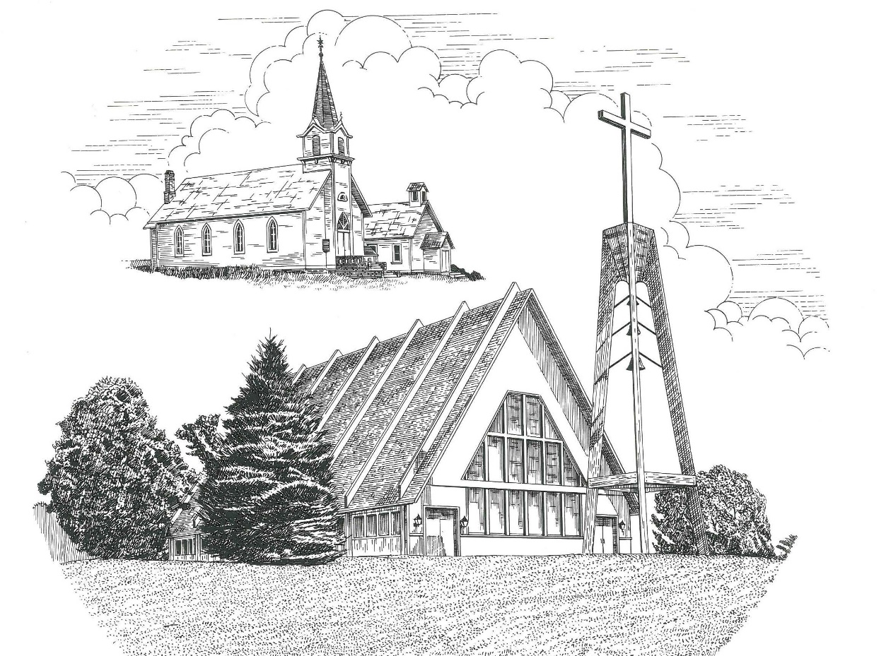

Nineteenth Sunday after Pentecost October 11th, 2020

WELCOME
Thanks for joining us!
Pastor Jacob Sherry Missouri Synod

~~PLEASE NOTE~~
Calling on the name of the Lord
Does not include the use of cell phones in the worship sanctuary.
Please check yours before the service begins. Thank you for your courtesy.
~~TO OUR GUESTS AND VISITORS~~
Please sign our guest book located on the stand at the church entrance. During the service, we ask you to sign the attendance booklet located at the end of each pew. If you need assistance or have questions about our worship service, please talk to an elder or any one of our church family. We are glad you could join us and hope to have you worship with us again soon.

~~ATTENDING HOLY COMMUNION~~
By checking the “Communing Today” box on the registration form found in the attendance booklet, you are agreeing with the following statements:

- I am a baptized Christian who believes Jesus Christ is my Lord and Savior.
- I believe that I am a sinner in need of Christ freely offered forgiveness.
- I believe that in the Lord’s Supper the body and blood of Jesus Christ
are truly present in, with, and under the bread and wine.
- I believe that my participation in Holy Communion grants me forgiveness
of my sins, new spiritual life, and eternal salvation.
- With God’s help, I sincerely seek to repent of my sins, live in service
to my Lord, and await His return.

If you agree with the above statements, you are welcome to attend the Lord’s Supper with us. May God bless your worship time with us.
We do offer gluten-free wafers, please quietly ask an elder to help you.

Order of Divine Service Setting Four

Pre-Service Music……………..Call to Worship………………….Greeting

OPENING HYMN: “Rejoice, O Pilgrim Throng”…..………………...LSB #813
OPENING LITURGY:
Confession & Absolution……………………………………….LSB p. 203
Kyrie……………………………………………………………..LSB p. 204
Gloria in Excelsis………………………………………………..LSB p. 204
Salutation….…………………………………………………….LSB p. 205

Collect Prayer
Almighty God, You invite us to trust in You for our salvation. Deal with us not in the severity of Your judgment but by the greatness of Your mercy; through Jesus Christ, Your Son, our Lord, who lives and reigns with You and the Holy Spirit, one God, now and forever.

THE HOLY SCRIPTURES

OLD TESTAMENT: (Isaiah 25:6-9)
⁶ On this mountain the Lord of hosts will make for all peoples
a feast of rich food, a feast of well-aged wine,
of rich food full of marrow, of aged wine well refined.
⁷ And he will swallow up on this mountain
the covering that is cast over all peoples,
the veil that is spread over all nations.
⁸ He will swallow up death forever;
and the Lord God will wipe away tears from all faces,
and the reproach of his people he will take away from all the earth,
for the Lord has spoken.
⁹ It will be said on that day,
“Behold, this is our God; we have waited for him, that he might save us.
This is the Lord; we have waited for him;
let us be glad and rejoice in his salvation.”

R: This is the Word of the Lord. Cong: Thanks be to God.

GRADUAL
Reader: He will command his angels concerning you
Cong.: to guard you in all your ways.
Reader: Bless the Lord, O my soul,
Cong.: and all that is within me, bless his holy name!

EPISTLE: (Philippians 4:4-13)
⁴ Rejoice in the Lord always; again I will say, rejoice. ⁵ Let your reasonableness be known to everyone. The Lord is at hand; ⁶ do not be anxious about anything, but in everything by prayer and supplication with thanksgiving let your requests be made known to God. ⁷ And the peace of God, which surpasses all understanding, will guard your hearts and your minds in Christ Jesus.
⁸ Finally, brothers, whatever is true, whatever is honorable, whatever is just, whatever is pure, whatever is lovely, whatever is commendable, if there is any excellence, if there is anything worthy of praise, think about these things. ⁹ What you have learned and received and heard and seen in me—practice these things, and the God of peace will be with you.
¹⁰ I rejoiced in the Lord greatly that now at length you have revived your concern for me. You were indeed concerned for me, but you had no opportunity. ¹¹ Not that I am speaking of being in need, for I have learned in whatever situation I am to be content. ¹² I know how to be brought low, and I know how to abound. In any and every circumstance, I have learned the secret of facing plenty and hunger, abundance and need. ¹³ I can do all things through him who strengthens me.

R: This is the Word of the Lord. Cong: Thanks be to God.

(PLEASE RISE for the reading of the Gospel)

R: The Holy Gospel according to St. Matthew, the 22nd chapter.
Cong: Glory to You, O Lord.

HOLY GOSPEL: (Matthew 22:1-14)
And again Jesus spoke to them in parables, saying, ² “The kingdom of heaven may be compared to a king who gave a wedding feast for his son, ³ and sent his servants to call those who were invited to the wedding feast, but they would not come. ⁴ Again he sent other servants, saying, ‘Tell those who are invited, “See, I have prepared my dinner, my oxen and my fat calves have been slaughtered, and everything is ready. Come to the wedding feast.”’ ⁵ But they paid no attention and went off, one to his farm, another to his business, ⁶ while the rest seized his servants, treated them shamefully, and killed them. ⁷ The king was angry, and he sent his troops and destroyed those murderers and burned their city. ⁸ Then he said to his servants, ‘The wedding feast is ready, but those invited were not worthy. ⁹ Go therefore to the main roads and invite to the wedding feast as many as you find.’ ¹⁰ And those servants went out into the roads and gathered all whom they found, both bad and good. So the wedding hall was filled with guests. ¹¹ “But when the king came in to look at the guests, he saw there a man who had no wedding garment. ¹² And he said to him, ‘Friend, how did you get in here without a wedding garment?’ And he was speechless. ¹³ Then the king said to the attendants, ‘Bind him hand and foot and cast him into the outer darkness. In that place there will be weeping and gnashing of teeth.’ ¹⁴ For many are called, but few are chosen.”

R: This is the Gospel of the Lord. Cong: Praise to You, O Christ.

Nicene Creed
I believe in one God, the Father Almighty, maker of heaven and earth and of all things visible and invisible.
And in one Lord Jesus Christ, the only-begotten Son of God, begotten of His Father before all worlds, God of God, Light of Light, very God of very God, begotten, not made, being of one substance with the Father, by whom all things were made; who for us men and for our salvation came down from heaven and was incarnate by the Holy Spirit of the virgin Mary and was made man; and was crucified also for us under Pontius Pilate. He suffered and was buried. And the third day He rose again according to the Scriptures and ascended into heaven and sits at the right hand of the Father. And He will come again with glory to judge both the living and the dead, whose kingdom will have no end.
And I believe in the Holy Spirit, the Lord and giver of life, who proceeds from the Father and the Son, who with the Father and the Son together is worshiped and glorified, who spoke by the prophets. And I believe in one holy Christian and apostolic Church, I acknowledge one Baptism for the remission of sins, and I look for the resurrection of the dead and the life of the world to come. Amen.

SERMON HYMN: “Wake, Awake, for Night Is Flying”………………LSB #516

SERMON

THE GENERAL PRAYERS

INSTITUTION OF THE LORD’S SUPPER
Preface…………………………………….…………….……….LSB p. 208

Proper Preface
It is truly good, right, and salutary that we should at all times and in all places give thanks to You, O Lord, holy Father, almighty and everlasting God, for the countless blessings You so freely bestow on us and all creation. Above all, we give thanks for Your boundless love shown to us when You sent Your only-begotten Son, Jesus Christ, into our flesh and laid on Him our sin, giving Him into death that we might not die eternally. Because He is now risen from the dead and lives and reigns to all eternity, all who believe in Him will overcome sin and death and will rise again to new life. Therefore, with angels and archangels and with all the company of heaven we laud and magnify Your glorious name, ever more praising You and saying:

Sanctus, Lord’s Prayer, The Words of Our Lord………………….....LSB pp. 208-209
Agnus Dei………………………………………………………………..LSB p. 210
If you are not communing it is acceptable to remaining seated.

COMMUNION DISTRIBUTION HYMNS:
LSB #676 “Behold a Host, Arrayed in White”
LSB #609 “Jesus Sinners Doth Receive”

CLOSING LITURGY:………………………………………………....LSB pp. 211-212

CLOSING HYMN: “In Thee Is Gladness”.............................................LSB #818

The Mission of Trinity Onekama Is To SERVE

For even the Son of Man did not come to be served
but to serve and to give his life as a ransom for many.
Mark 10:45

S haring Jesus’s truth
E quipping for life
R eaching Out
V aluing each other
E vangelizing all ages
Mission Statement
The mission of Trinity Onekama is to SERVE
For even the Son of Man did not come to be served, but to serve,
and to give his life as a ransom for many. Mark 10:45
S haring Jesus’ ruth
E quipping for life
R eaching Out
V aluing each other
E vangelizing all age

CHURCH INFORMATION
Church Office: (231) 889-4429 Website: www.trinityonekama.org
E-mail: trinityonekama@sbcglobal.net
Address: P.O. Box 119, 5471 Fairview Street, Onekama, MI 49675
Adult Bible Study: Sunday @ 9:15 am (year round)
Worship: Sunday @ 10:30 am The Lord’s Supper: Celebrated 2nd & 4th Sundays
Pastoral Hours: Wednesday and Friday 8:30am – Noon
Pastor Phone: 231-655-2680 Pastor Email: trinityonekama@gmail.com

Copyright licensing covered under CCLI #2802932

