231-889-4429 5471 Fairview Street, Box 119 Onekama, MI

TRINITY LUTHERAN CHURCH
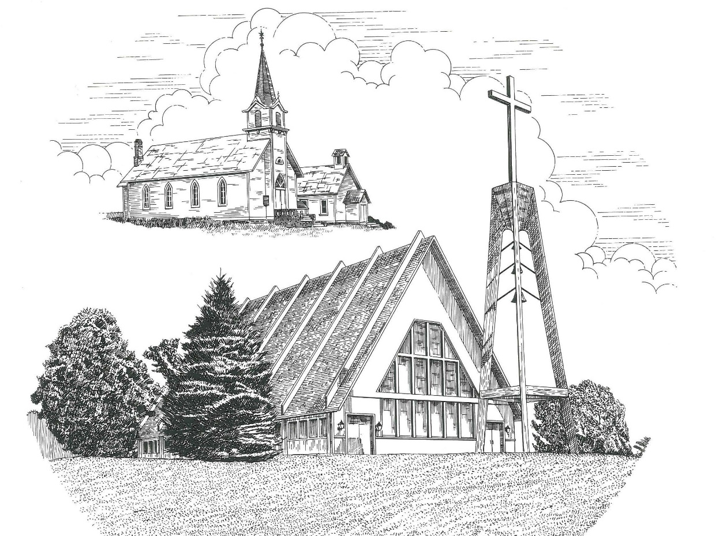

Twenty-Second Sunday after Pentecost October 24th, 2021

WELCOME
Thanks for joining us!
Pastor Jacob Sherry Missouri Synod

~~PLEASE NOTE~~
Calling on the name of the Lord
Does not include the use of cell phones in the worship sanctuary.
Please check yours before the service begins. Thank you for your courtesy.
~~TO OUR GUESTS AND VISITORS~~
Please sign our guest book located on the stand at the church entrance. During the service, we ask you to sign the attendance booklet located at the end of each pew. If you need assistance or have questions about our worship service, please talk to an elder or any one of our church family. We are glad you could join us and hope to have you worship with us again soon.

~~ATTENDING HOLY COMMUNION~~
By checking the “Communing Today” box on the registration form found in the attendance booklet, you are agreeing with the following statements:

- I am a baptized Christian who believes Jesus Christ is my Lord and Savior.
- I believe that I am a sinner in need of Christ freely offered forgiveness.
- I believe that in the Lord’s Supper the body and blood of Jesus Christ
are truly present in, with, and under the bread and wine.
- I believe that my participation in Holy Communion grants me forgiveness
of my sins, new spiritual life, and eternal salvation.
- With God’s help, I sincerely seek to repent of my sins, live in service
to my Lord, and await His return.

If you agree with the above statements, you are welcome to attend the Lord’s Supper with us. May God bless your worship time with us.
We do offer gluten-free wafers, please quietly ask an elder to help you.

Order of Divine Service Setting Three

Pre-Service Music……………..Call to Worship………………….Greeting

OPENING HYMN: “Today Your Mercy Calls Us”.................................LSB #915

OPENING LITURGY:
Confession & Absolution………..………………………………LSB pp. 184-185
Kyrie…………………………………….………………………..LSB p. 186
Gloria in Excelsis……...…………………………………………LSB pp. 187-188
Salutation….……………………………….…………………….LSB p. 189

Collect Prayer
O God, the helper of all who call on You, have mercy on us and give us eyes of faith to see Your Son that we may follow Him on the way that leads to eternal life; through the same Jesus Christ, Your Son, our Lord, who lives and reigns with You and the Holy Spirit, one God, now and forever.

THE HOLY SCRIPTURES

OLD TESTAMENT: (Jeremiah 31:7-9)
⁷ For thus says the Lord:
“Sing aloud with gladness for Jacob,
and raise shouts for the chief of the nations;
proclaim, give praise, and say,
‘O Lord, save your people,
the remnant of Israel.’
⁸ Behold, I will bring them from the north country
and gather them from the farthest parts of the earth,
among them the blind and the lame,
the pregnant woman and she who is in labor, together;
a great company, they shall return here.
⁹ With weeping they shall come,
and with pleas for mercy I will lead them back,
I will make them walk by brooks of water,
in a straight path in which they shall not stumble,
for I am a father to Israel,
and Ephraim is my firstborn.
R: This is the Word of the Lord. Cong: Thanks be to God.

GRADUAL
Reader: He will command his angels concerning you
Cong.: to guard you in all your ways.
Reader: Bless the Lord, O my soul,
Cong.: and all that is within me, bless his holy name!

EPISTLE: (Hebrews 7:23-28)
²³ The former priests were many in number, because they were prevented by death from continuing in office, ²⁴ but he holds his priesthood permanently, because he continues forever. ²⁵ Consequently, he is able to save to the uttermost those who draw near to God through him, since he always lives to make intercession for them. ²⁶ For it was indeed fitting that we should have such a high priest, holy, innocent, unstained, separated from sinners, and exalted above the heavens. ²⁷ He has no need, like those high priests, to offer sacrifices daily, first for his own sins and then for those of the people, since he did this once for all when he offered up himself. ²⁸ For the law appoints men in their weakness as high priests, but the word of the oath, which came later than the law, appoints a Son who has been made perfect forever.

R: This is the Word of the Lord. Cong: Thanks be to God.

(PLEASE RISE for the reading of the Gospel)

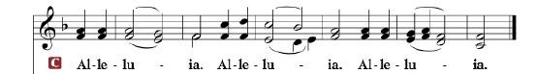

R: The Holy Gospel according to St. Mark, the 10th chapter.

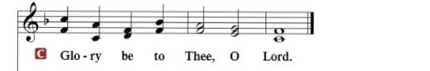

HOLY GOSPEL: (Mark 10:46-52)
⁴⁶ And they came to Jericho. And as Jesus was leaving Jericho with his disciples and a great crowd, Bartimaeus, a blind beggar, the son of Timaeus, was sitting by the roadside. ⁴⁷ And when he heard that it was Jesus of Nazareth, he began to cry out and say, “Jesus, Son of David, have mercy on me!” ⁴⁸ And many rebuked him, telling him to be silent. But he cried out all the more, “Son of David, have mercy on me!” ⁴⁹ And Jesus stopped and said, “Call him.” And they called the blind man, saying to him, “Take heart. Get up; he is calling you.” ⁵⁰ And throwing off his cloak, he sprang up and came to Jesus. ⁵¹ And Jesus said to him, “What do you want me to do for you?” And the blind man said to him, “Rabbi, let me recover my sight.” ⁵² And Jesus said to him, “Go your way; your faith has made you well.” And immediately he recovered his sight and followed him on the way.

R: This is the Gospel of the Lord.

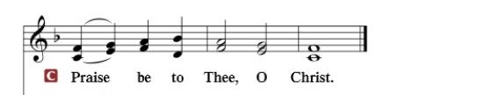

Nicene Creed
I believe in one God, the Father Almighty, maker of heaven and earth and of all things visible and invisible.
And in one Lord Jesus Christ, the only-begotten Son of God, begotten of His Father before all worlds, God of God, Light of Light, very God of very God, begotten, not made, being of one substance with the Father, by whom all things were made; who for us men and for our salvation came down from heaven and was incarnate by the Holy Spirit of the virgin Mary and was made man; and was crucified also for us under Pontius Pilate. He suffered and was buried. And the third day He rose again according to the Scriptures and ascended into heaven and sits at the right hand of the Father. And He will come again with glory to judge both the living and the dead, whose kingdom will have no end.
And I believe in the Holy Spirit, the Lord and giver of life, who proceeds from the Father and the Son, who with the Father and the Son together is worshiped and glorified, who spoke by the prophets. And I believe in one holy Christian and apostolic Church, I acknowledge one Baptism for the remission of sins, and I look for the resurrection of the dead and the life of the world to come. Amen.

SERMON HYMN: “I Know My Faith Is Founded”...............................LSB #587

SERMON

OFFERTORY……………………………………………………..……LSB pp. 192-193

THE GENERAL PRAYERS OF THE CHURCH

INSTITUTION OF THE LORD’S SUPPER
Preface…………………………………….…………….……….LSB p. 194

Proper Preface
It is truly good, right, and salutary that we should at all times and in all places give thanks to You, holy Lord, almighty Father, everlasting God, through Jesus Christ, our Lord, who, out of love for His fallen creation, humbled Himself by taking on the form of a servant, becoming obedient unto death, even death upon a cross. Risen from the dead, He has freed us from eternal death and given us life everlasting. Therefore, with angels and archangels and with all the company of heaven we laud and magnify Your glorious name, ever more praising You and saying:
Sanctus, Lord’s Prayer, The Words of Our Lord………………….....LSB pp. 195-197
Agnus Dei………………………………………………………………..LSB p. 198
If you are not communing it is acceptable to remain seated.

COMMUNION DISTRIBUTION HYMNS:
LSB #730 “What Is the World to Me”
LSB #629 “What Is This Bread”

NUNC DIMITTIS………………………………………………………LSB pp. 199-200

BENEDICTION

CLOSING HYMN: “Thine Forever, God of Love”...............................LSB #687

The Mission of Trinity Onekama Is To SERVE

For even the Son of Man did not come to be served
but to serve and to give his life as a ransom for many.
Mark 10:45

S haring Jesus’s truth
E quipping for life
R eaching Out
V aluing each other
E vangelizing all ages
Mission Statement
The mission of Trinity Onekama is to SERVE
For even the Son of Man did not come to be served, but to serve,
and to give his life as a ransom for many. Mark 10:45
S haring Jesus’ ruth
E quipping for life
R eaching Out
V aluing each other
E vangelizing all age

CHURCH INFORMATION
Church Office: (231) 889-4429 Website: www.trinityonekama.org
E-mail: trinityonekama@sbcglobal.net
Address: P.O. Box 119, 5471 Fairview Street, Onekama, MI 49675
Adult Bible Study: Sunday @ 9:15 am (year round)
Worship: Sunday @ 10:30 am The Lord’s Supper: Celebrated 2nd & 4th Sundays
Pastoral Hours: Wednesday and Friday 8:30am – Noon
Pastor Phone: 231-655-2680 Pastor Email: trinityonekama@gmail.com

Copyright licensing covered under CCLI #2802932

