**231-889-4429 5471 Fairview Street, Box 119 Onekama, MI**

**TRINITY LUTHERAN CHURCH**

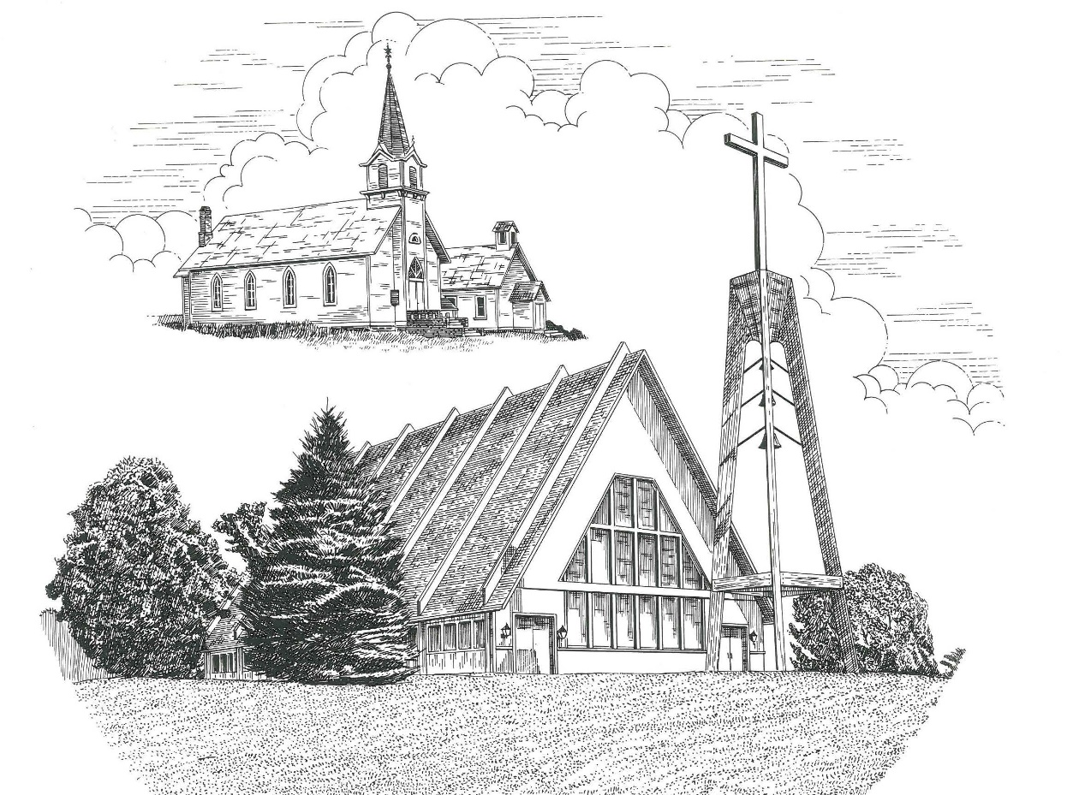

**Reformation Sunday October 25th, 2020**

**WELCOME**

**Thanks for joining us!**

**Pastor Jacob Sherry Missouri Synod**

**~~PLEASE NOTE~~Calling on the name of the Lord**

Does not include the use of cell phones in the worship sanctuary.

Please check yours before the service begins. Thank you for your courtesy.

**~~TO OUR GUESTS AND VISITORS~~**

Please sign our guest book located on the stand at the church entrance. During the service, we ask you to sign the attendance booklet located at the end of each pew. If you need assistance or have questions about our worship service, please talk to an elder or any one of our church family. We are glad you could join us and hope to have you worship with us again soon.

**~~ATTENDING HOLY COMMUNION~~**

By checking the “Communing Today” box on the registration form found in the attendance booklet, you are agreeing with the following statements:

* **I am a baptized Christian who believes Jesus Christ is my Lord and Savior.**
* **I believe that I am a sinner in need of Christ freely offered forgiveness.**
* **I believe that in the Lord’s Supper the body and blood of Jesus Christ**

**are truly present in, with, and under the bread and wine.**

* **I believe that my participation in Holy Communion grants me forgiveness**

**of my sins, new spiritual life, and eternal salvation.**

* **With God’s help, I sincerely seek to repent of my sins, live in service**

**to my Lord, and await His return.**

**If you agree with the above statements, you are welcome to attend the Lord’s Supper with us. May God bless your worship time with us.**

We do offer gluten-free wafers, please quietly ask an elder to help you.

**Order of Divine Service Setting One**

**Pre-Service Music……………..Call to Worship………………….Greeting**

**OPENING HYMN:** *“We Praise You and Acknowledge You, O God”*…...….....LSB #941

**CONFESSION & ABSOLUTION**…………………………………………....LSB p. 151

**KYRIE**…………………………………………………………………...LSB pp. 152-153

**THIS IS THE FEAST**……………………………………………………..…...LSB p. 155

**SALUTATION**…………………………………………………………….…..LSB p. 156

**Collect Prayer**

O God, You have commanded us to love You above all things and our neighbor as ourselves. Grant us the Spirit to think and do what is pleasing in Your sight, that our faith in You may never waver and our love for one another may not falter; through Jesus Christ, our Lord, who lives and reigns with You and the Holy Spirit, one God, now and forever.

**C: Amen.**

**THE HOLY SCRIPTURES**

**FIRST READING:** (Revelation 14:6-7)

**6**Then I saw another angel flying directly overhead, with an eternal gospel to proclaim to those who dwell on earth, to every nation and tribe and language and people.  **7**And he said with a loud voice, “Fear God and give him glory, because the hour of his judgment has come, and worship him who made heaven and earth, the sea and the springs of water.”

**R:** This is the Word of the Lord**.** **Cong: Thanks be to God.**

**GRADUAL**

Reader: He will command his angels concerning you

**Cong.: to guard you in all your ways.**

Reader: Bless the Lord, O my soul,

**Cong.: and all that is within me, bless his holy name!**

**EPISTLE:** (Romans 3:19-28)

**19**Now we know that whatever the law says it speaks to those who are under the law, so that every mouth may be stopped, and the whole world may be held accountable to God.  **20**For by works of the law no human being will be justified in his sight, since through the law comes knowledge of sin.

**21**But now the righteousness of God has been manifested apart from the law, although the Law and the Prophets bear witness to it— **22**the righteousness of God through faith in Jesus Christ for all who believe.  For there is no distinction: **23**for all have sinned and fall short of the glory of God, **24**and are justified by his grace as a gift, through the redemption that is in Christ Jesus, **25**whom God put forward as a propitiation by his blood, to be received by faith. This was to show God's righteousness, because in his divine forbearance he had passed over former sins.  **26**It was to show his righteousness at the present time, so that he might be just and the justifier of the one who has faith in Jesus.

**27**Then what becomes of our boasting? It is excluded. By what kind of law? By a law of works? No, but by the law of faith.  **28**For we hold that one is justified by faith apart from works of the law.

**R:** This is the Word of the Lord. **Cong: Thanks be to God.**

**(PLEASE RISE for the reading of the Gospel)**



**R:** The Holy Gospel according to St. Matthew, the 11th chapter.



**HOLY GOSPEL:** (Matthew 11:12-19)

**12**From the days of John the Baptist until now the kingdom of heaven has suffered violence, and the violent take it by force.  **13**For all the Prophets and the Law prophesied until John, **14**and if you are willing to accept it, he is Elijah who is to come.  **15**He who has ears to hear, let him hear.

**16**“But to what shall I compare this generation? It is like children sitting in the marketplaces and calling to their playmates,

**17**“‘We played the flute for you, and you did not dance;  
    we sang a dirge, and you did not mourn.’

**18**For John came neither eating nor drinking, and they say, ‘He has a demon.’  **19**The Son of Man came eating and drinking, and they say, ‘Look at him! A glutton and a drunkard, a friend of tax collectors and sinners!’ Yet wisdom is justified by her deeds.”

**R:** This is the Gospel of the Lord.



**SERMON HYMN**: *“A Mighty Fortress Is Our God”*………………….………LSB #656

**SERMON**

**NICENE CREED**

I believe in one God, the Father Almighty, maker of heaven and earth and of all things visible and invisible.

And in one Lord Jesus Christ, the only-begotten Son of God, begotten of His Father before all worlds, God of God, Light of Light, very God of very God, begotten, not made, being of one substance with the Father, by whom all things were made; who for us men and for our salvation came down from heaven and was incarnate by the Holy Spirit of the virgin Mary and was made man; and was crucified also for us under Pontius Pilate. He suffered and was buried. And the third day He rose again according to the Scriptures and ascended into heaven and sits at the right hand of the Father. And He will come again with glory to judge both the living and the dead, whose kingdom will have no end.

And I believe in the Holy Spirit, the Lord and giver of life, who proceeds from the Father and the Son, who with the Father and the Son together is worshiped and glorified, who spoke by the prophets. And I believe in one holy Christian and apostolic Church, I acknowledge one Baptism for the remission of sins, and I look for the resurrection of the dead and the life of the world to come. Amen.

**THE GENERAL PRAYERS OF THE CHURCH**

**SERVICE OF THE SACRAMENT**

**PREFACE**……………………………………………………………………..LSB p. 160

**Proper Preface**

It is truly good, right, and salutary that we should at all times and in all places give thanks to You, holy Lord, almighty Father, everlasting God, through Jesus Christ, who, out of love for His fallen creation, humbled Himself by taking on the form of a servant, becoming obedient unto death, even death upon a cross. Risen from the dead, He has freed us from eternal death and given us life everlasting. Therefore, with angels and archangels and with all the company of heaven we laud and magnify Your glorious name, ever more praising You and saying:

**SANCTUS**……………………………………………………………………...LSB p. 161

**LORD’S PRAYER**

**THE WORDS OF OUR LORD**…………………………………………….....LSB p. 162

**AGNUS DEI**…………………………………………………………………....LSB p. 163

*If you are not communing it is acceptable to remain seated.*

**COMMUNION DISTRIBUTION HYMNS**

LSB #578 *“Thy Strong Word”*

LSB #555 *“Salvation unto Us Has Come”*

**THANK THE LORD**………………………………………………………….LSB p. 164

**POST-COMMUNION COLLECT PRAYER**……………………………….LSB p. 166

**BENEDICTION**……………………………………………………………….LSB p. 166

**CLOSING HYMN:** *“Lift High the Cross”*……..……………………………..LSB #837

The Mission of Trinity Onekama Is To **SERVE**

For even the Son of Man did not come to be served

but to serve and to give his life as a ransom for many.            
                                                                       Mark 10:45



**S**haring Jesus’s **t**ruth

**E**quipping for life

**R**eaching Out

**V**aluing each other

**E**vangelizing all ages

Mission Statement

The mission of Trinity Onekama is to SERVE

For even the Son of Man did not come to be served, but to serve,

and to give his life as a ransom for many. Mark 10:45

S haring Jesus’ ruth

E quipping for life

R eaching Out

V aluing each other

E vangelizing all age

**CHURCH INFORMATION**

**Church Office:** (231) 889-4429 **Website:** www.trinityonekama.org

**E-mail:** [trinityonekama@sbcglobal.net](mailto:trinityonekama@sbcglobal.net)

**Address:** P.O. Box 119, 5471 Fairview Street, Onekama, MI 49675

**Adult Bible Study**: Sunday @ 9:15 am (year round)

**Worship:** Sunday @ 10:30 am **The Lord’s Supper:**  Celebrated 2nd & 4th Sundays

**Pastoral Hours:** Wednesday and Friday 8:30am – Noon

**Pastor Phone:** 231-655-2680 **Pastor Email:** trinityonekama@gmail.com

**Copyright licensing covered under CCLI #2802932**