231-889-4429 5471 Fairview Street, Box 119 Onekama, MI

TRINITY LUTHERAN CHURCH
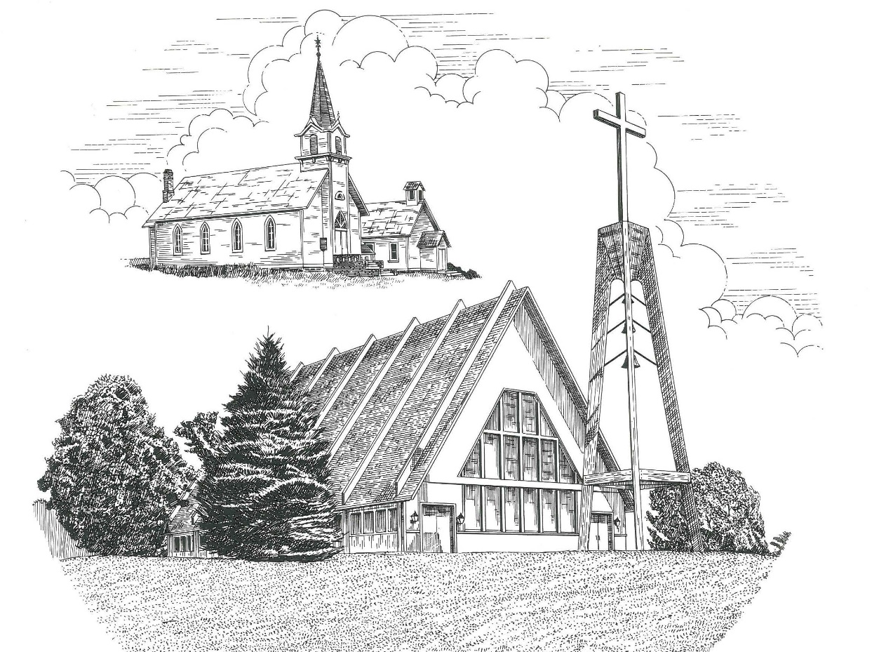

Reformation Sunday October 29th, 2023

WELCOME
Thanks for joining us!
Pastor Jacob Sherry Missouri Synod

~~PLEASE NOTE~~
Calling on the name of the Lord
Does not include the use of cell phones in the worship sanctuary.
Please check yours before the service begins. Thank you for your courtesy.
~~TO OUR GUESTS AND VISITORS~~
Please sign our guest book located on the stand at the church entrance. During the service, we ask you to sign the attendance sheet located in your bulletin and place it on the pew when you leave. If you need assistance or have questions about our worship service, please talk to an elder or any one of our church family. We are glad you could join us and hope to have you worship with us again soon.

~~ATTENDING HOLY COMMUNION~~
By checking the “Communing Today” box on the registration form found on the attendance sheet, you are agreeing with the following statements:

- I am a baptized Christian who believes Jesus Christ is my Lord and Savior.
- I believe that I am a sinner in need of Christ’s freely offered forgiveness.
- I believe that in the Lord’s Supper the body and blood of Jesus Christ
are truly present in, with, and under the bread and wine.
- I believe that my participation in Holy Communion grants me forgiveness
of my sins, new spiritual life, and eternal salvation.
- With God’s help, I sincerely seek to repent of my sins, live in service
to my Lord, and await His return.

If you agree with the above statements, you are welcome to attend the Lord’s Supper with us. May God bless your worship time with us.
We do offer gluten-free wafers, please quietly ask an elder to help you.

Order of Divine Service Setting Three

Pre-Service Music……………..Call to Worship………………….Greeting

OPENING HYMN: “By Grace I’m Saved”.............................................LSB #566

CONFESSION & ABSOLUTION
P: In the name of the Father and of the Son and of the Holy Spirit.
C: Amen.

P: Beloved in the Lord! Let us draw near with a true heart and confess our sins unto God our Father, beseeching Him in the name of our Lord Jesus Christ to grant us forgiveness.

P: Our help is in the name of the Lord,
C: who made heaven and earth.
P: I said, I will confess my transgressions unto the Lord,
C: and You forgave the iniquity of my sin.

P: O almighty God, merciful Father,
C: I, a poor, miserable sinner, confess unto You all my sins and iniquities with which I have ever offended You and justly deserve Your temporal and eternal punishment. But I am heartily sorry for them and sincerely repent of them, and I pray You of Your boundless mercy and for the sake of the holy, innocent, bitter sufferings and death of Your beloved Son, Jesus Christ, to be gracious and merciful to me, a poor, sinful being.

P: Upon this your confession, I, by virtue of my office, as a called and ordained servant of the Word, announce the grace of God unto all of you, and in the stead and by the command of my Lord Jesus Christ I forgive you all your sins in the name of the Father and of the Son and of the Holy Spirit.
C: Amen.

INTROIT
P: I will speak of your testimonies before kings, O Lord,
C: and shall not be put to shame.
P: I will bless the Lord at all times;
C: his praise shall continually be in my mouth.
P: My soul makes its boast in the Lord;
C: let the humble hear and be glad.
P: Come, O children, listen to me;
C: I will teach you the fear of the Lord.
P: The Lord redeems the life of his servants;
C: none of those who take refuge in him will be condemned.
ALL: Glory be to the Father and to the Son and to the Holy Spirit; as it was in the
beginning, is now, and will be forever. Amen.
P: I will speak of your testimonies before kings, O Lord,
C: and shall not be put to shame.

KYRIE…………………………………….…………………………..LSB p. 186
GLORIA IN EXCELSIS……………………………………………..LSB pp. 187-189
SALUTATION….……………………………….……………………LSB p. 189

Collect Prayer
Almighty and gracious Lord, pour out Your Holy Spirit on Your faithful people. Keep us steadfast in Your grace and trust, protect and deliver us in times of temptation, defend us against all enemies, and grant to Your Church Your saving peace; through Jesus Christ, Your Son, our Lord, who lives and reigns with You and the Holy Spirit, one God, now and forever.

THE HOLY SCRIPTURES

OLD TESTAMENT: (Revelation 14:6-7)
⁶ Then I saw another angel flying directly overhead, with an eternal gospel to proclaim to those who dwell on earth, to every nation and tribe and language and people. ⁷ And he said with a loud voice, “Fear God and give him glory, because the hour of his judgment has come, and worship him who made heaven and earth, the sea and the springs of water.”

R: This is the Word of the Lord. Cong: Thanks be to God.

GRADUAL
Reader: Great is the Lord and greatly to be praised
Cong.: in the city of our God!
Reader: Walk about Zion, go around her, number her towers,
Cong.: consider well her ramparts, go through her citadels,
Reader: that you may tell the next generation
Cong.: that this is God, our God forever and ever.

EPISTLE: (Romans 3:19-28)
¹⁹ Now we know that whatever the law says it speaks to those who are under the law, so that every mouth may be stopped, and the whole world may be held accountable to God. ²⁰ For by works of the law no human being will be justified in his sight, since through the law comes knowledge of sin.
²¹ But now the righteousness of God has been manifested apart from the law, although the Law and the Prophets bear witness to it— ²² the righteousness of God through faith in Jesus Christ for all who believe. For there is no distinction: ²³ for all have sinned and fall short of the glory of God, ²⁴ and are justified by his grace as a gift, through the redemption that is in Christ Jesus, ²⁵ whom God put forward as a propitiation by his blood, to be received by faith. This was to show God's righteousness, because in his divine forbearance he had passed over former sins. ²⁶ It was to show his righteousness at the present time, so that he might be just and the justifier of the one who has faith in Jesus.
²⁷ Then what becomes of our boasting? It is excluded. By what kind of law? By a law of works? No, but by the law of faith. ²⁸ For we hold that one is justified by faith apart from works of the law.

R: This is the Word of the Lord. Cong: Thanks be to God.

(PLEASE RISE for the reading of the Gospel)

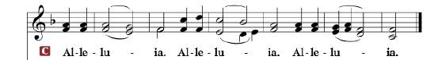

R: The Holy Gospel according to St. Matthew, the 11th chapter.

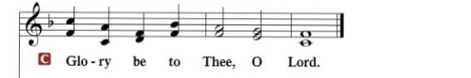

HOLY GOSPEL: (Matthew 11:12-19)
¹² From the days of John the Baptist until now the kingdom of heaven has suffered violence, and the violent take it by force. ¹³ For all the Prophets and the Law prophesied until John, ¹⁴ and if you are willing to accept it, he is Elijah who is to come. ¹⁵ He who has ears to hear, let him hear.
¹⁶ “But to what shall I compare this generation? It is like children sitting in the marketplaces and calling to their playmates,
¹⁷ “‘We played the flute for you, and you did not dance;
we sang a dirge, and you did not mourn.’
¹⁸ For John came neither eating nor drinking, and they say, ‘He has a demon.’ ¹⁹ The Son of Man came eating and drinking, and they say, ‘Look at him! A glutton and a drunkard, a friend of tax collectors and sinners!’ Yet wisdom is justified by her deeds.”

R: This is the Gospel of the Lord.

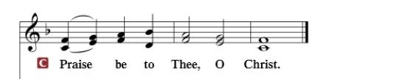

Nicene Creed
I believe in one God, the Father Almighty, maker of heaven and earth and of all things visible and invisible.
And in one Lord Jesus Christ, the only-begotten Son of God, begotten of His Father before all worlds, God of God, Light of Light, very God of very God, begotten, not made, being of one substance with the Father, by whom all things were made; who for us men and for our salvation came down from heaven and was incarnate by the Holy Spirit of the virgin Mary and was made man; and was crucified also for us under Pontius Pilate. He suffered and was buried. And the third day He rose again according to the Scriptures and ascended into heaven and sits at the right hand of the Father. And He will come again with glory to judge both the living and the dead, whose kingdom will have no end.
And I believe in the Holy Spirit, the Lord and giver of life, who proceeds from the Father and the Son, who with the Father and the Son together is worshiped and glorified, who spoke by the prophets. And I believe in one holy Christian and apostolic Church, I acknowledge one Baptism for the remission of sins, and I look for the resurrection of the dead and the life of the world to come. Amen.

SERMON HYMN: “Lord, Keep Us Steadfast in Your Word”……….…LSB #655

SERMON

COLLECTION OF THE OFFERING
OFFERTORY…………………………………………………………...LSB pp. 192-193

GENERAL PRAYERS OF THE CHURCH

Sharing the Peace of the Lord

SERVICE OF THE SACRAMENT
Preface…………………………………….…………….……….LSB p. 194
Proper Preface
It is truly good, right, and salutary that we should at all times and in all places give thanks to You, holy Lord, almighty Father, everlasting God, through Jesus Christ, our Lord, who, having created all things, took on human flesh and was born of the virgin Mary. For our sake He died on the cross and rose from the dead to put an end to death, thus fulfilling Your will and gaining for You a holy people. Therefore, with angels and archangels and with all the company of heaven we laud and magnify Your glorious name, ever more praising You and saying:

Sanctus, Lord’s Prayer, The Words of Our Lord………………….....LSB pp. 195-197
Agnus Dei………………………………………………………………..LSB p. 198
If you are not communing, it is acceptable to remain seated.

COMMUNION DISTRIBUTION HYMNS:
LSB #578 “Thy Strong Word”
LSB #644 “The Church’s One Foundation”
LSB #941 “We Praise You and Acknowledge You, O God”

NUNC DIMITTIS………………………………………………………LSB pp. 199-200

BENEDICTION

CLOSING HYMN: “A Mighty Fortress Us Is God”..............................LSB #656

CHURCH INFORMATION
Church Office: (231) 889-4429 Website: www.trinityonekama.org
E-mail: trinityonekama@sbcglobal.net
Address: P.O. Box 119, 5471 Fairview Street, Onekama, MI 49675
Sunday School & Adult Bible Study: Sunday @ 9:30 am
Worship: Sunday @ 10:30 am The Lord’s Supper: Celebrated 2nd & 4th Sundays
Pastoral Hours: Wednesday and Friday 9:00am – Noon
Pastor Phone: 231-655-2680 Pastor Email: trinityonekama@gmail.com

Copyright licensing covered under CCLI #2802932

