231-889-4429 5471 Fairview Street, Box 119 Onekama, MI

TRINITY LUTHERAN CHURCH
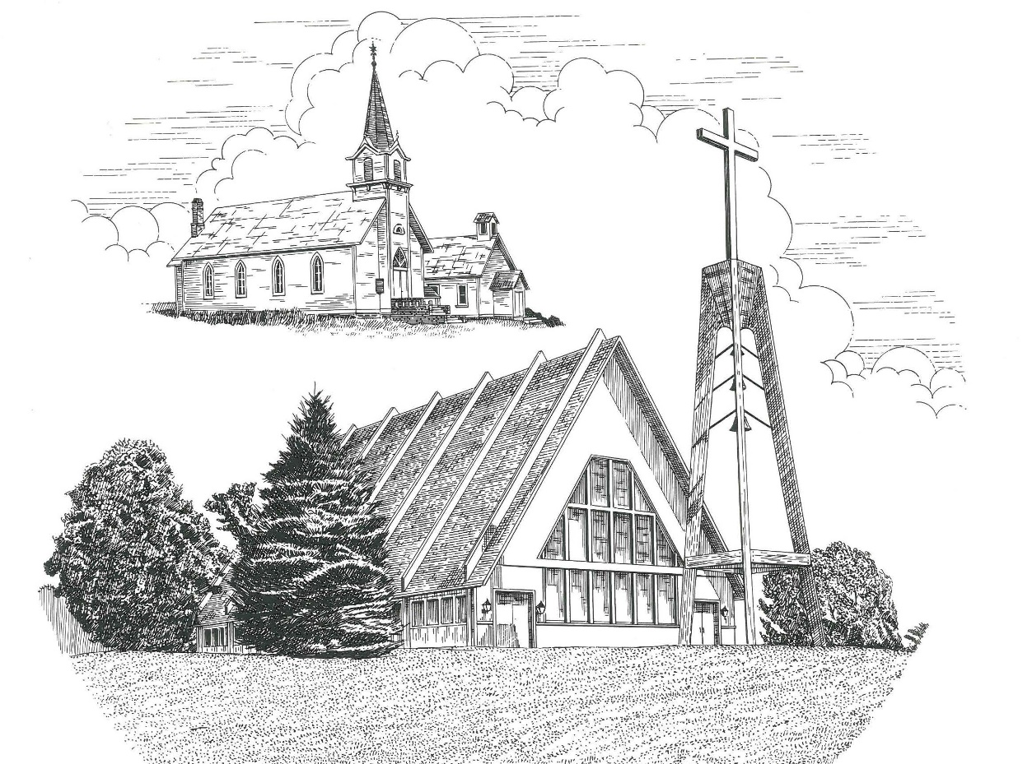

Reformation Day October 31st, 2021

WELCOME
Thanks for joining us!
Pastor Jacob Sherry Missouri Synod

~~PLEASE NOTE~~
Calling on the name of the Lord
Does not include the use of cell phones in the worship sanctuary.
Please check yours before the service begins. Thank you for your courtesy.
~~TO OUR GUESTS AND VISITORS~~
Please sign our guest book located on the stand at the church entrance. During the service, we ask you to sign the attendance booklet located at the end of each pew. If you need assistance or have questions about our worship service, please talk to an elder or any one of our church family. We are glad you could join us and hope to have you worship with us again soon.

~~ATTENDING HOLY COMMUNION~~
By checking the “Communing Today” box on the registration form found in the attendance booklet, you are agreeing with the following statements:

- I am a baptized Christian who believes Jesus Christ is my Lord and Savior.
- I believe that I am a sinner in need of Christ freely offered forgiveness.
- I believe that in the Lord’s Supper the body and blood of Jesus Christ
are truly present in, with, and under the bread and wine.
- I believe that my participation in Holy Communion grants me forgiveness
of my sins, new spiritual life, and eternal salvation.
- With God’s help, I sincerely seek to repent of my sins, live in service
to my Lord, and await His return.

If you agree with the above statements, you are welcome to attend the Lord’s Supper with us. May God bless your worship time with us.
We do offer gluten-free wafers, please quietly ask an elder to help you.

Order of Divine Service Setting Five

Pre-Service Music……………..Call to Worship………………….Greeting

OPENING HYMN: “God Loved the World So That He Gave”.........................LSB #571

Confession & Absolution
(P) In the name of the Father and of the Son and of the Holy Spirit.
(C) Amen.

(P) Beloved in the Lord! Let us draw near with a true heart and confess our sins unto Got our Father, beseeching Him in the name of our Lord Jesus Christ to grant us forgiveness.

(P) Our help is in the name of the Lord,
(C) who made heaven and earth.
(P) I said, I will confess my transgressions unto the Lord,
(C) and You forgave the iniquity of my sin.

(P) O almighty God, merciful Father,
(C) I, a poor, miserable sinner, confess unto you all my sins and iniquities with which I have ever offended You and justly deserve Your temporal and eternal punishment. But I am heartily sorry for them and sincerely repent of them, and I pray You of Your boundless mercy and for the sake of the holy, innocent, bitter sufferings and death of Your beloved Son, Jesus Christ, to be gracious and merciful to me, a poor, sinful being.

(P) Upon this your confession, I, by virtue of my office, as a called and ordained servant of the Word, announce the grace of God unto all of you, and in the stead and by the command of my Lord Jesus Christ, I forgive you all your sins in the name of the Father and of the Son and of the Holy Spirit.
(C) Amen.

KYRIE – Lord, Have Mercy….………………………………………...............LSB #944

GLORIA – We Praise You and Acknowledge You, O God…………………...LSB #941

Salutation
(P) The Lord be with you.
(C) And also with you.

(P) Let us pray.
Collect Prayer
Almighty and gracious Lord, pour out Your Holy Spirit on Your faithful people. Keep us steadfast in Your grace and truth, protect and deliver us in times of temptation, defend us against all enemies, and grant to Your Church Your saving peace; through Jesus Christ, Your Son, our Lord, who lives and reigns with You and the Holy Spirit, one God, now and forever.
(C) Amen.

THE HOLY SCRIPTURES

OLD TESTAMENT: (Revelation 14:6-7)
⁶ Then I saw another angel flying directly overhead, with an eternal gospel to proclaim to those who dwell on earth, to every nation and tribe and language and people. ⁷ And he said with a loud voice, “Fear God and give him glory, because the hour of his judgment has come, and worship him who made heaven and earth, the sea and the springs of water.”

R: This is the Word of the Lord. Cong: Thanks be to God.

GRADUAL
Reader: Great is the Lord and greatly to be praised
Cong.: in the city of our God!
Reader: Walk about Zion, go around her, number her towers,
Cong.: consider well her ramparts, go through her citadels,
Reader: that you may tell the next generation
Cong.: that this is God, our God forever and ever.

EPISTLE: (Romans 3:19-28)
¹⁹ Now we know that whatever the law says it speaks to those who are under the law, so that every mouth may be stopped, and the whole world may be held accountable to God. ²⁰ For by works of the law no human being will be justified in his sight, since through the law comes knowledge of sin. ²¹ But now the righteousness of God has been manifested apart from the law, although the Law and the Prophets bear witness to it— ²² the righteousness of God through faith in Jesus Christ for all who believe. For there is no distinction: ²³ for all have sinned and fall short of the glory of God, ²⁴ and are justified by his grace as a gift, through the redemption that is in Christ Jesus, ²⁵ whom God put forward as a propitiation by his blood, to be received by faith. This was to show God's righteousness, because in his divine forbearance he had passed over former sins. ²⁶ It was to show his righteousness at the present time, so that he might be just and the justifier of the one who has faith in Jesus.
²⁷ Then what becomes of our boasting? It is excluded. By what kind of law? By a law of works? No, but by the law of faith. ²⁸ For we hold that one is justified by faith apart from works of the law.

R: This is the Word of the Lord. Cong: Thanks be to God.

HYMN OF THE DAY: “Thy Strong Word”…………………………………...LSB #578

(PLEASE RISE for the reading of the Gospel)

R: The Holy Gospel according to St. John, the 8th chapter.
Cong.: Glory to You, O Lord.

HOLY GOSPEL: (John 8:31-36)
³¹ So Jesus said to the Jews who had believed him, “If you abide in my word, you are truly my disciples, ³² and you will know the truth, and the truth will set you free.” ³³ They answered him, “We are offspring of Abraham and have never been enslaved to anyone. How is it that you say, ‘You will become free’?” ³⁴ Jesus answered them, “Truly, truly, I say to you, everyone who practices sin is a slave to sin. ³⁵ The slave does not remain in the house forever; the son remains forever. ³⁶ So if the Son sets you free, you will be free indeed.

R: This is the Gospel of the Lord.
Cong.: Praise to You, O Christ.

CREED HYMN – We All Believe in One True God…………………………LSB #953

SERMON

PRAYERS OF THE CHURCH
(P) Friends in Christ, I urge you all to lift up your hearts to God and pray with me as Christ our Lord taught us and freely promised to hear us.

(P) God, our Father in heaven, look with mercy on us, Your needy children on earth, and grant us grace that Your holy name be hallowed by us and all the world through the pure and true teaching of Your Word and the fervent love shown forth in our lives. Graciously turn from us all false doctrine and evil living whereby Your precious name is blasphemed and profaned. Lord, in Your mercy,
(C) hear our prayer.
(P) May Your kingdom come to us and expand. Bring all transgressors and those who are blinded and bound in the devil’s kingdom to know Jesus Christ, Your Son, by faith that the number of Christians may be increased. Lord, in Your mercy,
(C) hear our prayer.
(P) Strengthen us by Your Spirit according to Your will, both in life and in death, in the midst of both good and evil things, that our own wills may be crucified daily and sacrificed to Your good and gracious will. Into Your merciful hands we commend all who are in need, praying for them at all times: Thy will be done. Lord, in Your mercy,
(C) hear our prayer.
(P) Grant us our daily bread, preserve us from greed and selfish cares, and help us trust in You to provide for all our needs. Lord, in Your mercy,
(C) hear our prayer.
(P) Forgive us our sins as we also forgive those who sin against us so that our hearts may be at peace and may rejoice in a good conscience before You, and that no sin may ever frighten or alarm us. Lord, in Your mercy,
(C) hear our prayer.
(P) Lead us not into temptation, O Lord, but help us by Your Holy Spirit to subdue our flesh, to turn from the world and its ways, and to overcome the devil with all his wiles. Lord, in Your mercy,
(C) hear our prayer.
(P) And lastly, O heavenly Father, deliver us from all evil of both body and soul, now and forever. Lord, in Your mercy,
(C) hear our prayer.
(P) We trust, O Lord, in Your great mercy to hear and answer us; through Jesus Christ, our Lord.
(C) Amen.

SERVICE OF THE SACRAMENT
(P) The Lord be with you.
(C) And also with you.
(P) Lift up your hearts.
(C) We lift them to the Lord.
(P) Let us give thanks to the Lord our God.
(C) It is right to give Him thanks and praise.

(P) It is truly good, right, and salutary that we should at all times and in all places give thanks to You, O Lord our God, king of all creation, for You have had mercy on us and given Your only-begotten Son that whoever believes in Him should not perish but have eternal life. Grant us Your Spirit, gracious Father, that we may give heed to the testament of Your Son in true faith and, above all, firmly take to heart the words with which Christ gives to us His body and blood for our forgiveness. By Your grace, lead us to remember and give thanks for the boundless love which He manifested to us when, by pouring out His precious blood, He saved us from Your righteous wrath and from sin, death, and hell. Grant that we may receive the bread and wine, that is, His body and blood, as a gift, guarantee, and pledge of His salvation. Graciously receive our prayers; deliver and preserve us. To You alone, O Father, be all glory, honor, and worship, with the Son and the Holy Spirit, one God, now and forever.
(C) Amen.

(ALL) Our Father, who art in heaven,
hallowed be Thy name,
Thy kingdom come,
Thy will be done on earth as it is in heaven;
give us this day our daily bread;
and forgive us our trespasses as we forgive those who trespass against us;
and lead us not into temptation,
but deliver us from evil.
For thine is the kingdom and the power and the glory forever and ever. Amen.

(P) In the name of our Lord and Savior Jesus Christ, at his command, and with His own words, we receive His testament:

The Words of Our Lord
(P) Our Lord Jesus Christ, on the night when he was betrayed, took bread, and when He had given thanks, He broke it and gave it to the disciples and said, “Take, eat; this is My body, which is given for you. This do in remembrance of Me.” In the same way also He took the cup after supper, and when He had given thanks, He gave it to them, saying: “Drink of it, all of you; this cup is the new testament in My blood, which is shed for you for the forgiveness of sins. This do, as often as you drink it, in remembrance of Me.”

SANCTUS – Holy, Holy, Holy verses 1 & 4…………………………………LSB #507

(P) The peace of the Lord be with you always. (C) Amen.

AGNUS DEI – Lamb of God, Pure and Holy………………………………...LSB #434
If you are not communing it is acceptable to remain seated.

COMMUNION DISTRIBUTION HYMNS:
LSB #613 “To Thee, Omniscient Lord of All”
LSB #798 “The God of Abraham Praise”

NUNC DIMITTIS – Lord, Bid Your Servant Go In Peace………………….LSB #937

(P) Let us pray.
(P) We give thanks to You, almighty God, that You have refreshed us through this salutary gift, and we implore You that of Your mercy You would strengthen us through the same in faith toward You and in fervent love toward one another; through Jesus Christ, Your Son, our Lord, who lives and reigns with You and the Holy Spirit, one God, now and forever.
(C) Amen.

(P) Let us bless the Lord. (C) Thanks be to God.

(P) The Lord bless you and keep you.
The Lord make His face shine on you and be gracious to you.
The Lord look upon you with favor and give you peace.
(C) Amen.

CLOSING HYMN: “A Mighty Fortress Is Our God”........................................LSB #656

